Samsung galaxy tab 10.1. | Bluetooth keyboard case for Samsung galaxy tab 10.1.  Detachable Bluetooth keyboard, with genuine leather case. Ultra thin | 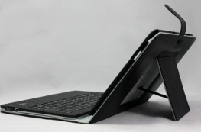 |  | Samples pcs | 100-500 | 500-1000 | >1000pcs | OEM
Samsung galaxy tab 10.1. |  |  |  | PU leather |  |  |  | OEM service is available.
Samsung galaxy tab 10.1. |  |  |  | 28.74US$ | 26.8 US$ | 25 US$ | 24.3 US$ | OEM service is available.
Samsung galaxy tab 10.1. |  |  |  | Genuine leather |  |  |  | OEM service is available.
Samsung galaxy tab 10.1. |  |  |  | 35.74 US$ | 33.8 US$ | 32 US$ | 31.3 US$ | OEM service is available.
 | Delivery Date: | 1-3 days after confirm payment |  | Shipping Fee |  |  |  | OEM service is available.
 | Shipping Methods | DHL, FEDEX(3-6days) |  | US$31.00/pc | US$10.00/pc
 | Total Cost |  |  | PU leather 59.74 US$  Genuine leather  66.74 US$ | PU leather  36.8 US$  Genuine  43.8 US$ | PU leather  35 US$  Genuine  42 US$ | PU leather  34.3 US$  Genuine leather  41.3 US$ | DHL, FEDEX(3-6days)standard mailing to Vancouver, Canada
Remark:
Packing:  Size&weight:0.65kg/pc Carton Size: 55.5*45*42cm  QTY: 50pcs/carton  Package Contents Included:  galaxy tab 10.1 leather case  Bluetooth keyboard |  |  | 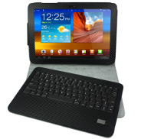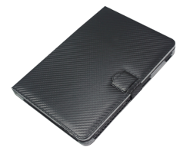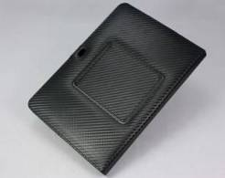

Samsung galaxy tab 10.1. | Bluetooth keyboard case for Samsung galaxy tab 10.1.  Detachable Bluetooth keyboard, with solar charger, with genuine leather case. Ultra thin | 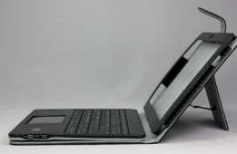 |  | Samples |  | 100-500 |  | 500-1000 |  | >1000pcs
Samsung galaxy tab 10.1. |  |  |  | PU leather |  |  |  |  |  |  | OEM service is available.
Samsung galaxy tab 10.1. |  |  |  | 28.9 US$ |  | 26.8 US$ |  | 25 US$ |  | 24.2 US$ | OEM service is available.
Samsung galaxy tab 10.1. |  |  |  | Genuine leather |  |  |  |  |  |  | OEM service is available.
Samsung galaxy tab 10.1. |  |  |  | 35.9 US$ | 33.8 US$ |  |  | 32 US$ |  | 31.2 US$ | OEM service is available.
 | Delivery Date: | 1-3 days after confirm payment |  | Shipping Fee |  |  |  |  |  |  | OEM service is available.
 | Shipping Methods | DHL, FEDEX(3-6days) |  | US$31.00/pc |  |  | US$10.00/pc
 | Total Cost |  |  | PU leather 59.9US$  Genuine leather  66.9 US$ |  |  | PU leather  36.8 US$  Genuine  43.8 US$ | PU leather  35 US$  Genuine  42 US$ | PU leather  34.2 US$  Genuine  41.2 US$ |  | DHL, FEDEX(3-6days)standard mailing to Vancouver, Canada
Remark:
Packing:  Size&weight:0.65kg/pc Carton Size: 55.5*45*42cm  QTY: 50pcs/carton  Package Contents Included:  galaxy tab 10.1 leather case  Bluetooth keyboard |  |  | 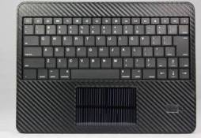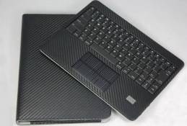

Samsung galaxy tab 10.1. | Wireless  Touchpad  Mouse Bluetooth keyboard for galaxy tab 10.1’,Mac, Windows, PS3, Xbox, android | 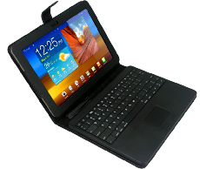 | Samples | 100-500 |  | 500-1000 | >1000pcs
Samsung galaxy tab 10.1. |  |  | PU leather |  |  |  |  | OEM service is available.
Samsung galaxy tab 10.1. |  |  | 29.9 US$ | 28.5 US$ |  | 27.7 US$ | 26.8 US$ | OEM service is available.
Samsung galaxy tab 10.1. |  |  | Genuine Leather |  |  |  |  | OEM service is available.
Samsung galaxy tab 10.1. |  |  | 36.9 US$ |  | 35.5 US$ | 34.7 US$ | 33.8 US$ | OEM service is available.
Samsung galaxy tab 10.1. |  |  | Shipping Fee |  |  |  |  | OEM service is available.
 | Delivery Date: | Sample: 1-3 days after payment confirm. |  |  |  |  |  | OEM service is available.
 | Shipping Methods | DHL, FEDEX(3-6days) | US$31.00/pc |  | US$10.00/pc
 | Total Cost |  | PU leather 60.9US$  Genuine leather  67.9 US$ |  | PU leather 38.5US$  Genuine leather  45.5 US$ | PU leather 37.7  Genuine  44.7 US$ | PU leather 36.8US$  Genuine  33.8 US$ | DHL, FEDEX(3-6days)standard mailing to Vancouver, Canada
Remark:
Packing: G.W:0.6g/pc N.W:565g Carton Size: 55.5*45*42cm  QTY: 50pcs/carton  Package Contents Included:  Bluetooth keyboard  Micro-usb cable |  | 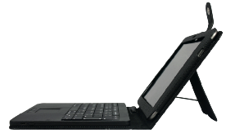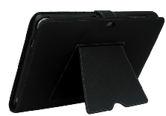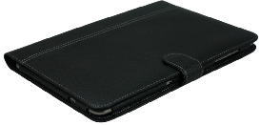
 EnjoyGadget Communications Equipment CO., LIMITED
www.enjoygadget.com Email：sales@enjoygadget.com Cell: +86-13725554931 Tel: +86-755-83951792

