 EnjoyGadget Communications Equipment CO., LIMITED
www.enjoygadget.com Email：sales@enjoygadget.com Cell: +86-13725554931 Tel: +86-755-83951792

Samsung galaxy tab 10.1. | Bluetooth keyboard case for Samsung galaxy tab 10.1.  Detachable Bluetooth keyboard, with genuine leather case. Ultra thin | 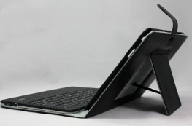 | Samples pcs | 100-500 | 500-1000 | >1000pcs | OEM
Samsung galaxy tab 10.1. |  |  | PU leather |  |  |  | OEM service is available.
Samsung galaxy tab 10.1. |  |  | 28.74 | 26.8 | 25 | 24.3 | OEM service is available.
Samsung galaxy tab 10.1. |  |  | Genuine leather |  |  |  | OEM service is available.
Samsung galaxy tab 10.1. |  |  | 7USD More than the PU leather quotation |  |  |  | OEM service is available.
 | Delivery Date: | 1-3 days after confirm payment | Discuss while order |  |  |  | OEM service is available.
Remark:
Packing:  Size&weight:0.65kg/pc Carton Size: 55.5*45*42cm  QTY: 50pcs/carton  Package Contents Included:  galaxy tab 10.1 leather case  Bluetooth keyboard |  | 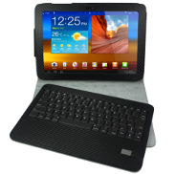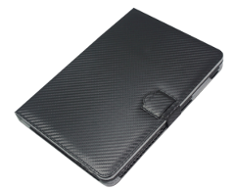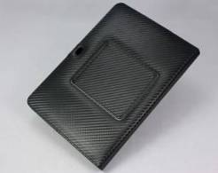

Samsung galaxy tab 10.1. | Bluetooth keyboard case for Samsung galaxy tab 10.1.  Detachable Bluetooth keyboard, with solar charger, with genuine leather case. Ultra thin | 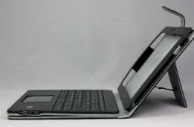 | Samples | 100-500 | 500-1000 | >1000pcs
Samsung galaxy tab 10.1. |  |  | PU leather |  |  |  | OEM service is available.
Samsung galaxy tab 10.1. |  |  | 28.9 | 26.8 | 25 | 24.2 | OEM service is available.
Samsung galaxy tab 10.1. |  |  | Genuine leather |  |  |  | OEM service is available.
Samsung galaxy tab 10.1. |  |  | 7USD More than the PU leather quotation |  |  |  | OEM service is available.
 | Delivery Date: | 1-3 days after confirm payment | Discuss while order |  |  |  | OEM service is available.
Remark:
Packing:  Size&weight:0.65kg/pc Carton Size: 55.5*45*42cm  QTY: 50pcs/carton  Package Contents Included:  galaxy tab 10.1 leather case  Bluetooth keyboard |  | 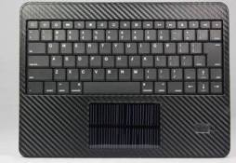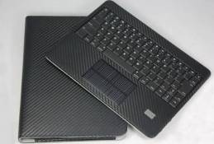

Samsung galaxy tab 10.1. | Wireless  Touchpad  Mouse Bluetooth keyboard for galaxy tab 10.1’,Mac, Windows, PS3, Xbox, android | 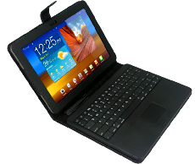 | Samples |  | 100-500 | 500-1000 | >1000pcs
Samsung galaxy tab 10.1. |  |  | PU leather |  |  |  |  | OEM service is available.
Samsung galaxy tab 10.1. |  |  | 29.9 |  | 28.5 | 27.7 | 26.8 | OEM service is available.
Samsung galaxy tab 10.1. |  |  | Genuine Leather | 7USD More than the PU leather quotation |  |  |  | OEM service is available.
Samsung galaxy tab 10.1. |  |  | Discuss while order |  |  |  |  | OEM service is available.
 | Delivery Date: | Sample: 1-3 days after payment confirm. |  |  |  |  |  | OEM service is available.
Remark:
Packing: G.W:0.6g/pc N.W:565g Carton Size: 55.5*45*42cm  QTY: 50pcs/carton  Package Contents Included:  Bluetooth keyboard  Micro-usb cable |  | 