**1. Roles in Scrum**

There are three chief roles in Scrum Testing – Product Owner, Scrum Master and The Development Team. Let’s study them in detail

| **Product Owner** | **Scrum Master** | **The Team** |
| --- | --- | --- |
| * He/She defines features of the product. | * He/She manages the team and look after the team’s productivity | * The team is usually about 5-9 members |
| * Product Owner decides the release date and corresponding features | * He/She maintains the block list and removes barriers in the development | * It includes developers, designer and sometimes testers, etc. |
| * They prioritize the features according to the market value and profitability of the product | * He/She coordinates with all roles and functions | * The team organizes and schedule their work on their own |
| * He/She is responsible for the profitability of the product | * He/She shields team from external interferences | * Has right to do everything within the boundaries of the project to meet the sprint goal |
| * He/She can accept or reject work item result | * Invites to the daily scrum, sprint review and planning meetings | * Actively participate in daily ceremonies |

**2. Scrum Artifacts**

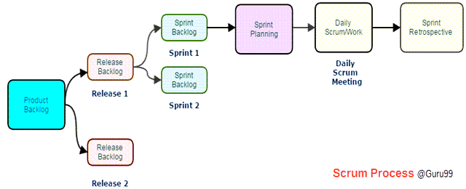

A scrum process includes

* **User stories:**They are a short explanation of functionalities of the system under test. Example for Insurance Provider is – “Premium can be paid using the online system.”
* **Product Backlog:** It is a collection of user stories captured for a scrum product.**The product owner prepares** and maintains the product backlog. It is prioritized by the product owner, and anyone can add to it with approval from the product owner.
* **Release Backlog:**A release is a time frame in which the number of iterations is completed.**The product owner co-ordinates** with the scrum master to decide which stories should be targeted for a release. Stories in the release backlog are targeted to be completed in a release.
* **Sprints:**It is a set period of time to complete the user stories, decided by the product owner and developer team, usually 2-4 weeks of time.
* **Sprint Backlog:**It’s a set of user stories to be completed in a sprint. During sprint backlog, work is never assigned, and the team signs up for work on their own. It is owned and managed by the team while the estimated work remaining is updated daily. It is the list of task that has to be performed in Sprint
* **Block List:**It is a list of blocks and unmade decisions owned by scrum master and updated daily
* **Burndown chart:**Burn-down chart represents overall progress of the work in progress and work completed throughout the process. It represents in a graph format the stories and features not completed

**3. Ceremonies (Processes) in Scrum**

* **Sprint Planning:**A sprint begins with the team importing stories from the release backlog into the sprint backlog; it is hosted by scrum master. The Testers estimate effort to test the various stories in the Sprint Backlog.
* **Daily Scrum:**It is hosted by scrum master, it last about 15 minutes. During Daily Scrum, the members will discuss the work completed the previous day, the planned work for the next day and issues faced during a sprint. During daily stand-up meeting team progress is tracked.
* **Sprint Review/ Retrospective:**It is also hosted by scrum master, it last about 2-4 hours and discuss what the team has accomplished in the last sprint and what lessons were learned.

**Role of Tester in Scrum**

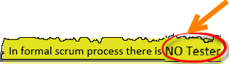

**There is no active role of Tester in the Scrum** Process. Usually, testing is carried out by a developer with Unit Test. While product owner is also frequently involved in the testing process during each sprint. **Some Scrum projects do have dedicated test teams depending on the nature & complexity of the project**.

The next question is, what tester do in a scrum? Following note will answer