**Name - Gaurang A Raorane Roll No - 49**

**Class - D15A Batch - C**

**EXPERIMENT 1**

Aim - To understand the process of Breaking the Mono-alphabetic Substitution Cipher using Frequency Analysis method.

**Q1)**

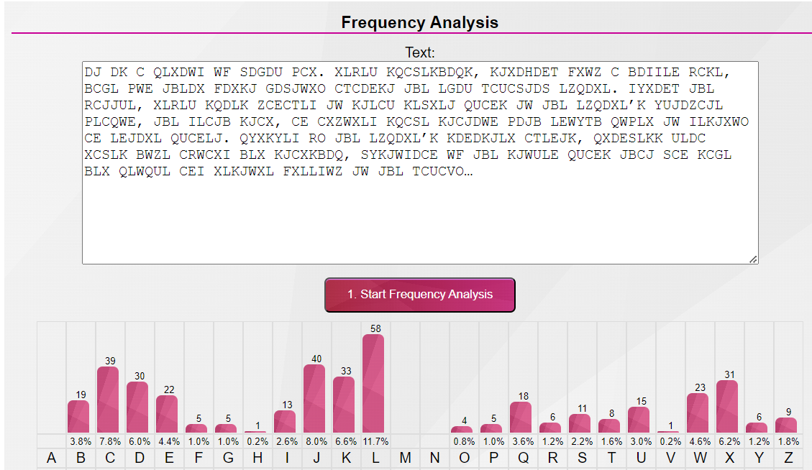

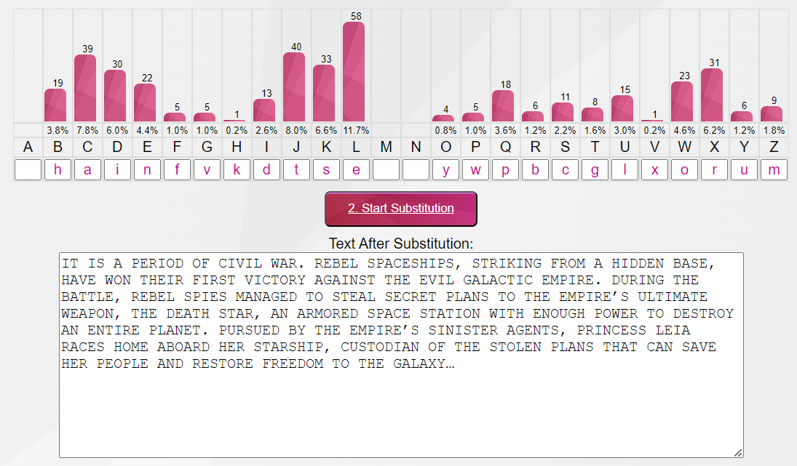

**Q2)** 