**Name:-** Gaurang A Raorane **Div:-** D15A

**Roll No:-** 49 **Batch:-** C

**LAB 2**

**Aim :- To understand Version Control System / Source Code**

**Management, install git and create a GitHub account.**

**INSTALLATION OF GIT :-**

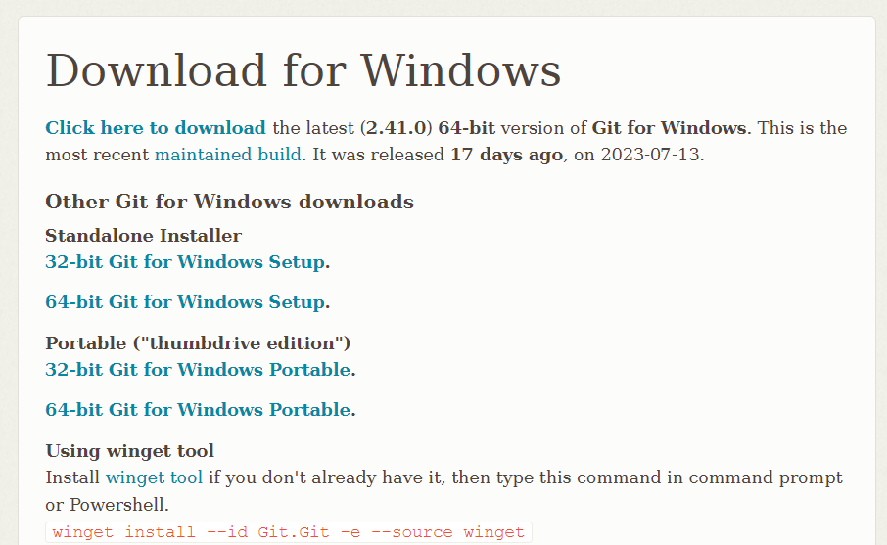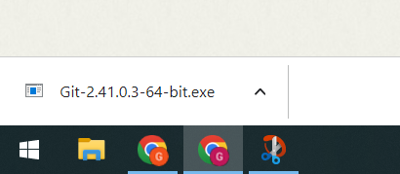

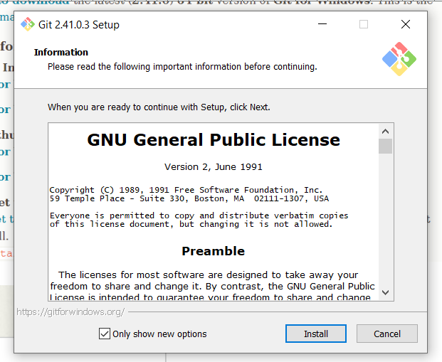

**Github Account:-**

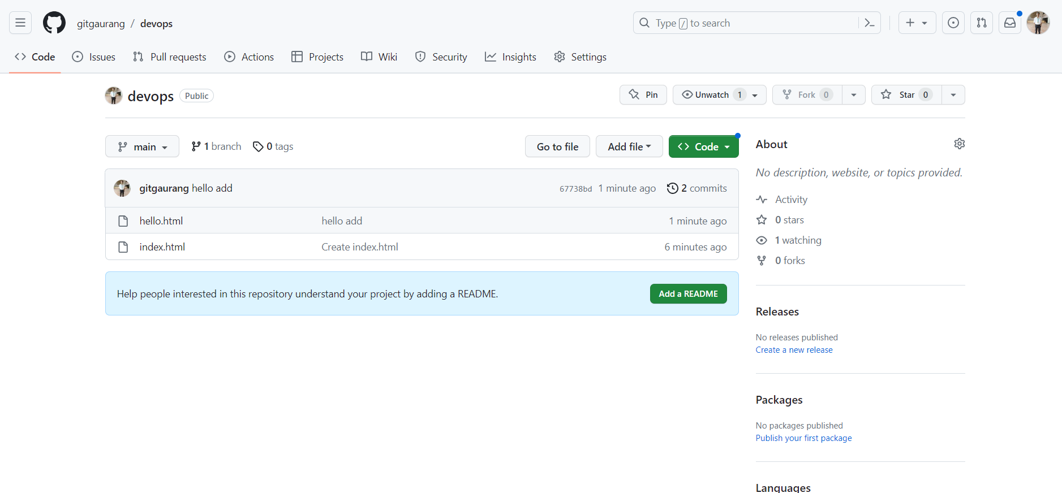

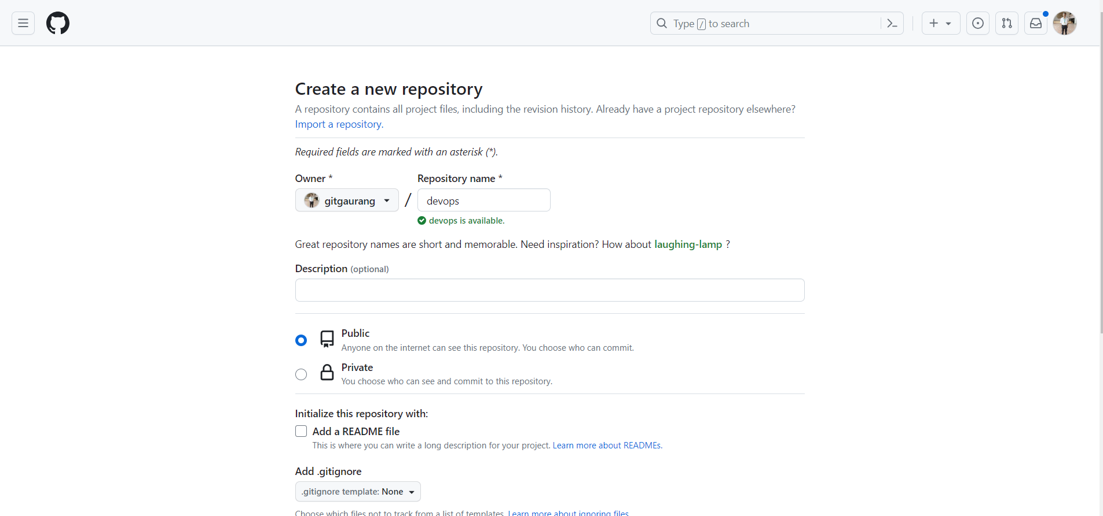

**Conclusion:-**

Installed Git and created a Github account.

1. Learned Installation of git and creation of github account.
2. Faced errors while logging in to git bash in new Device.