

Blog Topic : What is ajax why to use with php?

Written by : Mohd Wasim

Course : Web Master

ID : AD/RH/WM/08-19/27

Mentor : Abhishek Sinha

Project Topic : E-Commerce Clothes Website

**By**

**Mohd Wasim**

(Web Master)

Index

|  |  |  |
| --- | --- | --- |
| S.No | Topic | Page No. |
| 1 | What is Ajax? | 3 |
| 2 | Types of Ajax | 4 |
| 3 | Ajax in PHP | 6 |

What is Ajax?

Ajax (Asynchronous Javascript and XML ) is a web development technique which helps to create highly responsive, near software like fast and dynamic user experience web applications pages. It just uses a combination of a built-in XML Http requests objects of the browser and javascript in the background, which is used to request data from the server, and we can display the data via html to the web browser where user will see the data response within penalty of time gap. Html, Css for the representation, Json/Xml for sorting data, XMLHttp request object for action in the background and Javascript put all this together.

Asynchronous Javascript and XML is used in web pages or web applications to be updated asynchronously by swapping the data with the web server behind the scene. This makes possible for the developers to update the particular part of the websites without reloading the whole page. Using ajax we can make our web applications faster, it is not a programming language it is just a technique of web development. Javascript is known as a client-side programming language and XML(Extensible Markup Language) is a markup language which is used to define data.

Some of the examples where ajax is used are:

1. Showing suggestions while searching
2. Adding review to product
3. Like and Comment feature
4. Star rating
5. Load more page content

Why use Ajax?

1. Better User Experience
2. No page reload on each request
3. Send/ Receive data to the server in the background
4. Update the particular part of the page
5. Improves speed and performance

Types of Ajax

There are two types of ajax:

1. Asynchronous Ajax
   * Asynchronous ajax call allows us to execute the next line even if the previous code isn’t completed.
2. Synchronous Ajax
   * Synchronous ajax call stop javascript execution until the response from the server.

Asynchronous ajax will effect the SEO because we will not have specific url’s of the pages.

How to use ajax in your code?

There are two methods to use ajax in your web application, the first one is the traditional way by using ajax with javascript and the second one is to use ajax with jquery. Ajax used to communicate with server and get the data from the server. Let’s see an example of how server respond without ajax request.

If we submit a form through php as the server side language and mysql as the database, when we click the submit button the form data directly go to the php page and from there it stored in the mysql database. When the form get submitted the page reloads and user will scroll down again to resume where they left. This counts to the bad user experience.

Now, let’s discuss an example with ajax request code.

We will do the same code as we were doing previous but the only change will be that we will submit the form data through the ajax not by the default form method. We will make javascript prevent default method to preventing the form submission and call a jquery function on form submit, and in that function we will get all the form data and send it to the php or any server side language we are using to that page, we will set the method of the data to post or get the data of the form will transfer to the php in the background and within few seonds the result can be seen on the form page without the page reloads users can’t even realize that the form is submitted until sees some message, and from the php code we will get some data in return, we will show the user a message that the data is submitted successfully or not. In the php code we will submit the data to the database mysql.

This how the ajax with jQuery code looks:

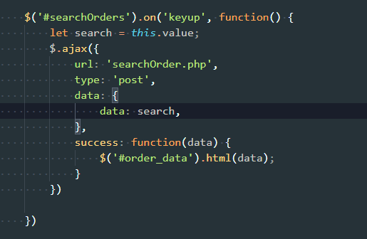

Prior knowledge before learning ajax is any server side language like Php, Python or any other language and any database like Mysql. Then you should know client side programming language like javascript or jquery. We prefer to use ajax with jquery because it is very easy to implement ajax with jquery we have to write very few lines of code but in javascript it is very large lines of code we have to write and sometime it’s become difficult to understand the code.

Why use ajax in PHP?

A majority of PHP based sites are using ajax jquery based solutions for better user experience on their wesites, because asynchronous javascript and xml allows for such rich features in the website which php alone or just javascript can’t provide us in the website such as:

* Search auto suggestions
* Form submitting without page reload
* Content loading on the scroll

So while working with php a server side language using ajax for some small task will make our lives easy, we don’t need to make multiple pages and it also provides a better user experience because user have not to wait for the page to be reloaded again and it is very easy to write ajax code with jquery in comparision to the ajax with javascript.

There are many advantages of using ajax in our web applications, some of them are mentioned below:

1. **Callbacks:**

Ajax make a callback in background, it makes possible to communicate with the server very fastly without the page reload.

1. **Asynchronous:**

By using ajax we can achieve assynchrounous call to website servers this method allows the browsers to avoid the waiting period to get the data.

1. **User-Friendly:**

The applications which use ajax are more faster and responsive to the user in comparision of others web applications which don’t use ajax.