ABBV-CLS-484 Enhances Anti-Tumor Immunity by Modulating IL-6/STAT3 Signaling and Regulatory T Cell Stability

Stephen Wilson*, Yao Zhan*, ODR team members, Gtech team members, Calico collaborators, Christina Baumgartner, Kyle Halliwill

*Contributed equally

Abstract
Regulatory T cells (Tregs) play a critical role in suppressing anti-tumor immunity, presenting a major barrier to effective cancer immunotherapy. We demonstrate that pharmacological inhibition of PTPN1/2 with ABBV-CLS-484 in a mouse tumor model disrupts Treg identity and function. Single-cell RNA sequencing revealed decreased Treg proportions and activation, alongside enhanced activation and clonal expansion of Cd4 and Cd8 effector T cells, shifting the tumor microenvironment toward an anti-tumor inflammatory state. Exploration of multimodal gene expression and chromatin conformation data confirmed changes in chromatin accessibility associated with reduced Ptpn2 activity driving downregulation of Foxp3 through the Il6/Stat3/Dnmt3a signaling axis. Importantly, our analysis suggests that administration of ABBV-CLS-484 may drive Treg depletion and boost effector T cell-driven antitumor responses in human cancer. Our findings establish ABBV-CLS-484 as a promising approach to overcome Treg-mediated immune suppression and support its integration into rationally designed cancer immunotherapy regimens.

Introduction
Regulatory T cells (Tregs) are an immunosuppressive T cell subset that suppresses the activity of effector T cells¹. Tregs develop either in the thymus (tTregs), marked by stable FOXP3 expression, or in the periphery (iTregs) in the presence of IL-2 and TGF-β1². Elevated Treg frequencies in breast, colorectal, and ovarian cancers are associated with poorer prognoses³. Efforts to target Tregs in cancer aim to restore protective antitumor immunosurveillance without compromising self-tolerance, which remains a substantial challenge⁴. One possible approach involves targeting upstream regulators of FOXP3 expression, which can influence the suppressive activity of both tTregs and iTregs.
PTPN1 and PTPN2 (protein tyrosine phosphatase non-receptor type 1/2) are regulatory phosphatases with diverse roles modulating intracellular signaling⁵. PTPN2 acts as a critical intracellular immune checkpoint, negatively regulating the Jak-Stat pathway in T cells, including Tregs, and tumor cells, thereby restraining anti-tumor immunity and dampening responses to interferons and immune checkpoint therapies⁶. Genetic deletion or pharmacological inhibition of PTPN2 in preclinical models enhances antigen presentation, increases inflammatory cytokine signaling, and improves T cell function and recruitment in the tumor microenvironment^{7,8}. Loss-of-function SNPs within PTPN2 are associated with several autoimmune diseases^{9,10}, and full-body Ptpn2 deletion in mice causes fatal systemic myeloid cell-driven inflammation¹¹. However, conditional deletion of Ptpn2 has been shown to enhance TCR signaling, thymic selection, and peripheral T cell proliferation¹².
We have previously demonstrated that ABBV-CLS-484 (AC484), a potent inhibitor of PTPN1 and PTPN2, inflames the tumor microenvironment and promotes natural killer cell and CD8 T cell function by enhancing Jak-Stat signaling and reducing T cell dysfunction⁶. However, the impact of AC484 on Tregs has not been explored. In this study, we investigate shifts in Treg and effector T cell proportions, TCR stabilization within CD4 and CD8 T cell populations, and changes in the Il6–Stat3 signaling axis following AC484 mediated Ptpn1/Ptpn2 inhibition, both alone and in combination with anti-PD1 antibody (aPD1). We describe a potent effect of AC484 on the phenotype and abundance of Tregs within the tumor microenvironment which is distinct from the activity of aPD1 treatment and highlights a novel mechanism for AC484 to drive antitumor immunity.

Methods
Tumor-infiltrating Immune Cell scRNAseq
C57BL/6J mice received subcutaneous injections of CT26 tumors and were administered either AC484, anti-PD-1 (aPD1), both, or left untreated. For the study, 16 unilateral CT26 tumors (5 untreated, 5 treated with anti-PD-1, and 6 treated with AC484) and 12 unilateral CT26 tumors (4 untreated, 4 treated with anti-PD-1, and 4 treated with AC484) from GVAX-vaccinated mice were collected on day 13. The tumors were weighed, cut into smaller pieces, and then processed using a tumor dissociation kit (Miltenyi) and a gentleMACS dissociator (Miltenyi) with the m-TDK-1 program for chemical and mechanical digestion. Immune cells were isolated through density centrifugation using a lympholyte reagent (Cedarlane Labs), followed by CD45+ cell selection using MicroBeads and a magnetic separator (Miltenyi). Single-cell isolation in droplets and the preparation of 5' sequencing libraries was completed with a Chromium Controller and the 10x Genomics platform according to the manufacturer's instructions. Libraries were generated using Chromium Next GEM Single Cell Reagent kits, specifically the 5′ v.1 chemistry or 5′ v.2.2 chemistry. scRNAseq profiles were obtained from 4–6 tumors for each treatment condition within each model, yielding a dataset of 102863 immune cell transcriptomes for all combined conditions.

Single-cell data analyses
Equimolar pooled 5′ 10x output libraries were sequenced on an Illumina SP flow cell utilizing a paired-end 150 cycle kit. Subsequent preprocessing was conducted with cellranger (v.5.0.1), where the quality of individual replicates was assessed by examining the number of recovered cells, mean reads per cell, and median genes per cell. All replicates achieved sequencing depth exceeding Cell Ranger's recommendation of 25,000 mean reads per cell. An anti-PD-1-treated KPC tumor with low cell recovery was excluded based on early quality-control metrics. Following this exclusion, 102,863 cells were recovered across all conditions. Further cell and gene filtering was performed using scanpy¹³ (v.1.7.2). Cells with over 10% mitochondrial gene content were removed. Additionally, genes absent in all cells were excluded from later analysis.
Gene counts were normalized to a library size of 100,000 and underwent log transformation with a pseudo-count of 1. PCA and nearest neighbor graphs were computed for visualization on a UMAP projection. Harmony batch correction was applied to adjust PCA embeddings for technical batch effects between ¹⁴. The leiden algorithm grouped cells into 21 distinct clusters, excluding those with high doublet scores or markers of low cell viability, like the long noncoding RNA Malat1. After this filtering, 68,080 cells remained for further analysis. Cells were re-clustered and classified based on one-vs-rest differential expression and immune-related gene signatures using scanpy's built-in cell annotation functions¹³. For finer distinction between T and NK cell subtypes, sub clustering focused on clusters expressing Cd8a, Cd4, and Ncr1 transcripts. New PCA embeddings, nearest neighbor graphs, and harmony batch corrections were recomputed for this subset using the top 10,000 highly variable genes. Differential gene expression between treatment conditions was calculated through a logistic regression model, creating ranked gene lists with signed p-values from logistic regression¹⁵. TCR analysis and visualization was performed using the scRepertoire package¹⁶. Cells were grouped based on clone recurrence, with singlets appearing only once, intermediate clones appearing 2-9 times, and expanded clones occurring 10 or more times.

Two proportion Z-Test
To assess differences in proportions, the two-proportions z-test in R was employed. The proportions of different cell types were determined by dividing the number of cells in each specific group by the total number of cells per treatment condition, and these were then compared between treatment conditions using the two-proportions z-test. The null hypothesis assumes no difference in proportions, while the alternative hypothesis suggests a difference exists. The calculated z-score was evaluated against the standard normal distribution to assess statistical significance, with a p-value of less than 0.05 indicating a significant difference between the two proportions. The results were illustrated with bar plots created using the R package ggplot2.

Mouse Genome Informatics Gene Ontology Browser and Gene Set Scoring
Gene Ontology (GO) term investigation was performed using the Mouse Genome Informatics (MGI) Gene Ontology browser¹⁷ to identify and select relevant ontological gene sets associated with the biological processes of interest. Genes corresponding to the selected GO terms were compiled for downstream enrichment analysis. Gene set enrichment analysis was conducted using the Enrichr platform^{18–20}. The lists of genes derived from the MGI GO browser were submitted to Enrichr, which assesses enrichment for various biological categories based on curated gene set libraries. Statistical significance and enrichment scores were reported as provided by the platform.

AUcell Scoring of T cell Activation Signatures
The "FindMarkers" function from Seurat was employed to identify differentially expressed genes (DEGs) across various treatment scenarios, while activation signatures for Cd4 T cells, Cd8 T cells, and Tregs were developed. SCENIC's AUCell scoring algorithm²¹ was used to quantify changes in these activation signatures within cell populations under different treatment conditions. AUCell determines the functional state of a cell's transcriptome by assessing gene set activity on a per-cell basis. It calculates the area under the cumulative distribution curve (AUC) to evaluate the expression ranking of a specific gene set within an individual cell. Initially, genes in each cell are ranked according to their expression levels, and the gene set's activity is then measured using AUC scores. This method offers significant advantages in analyzing gene set activity in high-dimensional single-cell datasets and is especially proficient in examining the impact of genes with low expression levels.

Monocle3 Trajectory Analysis
Pseudo-time trajectory analysis was carried out with Monocle3 to deduce the transcriptional progression of cells^{22,23}. We brought in the expression matrix alongside metadata from Seurat. Following normalization, dimensionality reduction was executed using Monocle3's reduce_dimension function, and the cells were grouped using the cluster_cells function. A trajectory graph of cells was developed via the learn_graph function, which facilitated the ordering of cells along the pseudo-time pathway. Expression patterns of selected genes were illustrated through plots across the pseudo-time, showcasing their trends along differentiation routes.

Public Data Acquisition from NCBI GEO
Publicly available gene expression and chromatin accessibility data were obtained from the NCBI Gene Expression Omnibus (GEO) under the accession number GSE123488 ("Loss-of-function of PTPN2 promotes pathogenic loss of FoxP3+ in RORgt+ Tregs"). This data series includes two subseries: GSE123484, consisting of bulk RNA-seq data, and GSE123486, consisting of ATAC-seq data. Each subseries pertains to the investigation of the effects of PTPN2 loss-of-function in FoxP3+ RORγt+ Tregs, as described in the associated publication²⁴. The raw and processed data files were downloaded directly from the GEO website (https://www.ncbi.nlm.nih.gov/geo/) using the respective accession numbers. Briefly, series matrix and supplementary files were accessed through the "Download Series Matrix File(s)" and "Supplementary files" sections on the GSE123488, GSE123484, and GSE123486 GEO pages. Data were downloaded as compressed files (.tar, .gz, or .zip formats) and extracted for further downstream analysis.

Meme suite tools
Motif analyses were performed using tools from the MEME Suite²⁵. To assess motif enrichment, we employed the Analysis of Motif Enrichment (AME) tool²⁶, which identifies statistically significant enrichment of known motifs in input DNA sequences compared to a control set. For finding individual motif occurrences, we used the Find Individual Motif Occurrences (FIMO) tool²⁷, which scans sequences to detect locations of motifs with defined thresholds for significance. For both enrichment and motif discovery analyses, we used the JASPAR 2026 CORE non-redundant motif database²⁸, selecting the collection of vertebrate transcription factor binding profiles. The relevant database was downloaded in MEME-compatible format and provided to both AME and FIMO as the motif input resource. All tools were run using default parameters unless otherwise specified. Motif occurrence thresholds were set according to recommended practices in the tool documentation. Results were further analyzed for biological relevance and visualized using meme-suite outputs.

Integrated Genome Viewer
Sequencing data aligned to the mm10 mouse reference genome were processed for visualization in the Integrative Genomics Viewer (IGV)²⁹. BED files containing genomic features were first sorted by chromosome and start position using standard UNIX sort commands to ensure compatibility using the samtools package³⁰. The sorted BED files were compressed with bgzip, then indexed with tabix to enable efficient loading and navigation within IGV. All processed files—compressed and indexed BED tracks (. bed.gz with accompanying .tbi files) and bigWig (.bw) tracks—were loaded into IGV, with the mm10 reference genome selected.

Results
Ptpn1/2 inhibition through AC484 increases T effector and reduces Treg abundance in mouse tumors
We investigated the influence of AC484 and an anti-PD1 (aPD1) antibody, both individually and in combination, on the phenotype and abundance of tumor-infiltrating Treg and Cd4/Cd8 T cells using single-cell RNA sequencing (scRNAseq) on CD45+ tumor-infiltrating lymphocytes (TILs) from CT26 tumors (Fig. 1A). In total 102,863 sequenced cells passed quality filters and were used for analysis (Supplementary Table One). Expression profiles were clustered using uniform manifold approximation and projection (UMAP), which led to the identification of 16 distinct clusters within the CD45+-enriched immune cell population. (Fig. 1B). Clusters were annotated by cell type and evaluated for time and treatment-dependent effects on abundance (Fig. 1C).
In the cluster identified as Tregs, a significant proportional decrease was noted between day 3 and day 6 following AC484 treatment (Fig. 1Di), which was not observed in other regimes. Cd4 T cells demonstrated a decrease across all conditions except for AC484 + aPD1, where proportions increased significantly (Fig. 1Dii). In Cd8 T cells, a marked increase in proportions was seen between day 3 and day 10 for AC484 and AC484 + aPD1(Fig. 1Diii) treatments compared to Vehicle and aPD1.
We proceeded to compare changes in T cell proportion across Cd4, Cd8, and Treg clusters in all treatment regimens (Fig. 1E). Across all regimens the largest proportion changes changes involved Cd4 T cells, which decreased over the course of the study from day 3, with AC484 treated-animals exhibiting the greatest reduction. Treg abundance was the second largest at the start of the experiment on day 3, but was greatly reduced by day 10, with the greatest reduction seen in the AC484 and combination AC484 + aPD1 treatments. Lastly, we observed that Cd8 T cells were proportionally rarest at day 3, but expanded notably over time, with the highest Cd8 T cell proportion observed following AC484 treatment. Overall, these findings reveal an AC484-dependent shift in T cell composition over time, characterized by a relative decrease in Cd4 and Treg populations and a corresponding expansion of Cd8 T cells.

Gene set expression analysis shows AC484 increases CD8 T effector cell activation and reduces Treg suppression

We next examined changes in activation signatures across Treg, CD4, and CD8 T cell populations. To assess T cell activity, we used GO terms related to T cell activation, including T cell activation (GO:0042110), CD8-positive T cell activation (GO:0036037), CD4-positive T cell activation (GO:0035710), and regulatory T cell activation (GO:0045066), and applied AuCell-based scoring across treatment regimens (Fig.1F, Supp.Fig.1). Across the tumor microenvironment, AC484 treatment was associated with increased activation scores in CD4 and CD8 T cells and reduced activation scores in Tregs, suggesting a shift toward enhanced effector activity and diminished suppressive function. Consistent with this pattern, adjusted activation z-scores in Tregs were significantly altered on days 6 and 10, with the most notable changes in AC484-containing regimens, whereas CD4 and CD8 T cells showed significantly increased adjusted activation z-scores over time, particularly in the AC484 and AC484 + aPD1 groups. On day 10, when maximal CD8 polarization and activation was observed, differential expression analysis showed increased CD3 expression in both CD4 and CD8 T cells in AC484 and AC484 + aPD1 conditions relative to vehicle, consistent with broader activation-associated changes. In Tregs, CD3 expression was also elevated with aPD1, although fewer TCR-related genes were differentially expressed overall (Fig. 2A, Supp. Fig. 2A). Overall, these findings indicate that PTPN2 inhibition, alone or in combination with aPD1, promotes a more activated effector T cell state while attenuating Treg-associated activation signatures.

AC484 alters the clonal architecture and biases Cd8 T cells towards activated and expanded clones

TCR sequence recurrence was next evaluated across treatment time points in Treg, Cd4 T cell, and Cd8 T cell clusters, with clonal groups classified as singlets, intermediate, or expanded based on the number of cells sharing the same TCR sequence (Fig. 2B). In CD4 T cells, singlet clonality was significantly reduced in the AC484 + aPD1 groups relative to vehicle and aPD1, while expanded clonality was significantly increased in the AC484 and AC484 + aPD1 conditions. No significant differences were observed in intermediate clonality. In CD8 T cells, singlet clonality did not differ significantly across treatment groups; however, intermediate clonality was significantly decreased in the AC484 and AC484 + aPD1 groups, accompanied by a significant increase in expanded clonality relative to vehicle and aPD1. In contrast, Treg clonality remained largely unchanged across treatment regimens, with the majority of cells classified as singlets and only a small fraction exhibiting expanded clonality (Supplementary Figure 2B).
We then examined whether distinct TCR clonality populations were associated with different levels of activation. In both Cd4 and Cd8 T cells, gene set activation scores followed a consistent pattern in which singlet clonality exhibited the lowest scores, intermediate clonality showed modestly higher scores, and expanded clonality showed the highest activation scores (Fig. 2C). This pattern was reversed in Treg cells (Supplementary Figure 2C). Across all treatment regimens, singlet Cd4 and Cd8 T cells generally showed lower activation scores, whereas intermediate and expanded clonality groups displayed comparatively higher activation. This was particularly evidence following AC484 and AC484 + aPD1 treatmens. In Tregs, singlet clonality was associated with lower activation scores relative to vehicle, whereas intermediate clonality showed higher scores across regimens.
Overall, these data suggest that AC484 treatment is associated with increased TCR expression, enhanced clonal expansion of Cd4 and Cd8 T cells, and a corresponding shift toward a more activated effector T cell state while Treg cells remain comparatively less clonally expanded.

AC484 treatment destabilizes Foxp3 expression in Treg cluster
The effects on Treg activation and abundance were particularly intriguing as this represents a key regulator of anti-tumor immunity that is not strongly affected by aPD1 therapy. To better understand AC484’s activity on this population, we explored Treg clustering and gene expression, focusing on key regulatory pathways related to PTPN2. We specifically emphasized the Il6/Stat3/Dnmt3a axis as it is a key regulator of Treg identity and function (Fig. 3A)^{24,31}. This pathway provides a mechanistic framework for investigating how PTPN2 inhibition may reshape Treg biology and alter immune balance within the tumor microenvironment.
We examined the significantly differential expressed genes on day 10 relevant to the Treg subtype and the Il6/Stat3/Dnmt3a axis (Fig. 3B). we analyzed the expression of key genes within the Il6/Stat3/Dnmt3a signaling axis. We found increases in Il6st and Dnmt3a expression following AC484 and combined AC484 + aPD1 treatment compared to the vehicle. Next, we assessed gene signature scores related to Cellular Response to Il6 (GO:0071354), positive regulation of Stat phosphorylation (GO:0042531), and exhausted T cell differentiation (GO:0160083). Cellular response to Il6 signaling (Fig. 3C) was highest under AC484, with gene set scores under the combined AC484 + aPD1 condition much lower than those of the vehicle control. Notably, scores for positive regulation of Stat phosphorylation (Fig. 3D) was higher than vehicle under both aPD1 and AC484 treatments, with aPD1 being slightly greater, while the combination regimen yielded markedly lower scores than vehicle. Lastly, exhausted T cell differentiation (Fig. 3E) scores were highest under aPD1 and combined AC484 + aPD1 treatments compared to vehicle, with AC484 treatment scoring slightly above vehicle. These gene set scores indicate that following AC484 treatment, Tregs become more responsive to Il6 signaling; aPD1 and AC484 individually promote Stat phosphorylation, but not in combination; and differentiation into an exhaustion state is most pronounced under aPD1.The treatment regimens explored in this study appear to influence the downstream transcriptional regulation of Pdcd1 and Il6ra/Il6st receptors.

Clustering and Trajectory Analysis of Treg and CD4 T Cells
We next sought to define the effects of AC484, aPD1, and combination therapy across the totality of the Cd4 population. We found that Cd4 and Cd4 Tregs clustered tightly in our UMAP plots (Fig. 4A), as expected. Evaluating genes associated with negative regulation of Treg differentiation ( GO:0045590) showed a clear effect of AC484 treatment, alone or in combination, that contrasted strongly with both vehicle and aPD1 treatments (Fig. 4B). To assess how treatments influenced the overall transcriptional profile, we employed gene expression trajectory analysis.
Using Monocle3, we constructed a trajectory analysis of the Treg and Cd4 T cell populations, based on transcriptional similarity (Fig. 4C). The trajectory showed a distinct "C" shape, with Treg cells in the upper portion, while Cd4 T cells exclusively occupied the lower portion. To establish the trajectory's root node, we analyzed the expression of Tcf7 which is a marker of naive Cd4 T cells³² and regulation of T cell inflammatory responses^{33,34} (Fig. 4D). Once the root node was designated, we mapped the association of Tcf7+ cells with the trajectories of Cd4 T cells and Tregs using the pseudo-time variable to indicate their transcriptional similarity to naive T cells (Fig.4E).
We further investigated transcriptional state dynamics across treatment regimens by using density plots to illustrate Treg cell distributions across pseudotime (Fig. 4F). Within the Treg trajectory, the Vehicle group exhibited two distinct density peaks, centered between pseudotime 4–8 and 12–16. In contrast, the other treatment regimens showed reduced cell density between pseudotime 4–8 and a corresponding increase in density between pseudotime 12–16, suggesting a shift away from transcriptional states associated with earlier Tcf-7-like profiles toward later pseudotime states. In the Cd4 T cell trajectory, a similar bimodal density pattern was observed across the Vehicle, aPD1, and AC484 + aPD1 treatment groups, with peaks at pseudotime 0–3 and 9–12. Notably, AC484 treatment was associated with increased cell density between pseudotime 3–6, indicating a redistribution of cells within the Cd4 trajectory. Prior studies have highlighted the role of Ptpn2 in maintaining Foxp3 expression and Treg stability, suggesting that Ptpn2 inhibition may redirect naïve Cd4 T cells away from a Treg-like fate and toward alternative Cd4 lineages. Overall, these findings support a model in which AC484 alters Treg transcriptional progression and redirects Cd4 T cell fate decisions away from a stable Treg phenotype and toward alternative Cd4 lineages within the tumor microenvironment.
To further clarify these findings, we conducted differential gene expression analysis along the Treg trajectory. Cells were binned into pseudotime intervals, and the average gene expression was reported. Key T cell lineage markers and the Il6/Stat3/Dnmt3a signaling axis were evaluated (Fig. 4G). Peak expression of the naïve T cell marker Tcf7 occurred at the earliest pseudotime, and maximal Foxp3 expression emerging after pseudotime 12. Notably, Dnmt3a expression was absent at pseudotime 6 for AC484 and AC484 + aPD-1 regimens; at pseudotime 9, Foxp3 and Ikzf2 expression were lowest under AC484 conditions, while Stat3 expression was elevated for all treatment regimens except Vehicle. Finally, Pdcd1 expression reached its lowest levels with AC484 treatment, whereas aPD-1 and combination AC484 + aPD-1 treatments resulted in slightly higher levels compared to vehicle. Ultimately, these results reveal that AC484 actively remodels the Treg compartment along the pseudotime trajectory, driving cells toward a transcriptionally destabilized state marked by coordinated reductions in Foxp3 and Ikzf2, and altered Stat3/Dnmt3a signaling.

Ptpn2 Haploinsufficiency within autoimmune SKG Mouse model supports a Treg-intrinsic through the Il6/Stat3/Dnmt3a mechanism
Our prior analysis highlighted AC484 treatment-related alteration of Treg expression states, but lacked the resolution needed to detect finer changes in transcription factor activity and more fully articulate the causal mechanism driving these changes. To add this resolution, we utilized a dataset characterizing the functional consequences of Ptpn2 gene ablation through both gene expression and chromatin accessibility profiling²⁴.
First, we investigated shifts in gene expression and chromatin accessibility between Ptpn2+/+ and Ptpn2+/- Tregs isolated from the B6.H2d.SKG mouse strain. To do so, we overlapped gene lists obtained from bulk RNA-seq and ATAC-seq datasets generated prior to IL-6 stimulation (Fig. 5A). The resulting intersection identified genes with concordant changes in both transcription and chromatin accessibility, providing a shortlist of candidates potentially under direct Ptpn2 regulation. Next, we assessed whether similar patterns were observed in genes implicated in Il-6/Stat3/Dnmt3a signaling, as detailed in our study (Fig. 5B). We found that Foxp3 expression was increased in Ptpn2+/- Tregs, along with elevated expression of Il6, Stat3, and Dnmt3a.
To further characterize functional impacts of Ptpn2 inhibition, we performed gene set enrichment analysis using KEGG and Gene Ontology Biological Processes gene sets on the overlapping gene list identified through the Venn diagram analysis (Fig. 5C). The significantly enriched pathways were closely related to T cell biology and were consistent with Ptpn2’s known role as phosphatase. Together, these findings suggest that reduced Ptpn2 activity contributes to destabilization of Treg identify.
Next, to identify factors mediating the Ptpn2-driven disruption in Treg identify, we looked for alterations to transcription factor accessibility following across genotypes. Peak regions unique to Ptpn2+/- Tregs prior to Il-6 stimulation were screened for transcription factor binding sites using MEME suite tools (AME and FIMO), with the JASPAR 2026 CORE non-redundant motif database as reference. Both motif enrichment and individual transcription factor occurrences relevant to Treg biology were summarized in Supplementary Table 2. Focusing on STAT family binding sites, we examined the genomic region surrounding the Dnmt3a locus (Fig. 5D). In Ptpn2+/+ Tregs, a peak upstream of exon 1 at transcripts NM_001271753.1, NM_007872.4, and XM_030246538.1, was absent prior to IL-6 stimulation, whereas a corresponding peak was detected in Ptpn2+/- Tregs. Following IL-6 stimulation, both genotypes exhibited a peak that persisted for up to 72 hours. Notably, STAT family transcription factor binding sites overlapped with these peaks near exon 1, suggesting that Ptpn2 may influence Dnmt3a regulation through STAT transcription factor-associated chromatin accessibility. Overall, these findings support a model in which reduced Ptpn2 activity promotes changes in chromatin accessibility and transcription factor occupancy at key Treg-related loci, potentially contributing to altered Treg identity and function.
Discussion
In this study we describe the effects of a novel PTPN1/2 inhibitor, AC484, on the T cell compartment in a mouse model of cancer. We found that treatment with AC484 drove quantitatively and qualitatively different effects on the T cell compartment, including both Cd8 T cells and Tregs, as compared to aPD1 treatment. We found Cd8 T cell abundance, expansion, and activation to be driven most potently by AC484, alone or in combination with aPD1. We found Treg abundance and phenotype to be altered by AC484, with the transcriptional phenotype of AC484 treated Tregs biased towards reduced suppressive activity. Through a multimodal analysis of Treg gene expression and chromatin accessibility following Ptpn2 ablation, we were able to link the changes in Treg phenotype to transcription factor accessibility at the Dnmt3a locus, providing a mechanistic link between AC484 treatment, PTPN2 activity, and Treg function.
In conclusion, our study demonstrates that pharmacological inhibition of PTPN2 through AC484 effectively remodels the tumor immune microenvironment by destabilizing Treg identity and reducing their suppressive activity, primarily through modulation of the Il6/Stat3/Dnmt3a axis and downregulation of Foxp3. This destabilization is accompanied by enhanced activation and clonal expansion of Cd4 and Cd8 effector T cells, indicating a shift toward a more robust anti-tumor immune response. The use of single-cell transcriptomics, trajectory analysis, and validation with public datasets highlights both direct and lineage-specific impacts on T cell populations, supporting the mechanistic relevance and translational potential of Ptpn2 targeting in immunotherapy. Importantly, our data suggest that use of Ptpn2 inhibition may optimize depletion of immunosuppressive Tregs while maximizing effector T cell responses. Furthermore, the differential effects on immune checkpoint markers such as CTLA4, TIGIT, and LAG3 highlight alternative combinatorial strategies to further enhance anti-tumor immunity. Together, these findings establish the rationale for PTPN2 inhibition through AC484 to overcome regulatory T cell-mediated immune suppression and reinforce the need for carefully designed combination regimens to fully realize the therapeutic benefits in cancer immunotherapy.
Figures
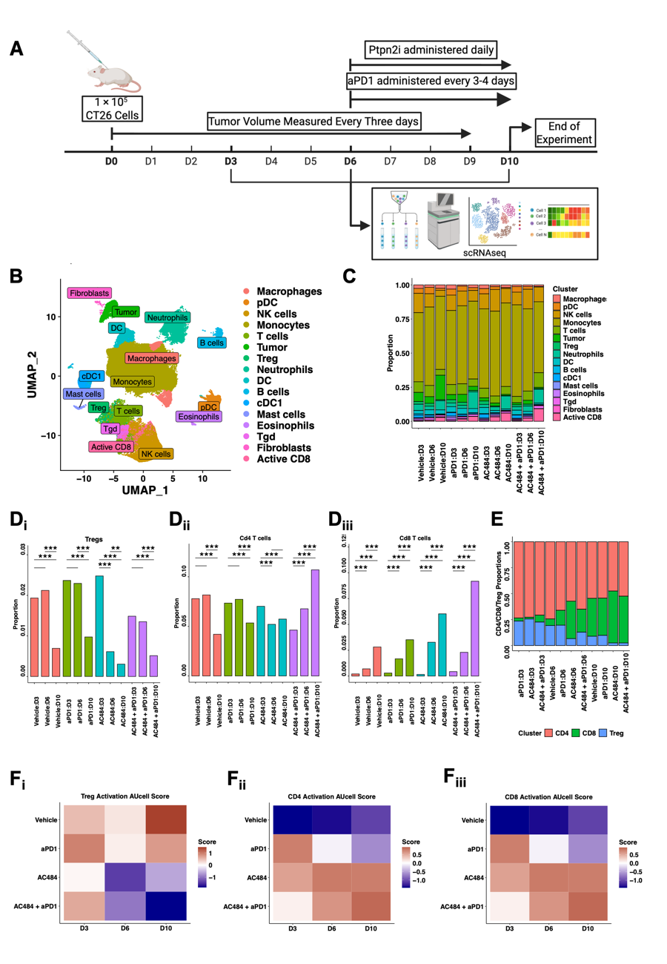
Figure One: T cell Population response to AC484 treatment regimen
(A) Schematic of scRNAseq experimental design. (B) UMAP of total scRNAseq experiment. (C) Stacked bar plot of population changes across scRNAseq experiment. (D) Changes in T cell proportions across treatment regimen for i. Tregs, ii. Cd4 T cells, iii. Cd8 T cells, and iv. Effector vs. Regulatory T cell Proportions across experiment. (E) Stacked bar plot or Cd4/Cd8/Treg ratios across treatment regimen. (F) Heatmap of AuCell Gene Set scoring of differentially expressed genes that belong for i. Treg Activation, ii. Cd4 T cell Activation, iii. Cd8 T cell Activation.
AC484 upregulates TCR genes, expands TCR Clonality, and Activation of Cd4 and Cd8 T cells
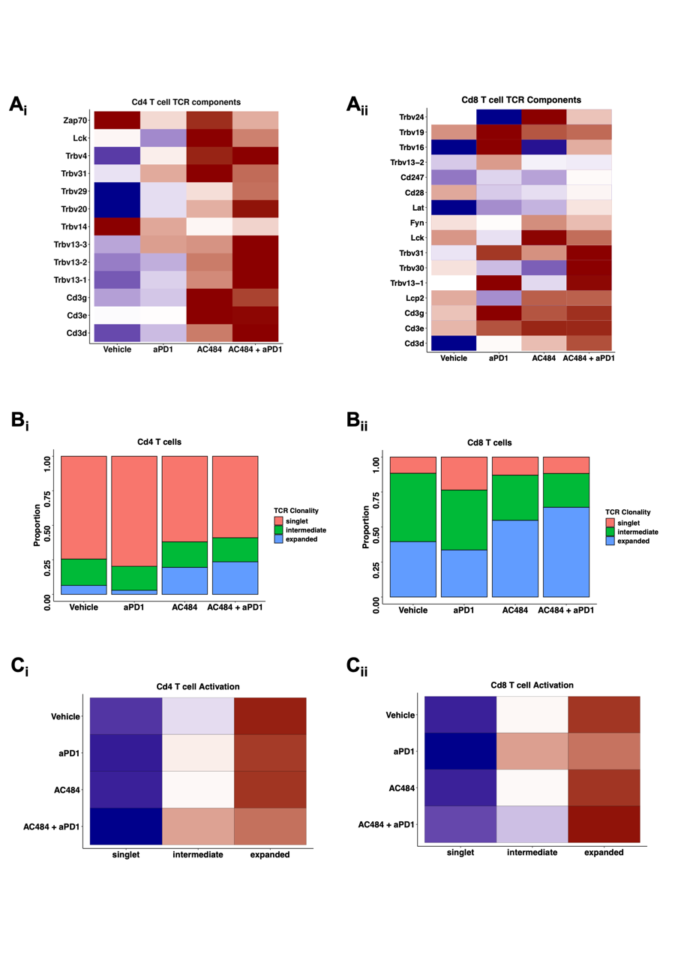
Figure Two: TCR clonality and T cell Activation following AC484
(A) Heatmap of D10 expression of DEG TCR components for i. Cd4 T cells and ii. Cd8 T cells. (B) Stacked bar plot of TCR clonality prevalence following treatment regimen for i. Cd4 T cells and ii. Cd8 T cells. (C) Heatmap of Activation Scores per treatment and TCR clonality groups for i. Cd4 T cells and ii. Cd8 T cells.
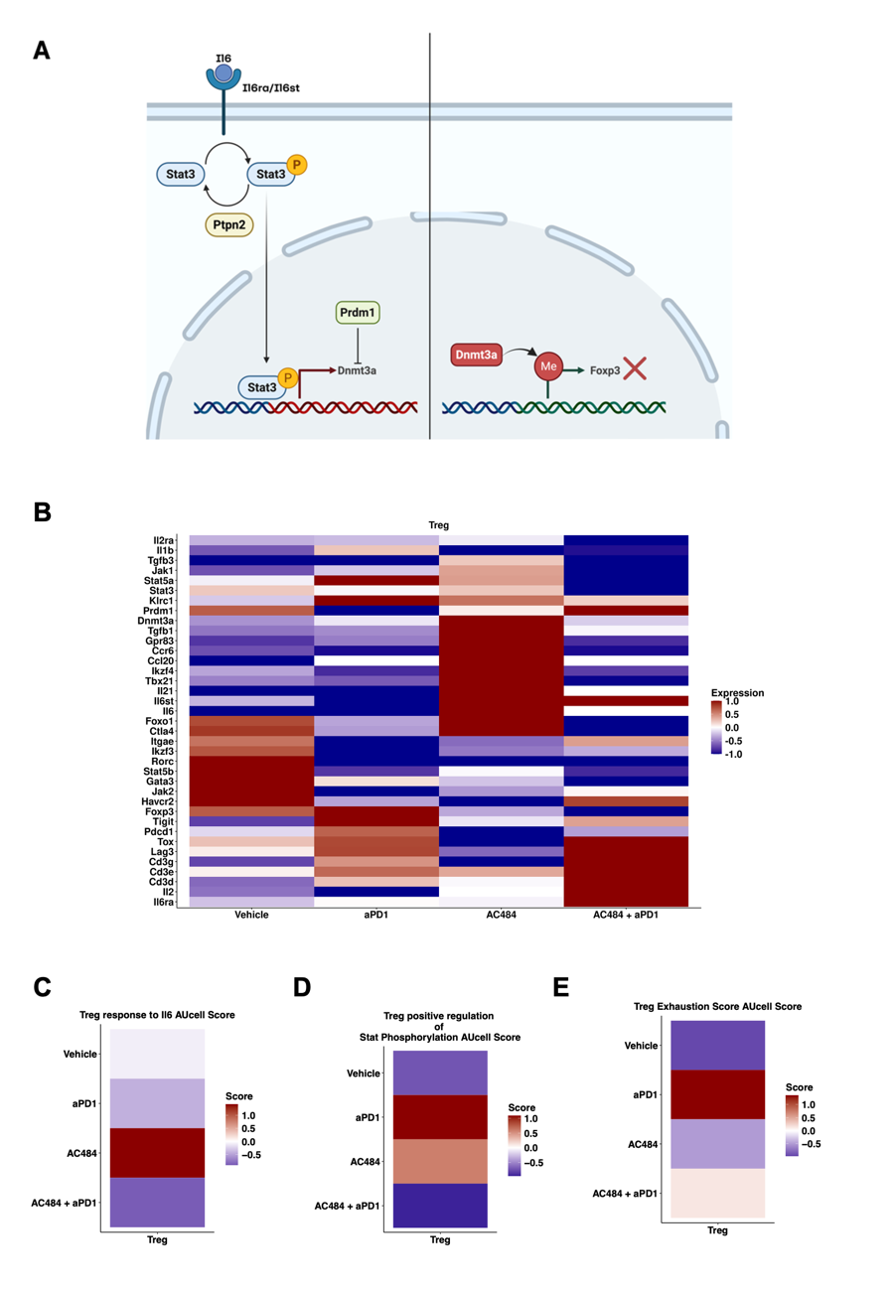

Figure Three: Il6/STAT3/Dnmt3a signaling axis destabilizes Foxp3 expression Treg population following AC484
(A) Schematic of Il6/Stat3/Dnmt3a regulation of Foxp3 expression within Tregs. (B) D10 heatmap of key genes differentially expressed within the Treg cluster. (C) Heatmap of AuCell Gene Set scoring of differentially expressed genes belonging to GOBP: Cellular response to Interleukin-6 signaling. (D) Heatmap of AuCell Gene Set scoring of differentially expressed genes belonging to GOBP: Positive Regulation of Stat Phosphorylation. (E) Heatmap of AuCell Gene Set scoring of differentially expressed genes belonging to GOBP: Treg exhaustion. (F) Venn diagram of known transcription factors that are downstream from Pdcd1 and Il6 signaling.

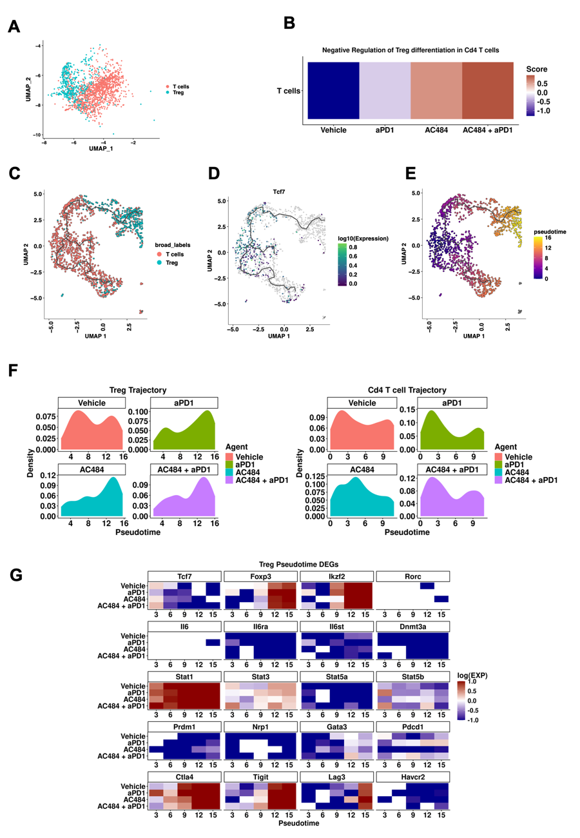
Figure Four: AC484 regimen impact on T cell trajectory
(A) UMAP of Treg and neighboring Cd4 T cells (B) AuCell scores of Negative Regulation of Treg Differentiation in Cd4 T cells. (C) UMAP of Monocle Trajectory of Treg and Cd4 T cells. (D) Using Tcf7 expression as a marker to set the root node for monitoring T cell maturation. (E) UMAP of Monocle Trajectory colored by pseudotime. (F) Density plot of T cells along the Treg trajectory following days of treatment. (G) Heatmap of Treg DEGs across pseudo-time expressed along Treg trajectory.

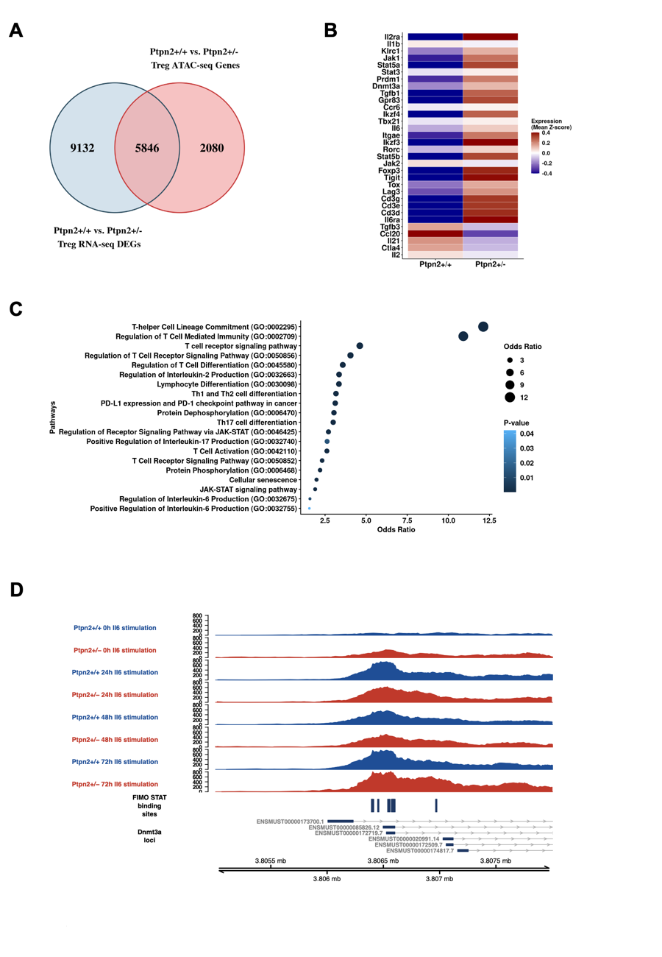
Figure 5: Reduced expression of phosphatase PTPN2 promotes pathogenic conversion of Tregs in autoimmunity
(A) Venn diagram of differentially expressed genes and differentially unique genomic regions between Ptpn2+/+ and Ptpn2+/- Tregs prior to IL6 stimulation. (B) Heatmap of Differentially expressed Treg lineage affirming genes between Ptpn2+/+ and Ptpn2+/- Tregs prior to IL6 stimulation. (C) Dot plot of significantly enriched Pathways and biological processes obtained from the Venn Diagram pertaining to IL6/STAT mediated regulation of Treg to Th17 differentiation. (D) IGV plot of GSE123484 Treg experiment between Ptpn2+/+ and Ptpn2+/- Tregs prior to and following IL6 stimulation at 0h, 24h, 48h, and 72h. Additionally using FIMO tool with Jasper STAT3 motif we scanned these differentially expressed regions with STAT3 binding regions.

Supplementary Information
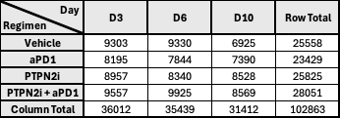

Supplementary Table One: Total number of cells per day per treatment regimen

Supplementary Table Two: GSE123484 Meme suite motif occurrences and enrichment within differential peak regions between Ptpn2^{+/+} and Ptpn2^{+/-} Tregs at 0h stimulation.

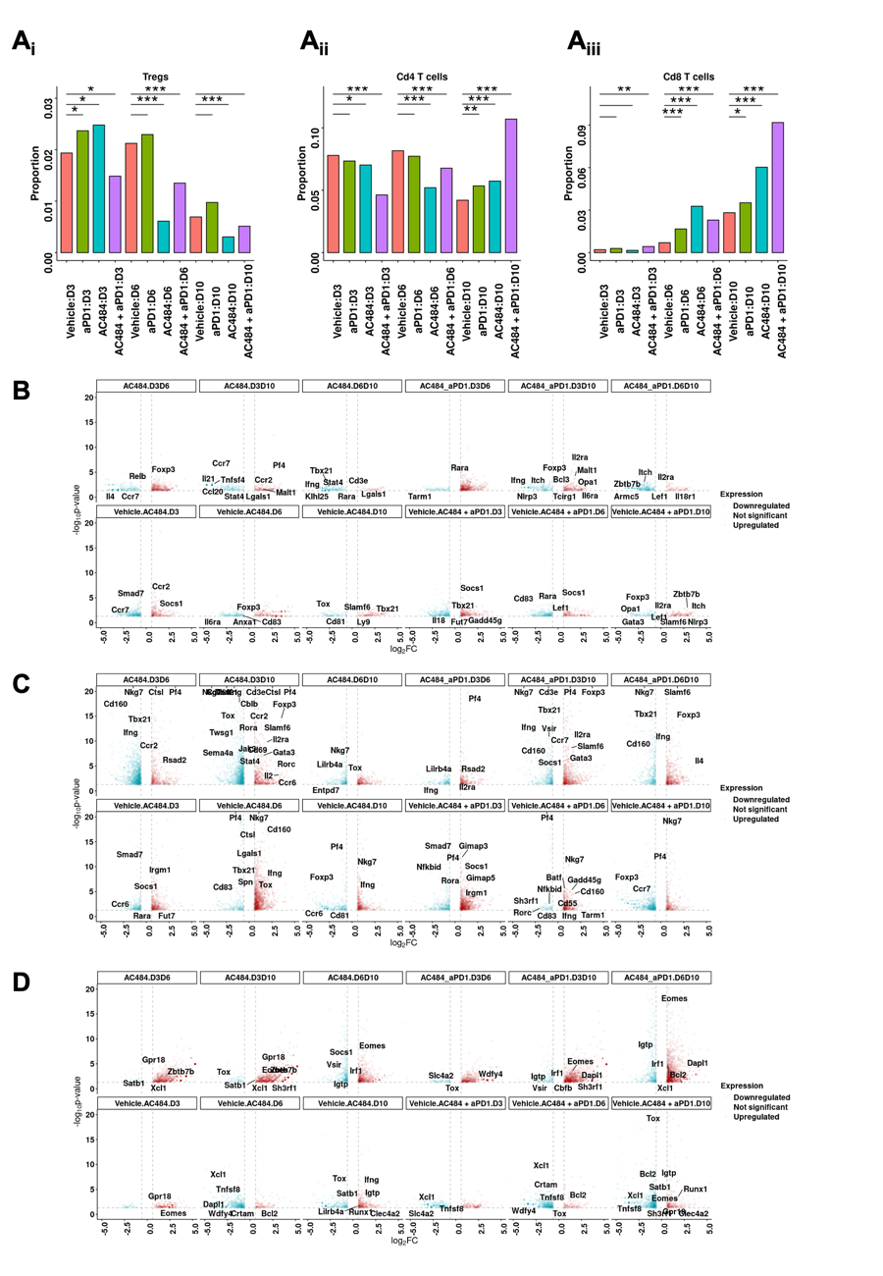
Supplementary Figure One: Proportional changes and differential gene expression upon AC484 treatment
(A) Proportional changes across treatment regimens for i. Tregs, ii. Cd4 T cells, iii. Cd8 T cells.
Volcano plots of Activation markers within (B) Tregs (C) Cd4 T cells, and (D) Cd8 T cells.

Supplementary Figure Two: Altered Treg TCR component gene expression, clonality, and activation states
(A) Heatmap of differentially expressed TCR protein components. (B) Stacked bar plot of TCR clonality for Tregs. (C) Treg Activation scores split by TCR clonality.

Acknowledgements

Author Contributions

Peer Review

Data Availability

Competing Interests

Footnotes

Contributor Information

Extended data

References

1. Bettelli, E. et al. Reciprocal developmental pathways for the generation of pathogenic effector TH17 and regulatory T cells. Nature 441, 235–238 (2006).
2. Shevyrev, D. & Tereshchenko, V. Treg Heterogeneity, Function, and Homeostasis. Front. Immunol. 10, 3100 (2020).
3. Dranoff, G. The Therapeutic Implications of Intratumoral Regulatory T Cells. Clin. Cancer Res. 11, 8226–8229 (2005).
4. Li, C., Jiang, P., Wei, S., Xu, X. & Wang, J. Regulatory T cells in tumor microenvironment: new mechanisms, potential therapeutic strategies and future prospects. Mol. Cancer 19, 116 (2020).
5. Tautz, L., Critton, D. A. & Grotegut, S. Phosphatase Modulators. Methods Mol. Biol. (Clifton, NJ) 1053, 179–221 (2013).
6. Baumgartner, C. K. et al. The PTPN2/PTPN1 inhibitor ABBV-CLS-484 unleashes potent anti-tumour immunity. Nature 622, 850–862 (2023).
7. Wiede, F. et al. PTPN2 phosphatase deletion in T cells promotes anti‐tumour immunity and CAR T‐cell efficacy in solid tumours. EMBO J. 39, EMBJ2019103637 (2020).
8. Liang, S. et al. A small molecule inhibitor of PTP1B and PTPN2 enhances T cell anti-tumor immunity. Nat. Commun. 14, 4524 (2023).
9. Parlato, M. et al. Loss-of-Function Mutation in PTPN2 Causes Aberrant Activation of JAK Signaling Via STAT and Very Early Onset Intestinal Inflammation. Gastroenterology 159, 1968-1971.e4 (2020).
10. Thaventhiran, J. E. D. et al. Whole-genome sequencing of a sporadic primary immunodeficiency cohort. Nature 583, 90–95 (2020).
11. You-Ten, K. E. et al. Impaired Bone Marrow Microenvironment and Immune Function in T Cell Protein Tyrosine Phosphatase–deficient Mice. J. Exp. Med. 186, 683–693 (1997).
12. Wiede, F. et al. T cell protein tyrosine phosphatase attenuates T cell signaling to maintain tolerance in mice. J. Clin. Investig. 121, 4758–4774 (2011).
13. Wolf, F. A., Angerer, P. & Theis, F. J. SCANPY: large-scale single-cell gene expression data analysis. Genome Biol. 19, 15 (2018).
14. Korsunsky, I. et al. Fast, sensitive and accurate integration of single-cell data with Harmony. Nat. Methods 16, 1289–1296 (2019).
15. Ntranos, V., Yi, L., Melsted, P. & Pachter, L. A discriminative learning approach to differential expression analysis for single-cell RNA-seq. Nat. Methods 16, 163–166 (2019).
16. Borcherding, N., Bormann, N. L. & Kraus, G. scRepertoire: An R-based toolkit for single-cell immune receptor analysis. F1000Research 9, 47 (2020).
17. Baldarelli, R. M. et al. Mouse Genome Informatics: an integrated knowledgebase system for the laboratory mouse. GENETICS 227, iyae031 (2024).
18. Chen, E. Y. et al. Enrichr: interactive and collaborative HTML5 gene list enrichment analysis tool. BMC Bioinform. 14, 128 (2013).
19. Kuleshov, M. V. et al. Enrichr: a comprehensive gene set enrichment analysis web server 2016 update. Nucleic Acids Res. 44, W90–W97 (2016).
20. Xie, Z. et al. Gene Set Knowledge Discovery with Enrichr. Curr. Protoc. 1, e90–e90 (2021).
21. Aibar, S. et al. SCENIC: single-cell regulatory network inference and clustering. Nat. Methods 14, 1083–1086 (2017).
22. Trapnell, C. et al. The dynamics and regulators of cell fate decisions are revealed by pseudotemporal ordering of single cells. Nat. Biotechnol. 32, 381–386 (2014).
23. Cao, J. et al. The single-cell transcriptional landscape of mammalian organogenesis. Nature 566, 496–502 (2019).
24. Svensson, M. N. D. et al. Reduced expression of phosphatase PTPN2 promotes pathogenic conversion of Tregs in autoimmunity. J. Clin. Investig. 129, 1193–1210 (2019).
25. Bailey, T. L., Johnson, J., Grant, C. E. & Noble, W. S. The MEME Suite. Nucleic Acids Res. 43, W39–W49 (2015).
26. McLeay, R. C. & Bailey, T. L. Motif Enrichment Analysis: a unified framework and an evaluation on ChIP data. BMC Bioinform. 11, 165 (2010).
27. Grant, C. E., Bailey, T. L. & Noble, W. S. FIMO: scanning for occurrences of a given motif. Bioinformatics 27, 1017–1018 (2011).
28. Baydar, D. O. et al. JASPAR 2026: expansion of transcription factor binding profiles and integration of deep learning models. Nucleic Acids Res. 54, D184–D193 (2026).
29. Robinson, J. T. et al. Integrative genomics viewer. Nat. Biotechnol. 29, 24–26 (2011).
30. Li, H. et al. The Sequence Alignment/Map format and SAMtools. Bioinformatics 25, 2078–2079 (2009).
31. Korn, T. & Hiltensperger, M. Role of IL-6 in the commitment of T cell subsets. Cytokine 146, 155654 (2021).
32. Escobar, G., Mangani, D. & Anderson, A. C. T cell factor 1: A master regulator of the T cell response in disease. Sci. Immunol. 5, eabb9726 (2020).
33. Sun, Y., Liu, T. & Bai, W. MAF bZIP Transcription Factor B (MAFB) Protected Against Ovalbumin-Induced Allergic Rhinitis via the Alleviation of Inflammation by Restoring the T Helper (Th) 1/Th2/Th17 Imbalance and Epithelial Barrier Dysfunction. J. Asthma Allergy 15, 267–280 (2022).
34. Gilchrist, M. et al. Activating transcription factor 3 is a negative regulator of allergic pulmonary inflammation. J. Exp. Med. 205, 2349–2357 (2008).
35. Ottonello, S. et al. Association Between Response to Nivolumab Treatment and Peripheral Blood Lymphocyte Subsets in Patients With Non-small Cell Lung Cancer. Front. Immunol. 11, 125 (2020).
36. Koh, J. et al. Regulatory (FoxP3+) T cells and TGF-β predict the response to anti-PD-1 immunotherapy in patients with non-small cell lung cancer. Sci. Rep. 10, 18994 (2020).
37. Scognamiglio, G. et al. The Ratio of GrzB+ − FoxP3+ over CD3+ T Cells as a Potential Predictor of Response to Nivolumab in Patients with Metastatic Melanoma. Cancers 13, 2325 (2021).
38. Oleinika, K., Nibbs, R. J., Graham, G. J. & Fraser, A. R. Suppression, subversion and escape: the role of regulatory T cells in cancer progression. Clin. Exp. Immunol. 171, 36–45 (2013).
39. Ohaegbulam, K. C., Assal, A., Lazar-Molnar, E., Yao, Y. & Zang, X. Human cancer immunotherapy with antibodies to the PD-1 and PD-L1 pathway. Trends Mol. Med. 21, 24–33 (2015).
40. Alsaab, H. O. et al. PD-1 and PD-L1 Checkpoint Signaling Inhibition for Cancer Immunotherapy: Mechanism, Combinations, and Clinical Outcome. Front. Pharmacol. 8, 561 (2017).
41. Wiede, F. et al. PTPN2 regulates T cell lineage commitment and αβ versus γδ specification. J. Exp. Med. 214, 2733–2758 (2017).
42. Wiede, F., Gruta, N. L. L. & Tiganis, T. PTPN2 attenuates T-cell lymphopenia-induced proliferation. Nat. Commun. 5, 3073 (2014).
43. Vliet, C. van et al. Selective regulation of tumor necrosis factor–induced Erk signaling by Src family kinases and the T cell protein tyrosine phosphatase. Nat. Immunol. 6, 253–260 (2005).
44. Kumagai, S. et al. The PD-1 expression balance between effector and regulatory T cells predicts the clinical efficacy of PD-1 blockade therapies. Nat. Immunol. 21, 1346–1358 (2020).
45. Chen, X. et al. PD‐1 regulates extrathymic regulatory T‐cell differentiation. Eur. J. Immunol. 44, 2603–2616 (2014).
46. Xydia, M. et al. Common clonal origin of conventional T cells and induced regulatory T cells in breast cancer patients. Nat. Commun. 12, 1119 (2021).
47. Bothur, E. et al. Antigen receptor-mediated depletion of FOXP3 in induced regulatory T-lymphocytes via PTPN2 and FOXO1. Nat. Commun. 6, 8576 (2015).
48. Li, D. et al. MiR-125a-5p Decreases the Sensitivity of Treg cells Toward IL-6-Mediated Conversion by Inhibiting IL-6R and STAT3 Expression. Sci. Rep. 5, 14615 (2015).
49. Garg, G. et al. Blimp1 Prevents Methylation of Foxp3 and Loss of Regulatory T Cell Identity at Sites of Inflammation. Cell Rep. 26, 1854-1868.e5 (2019).
50. Whiteside, T. L., Schuler, P. & Schilling, B. Induced and natural regulatory T cells in human cancer. Expert Opin. Biol. Ther. 12, 1383–1397 (2012).
51. MR, S. et al. PTPN2 controls differentiation of CD4⁺ T cells and limits intestinal inflammation and intestinal dysbiosis. Mucosal Immunol 8, 918–29 (2015).
52. Amarnath, S. et al. The PDL1-PD1 Axis Converts Human TH1 Cells into Regulatory T Cells. Sci. Transl. Med. 3, 111ra120 (2011).
53. Francisco, L. M. et al. PD-L1 regulates the development, maintenance, and function of induced regulatory T cells. J. Exp. Med. 206, 3015–3029 (2009).
54. Stathopoulou, C. et al. PD-1 Inhibitory Receptor Downregulates Asparaginyl Endopeptidase and Maintains Foxp3 Transcription Factor Stability in Induced Regulatory T Cells. Immunity 49, 247-263.e7 (2018).
55. Togashi, Y., Shitara, K. & Nishikawa, H. Regulatory T cells in cancer immunosuppression — implications for anticancer therapy. Nat. Rev. Clin. Oncol. 16, 356–371 (2019).
56. Fourcade, J. et al. CD226 opposes TIGIT to disrupt Tregs in melanoma. JCI Insight 3, e121157 (2018).
57. Kandel, S., Adhikary, P., Li, G. & Cheng, K. The TIM3/Gal9 signaling pathway: An emerging target for cancer immunotherapy. Cancer Lett. 510, 67–78 (2021).
58. Long, L. et al. The promising immune checkpoint LAG-3: from tumor microenvironment to cancer immunotherapy. Genes Cancer 9, 176–189 (2018).
59. Durham, N. M. et al. Lymphocyte Activation Gene 3 (LAG-3) Modulates the Ability of CD4 T-cells to Be Suppressed In Vivo. PLoS ONE 9, e109080 (2014).
60. Simpson, T. R. et al. Fc-dependent depletion of tumor-infiltrating regulatory T cells co-defines the efficacy of anti–CTLA-4 therapy against melanoma. J. Exp. Med. 210, 1695–1710 (1997).
61. Romano, E. et al. Ipilimumab-dependent cell-mediated cytotoxicity of regulatory T cells ex vivo by nonclassical monocytes in melanoma patients. Proc. Natl. Acad. Sci. 112, 6140–6145 (2015).
62. Sharma, A. et al. Anti-CTLA-4 immunotherapy does not deplete FOXP3+ regulatory T cells (Tregs) in human cancers. Clin. Cancer Res. 25, clincanres.0762.2018 (2019).

