# Heading One

This test document includes a manual page break between pages 1 and 2. And includes a heading (Heading Three) with “page break before” set on its paragraph style.

Then there are many paragraphs, causing pagination.

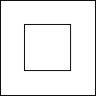

Manual page break follows.

# Heading Two



# Heading Three (page break before)



Image after multiple paragraphs, causing pagination.

