**PRACTICAL EXAMINATION 02**Subject code: FER201m – SU 2023   
Duration: 85 minutes

FPT University is currently implementing the construction of a news website to promote the image and activities of the university, using the create-react-app technique to render a mobile-friendly website. The application requires the logo of the university to be displayed, a menu section for navigating within the website. Below the menu bar, there will be 2 columns displayed, one column showing the input form and the other displaying the latest news (including images, titles, and dates). The input form will validate the input data, requiring data to be entered and checking the limits (the title must be greater than 5 and less than 250 characters); if entered correctly, a popup model will display the entered information.

**Note**: Only news articles with a status of "true" will be displayed. When a user clicks on a news article of interest, the website will be redirected to another page to view the details of that article.

The student should put the code of the app in a zip file named "**FPTUniversity_code.zip**"   
(please avoid using the student's name or ID).

The student can write the code based on the specific tasks:

1. Create a **News** component to render the information of News (id, name, image, description, date). (2 marks)
2. Create a **NewsList** component to render the information of the dynamic lists of news (3 marks)
3. Create a **MenuForm** component to display the navigation menu (0.5 marks)
4. Create a **ContactForm** component that allows users to input information. If the input is correct, display a message on the screen. If it is incorrect, display an error message. (3 marks)
5. Create a beautiful interface using Bootstrap. (1.5 marks)

The materials that the student must submit to the lsmdn system for marking include:

1. FPTUniversity_FER201m.zip
2. A PDF file with screenshots of the application. If the app has errors and cannot render the view, please note "App has error" on the file.

**Note:**

* The images and the news.js file are located in the provided folder, which students can use for test.
* Students are allowed to use different versions of React to complete the test.
* Students are required to use React 16.
* Students are allowed to use resources on their computer, but only use the Internet to download the exam questions, submit their exams, and install via the Terminal.
* During the file compression for submission, please exclude the node_modules folder.
* The interface should be able to be responsive on different device platforms, such as mobile.

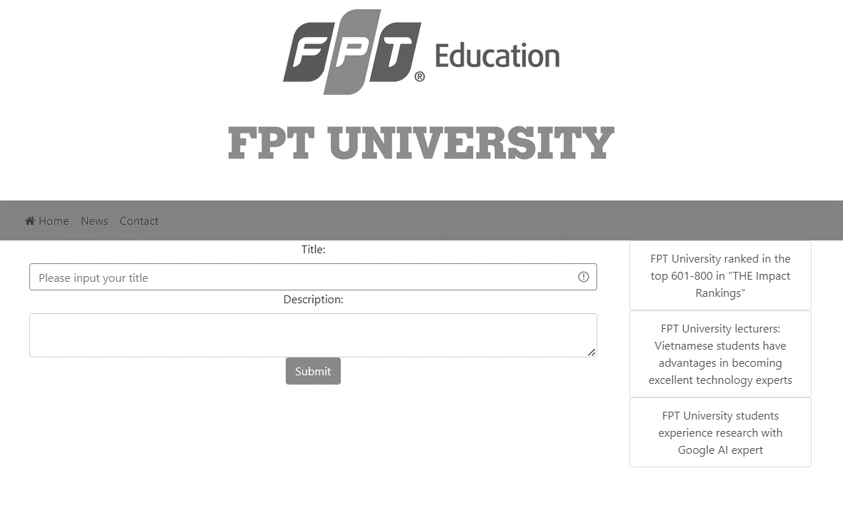  
*The template is only for the reference purpose, student can use different interface.*

**MenuForm**

**ContactForm**

**NewList**

news.js

export const NEWS = [

    {

      id: 1,

      name: 'FPT University ranked in the top 601-800 in "THE Impact Rankings"',

      image: '/assets/images/university-01.webp',

      status: true,

      description: 'FPT University has been ranked 601-800 in the global university sustainability ranking "THE Impact Rankings", with successful progress and recognition for SDG 4 - Quality Education',

      date: '06/02/2023'

    },

    {

      id: 2,

      name: 'FPT University lecturers: Vietnamese students have advantages in becoming excellent technology experts',

      image: '/assets/images/university-02.webp',

      status: true,

      description: 'Having worked abroad and taught at FPT University Danang and FPT University AI Quy Nhon, Mr. Nguyen Gia Tri evaluates the training program and facilities in Vietnam as opening up opportunities for developing many good human resources in the field of information technology.',

      date: '05/25/2023'

    },

    {

      id: 3,

      name: 'FPT University students experience research with Google AI expert',

      image: '/assets/images/university-03.webp',

      status: true,

      description: 'FPT University students experience research with AI expert through the Reinforcement Learning program for (large) language models in education with guest speaker - Dr. Sian Gooding, Google AI expert from Cambridge University.',

      date: '05/30/2023'

    },

    {

      id: 4,

      name: 'Admire the beauty of FPT University student in Danang campus',

      image: '/assets/images/university-04.webp',

      status: false,

      description: 'Hanhnhan - a K16 student majoring in Hotel Management at FPT University Danang campus is a very prominent name at F with a beautiful appearance and outstanding extracurricular activity achievements.',

      date: '05/29/2023'

    },

  ];