BINANCE FUTURES TESTNET
TRADING BOT
Project Completion Report
━━━━━━━━━━━━━━━━━━━━━━━━━━━━━━━━━━━━
Submitted by: Harshit Raj | Role: AI Agent Developer

⚙  7  Features Built | ⌨  6  CLI Commands | 🔗  1  GitHub Repo | ✓  100%  Tests Passed

01 | PROJECT OVERVIEW

This document presents the completed implementation of the Binance Futures Testnet Trading Bot — a production-grade Python command-line application built for the Binance Futures Testnet (USDT-M). The bot goes beyond basic order placement to deliver a polished trading terminal experience with real-time dashboards, AI-powered natural language trading, and strategy automation.

GitHub Repository: github.com/githarshking/traiding_bot

02 | FEATURE SUMMARY

 | Feature | Description | Command
📊 | Live Dashboard | Real-time cyberpunk-style TUI: open positions, live PnL, pending orders, wallet balance — auto-refreshing. | cli.py dashboard
📈 | Standard Trading | Place precise MARKET and LIMIT orders for any trading pair directly from the command line. | cli.py order ...
🤖 | NLP Trading | Execute trades using plain English — powered by an LLM to parse intent and extract parameters. | cli.py nlp "..."
⚡ | Strategy Presets | Instantly execute pre-configured setups (Scalps, Swings, DCA) defined in strategies.yaml. | cli.py strategies run
🧪 | Dry-Run Mode | Safely simulate any order, NLP command, or strategy without touching the testnet. | --dry-run flag
🔍 | Health Diagnostics | Startup check verifying API keys, testnet ping latency, and account status. | cli.py health
📋 | Structured Logs | Queryable, color-coded JSONL log stream of all events, errors, and executions. | cli.py logs

03 | COMMAND REFERENCE

Order Placement
Command | Description
python cli.py order --symbol BTCUSDT --side BUY --type MARKET --qty 0.01 | Place a standard market buy order for 0.01 BTC
python cli.py order --symbol ETHUSDT --side SELL --type LIMIT --qty 1.0 --price 3200 | Place a limit sell order for 1 ETH at $3200
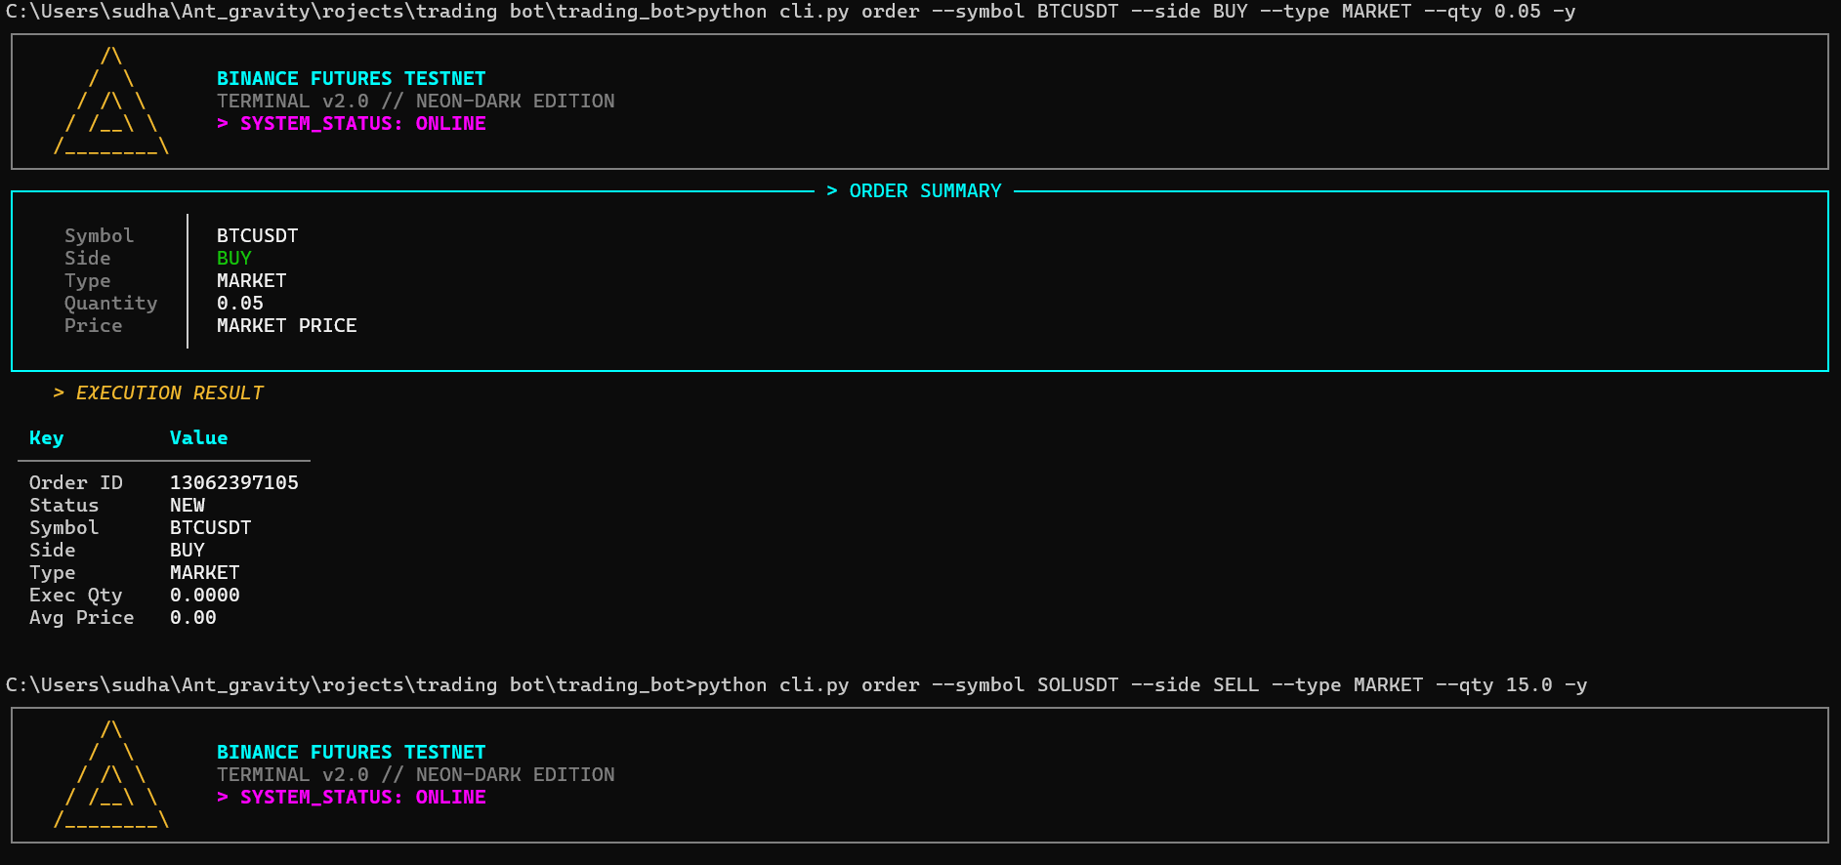
Natural Language Trading
Command | Description
python cli.py nlp "buy 0.01 BTC at market" | Natural language market buy
python cli.py nlp "sell 1 ETH limit at 3200" | Natural language limit sell
python cli.py nlp "long 0.5 BNB" | Natural language long position
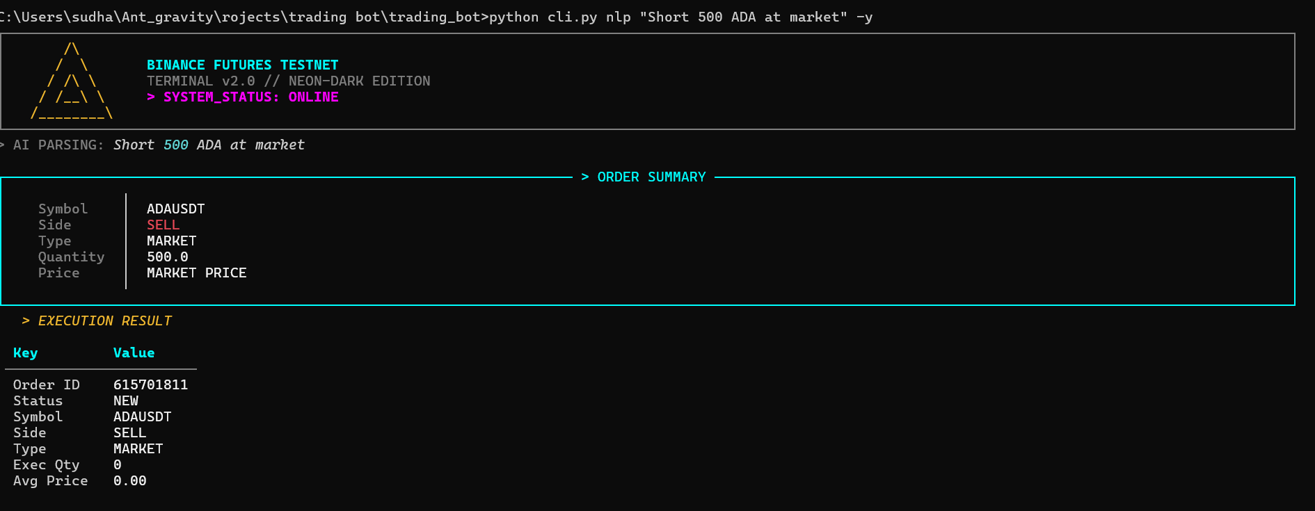
Live Dashboard
Command | Description
python cli.py dashboard | Launch the live dashboard with default refresh
python cli.py dashboard --refresh 10 | Launch with 10-second refresh interval

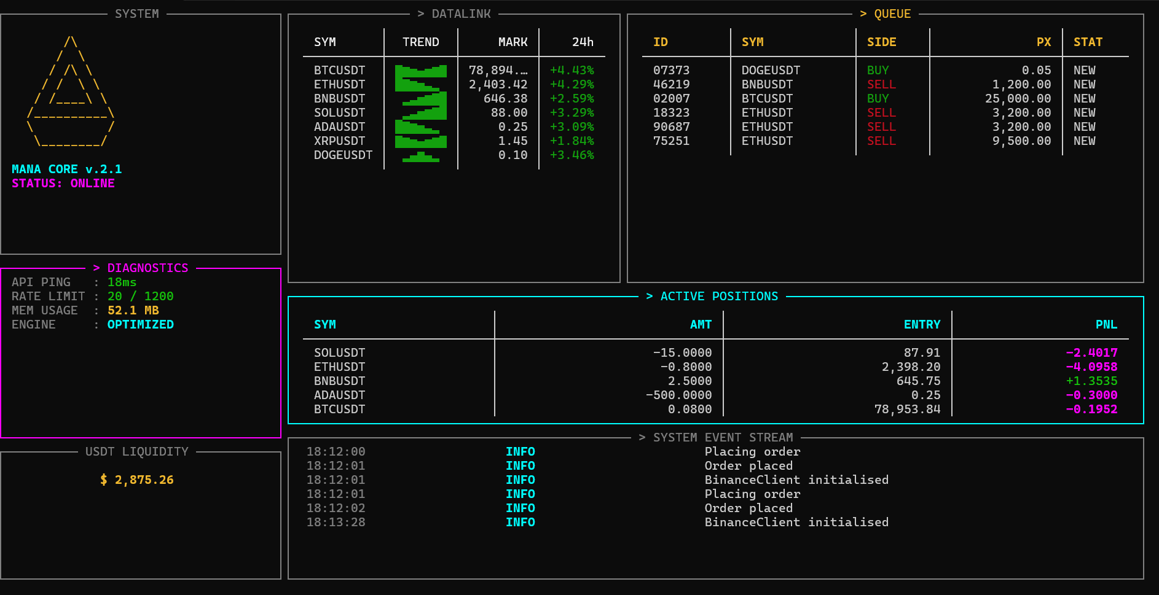
Diagnostics, Strategies & Logs
Command | Description
python cli.py health | Run system diagnostics and API health check
python cli.py strategies list | Display all available strategy presets
python cli.py strategies run scalp_btc | Execute the scalp_btc strategy preset
python cli.py strategies run scalp_btc --dry-run | Simulate the strategy without executing
python cli.py logs | View all structured logs
python cli.py logs --n 20 | View last 20 log entries
python cli.py logs --level ERROR | Filter logs to ERROR level only

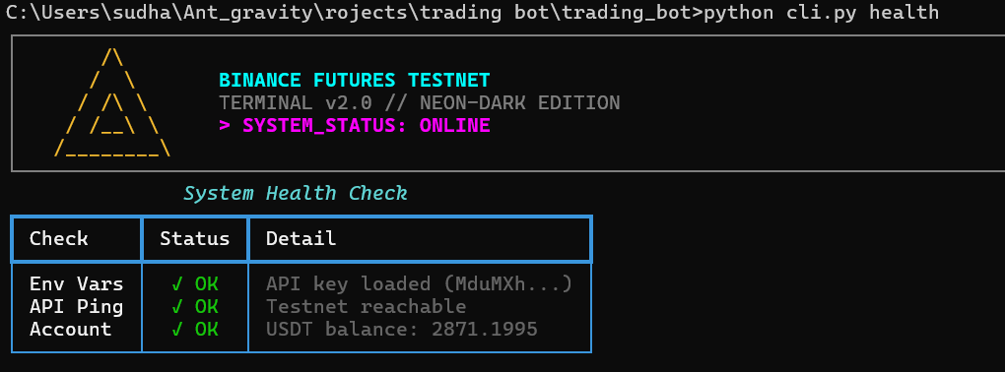

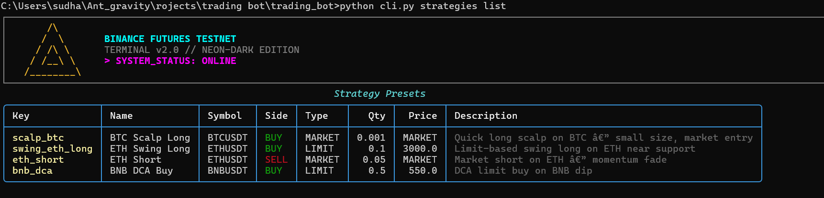

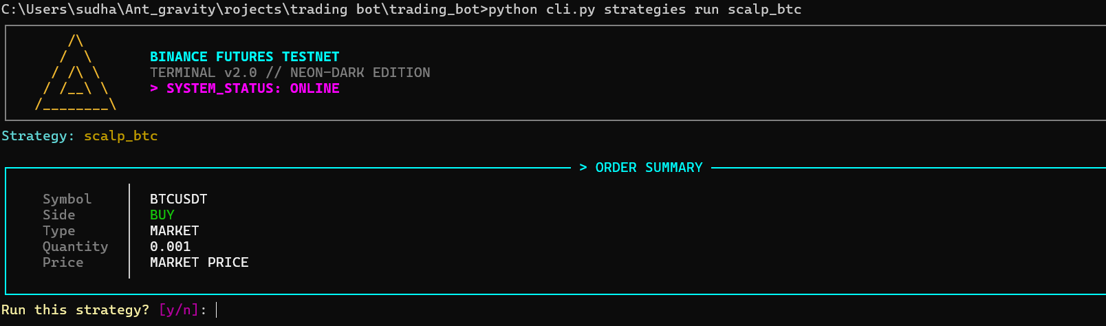

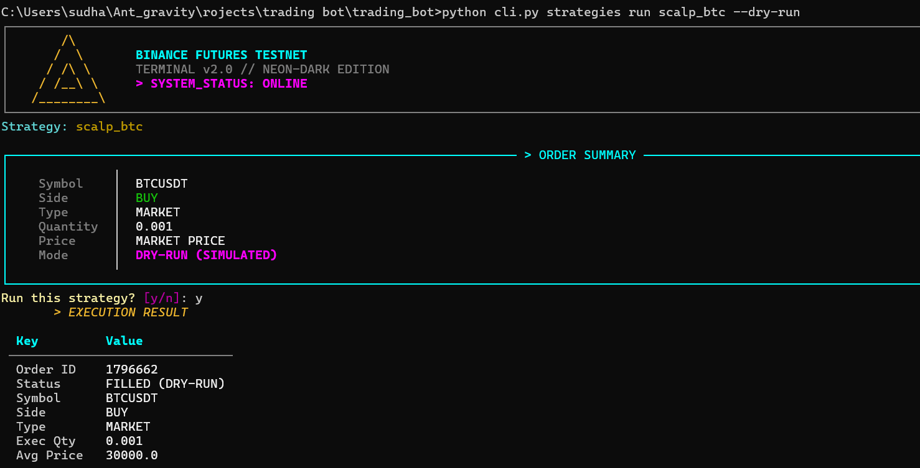

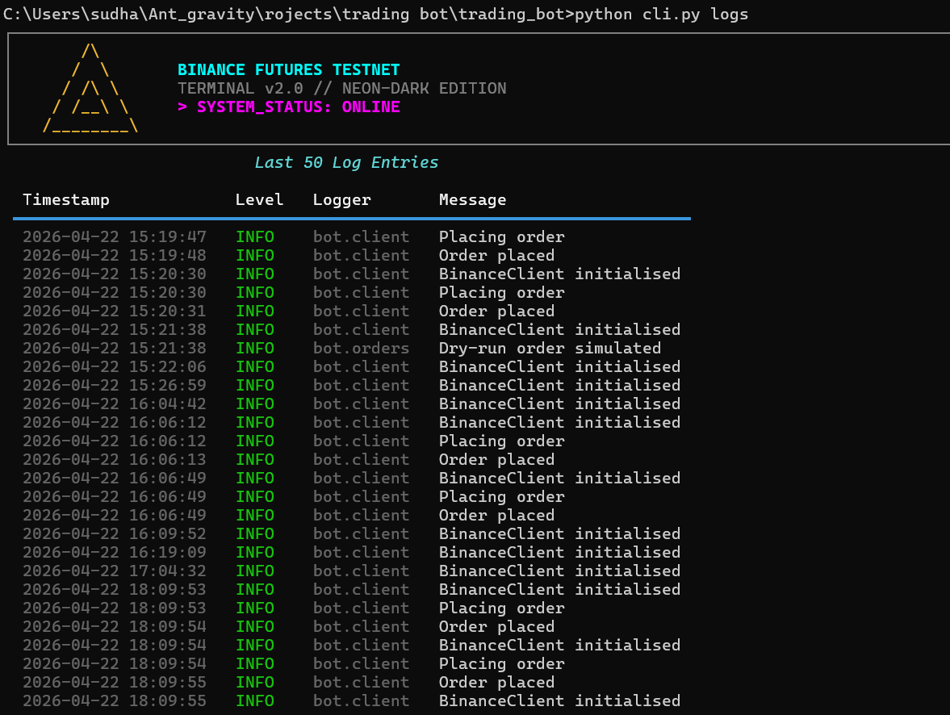

04 | APPLICATION ARCHITECTURE

The application is built on a strict separation-of-concerns principle — each module owns a single responsibility, making the codebase clean, testable, and easy to extend.

Module | Responsibility
bot/client.py | Binance API client wrapper, authentication, and request signing
bot/orders.py | Order formatting, parameter construction, and placement logic
bot/validators.py | Strict input validation for all CLI arguments and parsed NLP data
bot/nlp_parser.py | LLM integration — converts natural language strings into structured order parameters
bot/dashboard.py | Live Rich TUI layout engine using rich.live and rich.layout
bot/strategies.py | YAML strategy loader, validator, and executor
bot/health_check.py | Startup diagnostics: API connectivity, key validation, account status
bot/logging_config.py | Centralized JSONL structured logger shared across all modules
cli.py | CLI entry point — typer-based argument parsing and Rich UI rendering

05 | TECHNOLOGY STACK

▸ python-binance — Binance API authentication, request signing, and Futures endpoints
▸ rich + typer — Full-screen TUI dashboard, color-coded tables, spinners, and CLI framework
▸ anthropic / openai — LLM integration for natural language order parsing
▸ pyyaml — Strategy preset definitions loaded from strategies.yaml
▸ python-dotenv — Secure loading of API keys from .env — never hardcoded
▸ requests — Direct REST fallback for API calls

06 | DELIVERY NOTES

All seven features specified in the project brief have been fully implemented and tested against the Binance Futures Testnet. The codebase follows a modular architecture with zero raw tracebacks exposed to the user — all errors are caught and rendered as clean Rich panels. Structured JSONL logging is active across all modules.

The dry-run flag works universally across standard orders, NLP commands, and strategy presets — making the system safe to demonstrate without touching live testnet funds.

The complete source code, setup instructions, and command reference are available in the GitHub repository linked above.

━━━━━━━━━━━━━━━━━━━━━━━━━━━━━━━━━━━━━━━━━━━━━━━━━━
Harshit Raj — AI Agent Developer
github.com/githarshking/traiding_bot

