Consider the following software

A user gives certain input to the software. The input is validated against a system dictionary to be a valid string. If it is not a string then an error message is displayed back to the user. If the input is a valid string then the software asks for the following options

- Reverse the string
- Count characters in the string
- Append a new string to the entered string

If user selects to reverse the string, then the software prints the entered string character by character in the reverse direction. If user selects option no. 2 then the software counts the characters in the string and then displays the result. If the user selects option no. 3 then the software asks the user to enter a new string. This newly entered string is concatenated with the old one and then the result is displayed back to the user.

Level 0 DFD

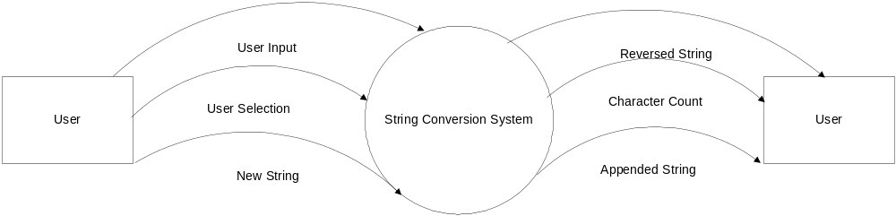

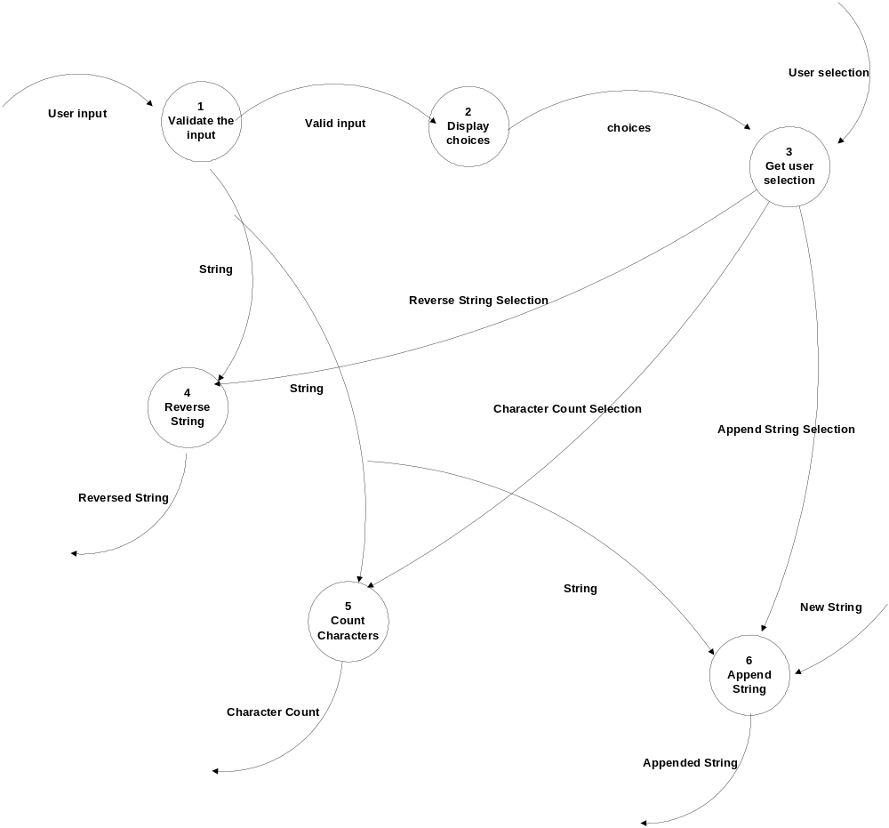Level 1 DFD

Level 2 DFD

