Lyn: Ai Foundations Thinking Machines
// 101 Intro
AI: Any system that exhibits behavior that could be interpreted as human intelligence
There’s no one standard for human intelligence.

A Game is perfect pattern for AI:
- Set rules
- Certain possibilities
- Easy pattern matching for possible answers

// 102 GPS
Physical Symbol System Hypothesis (1996):
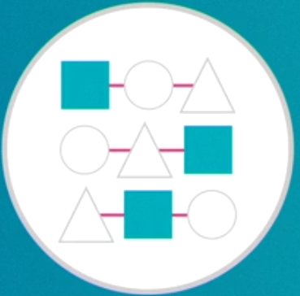
If we can connect symbols than we can achieve an intelligent machine.

Combinatorial explosion: matching pattern and producing result. Patterns recorded by expert also names as expert system

// 103 Strong AI vs Weak AI
Strong: Display all person-like behaviour
Weak or Narrow: Machine is confined to a very narrow task
It will assist you for narrow tasks.

// 104 Planning
Expert system as now named as Planning AI, how to match your symbols with heuristic reasoning. Google map uses it.
Symbolic system and Planning AI works well for some apps.

// 201 Machine Learning
Machine learn, where we make computer to learn its pattern and generate solution by itself. It is better than Expert system, because ML can improve by each new content pattern increment.

// 202 ANN: Artificial Neural Network
It tries to mimic biological brain. Large scale trial and errors.

// 203 Perceptions
ML started with symbolic system and has taken a pause.
Perceptrons are initial ANN. First machine name is Mark 1 Perception

1990’s Deep Learning: because there are many hidden layer b/w input and output generated, works on back propagation
Clustering is allowing categorisation

// 301 Match Patterns
ML is better over Symbolic reasoning

// 302 Data
Which approach for ML should we taken?
- Symbolic reasoning = Abstract problem, but know steps
  - Long setup and no outside data
- Machine learning = Look for patterns
  - Lots of data that needs regular self-tweaking

Or a mix ratio of two

Deep learning example to train for fan recognition:
- Fill data in form of image, videos for fan
- Fill sounds of fan
- Fill and train fan rotation sensor detection
ML advantages:
- Zero in on perfect pattern match
- Flexible and No human reliance

// 303 Unsupervised
Supervised Learning
- Giving training set
- Human intervention
Unsupervised Learning
- No Human intervention while training

// 304 Back Propagation or Error correction
// 305 Regression analysis for training
Relation b/w dependent and independent variables

Classification (Sorting) vs Regression (Connecting)

ANN will only show the patterns of input, not any answer

// 401 Robotics: works on physical tasks
// 402 NLP Natural Language Processing
// 403 IOT
// 501 Big Data
ML requires training and frameworks
Data mining uses broader tools without required training

// 502 Data Science
Programming, Data, Math, Statistics, Hacking
Finding why in data pattern

// 601 Pitfalls
Does the program require abstract reasoning or detailed pattern matching?
Symbolic Reasoning:
Decisions, Actions, Symbols
Machine Learning:
ANN for key pattern recognition

Lyn: Elastic Search Essential Training

// 101 Origins
Started from Lucene 1999
Moved to Compass 2004
Now as Elasticsearch 2010

// 102 Elastic the company
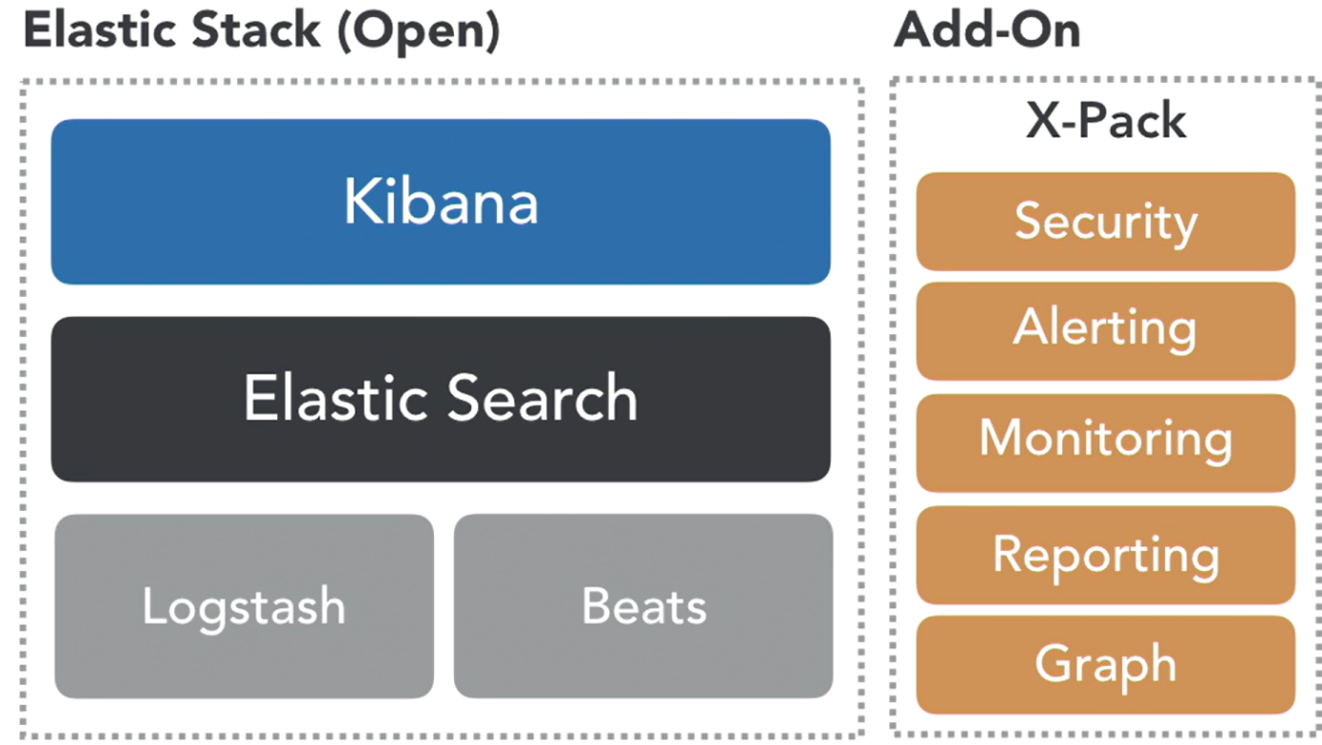
// 103 Elastic Overview

- Scalability, Near Real-Time
- NoSQL platform, Schema less
- Advance Query Language

// 104 Use cases
- Security / Log analytics
- Marketing - Search - Operations

// 105 Elastic Cluster
Cluster Node Index (table)
Type (partitioner) Document (json)
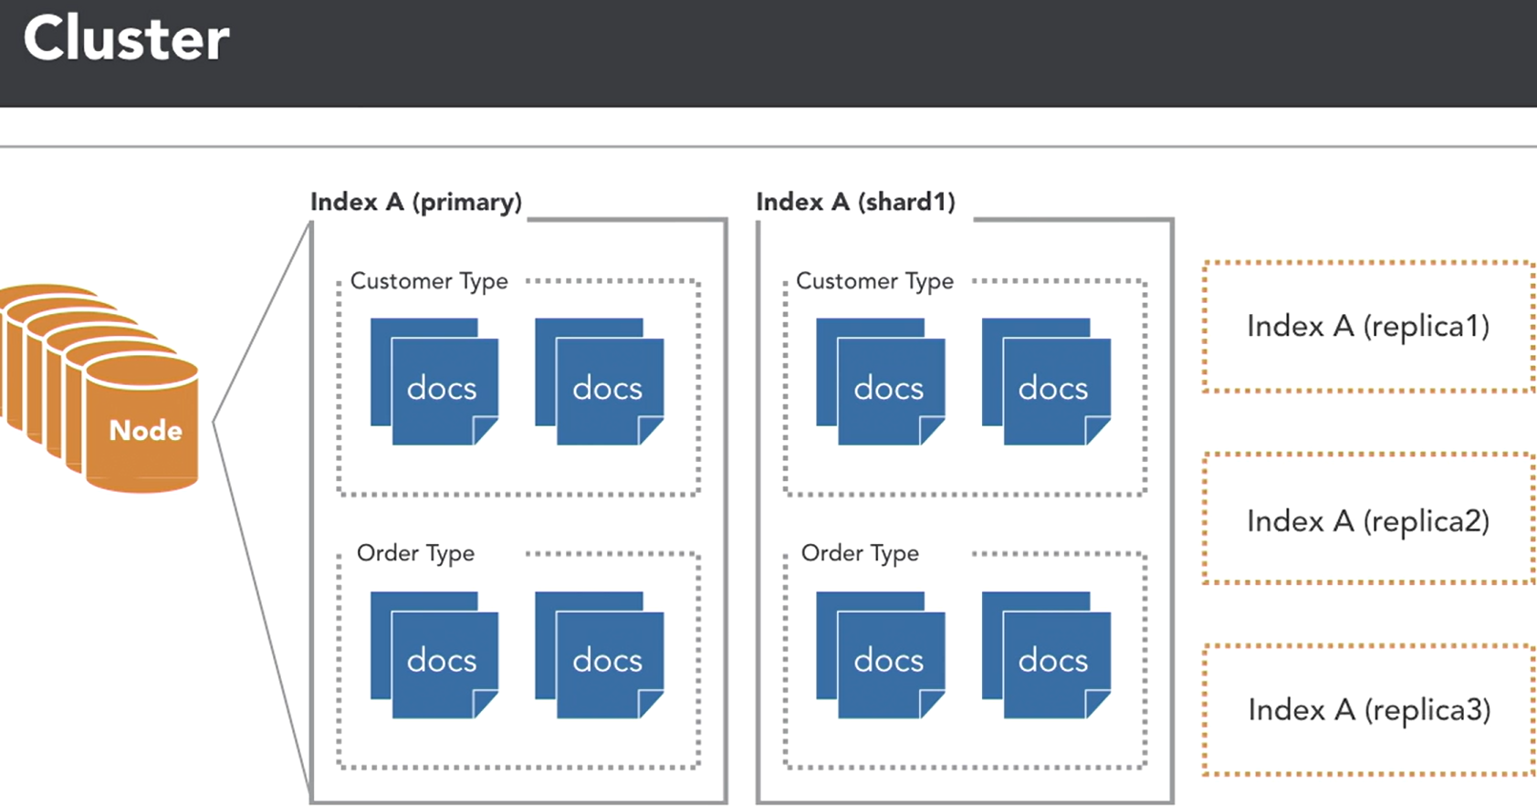
Shard / Replica

// 201 Elastic Cloud
// basic cloud account setup high level

// 202 Install Elastic locally with Kibana (java)
// 203 Explore cluster

// 301 Bulk loading data
// 302 Load sample data
// 303 Data types
Core, Complex, Geo, Specialized

// 401 Simple Queries
# show me everything
GET bank/account/_search

# find CA accounts only
GET bank/account/_search
{ "query": {
"match": { "state": "CA" } } }

# find "Techade" accounts in CA only
GET bank/account/_search
{ "query": {
"bool": {
"must": [ { "match": {"state": "CA"} },
{ "match": {"employer": "Techade"} } ] } } }

# find non "Techade" accounts outside of CA
GET bank/account/_search
{"query": {
"bool": {
"must_not": [ { "match": {"state": "CA"} },
{ "match": {"employer": "Techade"} } ] } } }

# Boost results for Smith
GET bank/account/_search
{"query": {
"bool": {
"should": [ { "match": {"state": "CA"} },
{ "match": {"lastname": { "query": "Smith","boost": 3 }
} } ] } } }

// 402 AWS Glacier

// 403 AWS Glacier

// 501 AWS Glacier

// 502 AWS Glacier

// 503 AWS Glacier

// 601 AWS Glacier

// 602 AWS Glacier

// 603 AWS Glacier

// 701 AWS Glacier

Lyn: TypeScrg
https://catalog.workshops.aws/stepfunctions/en-US

// 201 A

// 202 A

// 203 A

// 204 A

// 05 A

// 06 A

// 201 A

// 202 A

// 203 A

// 204 A

// 05 A

// 06 A

// 201 A

// 202 A

// 203 A

// 204 A

// 05 A

// 06 A

// 201 A

// 202 A

// 203 A

// 204 A

// 05 A

// 06 A

// 201 A

// 202 A

// 203 A

// 204 A

// 05 A

// 06 A

// 201 A

// 202 A

// 203 A

// 204 A

// 05 A

// 06 A

// 201 A

// 202 A

// 203 A

// 204 A

// 05 A

// 06 A

// 201 A

// 202 A

// 203 A

// 204 A

// 05 A

// 06 A

Lyn: TypeScrg
https://catalog.workshops.aws/stepfunctions/en-US

// 201 A

// 202 A

// 203 A

// 204 A

// 05 A

// 06 A

// 201 A

// 202 A

// 203 A

// 204 A

// 05 A

// 06 A

// 201 A

// 202 A

// 203 A

// 204 A

// 05 A

// 06 A

// 201 A

// 202 A

// 203 A

// 204 A

// 05 A

// 06 A

// 201 A

// 202 A

// 203 A

// 204 A

// 05 A

// 06 A

// 201 A

// 202 A

// 203 A

// 204 A

// 05 A

// 06 A

// 201 A

// 202 A

// 203 A

// 204 A

// 05 A

// 06 A

// 201 A

// 202 A

// 203 A

// 204 A

// 05 A

// 06 A

Lyn: TypeScrg
https://catalog.workshops.aws/stepfunctions/en-US

// 201 A

// 202 A

// 203 A

// 204 A

// 05 A

// 06 A

// 201 A

// 202 A

// 203 A

// 204 A

// 05 A

// 06 A

// 201 A

// 202 A

// 203 A

// 204 A

// 05 A

// 06 A

// 201 A

// 202 A

// 203 A

// 204 A

// 05 A

// 06 A

// 201 A

// 202 A

// 203 A

// 204 A

// 05 A

// 06 A

// 201 A

// 202 A

// 203 A

// 204 A

// 05 A

// 06 A

// 201 A

// 202 A

// 203 A

// 204 A

// 05 A

// 06 A

// 201 A

// 202 A

// 203 A

// 204 A

// 05 A

// 06 A

Lyn: TypeScrg
https://catalog.workshops.aws/stepfunctions/en-US

// 201 A

// 202 A

// 203 A

// 204 A

// 05 A

// 06 A

// 201 A

// 202 A

// 203 A

// 204 A

// 05 A

// 06 A

// 201 A

// 202 A

// 203 A

// 204 A

// 05 A

// 06 A

// 201 A

// 202 A

// 203 A

// 204 A

// 05 A

// 06 A

// 201 A

// 202 A

// 203 A

// 204 A

// 05 A

// 06 A

// 201 A

// 202 A

// 203 A

// 204 A

// 05 A

// 06 A

// 201 A

// 202 A

// 203 A

// 204 A

// 05 A

// 06 A

// 201 A

// 202 A

// 203 A

// 204 A

// 05 A

// 06 A

Lyn: TypeScrg
https://catalog.workshops.aws/stepfunctions/en-US

// 201 A

// 202 A

// 203 A

// 204 A

// 05 A

// 06 A

// 201 A

// 202 A

// 203 A

// 204 A

// 05 A

// 06 A

// 201 A

// 202 A

// 203 A

// 204 A

// 05 A

// 06 A

// 201 A

// 202 A

// 203 A

// 204 A

// 05 A

// 06 A

// 201 A

// 202 A

// 203 A

// 204 A

// 05 A

// 06 A

// 201 A

// 202 A

// 203 A

// 204 A

// 05 A

// 06 A

// 201 A

// 202 A

// 203 A

// 204 A

// 05 A

// 06 A

// 201 A

// 202 A

// 203 A

// 204 A

// 05 A

// 06 A

Lyn: TypeScrg
https://catalog.workshops.aws/stepfunctions/en-US

// 201 A

// 202 A

// 203 A

// 204 A

// 05 A

// 06 A

// 201 A

// 202 A

// 203 A

// 204 A

// 05 A

// 06 A

// 201 A

// 202 A

// 203 A

// 204 A

// 05 A

// 06 A

// 201 A

// 202 A

// 203 A

// 204 A

// 05 A

// 06 A

// 201 A

// 202 A

// 203 A

// 204 A

// 05 A

// 06 A

// 201 A

// 202 A

// 203 A

// 204 A

// 05 A

// 06 A

// 201 A

// 202 A

// 203 A

// 204 A

// 05 A

// 06 A

// 201 A

// 202 A

// 203 A

// 204 A

// 05 A

// 06 A

Lyn: TypeScrg
https://catalog.workshops.aws/stepfunctions/en-US

// 201 A

// 202 A

// 203 A

// 204 A

// 05 A

// 06 A

// 201 A

// 202 A

// 203 A

// 204 A

// 05 A

// 06 A

// 201 A

// 202 A

// 203 A

// 204 A

// 05 A

// 06 A

// 201 A

// 202 A

// 203 A

// 204 A

// 05 A

// 06 A

// 201 A

// 202 A

// 203 A

// 204 A

// 05 A

// 06 A

// 201 A

// 202 A

// 203 A

// 204 A

// 05 A

// 06 A

// 201 A

// 202 A

// 203 A

// 204 A

// 05 A

// 06 A

// 201 A

// 202 A

// 203 A

// 204 A

// 05 A

// 06 A

