Index
- Lyn: 2019 Advanced Python
- Lyn: Py Data Analysis [ skip ]
- Lyn: Advanced Python Working with Databases

- Lyn: 2019 Python Design Patterns
- Lyn: 2019 Python Advanced Design Patterns

- d

Lyn: Advanced Python
// 101 Python code style
PEP 8 – Styling Guide for Python Code
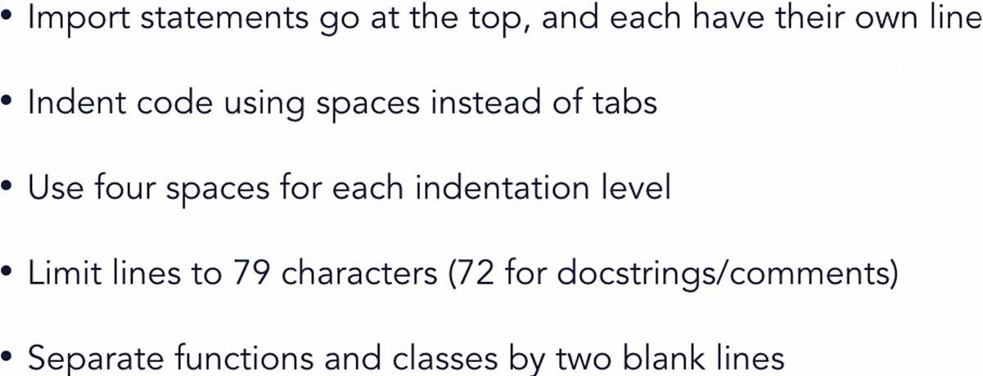
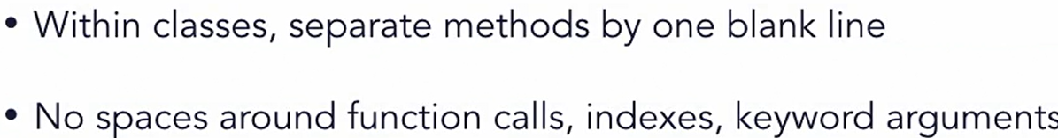
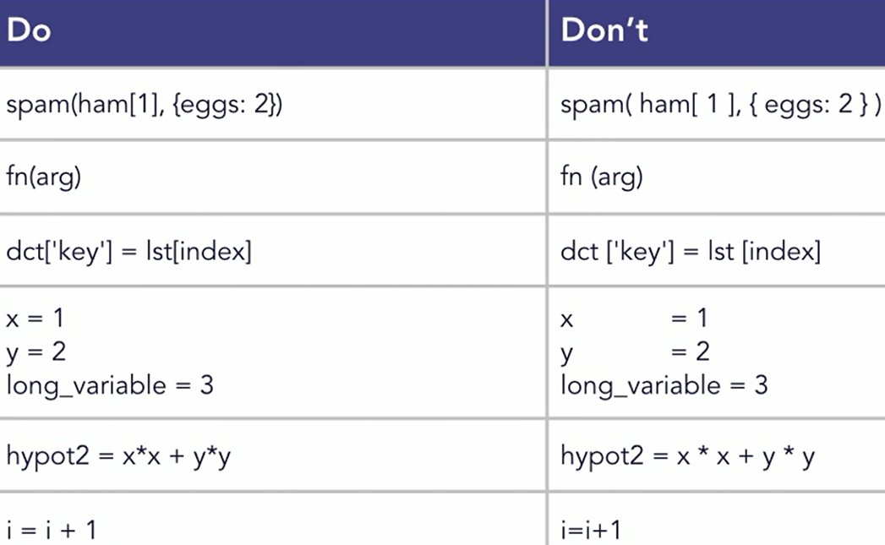
/peps/pep-0008

// 102 Truth value testing
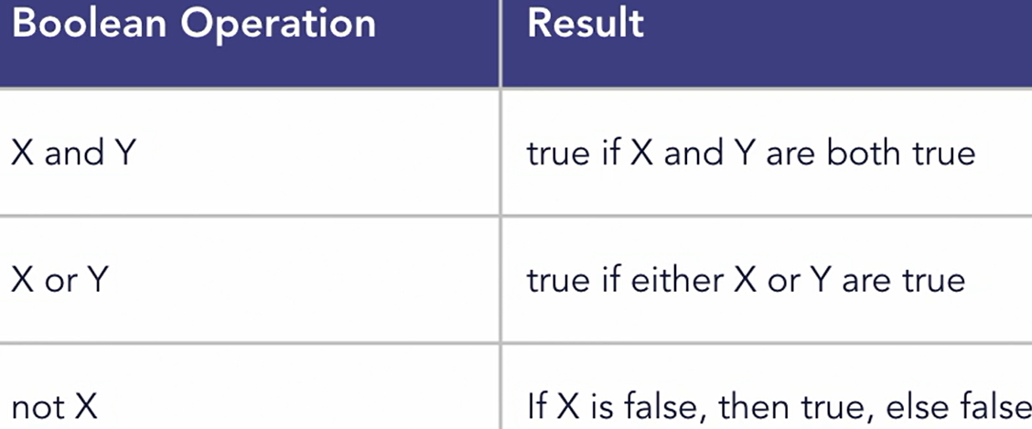
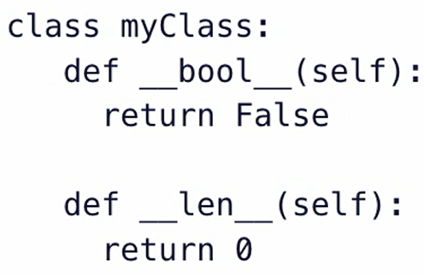
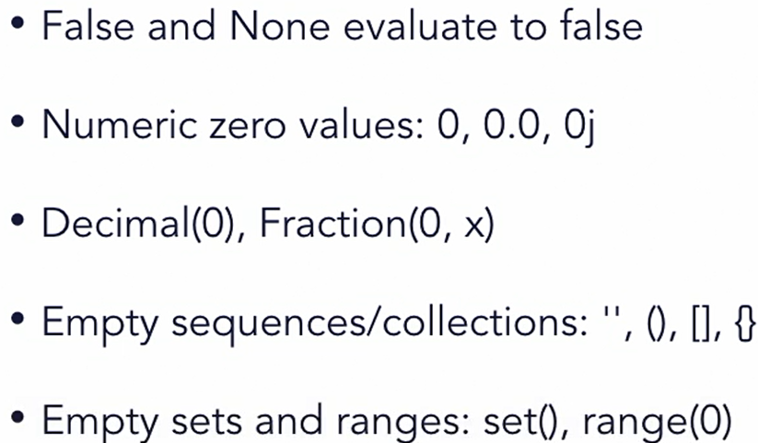
All below are examples of False value in Python:
x = list(); print(bool(x)); # False
y = dict(); print(bool(y)); # False
// 103 String VS Bytes
# strings and bytes are not directly interchangeable
# strings contain unicode, bytes are raw 8-bit values
# define some starting values
b = bytes([0x41, 0x42, 0x43, 0x44]); print(b)
s = "This is a string"; print(s)
# Try combining them. This will cause an error:
# print(s+b) # TypeError: can only concatenate....

# Bytes and strings need to be properly encoded and decoded before you can work on them together
s2 = b.decode('utf-8'); print(s+s2)
b2 = s.encode('utf-8'); print(b+b2)
b3 = s.encode('utf-32') # encode the string as UTF-32

// 104 Template Strings
from string import Template
# create a template with placeholders
templ = Template("You're watching ${title} by ${author}")
# use the substitute method with keyword arguments
str2 = templ.substitute(title="Adv Python", author="Joe")
print(str2)
# use the substitute method with a dictionary
data = { "author": "Joe”, "title": " Python" }
str3 = templ.substitute(data); print(str3)

// 201 Utilities # Build-in functions
any, all, min, max, sum
// 202 Iterator
days = ["Sun", "Mon", "Tue", "Wed", "Thu", "Fri", "Sat"]
daysFr = ["Dim", "Lun", "Mar", "Mer", "Jeu", "Ven", "Sam"]
i = iter(days); print(next(i)); print(next(i)); print(next(i))

# iterate using a function and a sentinel
# iter(object, sentinel)
# sentinel means on what value iter stop calling next()
with open("testfile.txt", "r") as fp:
for line in iter(fp.readline, ''): print(line)

# using enumerate reduces code and provides a counter
for i, m in enumerate(days, start=1): print(i, m)
# use zip to combine sequences
for m in zip(days, daysFr): print(m)

for i, m in enumerate(zip(days, daysFr), start=1):
print(i, m[0], "=", m[1], "in French")
==== ====
# reading fixed-width blocks from a binary file until the end
from functools import partial
with open("testfile.txt", "r") as f:
for block in iter(partial(f.read, 64), b''): print(block)
// 203 Transform # use functions like sorted, filter, map
def filterFunc(x):
if x % 2 == 0: return False
return True
def squareFunc(x): return x**2
def toGrade(x):
if (x >= 90): return "A"
elif (x >= 80 and x < 90): return "B"
elif (x >= 70 and x < 80): return "C"
elif (x >= 65 and x < 70): return "D"
return "F"

nums = (1, 8, 4, 5, 13, 26, 381, 410, 58, 47)
chars = "abcDeFGHiJklmnoP"
grades = (81, 89, 94, 78, 61, 66, 99, 74)

# use filter to remove items from a list
print([filter(filterFunc, nums)])
print([x for x in nums if x % 2 != 0])

# use map to create a new sequence of values
squares = list(map(squareFunc, nums)); print(squares)
# use sorted and map to change numbers to grades
grades = sorted(grades)
letters = list(map(toGrade, grades)); print(letters)

// 204 Itertools and Lambda function, lambda
import itertools
def testFunction(x): return x < 40
# cycle iterator can be used to cycle over a collection
seq1 = [1, 2]; cycle1 = itertools.cycle(seq1)
print(next(cycle1)) # 1
print(next(cycle1)) # 2 print(next(cycle1)) # 1
# use count to create a simple counter
count1 = itertools.count(100, 10)
print(next(count1)) # 100
print(next(count1)) # 110 print(next(count1)) # 120

# accumulate creates an iterator that accumulates values
vals = [10,20,30,40,50,40,30]
# sum-of-digits [10, 30, 60, 100, 150, 190, 220]
print(list(itertools.accumulate(vals)))

acc = itertools.accumulate(vals, max)
print(list(acc)) # [10, 20, 30, 40, 50, 50, 50]
# use chain to connect sequences together
x = itertools.chain("ABCD", "1234"); print(list(x))

# return values until certain condition is met that stops them
print(list(itertools.dropwhile(lambda x: x < 40, vals)))
print(list(itertools.takewhile(testFunction, vals)))
// 301 function documentation string from py terminal
>>> print(map.__doc__)
>>> print(collections.__doc__)

>>> def myFunction(arg1, arg2=None):
"""myFunction(arg1, arg2=None) --> Doesn't really do anything special.

Parameters:
arg1: the first argument. Whatever you feel like passing.
arg2: the second arg Defaults to None. Whatever happy.
"""
print(arg1, arg2)

>>> print(myFunction.__doc__)
# PEP 257

// 302 Variable argument list
def addition(base, *args):

// 303 Lambda function : Anonymous
print(list(map(lambda t: (t-32) * 5/9, ftemps)))
# ftemps is iterable list here

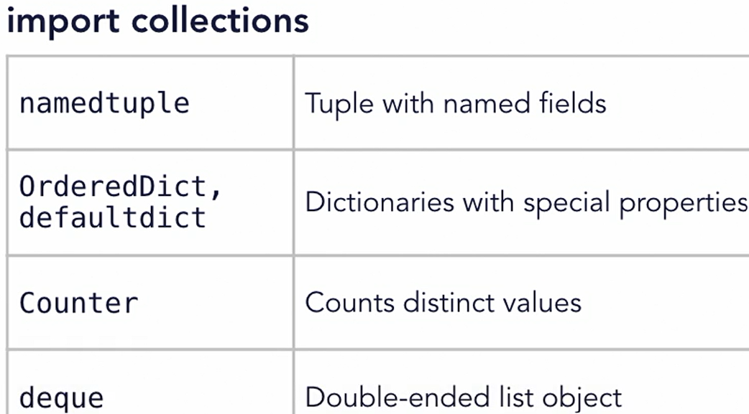
// 304 Keyword only arguments
def myFunction(arg1, arg2, *, suppressExceptions=False):
# keyword arguments can come later after all the other args

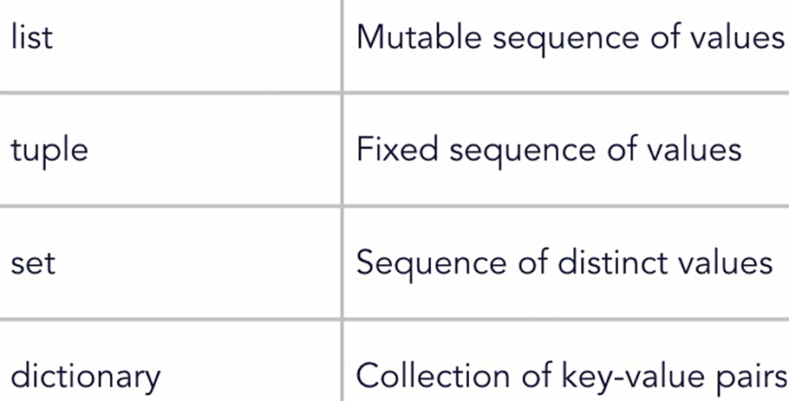
// 401 Advanced collection overview

// 402 namedtuple
import collections # create a Point namedtuple
Point = collections.namedtuple("Point", "x y")
p1 = Point(10, 20); print(p1.x, p1.y)

p3 = p1._replace(x=100) # use _replace create new instance

print(p1) # Point(x=10, y=20), so p1 remain same, no change
print(p3) # Point(x=100, y=20)

// 403 defaultdict
from collections import defaultdict
# define a list of items that we want to count
fruits = ['apple', 'pear', 'orange', 'banana',
'apple', 'grape', 'banana', 'banana']

# use a dictionary to count each element
fruitCounter = defaultdict(int)
# Count the elements in the list
for fruit in fruits: fruitCounter[fruit] += 1
# print the result
for (k, v) in fruitCounter.items(): print(k + ": " + str(v))

# apple: 2 pear: 1 orange: 1
# banana: 3 grape: 1

fruitCounter = defaultdict(lambda: 10) # start each with 10
# apple: 12 pear: 11 orange: 11
# banana: 13 grape: 11

// 404 Counters
from collections import Counter
# list of students in class 1
class1 = ["Bob", "James", "Chad", "Darcy", "Penny", "Hannah"
"Kevin", "James", "Melanie", "Becky", "Steve", "Frank"]
# list of students in class 2
class2 = ["Bill", "Barry", "Cindy", "Debbie", "Frank",
"Gabby", "Kelly", "James", "Joe", "Sam", "Tara", "Ziggy"]

# Create a Counter for class1 and class2
c1 = Counter(class1); c2 = Counter(class2)

print(c1["James"]) # How many students class 1 name James?
# How many students are in class 1?
print(sum(c1.values()), "students in class 1")

c1.update(class2) # Combine the two classes
print(sum(c1.values()), "students in class 1 and 2")
# 23 students in class 1 and 2

# What's the most common name in the two classes?
print(most_common, c1.most_common(3))
# most_common [('James', 3), ('Frank', 2), ('Bob', 1)]

mc = c1.most_common(3);
print('most_common_name', mc[0][0]) # James
c1.subtract(class2) # Separate the classes again
print('most_common', c1.most_common(3))

print(c1 & c2) # What's common between the two classes?
# Counter({'James': 1, 'Frank': 1})

// 405 OrderedDict
# remember order of insertion to dict
from collections import OrderedDict
# list of sport teams with wins and losses
sportTeams = [("Royals", (18, 12)), ("Rockets", (24, 6)),
("Cardinals", (20, 10)), ("Dragons", (22, 8)),
("Kings", (15, 15)), ("Chargers", (20, 10)),
("Jets", (16, 14)), ("Warriors", (25, 5))]

# sort the teams by number of wins
sortedTeams = sorted(sportTeams, key=lambda t: t[1][0], reverse=True)
print(sortedTeams)
print(sortedTeams[0]) # ('Warriors', (25, 5))

# create an ordered dictionary of the teams
teams = OrderedDict(sortedTeams)
print(teams)
# Use popitem to remove the top item
tm, wl = teams.popitem(False)
print("Top team: ", tm, wl) # Warriors (25, 5)

# What are next the top 4 teams?
for i, team in enumerate(teams, start=1):
print(i, team) # 1 Rockets
if i == 4: break

# test for equality
a = OrderedDict({"a": 1, "b": 2, "c": 3})
b = OrderedDict({"a": 1, "c": 3, "b": 2})
print("Equality test: ", a == b) # False

// 406 Deque Objects
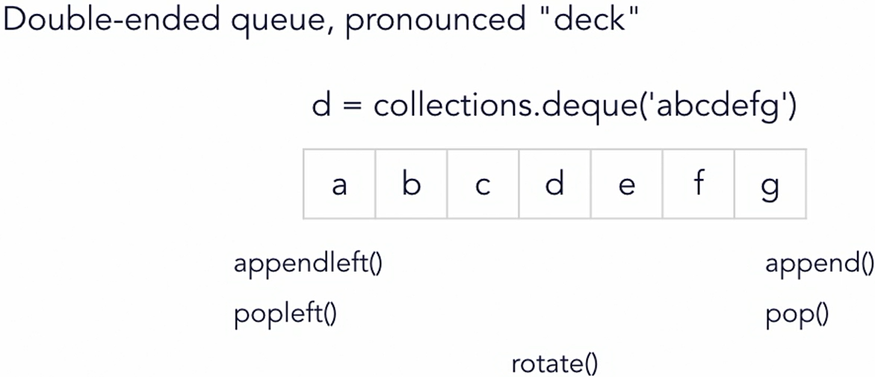
b/w stack and queue, a hybrid object with memory efficient

import collections
import string
# initialize a deque with lowercase letters
d = collections.deque(string.ascii_lowercase)

# deques support the len() function
print("Item count: " + str(len(d))) # 26

# deques can be iterated over
for elem in d: print(elem.upper(), end=",")
# A,B,C,D,E,F,G,H,I,J,K,L,M,N,O,P,Q,R,S,T,U,V,W,X,Y,Z,
# manipulate items from either end
d.pop() # removes last item in deque
d.popleft() # removes first item in deque
d.append(2) # adds 2 as last item in deque
d.appendleft(1) # adds 1 as first item in deque
print(d)
# deque([1, 'b', 'c', 'd', 'e', 'f', 'g', 'h', 'i', 'j', 'k', 'l', 'm', 'n', 'o', 'p', 'q', 'r', 's', 't', 'u', 'v', 'w', 'x', 'y', 2])

d.rotate(10) # rotate the deque
print(d)
# deque(['q', 'r', 's', 't', 'u', 'v', 'w', 'x', 'y', 2, 1, 'b', 'c', 'd', 'e', 'f', 'g', 'h', 'i', 'j', 'k', 'l', 'm', 'n', 'o', 'p'])

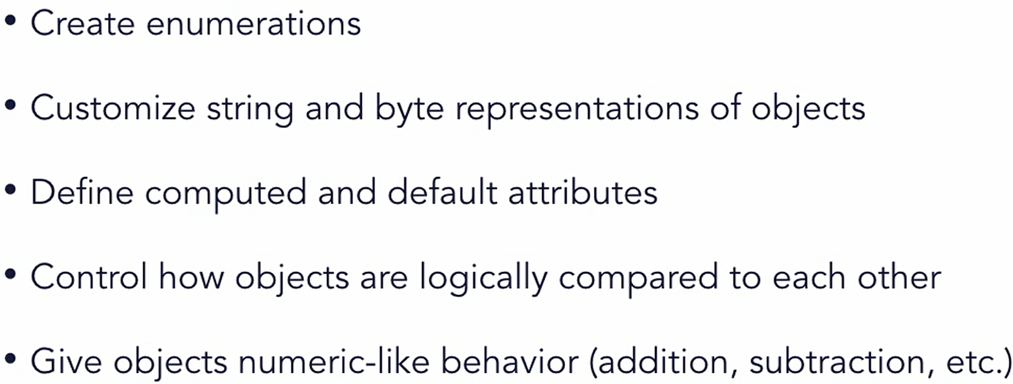
// 501 Advance classes overview

// 502 Enumeration class
from enum import Enum, unique, auto
@unique # it restricts same value for keys
class Fruit(Enum):
APPLE = 1
BANANA = 2
ORANGE = 3
TOMATO = 4
# POTATO = 1 # this is valid
# two key can have same value
# but not when using @unique
PEAR = auto() # will assign value 5 in this case

# enums have human-readable values and types
print(Fruit.APPLE); # Fruit.APPLE
print(type(Fruit.APPLE)) # <enum ‘Fruit’>
print(repr(Fruit.APPLE)) # <Fruit.APPLE: 1>

print(Fruit.APPLE.name, Fruit.APPLE.value) # APPLE 1
print(Fruit.PEAR.value) # 5 # print the auto-generated value

# enums are hashable - can be used as keys
myFruits = {}; myFruits[Fruit.BANANA] = "Come Mr. Tally"
print(myFruits[Fruit.BANANA]) # Come Mr. Tally

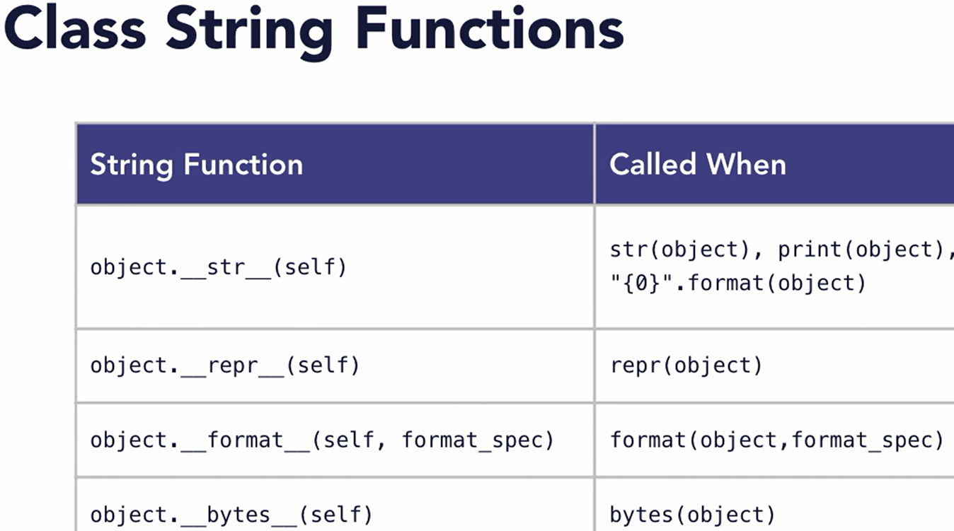
// 503 Class string values
class Person():
def __init__(self): self.fname = "Joe"; self.age = 25
# use __repr__ to create a string useful for debugging
def __repr__(self):
return "<Person Class - fname:{0},
age{1}>".format(self.fname, self.age)
# use str for a more human-readable string
def __str__(self):
return "Person ({0} is {1})".format(self.fname, self.age)
def __bytes__(self):
val = "Person:{0}:{1}".format(self.fname, self.age)
return bytes(val.encode('utf-8'))
def __format__(self, format_spec): return " - format - "

cls1 = Person()
print(str(cls1)) # Person (Joe is 25)
print(repr(cls1)) # <Person Class - fname:Joe, age25>
print("Formatted: {0}".format(cls1)) # Formatted: - format -
print(format(cls1)) # - format -
print(bytes(cls1)) # b'Person:Joe:25'

// 504 Computed attributes
Py gives opportunity to perform desired process get/set
__getattr__ when attr not found on object
__getattribute__ called first everytime for attribute get
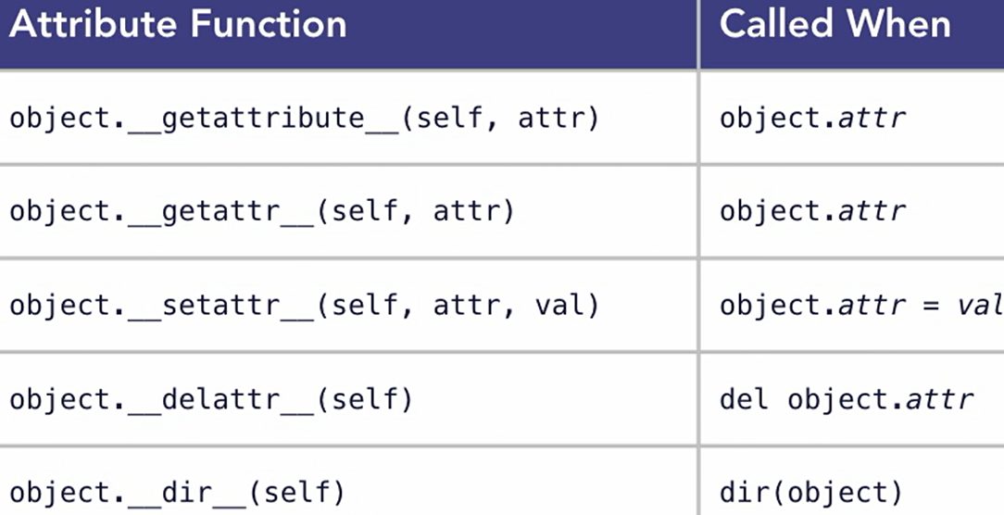
__dir__ when dir(obj) used on object
class myColor():
def __init__(self):
self.red = 50; self.green = 75; self.blue = 100

# use getattr to dynamically return a value
def __getattr__(self, attr):
if attr == "rgbcolor": return (self.red, self.green, self.blue)
elif attr == "hexcolor":
return "#{0:02x}{1:02x}{2:02x}"
.format(self.red, self.green, self.blue)
else: raise AttributeError

# use setattr to dynamically return a value
def __setattr__(self, attr, val):
if attr == "rgbcolor": self.red = val[0];
self.green = val[1]; self.blue = val[2]
else: super().__setattr__(attr, val)

# use dir to list the available properties
def __dir__(self): return ("rgbcolor", "hexcolor")

# defining return data type and self argument for function
def new_red(self) -> int: return self.red # custom function

cls1 = myColor() # create an instance of myColor
# print the value of a computed attribute
print(cls1.rgbcolor) # (50, 75, 100)
print(cls1.hexcolor) # #324b64
# set the value of a computed attribute
cls1.rgbcolor = (125, 200, 86)
print(cls1.rgbcolor) # (125, 200, 86)
print(cls1.hexcolor) # #7dc856
print(cls1.red) # 125 # access a regular attribute
# list the available attributes
print(dir(cls1)) # ['hexcolor', 'rgbcolor']
print(cls1.new_red()) # 125

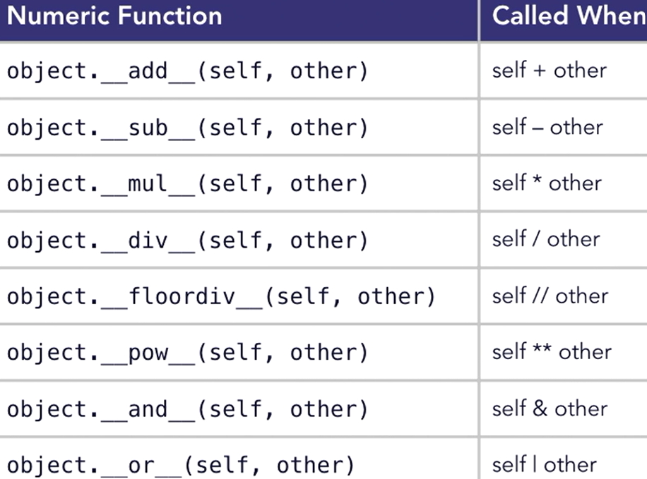
// 505 Class numeric operators
# give objects number-like behavior
class Point():
def __init__(self, x, y): self.x = x; self.y = y
def __repr__(self):
return "<Point x:{0},y:{1}>".format(self.x, self.y)
def __add__(self, other): # implement addition
return Point(self.x + other.x, self.y + other.y)
def __sub__(self, other): # implement subtraction
return Point(self.x - other.x, self.y - other.y)
def __iadd__(self, other): # in-place addition
self.x += other.x; self.y += other.y; return self

# Declare some points
p1 = Point(10, 20); p2 = Point(30, 30)
print(p1, p2) # <Point x:10,y:20> <Point x:30,y:30>
p3 = p1 + p2 # Add two points
print(p3) # <Point x:40,y:50>
p4 = p2 - p1 # subtract two points
print(p4) # <Point x:20,y:10>
p1 += p2 # Perform in-place addition
print(p1) # <Point x:40,y:50>

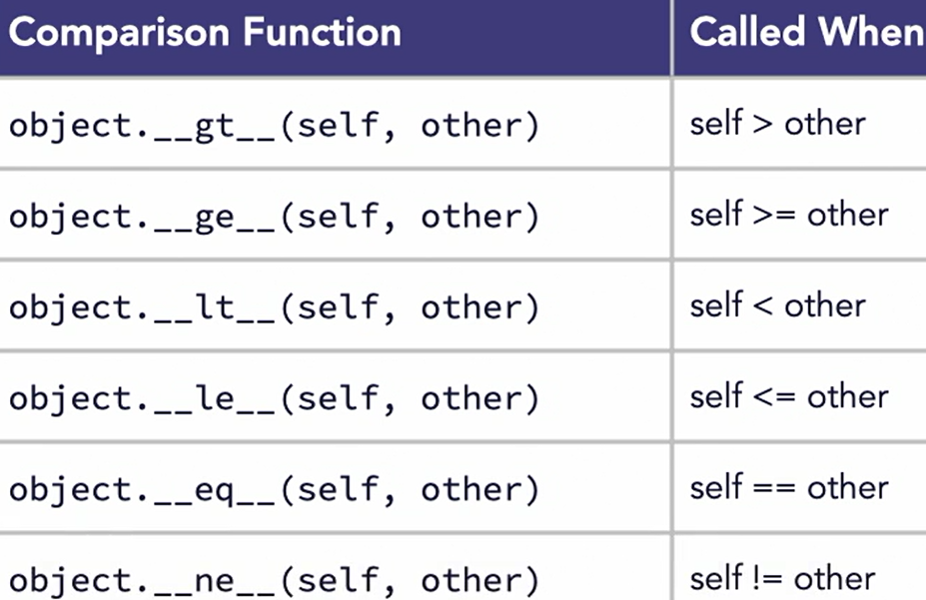
// 506 Object Comparisons
class Employee():
def __init__(self, level, yrs): self.level = level; self.yrs = yrs

def __ge__(self, other):
if self.level == other.level: return self.yrs >= other.yrs
return self.level >= other.level

def __gt__(self, other):
if self.level == other.level: return self.yrs > other.yrs
return self.level > other.level
def __lt__(self, other):
if self.level == other.level: return self.yrs < other.yrs
return self.level < other.level
def __le__(self, other):
if self.level == other.level: return self.yrs <= other.yrs
return self.level <= other.level
def __eq__(self, other): return self.level == other.level
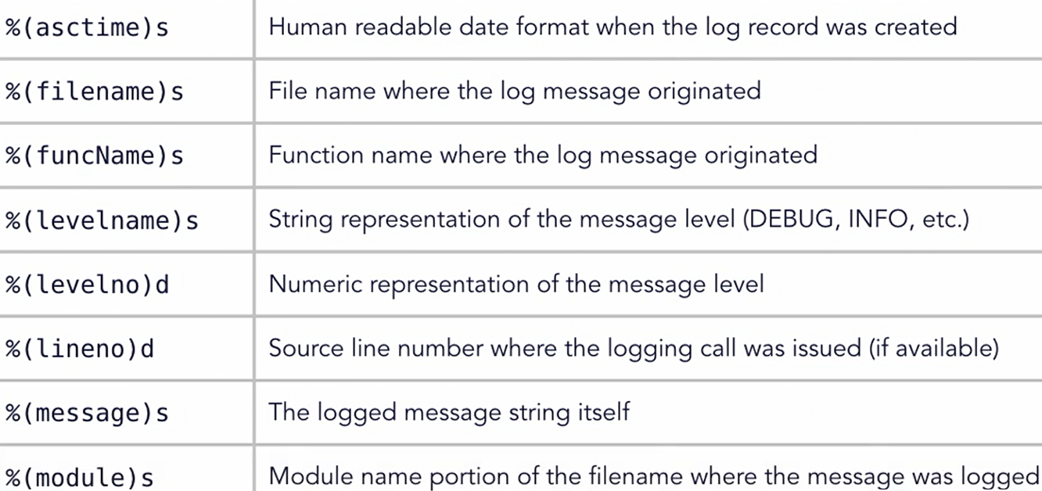
dept = []
dept.append(Employee(5, 9)); dept.append(Employee(4, 12))
dept.append(Employee(6, 6)); dept.append(Employee(5, 13))

print(bool(dept[0] > dept[1])) # True # Who's more senior?
print(bool(dept[3] < dept[2])) # True

emps = sorted(dept) # 4, 5, 5, 6 # sort the items

// 601 Logging Overview // 602 logging module
# use the built-in logging module
import logging

# Use basicConfig to configure logging
# this is only executed once, subsequent calls to
# basicConfig will have no effect
logging.basicConfig(level=logging.DEBUG,
filemode="w",
filename="output.log")

logging.debug("This is a debug-level log message")
logging.info("This is an info-level log message")
logging.warning("This is a warning-level message")
logging.error("This is an error-level message")
logging.critical("This is a critical-level message")

# Output formatted string to the log
logging.info("Here's a {} variable and an int: {}".format("string", 10))

# Above code writes logs to file at root folder location as :
# output.log

DEBUG:root:This is a debug-level log message
INFO:root:This is an info-level log message
WARNING:root:This is a warning-level message
ERROR:root:This is an error-level message
CRITICAL:root:This is a critical-level message
INFO:root:Here's a string variable and an int: 10
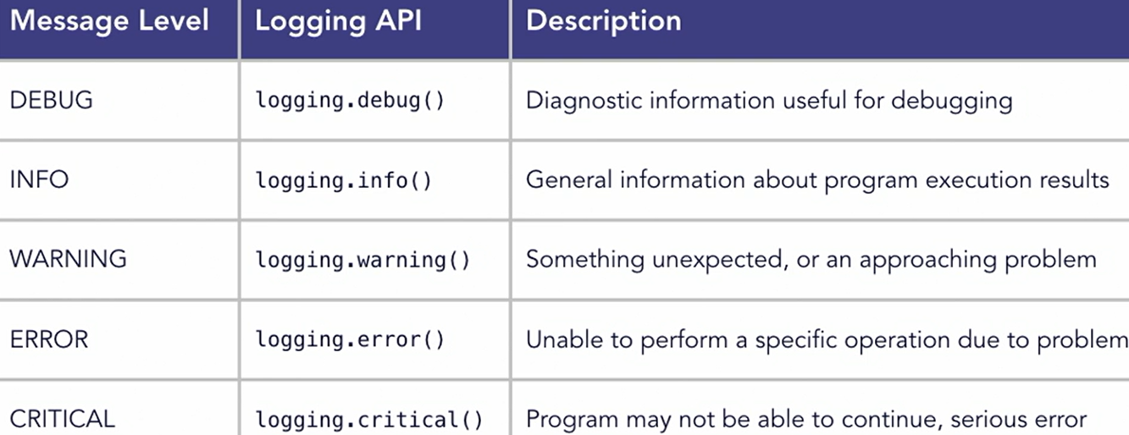

// 603 Custom logging

extData = {'user': 'joem@example.com'}
# use a custom formatting specification
fmtStr = "%(asctime)s: %(levelname)s: %(funcName)s Line:%(lineno)d User:%(user)s %(message)s"
dateStr = "%m/%d/%Y %I:%M:%S %p"
logging.basicConfig(filename="output.log",
level=logging.DEBUG, format=fmtStr, datefmt=dateStr)

logging.info("This is an info-level log message", extra=extData)
logging.warning("This is a warning-level message", extra=extData)

# Above code writes logs to file at root folder location as :
# output.log
05/01/2024 05:11:20 PM: INFO: main Line:18 User:joem@example.com This is an info-level log message
05/01/2024 05:11:20 PM: WARNING: main Line:19 User:joem@example.com This is a warning-level message

// 701 Comprehensions
Comprehensions are simplification for code using list & map

Example:
list ( map ( fahrenheit_to_celsius, [ 32, 34, 36] )
TO
[ ( t * 9/5 ) + 32 for t in [ 32, 34, 36 ] ]

The smaller syntax for loop is comprehension
It can be used to create list, dictionaries and sets also

// 702 List comprehensions
evens = [2, 4, 6, 8, 10, 12, 14, 16, 18, 20]; count = 'even => '
even_a = list(
map(lambda e: count + str(e), filter(
lambda e: e > 0 and e < 16, evens)))
print(even_a)
# Derive new list of numbers using comprehensions
even_b = [count + str(e) for e in evens if e > 0 and e < 16]
print(even_b) # even_a == even_b
// 703 Dictionary comprehensions
# define a list of temperature values
ctemps = [0, 12, 34, 100]
# Use a comprehension to build a dictionary
tempDict = {t: (t * 9/5) + 32 for t in ctemps if t < 100}
print(tempDict) # {0: 32.0, 12: 53.6, 34: 93.2}
print(tempDict[12]) # 53.6

# Merge two dictionaries with a comprehension
team1 = {"Jones": 24, "Jameson": 18, "Smith": 58, "Burns": 7}
team2 = {"White": 12, "Macke": 88, "Perce": 4}
newTeam = {k: v for team in (team1, team2) for k, v in team.items()}
print(newTeam)
# {'Jones': 24, 'Jameson': 18, 'Smith': 58, 'Burns': 7, 'White': 12, 'Macke': 88, 'Perce': 4}

# from py 3.9
newTeam = team1 | team2; print(newTeam)
# {'Jones': 24, 'Jameson': 18, 'Smith': 58, 'Burns': 7, 'White': 12, 'Macke': 88, 'Perce': 4}

newTeam = { **team1, **team2 } # from py 3.5

// 704 Set comprehensions
# Set used to contain unique value in curly braces format
ctemps = [5, 10, 12, 14, 10, 23, 41, 30, 12, 24, 12, 18, 29]

# build a set of unique Fahrenheit temperatures
ftemps_set = {(t * 9/5) + 32 for t in ctemps}
print(ftemps_set) # {64.4, 73.4, 41.0, 105.8, … }

# build a set from an input source
sTemp = "The quick brown fox jumped over the lazy dog"
chars_set = {c.upper() for c in sTemp if not c.isspace()}
print(chars_set) # {'M', 'W', 'T', 'C', 'V', 'E', 'J', 'O', ….. }

miss_list = [a for a in string.ascii_uppercase
if a not in chars_set]
print(miss_list) # [‘S’]

Lyn: Python Data Analysis [ Michele Vallisneri ] // skipped

// 201 Install Anaconda
It includes: python, numpy, pandas, matplotlib
Anaconda is an open-source distribution of the Python and R programming languages for data science that aims to simplify package management and deployment. Package versions in Anaconda are managed by the package management system, conda, which analyzes the current environment before executing an installation to avoid disrupting other frameworks and packages

The Anaconda distribution comes with over 250 packages automatically installed
https://www.anaconda.com/pricing

// 103 Working with Jupyter Notebook
From anaconda navigator
Find Jupyter app on home
Click launch
Create new notebook
Type you code to execute
Press Shift + Enter to execute

To write any comment, from drop-down
Select Markdown

copy command as: Esc + c
cut command as: Esc + x
paste command as: Esc + v
delete a cell: d + d
You can use menus as well

// 105 py in cloud via azure notebooks
// 201 Warmup with loops
Loop needs interables such as:
list, dic, set, interator or generators
import math
import collections

import numpy as np
import pandas as pd
import matplotlib.pyplot as pp

// 202 Sequence
List, tuple and slicing syntax
nephews = ["Huey", "Dewey", "Louie"]
nephews[-1] // “Louie”
nephews[-2] // “Dewey”

.append, .extend, .insert, .remove, +, .sort, sorted reverse
nephews.extend([‘a’, ‘b’]) // Extend to insert multiple

nephews.insert(0, ‘aa’) // insert ‘aa’ on position 0 index
del nephews[0]

ducks = nephews + ['e','f] // add and return

reverse_ducks = sorted(ducks, reverse=True)
// reverse means descending order

sq = [1,4,9,16,25,36,49]
sq[0:2] // 1, 4 // start at 0 and end at 2
sq[:4] // 1,4,9,16 // start at 0 and end at 4
sq[:] // copy full list
sq[0:7:2] // 1,0,25,49 // skip 2
sq[-3:-1] // 25,36 // starts from -3 and ends -1

sq[2:4] = ['four', 'nine'] // replace using slicing index
print(sq) // [1, 4, 'four', 'nine', 25, 36, 49]

del sq[4:6]
print(sq) // [1, 4, 'four', 'nine', 49]

Tuples are immutable collections of variables, so they can't be changed after creation. Sets are mutable collections of variables, so sets can be changed after creation.

List | Set | Tuple
Lists is Mutable | Set is Mutable | Tuple is Immutable
It is Ordered collection of items | It is Unordered collection of items | It is Ordered collection of items
Items in list can be replaced or changed | Items in set cannot be changed or replaced but you can remove and add new items. | Items in tuple cannot be changed or replaced
print(set_a[1]) // TypeError 'set' object is not subscriptable
tuple_a[1] = 0 // TypeError: 'tuple' object does not support item assignment
====== ====== ======
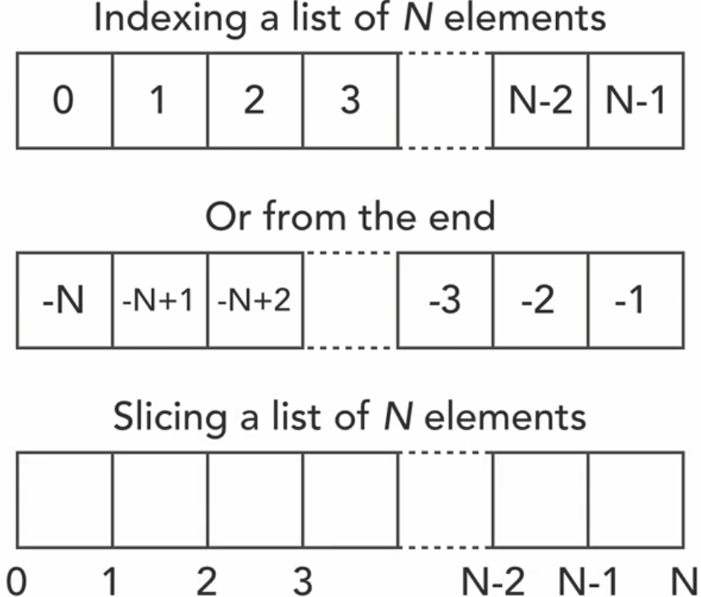
Variable assignation using tuple
(a,b) = (1, 2)
c, d = 3, 4
print(a,b,c,d) // 1, 2, 3, 4
====== ====== ======
def three_args(a, b, c): print(a, b, c)
my_args = (1,2,3); three_args(*my_args)

// 203 Dictionaries and sets
caps = { ‘A’: ‘a_val’, ‘B’: ‘b_val’, ‘C’: ‘c_val’ }# Dictionaries
morecaps = { ‘D’: ‘d_val’, ‘E’: ‘e_val’ }
print(‘A’ in caps) # True

caps + morecaps # TypeError: unsupported

caps.update(morecaps) # add morecaps to caps dict
del caps[‘E’] # delete item from caps dict

for k, v in caps.items(): print(k, v)
# A, a_val B, b_val C, c_val ….

caps.values() # dict_values([‘a_val’,’b_val’,’c_val ….
caps.keys() # dict_values([‘A’,’B’,’C’, ….

Note: The keys in dict can be any type
birthdays = {(7,15): 'Michele', (3,14): 'Albert'}
print(birthdays[(7,15)]) # ‘Michele’

b_dict = { hash(3): 'abc' }
print(b_dict[hash(3)]) # abc

Sets:
a_set = {'America', 'Europe', 'Asia', 'Oceania', 'Africa', 'Africa'}

print('Africa' in continents) # True

Other methods in set:
clear, copy, difference, intersection, issubset, issuperset,
symmetric_difference, union, update, discard, …

a_set.add('Antarctica')
a_set.remove('Antarctica')

list methods: w3schools
set methods: w3schools
tuple methods: w3schools
dict methods: w3schools
string methods: w3schools
file methods: w3schools
python keywords: w3schools
py exceptions: w3schools
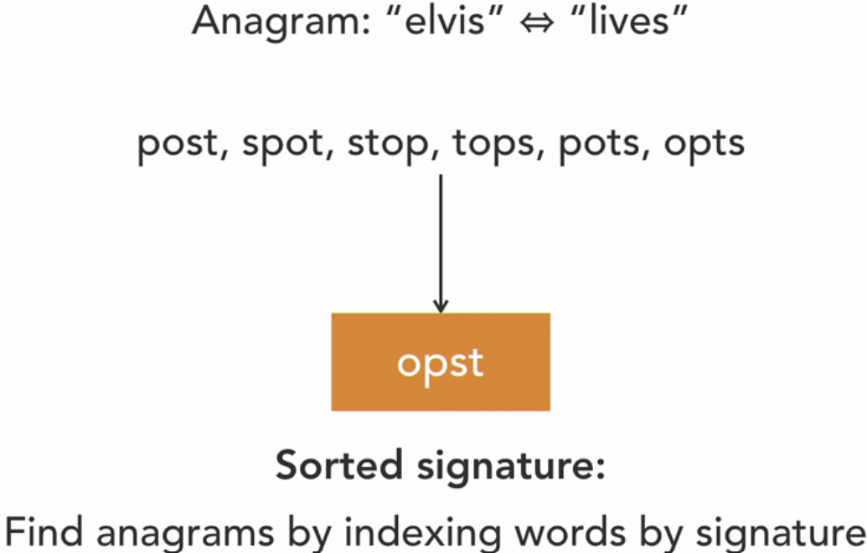
// 204 Comprehensions
[i**2 for i in range(1, 11) if i**2 % 4 == 0]
# [4, 16, 36, 64, 100] // values divisible by 4

sum(i**2 for i in range(1, 11)) # sum squares 1^2 to 10^2

# nested comprehension
counting = [ j for i in range(1, 11) for j in range(1, i+1) ]

// 205 Advance python containers
ptype = collections.namedtuple('p', ['fn’, 'ln', "b"])
a_ptype = ptype(‘a’,’b’,’c’)
type(a_ptype) # __main__.ptype
isinstance(a_ptype, ptype) # True
print(a_ptype) # p(fn=’a’, ln=’b’, b=’c’)

b_ptype = ptype(fn=’ba’, ln=’bb’, b=’bc’)
print(b_ptype) # p(fn=’ba’, ln=’bb’, b=’bc’ )
print(b_ptype.ln) # bb

ps = [("a1", "b1", "c1"), ("a2", "b2", "c2"),
("a3", "b3", "c3"), ("a4", "b4", "c4")]
c_ptype = ptype(*ps[0])
print(c_ptype) # p(fn=’a1’, ln=’b1’, b=’c1’ )

d_ptype = [p(*i) for i in ps]; print(d_ptype)
# [p(fn=’a1’, ln=’b1’, b=’c1’ ), p(fn=’a2’, ln=’b2’, b=’c2’ ), p(fn=’a3’, ln=’b3’, b=’c3’ ), p(fn=’a4’, ln=’b4’, b=’c4’ ) ]

====== ====== ======
def anynamefunc(): return ‘i don know’
q = collections.defaultdict(anynamefunc)
q['The meaning of life']
q['new life']
print(q)
# defaultdict(<function __main__.anynamefunc()>,
{'The meaning of life': ‘i don know’,
'new life': ‘i don know’})

====== ====== ======
from dataclasses import dataclass
@dataclass
class pclass: fn: str; ln: str; b: str = 'unknown'

a_pclass = pclass(‘a1’,’b1’)
print(a_plass) # pclass(fn=’a1’,ln=’b1’,b=’unknown’)

// 301 Anagrams
Anagrams means finding possible words our of given characters. For Example:
From 2 characters o and n, we can make on and no

// 202 Loading text from file
words = sorted({
line.strip().lower() for line in open('words.txt', 'r') })
// 203 Finding anagrams
sorted("elvis") == sorted("lives") # True
====== ====== ======

Lyn: Advanced Python Working with Databases

// 201 A

// 202 A

// 203 A

// 204 A

// 05 A

// 06 A

// 201 A

// 202 A

// 203 A

// 204 A

// 05 A

// 06 A

// 201 A

// 202 A

// 203 A

// 204 A

// 05 A

// 06 A

// 201 A

// 202 A

// 203 A

// 204 A

// 05 A

// 06 A

// 201 A

// 202 A

// 203 A

// 204 A

// 05 A

// 06 A

// 201 A

// 202 A

// 203 A

// 204 A

// 05 A

// 06 A

// 201 A

// 202 A

// 203 A

// 204 A

// 05 A

// 06 A

// 201 A

// 202 A

// 203 A

// 204 A

// 05 A

// 06 A

Lyn: Python Design Patterns

// 201 A

// 202 A

// 203 A

// 204 A

// 05 A

// 06 A

// 201 A

// 202 A

// 203 A

// 204 A

// 05 A

// 06 A

// 201 A

// 202 A

// 203 A

// 204 A

// 05 A

// 06 A

// 201 A

// 202 A

// 203 A

// 204 A

// 05 A

// 06 A

// 201 A

// 202 A

// 203 A

// 204 A

// 05 A

// 06 A

// 201 A

// 202 A

// 203 A

// 204 A

// 05 A

// 06 A

// 201 A

// 202 A

// 203 A

// 204 A

// 05 A

// 06 A

// 201 A

// 202 A

// 203 A

// 204 A

// 05 A

// 06 A

Lyn: Python Advanced Design Patterns

// 201 A

// 202 A

// 203 A

// 204 A

// 05 A

// 06 A

// 201 A

// 202 A

// 203 A

// 204 A

// 05 A

// 06 A

// 201 A

// 202 A

// 203 A

// 204 A

// 05 A

// 06 A

// 201 A

// 202 A

// 203 A

// 204 A

// 05 A

// 06 A

// 201 A

// 202 A

// 203 A

// 204 A

// 05 A

// 06 A

// 201 A

// 202 A

// 203 A

// 204 A

// 05 A

// 06 A

// 201 A

// 202 A

// 203 A

// 204 A

// 05 A

// 06 A

// 201 A

// 202 A

// 203 A

// 204 A

// 05 A

// 06 A

