Index
- Lyn: 2019: Python XML, JSON, and the Web
- 8

Lyn: Python XML, JSON, and the Web [ Joe Marini ]
// 104 Internet Protocol and Support – py docs
Native py standard libs:
urllib: work with request, error, parse, robotparser
http: client, server, cookies, cookiejar
json: dump stream of data
xml:
Third party:
lxml: feature rich xml and html
requests: simple api request data handling

// 105 httpbin to test api httpbin.org # loopback
// 201 urllib
- Request: Opening and reading of urls
- Error raised by request
- Parse url structure
- Robot parser for robot.txt files
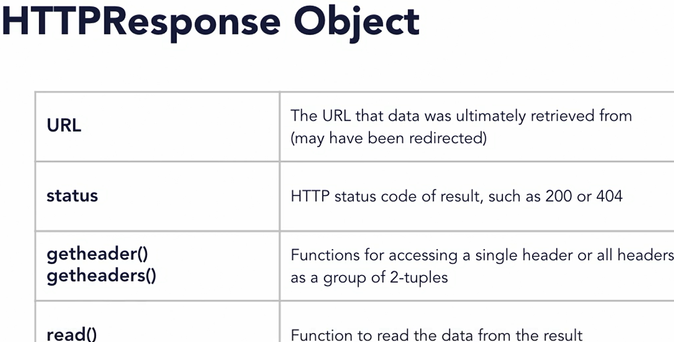
res = urllib.request.urlopen(url, data=None, [timeout, ... ], … )

// 202 Retrieve data
import urllib.request; url = "http://httpbin.org/xml"
res.getheaders(); res.read().decode("utf-8")

// 203 Send Data
# create some data to pass to the GET request
args = { "name" : "Joe Marini", "is_author" : True }
# url-encoded data before passing as arguments
data = urllib.parse.urlencode(args)
# issue the request with the data params as part of the URL
# result = urllib.request.urlopen(url + "?" + data)
# issue the request with a data parameter to use POST
url = http://httpbin.org/post; data = data.encode()
result = urllib.request.urlopen(url, data=data)
// 204 Error Handling
from urllib.error import HTTPError, URLError
from http import HTTPStatus
# use exception handling to attempt the URL access
try: result = urllib.request.urlopen(url)
print("Result code: {0}".format(result.status))
if (result.getcode() == HTTPStatus.OK):
print(result.read())
# occurs when the server returns a non-success error code
except HTTPError as err:
print("Error: {0}".format(err.code))
# occurs when something is wrong with the URL itself
except URLError as err:
print("Yeah, that server is bunk. {0}".format(err.reason))

// 205 Drawback of urllib
- Only support a subset of HTTP by default
- Not support patch, delete methods
- Doesn’t auto decode returned data
- No build in features for cookies, session, auth
- Require extra more modules
- Difficult to implement advanced features such as timeouts
- Processing json is cumbersome

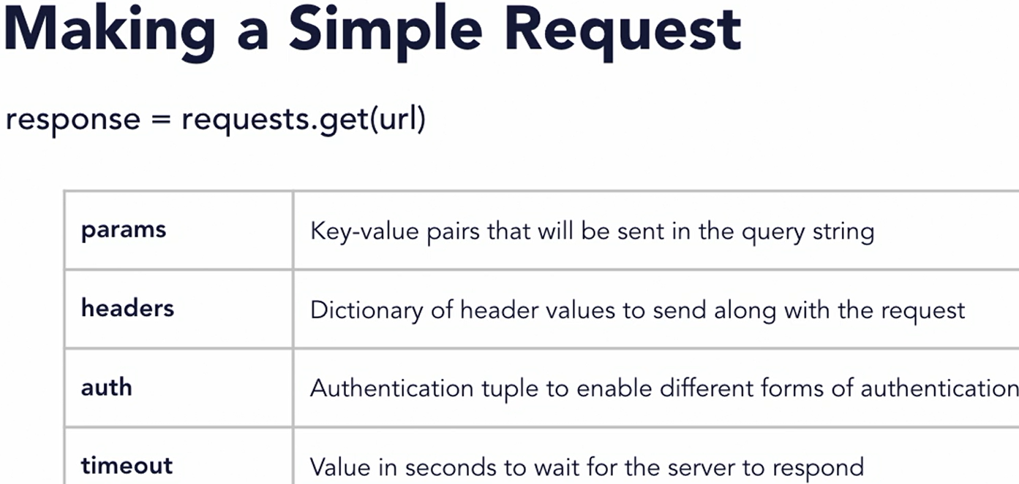

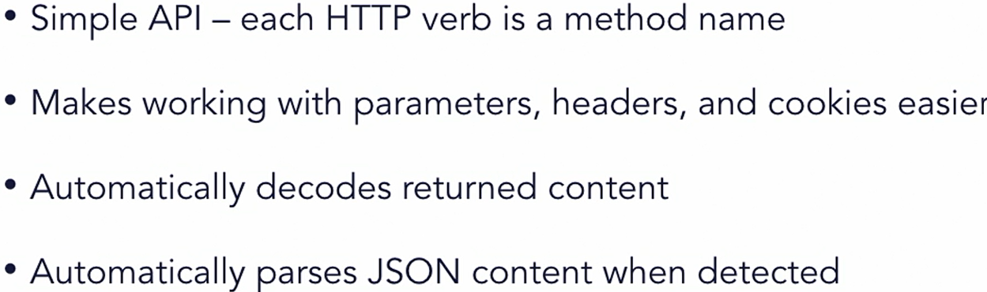
// 301 Request library

// 302 Send data - retrieve
import requests
def main():
result = requests.get(xml_url); printResults(result)
# Send some parameters to the URL via a GET request
dataValues = { 'key1' : 'value1', 'key2' : 'value2' }
result = requests.get(get_url, params=dataValues)
# result = requests.post(post_url, data=dataValues)
printResults(result)

# Pass a custom header to the server
headerValues = { 'User-Agent' : 'Joe Marini App / 1.0.0' }
result = requests.get(get_url, headers=headerValues)
printResults(result)
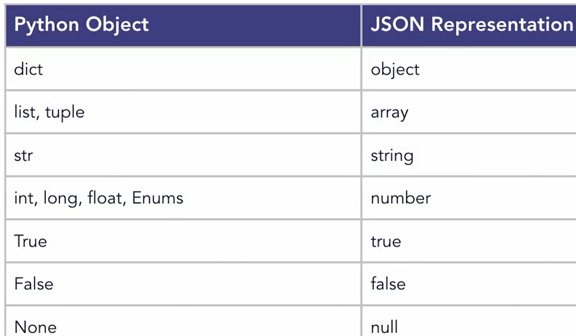
xml_url = "http://httpbin.org/xml"
get_url = "http://httpbin.org/get"
post_url = “http://httpbin.org/post”

print("Result code: {0}".format(resData.status_code))
print(resData.headers)
print("Returned data: ----------------------", resData.text)

// 303 Request error handling
import requests
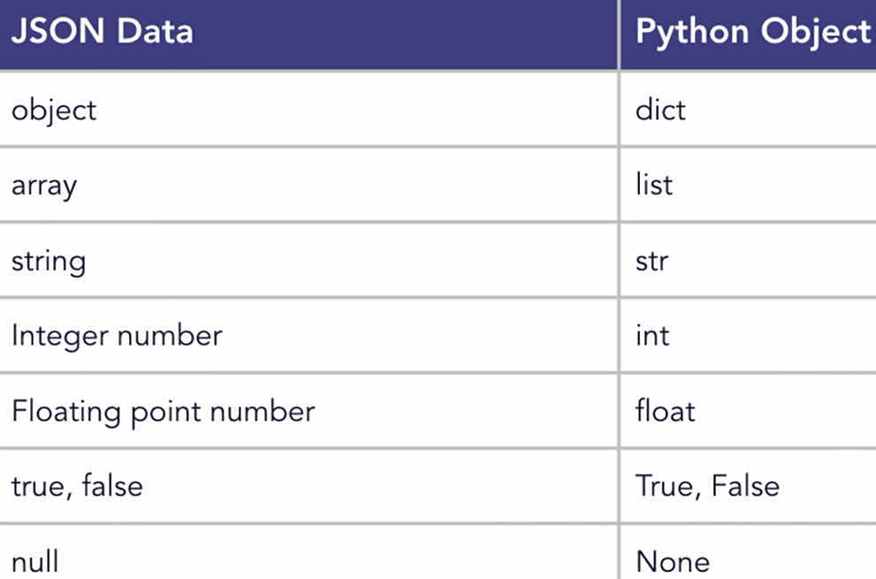
from requests.exceptions import HTTPError, Timeout
try:
url = "http://httpbin.org/status/404"
#url = "http://httpbin.org/delay/5"
result = requests.get(url, timeout=2)
# raise_for_status will throw an exception if an HTTP error
# code was returned as part of the response
result.raise_for_status()
printResults(result)
except HTTPError as err:
print("Error: {0}".format(err))
except Timeout as err:
print("Request timed out: {0}".format(err))

// 304 Using Authentication
from requests.auth import HTTPBasicAuth
# Access a URL that requires authentication - the format of this URL is that you provide the username/password to auth against
url = "http://httpbin.org/basic-auth/JoeMarini/MySecretWord"

# Create a credentials object using HTTPBasicAuth
myCreds = HTTPBasicAuth('JoeMarini', 'MySecretWord')

# Issue the request with the authentication credentials
result = requests.get(url, auth=myCreds)
printResults(result)

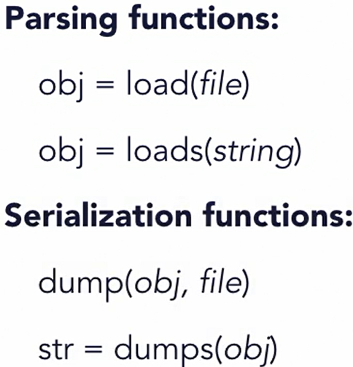
// 401 JSON Module
json.load # read json from file
json.dump # write obj to file as json

# practice what will get convert to what on console

// 402 Parsing _ Serialize JSON
# define a string of JSON code
jsonStr = '''{ "sandwich" : "Reuben", "toasted" : true,
"toppings" : [ "Thousand Island Dressing", "Sauerkraut" ],
"price" : 8.99 }'''

# parse the JSON data using loads
data = json.loads(jsonStr)
# print information from the data structure
print("Sandwich: " + data['sandwich'])

if (data['toasted']): print("And it's toasted!")
for topping in data['toppings']: print("Topping: " + topping)
------ ------ ------
# define a python dictionary to serialize to JSON using dump
pythonData = {
"sandwich": "Reuben",
"toasted": True,
"toppings": ["Thousand Island Dressing", "Sauerkraut" ],
"price": 8.99 }

# serialize to JSON using dumps
jsonStr = json.dumps(pythonData, indent=4)

# print the resulting JSON string
print("JSON Data: --------"); print(jsonStr)
// 403 JSON Exception Handling
from json import JSONDecodeError
try: # parse the JSON data using loads
data = json.loads(jsonStr)
# print information from the data structure
print("Sandwich: " + data['sandwich'])
if (data['toasted']): print("And it's toasted!")
for topping in data['toppings']: print("Topping: " + topping)
except JSONDecodeError as err:
print("Whoops, JSON Decoding error:")
print(err.msg); print(err.lineno, err.colno)

// 404 Request JSON
url = "http://httpbin.org/json"
result = requests.get(url)
# Use the built-in JSON function to return parsed data
dataobj = result.json()
print(json.dumps(dataobj,indent=4))
# Access data in the python object
print(list(dataobj.keys()))
print(dataobj['slideshow']['title'])
print("There are {0} slides".format( len(dataobj['slideshow']['slides'])) )

// 501 XML parsing models // 502 SAX API
// 503 XML SAX Module # skipped
// 601 XML Dom // 602 XML DOM minidom
// 603 Element Tree API // 604 Using LXML
// skipped xml as it has limited use for us
// 701 Next
Learning Python GUI Programming
Python Data Analysis

Lyn: TypeScrg
https://catalog.workshops.aws/stepfunctions/en-US

// 201 A

// 202 A

// 203 A

// 204 A

// 05 A

// 06 A

// 201 A

// 202 A

// 203 A

// 204 A

// 05 A

// 06 A

// 201 A

// 202 A

// 203 A

// 204 A

// 05 A

// 06 A

// 201 A

// 202 A

// 203 A

// 204 A

// 05 A

// 06 A

// 201 A

// 202 A

// 203 A

// 204 A

// 05 A

// 06 A

// 201 A

// 202 A

// 203 A

// 204 A

// 05 A

// 06 A

// 201 A

// 202 A

// 203 A

// 204 A

// 05 A

// 06 A

// 201 A

// 202 A

// 203 A

// 204 A

// 05 A

// 06 A

