Index
- Lyn: 2019: Python for JS Developers
- Lyn: 2019: Python Quick Start
- Lyn: 2019: Learning Python
- Lyn: Python for Students
- Lyn: 2017 Python Essential Training
- Lyn: 2020 Python Object-Oriented Programming

- Lyn: 2019 Python Essential Libraries
- Lyn: 2019 Learning the Python 3 Standard Library
- Lyn: 2019 Python Standard Library Essential Training

- 8

Lyn: Python for JS Developers
// 002 What you should know
JS oops
Lyn: Learning Python
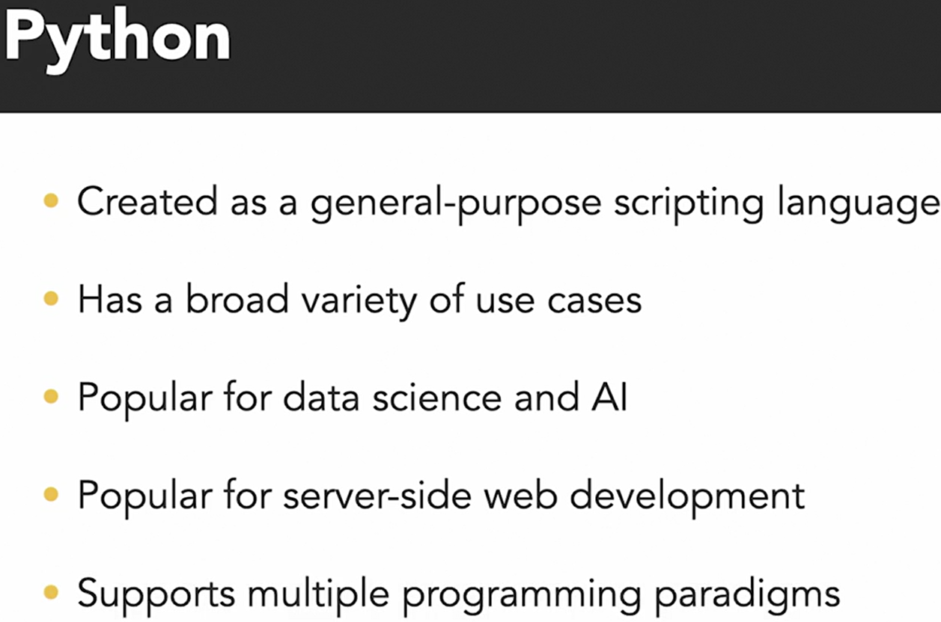
// 101 Compare Python to JS universe
Python, refer to CPython interpreter mostly by people
There are other interpreter / implementations of Python also.

// 102 Setting up env Python pip, pipenv
venv : it is a tools comes with python for creating virtual environment. In python, it is considered best practice to manage dependencies during project development.
https://docs.python.org/3/library/venv.html
https://docs.python.org/3/tutorial/venv.html

There are other dependencies manage tools available also for python. pipenv is a Python virtualenv management tool that supports a multitude of systems and nicely bridges the gaps between pip, python (using system python, pyenv or asdf) and virtualenv. Linux, macOS, and Windows are all first-class citizens in pipenv.
https://pypi.org/project/pipenv/

To create virtual env on project level using venv
python -m venv <name-of-env>
For our example, we used
python -m venv venv
// the name of vitual environment could be any
To activate created environment
Linux/Mac: source venv/bin/activate
Windows: ./<name-of-env>/Scripts/activate

Command line will change to
(<name-of-env>) …. $
To deactivate when it is running, run
deactivate

Install dependencies at project root folder
Keep all in <any-name>.txt
For example:
pytz==2020.4
sqlparse==0.4.1
And run from cmd when virtual env is activated:
- pip install -r <name-of-dependencies-list-file>.txt

Once completed install, final message will be:
- Successfully installed

// 103 Common ways of running python program
From cmd
As a web server
Using Jypyter Notebook

To run a simple python script
- python index-script.py

// 104 Debug python with ipdb
pdb — The Python Inbuild Debugger, is a part of Python's standard library.
https://docs.python.org/3/library/pdb.html

Other most used external package for debug:
ipdb exports functions to access the IPython debugger, which features tab completion, syntax highlighting, better tracebacks, better introspection with the same interface as the pdb module.
https://www.geeksforgeeks.org/using-ipdb-to-debug-python-code/
https://pypi.org/project/ipdb/

While code stops at breakpoint, we can type variable name for which we need see value for. Also we can use tab to auto-fill variable name.
import ipdb; ipdb.set_trace()
Shortcuts while in debug mode with ipdb
ll // (double small L) to show more code on breakpoint
next n // Execute the current line and move to the next one
step s // Step into the function call on the current line
continue c
// Continue execution until the next breakpoint or the end of the program
print p // Print the value of a variable
quit q // Quit the debugger

ipdb features
- Fully compatible with PDB
- Additional features such as post-mortem debugging and the ability to set breakpoints at specific columns.
- Syntax highlighting
- Tab-completion.
- Allows you to customize the way that your debugger display looks

//Extras
String template
return f"Hi {name}!" // filling name in string

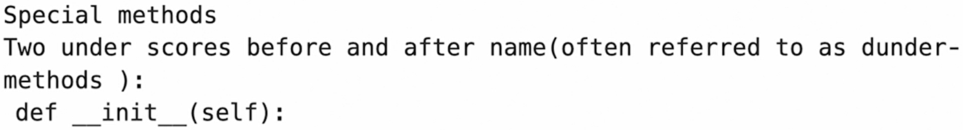
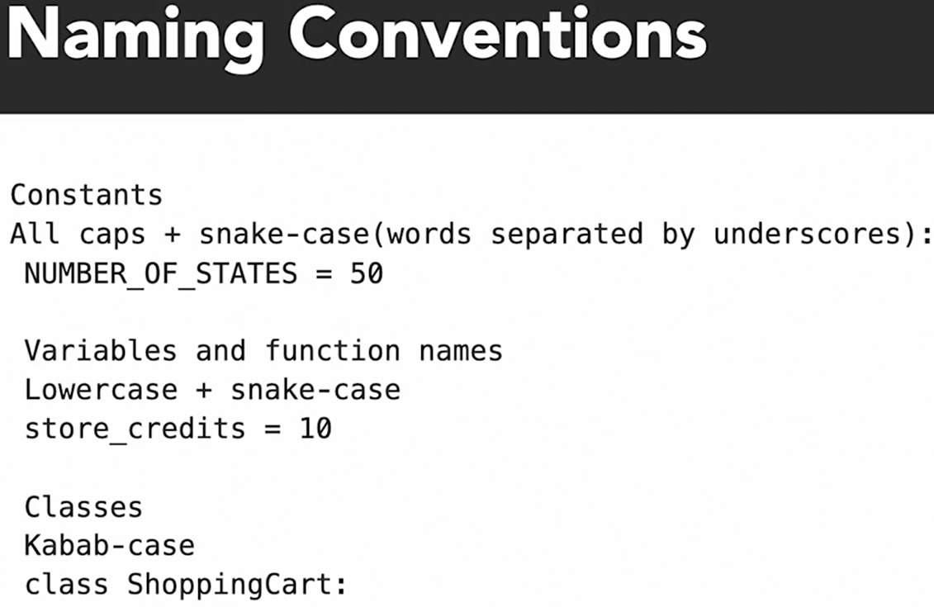
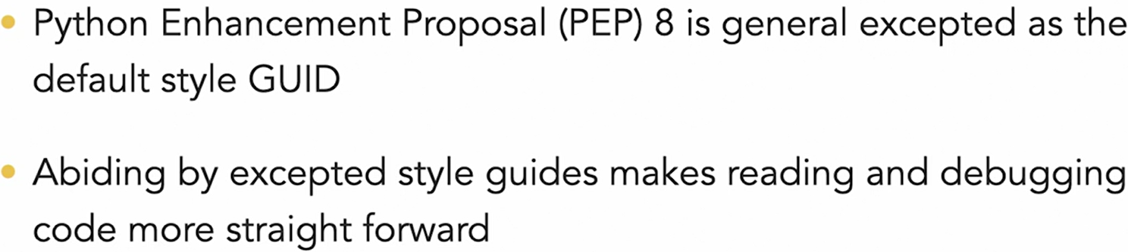
// 201 Why style is crucial

// 202 Numbers and Decimal types
from decimal import Decimal
unexpected = 0.2 + 0.1
expected = Decimal("0.2") + Decimal("0.1")
print(f"float 0.2 + 0.1 = {unexpected}")
print(f"decimal Decimal('0.2') + Decimal('0.1') = {expected}")

>output
float 0.2 + 0.1 = 0.30000000000000004
decimal Decimal('0.2') + Decimal('0.1') = 0.3

This is same behaviour to java script output.

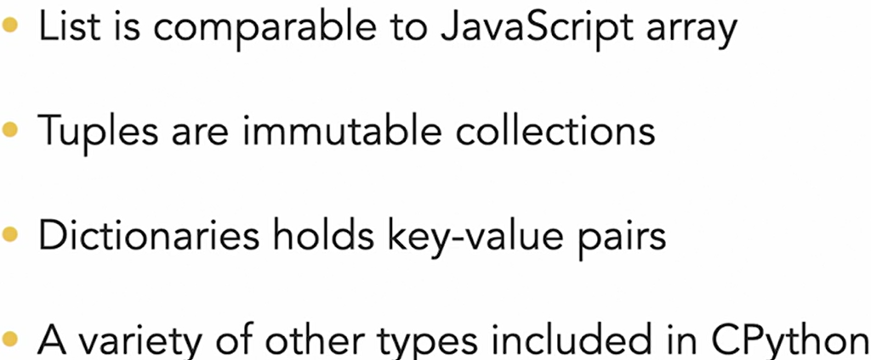
// 203 Migrating from array to python tuples, dict and list
* lists may be modified
* tuples are leaner and immutable
List Example:
names = ["Ronnie", "Mona", "Jack"]
names[2] = "Fred"
print(names)
result = 1 in [1, 2, 3, 4, 5] # True
print(result)
Tuple Example:
names_tuple = (
"Ronnie",
"Mona",
"Jack",
)
# Tuple cannot be changed once defined, does not support item assignment
# Below line will result in an error, because not changeable
names_tuple[2] = "Fred"

Dictionary Example:
names_age_dictionary = {"Jack": 20, "Jill": 21, "Hill": 1000}
print(names_age_dictionary["Jill"])
print(names_age_dictionary["Hill"])

// 204 Working with strings
NAME = "Ronnie"
greet = f"Hi {NAME}!"
formal_greet = greet.replace("Hi", "Greetings")
string_contains_name = NAME in greet # True
string_starts_with_hi = greet.startswith("Hi") # True
string_ends_with_hi = greet.endswith("Hi") # False

print("greet :", greet)
print("formal_greet :", formal_greet)
print("string_contains_name :", string_contains_name)
print("string_starts_with_hi :", string_starts_with_hi)
print("string_ends_with_hi :", string_ends_with_hi)

// output
greet : Hi Ronnie!
formal_greet : Greetings Ronnie!
string_contains_name : True
string_starts_with_hi : True
string_ends_with_hi : False

// 205 Python Slices like js array slice
AGES = [22, 82, 45, 100]
first_item = AGES[0] # 22
last_item = AGES[-1] # 100
first_two_items = AGES[:2] # [22, 82]
last_two_items = AGES[2:] # [45, 100]
middle_items = AGES[1:3] # [82, 45]
total = sum(AGES) # 249
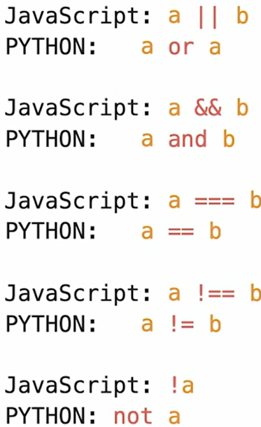
// 301 Using colon instead of braces for func


// 302 Control Flow
// 303 How loop differ Python vs JS
my_list = [1, 2, 3]; i = 0
while i < len(my_list): print(my_list[i]); i += 1

print("\nfor loop")
for i in my_list: print(i)

// 304 Try except in Python vs Try Catch in JS
# geeksforgeeks.org/try-except-else-and-finally-in-python

try: print(F”error in variable {corrupt_var_name} “)

except KeyError: print(“error”)
except Exception as e: print(“global exception handler”)

else: # execute if no exception

finally: # always execute at last

// 305 Loop on Dict
FRIENDS = [
{"name": "Graham"},
{"name": "John"},
{"name": "Michael"}
] # Members of Monty Python comedy troupe!

for friend in FRIENDS:
if "a" in friend["name"]: print(f"Hey {friend['name']}!")

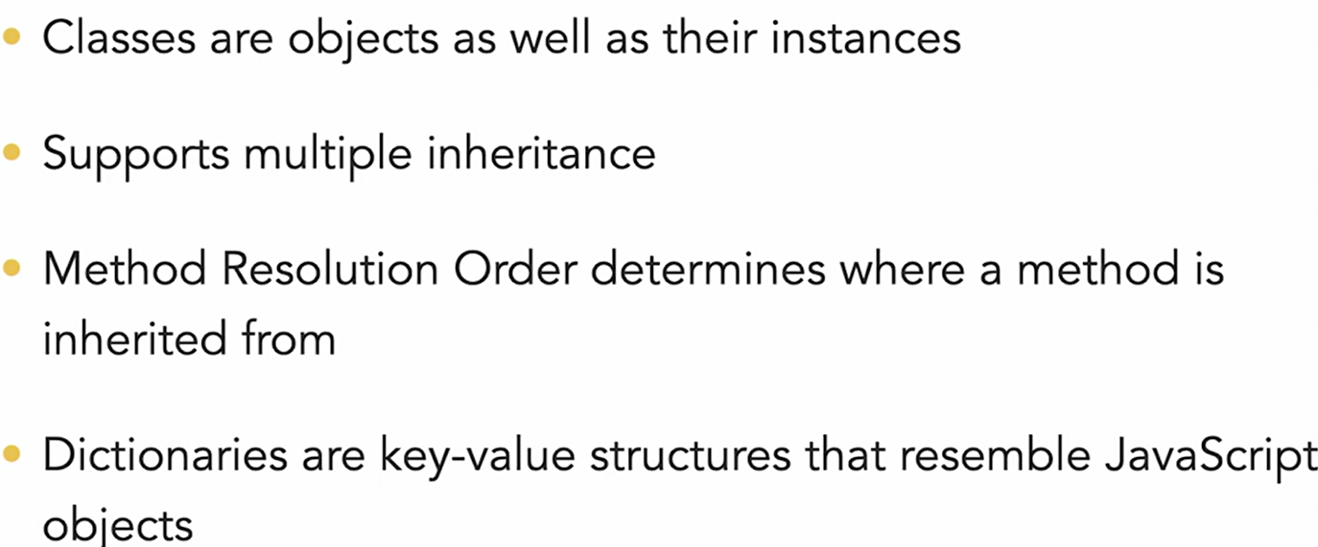
// 401 Classes, Objects, Inheritance in Python

// 402 Class definition in Python
class Soup: #Kabab Casing
def __init__(self, name="Optional-with-default-value"):
self.name = name
self.veggies = ["tomatoes", "onions"]
def print_veggies(self):
print(f"{self.name} soup with: ")
for veggie in self.veggies:
print(f"* {veggie}")
soup_instance = Soup("ExSoup") # Creating Obj
soup_instance.print_veggies()
Soup().print_veggies() # Call without instance
# Output after run as:
ExSoup soup with:
* tomatoes
* onions
Optional-with-default-value soup with:
* tomatoes
* onions

// 403 Super powers with Data Model
Methods name begins and ends with two under-scores
Example: __init__
These are special methods or dunder methods. Are powerful API that lets us interact with Python interpreter

# Dunder is short-form for double under scores
class Toppings:
def __init__(self):
self.items = ["tomato sauce", "peppers", "olives"]
def __len__(self):
# Extended global python interpreter func behaviour for this class instance
return len(self.items)

class Dough:
def __add__(self, other):
if type(other) == Toppings:
print("Did someone say pizza 🍕🍕🍕")

dough = Dough()
toppings = Toppings()
print(f"There are {len(toppings)} toppings.")
dough + toppings

# Output after run as:
There are 3 toppings:
Did someone say pizza 🍕🍕🍕

// 404 Inheritance and Mixins
Mixin Pattern:
- Straightforward way to compose classes
- Adheres to DRY (don’t repeat yourself)

# passing context to class
OR
# making an extended class
class VeggieSoup(VeggieMixin, SoupMixin, FoodMixin):
pass

# Here pass context to FoodMixin with context from
# VeggieMixin and SourMixin
# Created new class VeggieSoup with final mixing of all three
import time
class VeggieMixin:
veggies = ["tomatoes", "onions", "carrots", "brocholi"]
class SoupMixin:
temprature = "199.4°F"
water_percentage = 50
cooking_time = 1
class SaladMixin:
temprature = "41.0°F"
water_percentage = 0
cooking_time = 0
class FoodMixin:
def make_food(self):
print(f"Making wait {self.cooking_time} seconds")
time.sleep(self.cooking_time) # time sleep
print(self.water_percentage, " percent water")
print(self.temprature)
class VeggieSoup(VeggieMixin, SoupMixin, FoodMixin):
pass # means no further code for this definition
class VeggieSalad(VeggieMixin, SaladMixin, FoodMixin):
pass # good in case when making wrapper class

VeggieSoup().make_food()
VeggieSalad().make_food()

// 405 Challenge
# Using mixin to achieve code reusability
# Using decorator: @property
class UserMixin:
@property
def data(self):
return [
{"id": 1, "name": "Bill", "store_credits": Decimal("10")}, …, ]

class ListMixin():
def get(self, request, format=None):
return Response(self.data, status=status.HTTP_200_OK)
class ItemListView(APIView, ItemsMixin, ListMixin):
pass
# after it we can use self.data to refer to array returned

// 501 range, zip, getsizeof
zero_to_nine = [0, 1, 2, 3, 4, 5, 6, 7, 8, 9]
for num in zero_to_nine: print(num) # print 0 to 9

from sys import getsizeof
a_range = range(9) # range takes less space in memory
print("a_range size => ", getsizeof(a_range)) # 48
for num in a_range: print(num) # print 0 to 8
a_list = list(a_range)
print("a_list size => ", getsizeof(a_list)) # 136
// 502 Build-in method Python
NAMES = ["Jake", "Jay", "Jim", "Jill"]
AGES = [34, 25, 55, 42]
for name, age in zip(NAMES, AGES):
print(f"{name} => {age}") # Jake => 34
for num in reversed(AGES): print(num)
for num in sorted(AGES): print(num)
print("=====iterating index, name with enumerate=====")
for i, name in enumerate(NAMES):
print(i, name) # 0 Jake

// 503 Build-in Comprehensions Python
import ipdb
ZERO_TO_FOUR = [0, 1, 2, 3, 4]
NEW_LIST = [number + 1 for number in ZERO_TO_FOUR]
FILTER_NEW_LIST = [
number for number in NEW_LIST if number > 2 ]
ipdb.set_trace() # setting breakpoint for debugger
FRIENDS = [ {"name": "Graham"}, {"name": "Eric"},
{"name": "Michael"} ]
NAME_STR = [ friend["name"] for friend in FRIENDS ]
NAMES_WITH_H = [str for str in NAME_STR if "h" in string]
ipdb.set_trace() # setting breakpoint for debugger

// 504 Decorators Python
// Flask python web framework use decorators highly
// Most basic decorator as below:
def add_greet(func):
name = func()
print(f"hey {name}!") # hey Terry!

@add_greet
def get_name(): return "Terry"

// 505 Challenge Map to comprehension
name = “Panku Patri”
name_lower = name.lower() # panku patri

// 601 Other Python Study resources
Lyn: Building a personal portfolio with Django
Lyn: Data Science Foundation Python Scientific Stack
Lyn: Secure Coding in Python

Lyn: 2019: Python Quick Start [ Lavanya Vijayan ]
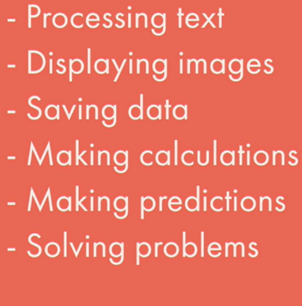
// 101 Python ?

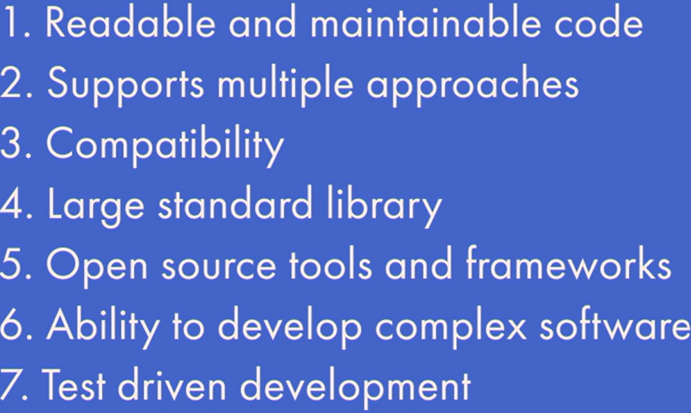
// 102 Why Python

// 201 Setup Python Env
Jupyter Notebook
Anaconda is a distribution of the Python and R programming languages for scientific computing, that aims to simplify package management and deployment. The distribution includes data-science packages suitable for Windows, Linux, and macOS.

// 202 Types in Python
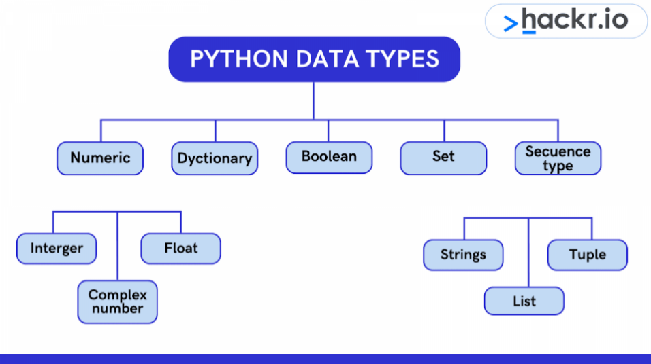

5e10 = 10 * 10 * 10 * 10 * 10
5e-10 = -10 * -10 * -10 * -10 * -10
// 203 Data variables // 301 Functions
// 302 Built-in functions // 303 Define func
// 304 Types of Functions
// 305 Python Modules
calendar is a module in python, which has many useful methods related to calendar
import calendar
cal = calendar.month(2019,7)
print(cal)
https://docs.python.org/3/library/calendar.html
Some other build-in modules:
https://docs.python.org/3/library/datatypes.html
https://docs.python.org/3/library/index.html
import math
res = math.sqrt(49) # 7

Choosing random item from given sequence
import random
watch = random.choice(moviesList)
random.shuffle(moviesList) # shuffle items in sequence
// 401 Sequence Type?
Sequence: Strings, List, Tuple
// 402 Lists // 403 Tuples cannot be modified once defined

// 501 Conditional Statement
ka = “3”; print(type(ka)); na = int(ka); print(type(na));
// 502 If Statement // 503 If-else statement
// 504 if elif if elif else
if x < y: return “x is smaller”
elif x > y: return “y is smaller”
else: return “x and y are equal”
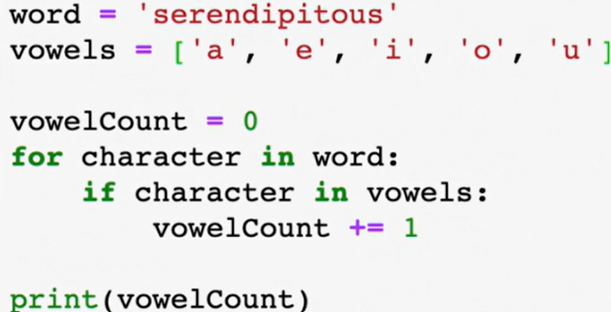
// 601 Iteration

// 602 For loop
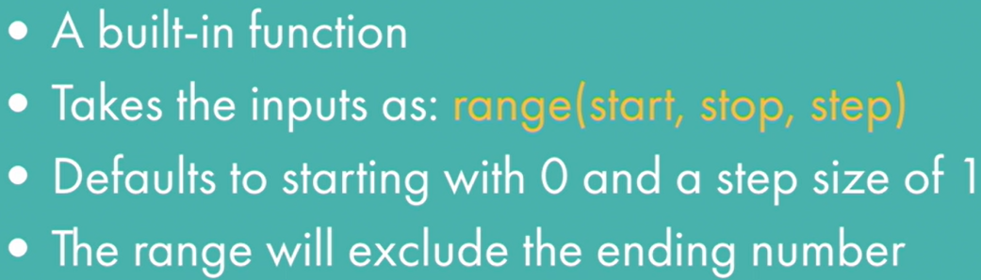
- range
for i in range(1, 8, 2): print(i) # 1 3 5 7

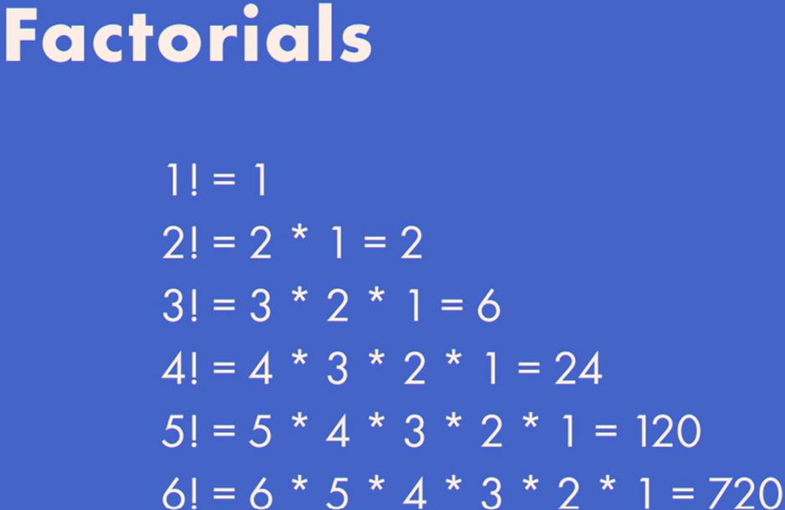
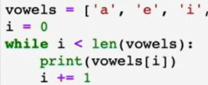
// 603 While

// 701 Recursive Function
def fac(n):
if n == 1: return 1
else: return n* fac( n – 1 )
# factorial math formula n! = n(n-1)(n-2)…. OR n != n (n-1)!

// 702 Define recursive func
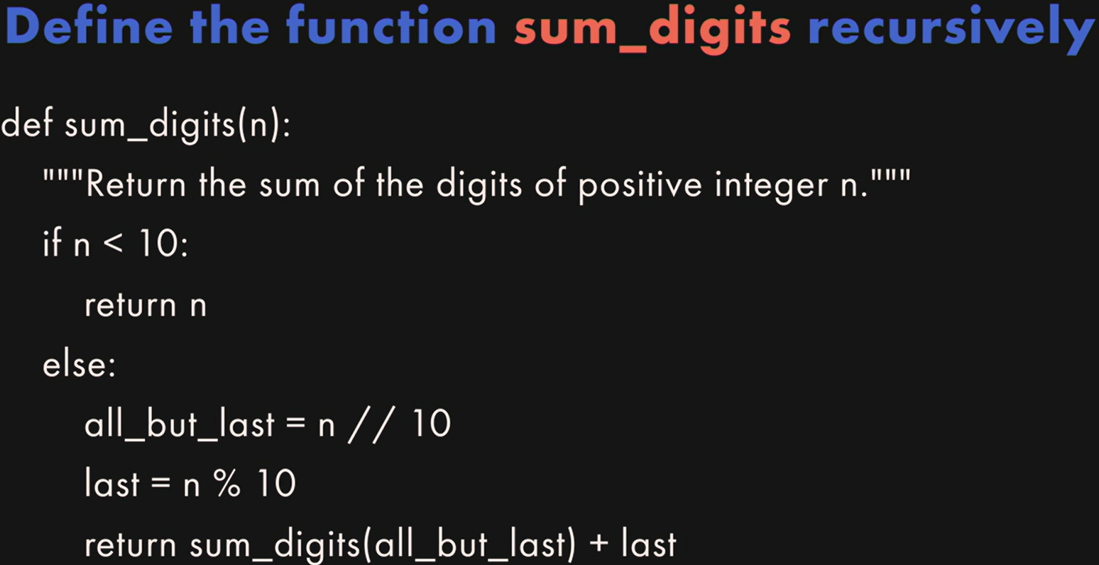
Sum of the digits = sum of all digits before last digit + last digit

Using triple single/double quotes for multi-line string value
my_str = """I \
am \
Geek !"""
- Palindrome or not ?
Words like: mom, k, 5, 121, 1221, etc.
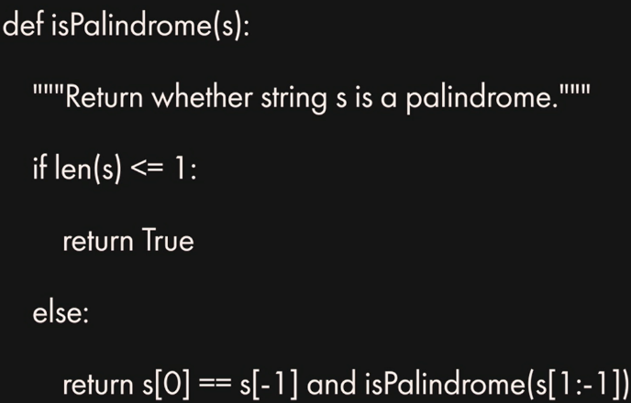
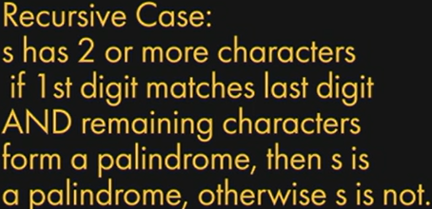

// 801 OOPS

// 901 Next
Lavanya Vijayan – Python & Data Science Instructor

Lyn: 2019: Learning Python

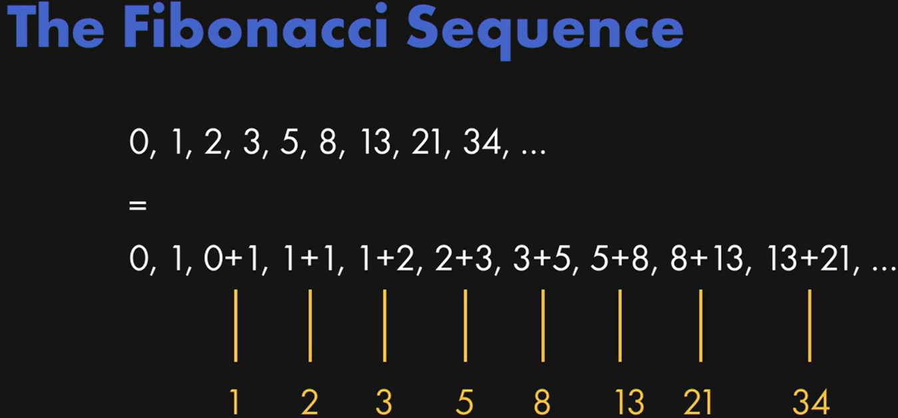
// 103 VSCode dev settings
- Ctrl + , for opening settings for VSCode
- Search executeinfiledir Check it
When executing a file in the terminal, whether to use execute in the file’s directory, instead of the current open folder
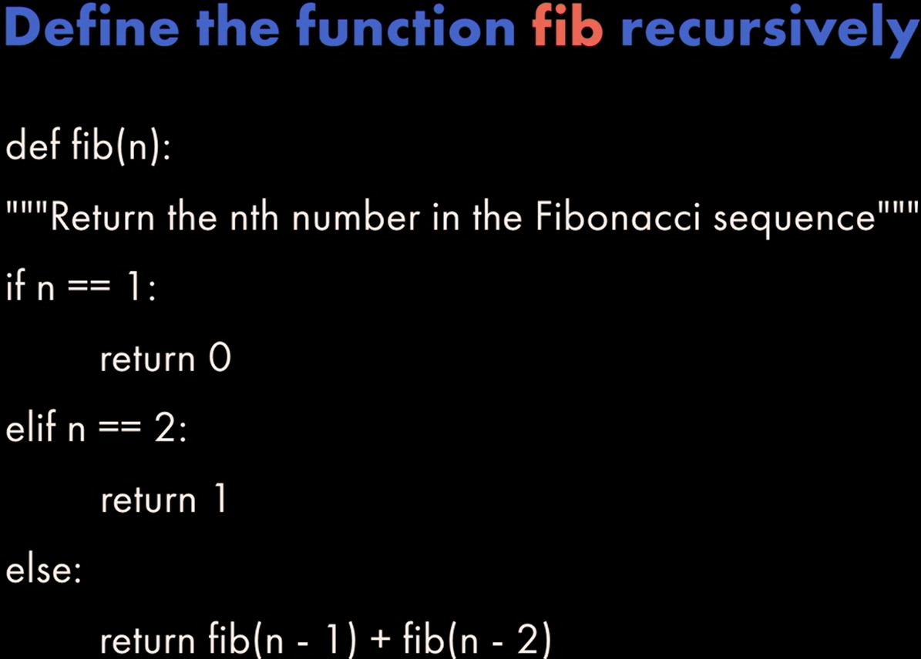
- Few other helpful VSCode extension:
  - Python, Pylance
  - Python Debugger
- Use latest VSCode
- From Left side bar Run and Debug
Create a launch.json
Python File: Debug the currently active Python file
Add extra lines to configurations launch.json
“cwd”: “${fileDirname}”,
“stopOnEntry”: true,
“console”: “internalConsole”
// in case you want to use debugConsole comes with VSCode

code.visualstudio.com/docs/python/debugging

// 201 Py program from terminal
Python is interpreted language as Javascript, so each line it interpreted and execute when get hit.

To find whether we are running our code on main module or not, we can use
def main(): print("hello world!")
if __name__ == "__main__": main()
# Here we are looking special global variable from py __name__ which reflects module name
and checking whether we running it directly or not

# If the file with this code is imported by other module, then if statement will fail, as it won’t be the __main__ module for that program. So our main() func won’t get execute automatically until explicitly triggered.

// 202 Run py in VSCODE // 203 Variables
f = “abc”; print(f)
print(“str “ + str(123)) # type-cast number to string

def someFunction():
global f # re-use var f from outer scope
# else it will create new local var f
f = "def"; print (f)

del f # delete definition of variable previously declared
print(f) # NameError: name 'f' is not defined
// 204 Functions
# function with default value for an argument
def power(num, x=1):
result = 1
for i in range(x): result = result * num
return result

# function with variable number of arguments
def multi_add(*args):
result = 0
for x in args: result = result + x
return result

print(power(2)) # 2
print(power(2, 3)) # 8
print(power(x=3, num=2)) # 8
print(multi_add(4, 5, 10, 4)) # 23

// 205 Conditional Structure // 206 Loop
# using the enumerate() function to get index
days = ["Mon","Tue","Wed","Thu","Fri","Sat","Sun"]
for index, day in enumerate(days): print (index, day)

// 207 Class
class MyClass():
def method1(self): print("MyClass method1")
def method2(self, someString):
print("MyClass method2: " + someString)
class AnotherClass(MyClass): # inherit MyClass
def method1(self):
MyClass.method1(self)
print("AnotherClass method1")
def main():
c = MyClass(); c.method1(); c.method2("This is a string")
c2 = AnotherClass(); c2.method1()

// 208 Import using modules
import math; print(math.pi)

// 301 date_time and datetime classes
from datetime import date
from datetime import datetime
def main():
## DATE OBJECTS
# Get today's date from the simple today() method from the date class
today = date.today(); print ("Today's date is ", today)
# 2024-04-16
# print out the date's individual components
print ("Date Components: ", today.day, today.month, today.year) # 16 4 2024
# retrieve today's weekday (0=Monday, 6=Sunday)
print ("Today's Weekday #: ", today.weekday()) # 1
days = ["monday","tuesday", … ]
print ("Which is a " + days[today.weekday()]) # tuesday

## DATETIME OBJECTS
# Get today's date from the datetime class
today = datetime.now(); print("Current date time", today)
# 2024-04-16 08:45:14.849748
# Get the current time
t = datetime.time(datetime.now())
print ("The current time is ", t) # 08:45:14.849748

// 302 format time output
now = datetime.now()
print (now.strftime("%a, %d %B, %y")) # Tue, 16 April, 24
print (now.strftime("Locale date and time: %c"))
print (now.strftime("Locale date: %x"))
print (now.strftime("Locale time: %X"))
%m/%d/%y = 03/15/24
# %I/%H - 12/24 Hour, %M - minute, %S - second,
# %p - locale's AM/PM
now.strftime("Current time: %I:%M:%S %p")
# 12-Hour:Minute:Second AM/PM
now.strftime("24-hour time: %H:%M") # 24-Hour:Minute
%b-%d-%Y = Dec-27-2022

// 303 Using timedelta objects
from datetime import date
from datetime import datetime
from datetime import timedelta

# construct a basic timedelta and print it
print (timedelta(days=365, hours=5, minutes=1))

# print today's date
now = datetime.now(); print ("today is: " + str(now))

# print today's date one year from now
print ("one year from now it will be: " + str(now + timedelta(days=365)))

# create a timedelta that uses more than one argument
print ("in two weeks and 3 days it will be: " +
str(now + timedelta(weeks=2, days=3)))

# calculate the date 1 week ago, formatted as a string
t = datetime.now() - timedelta(weeks=1)
s = t.strftime("%A %B %d, %Y")
print (s)

### How many days until April Fools' Day?
today = date.today() # get today's date
afd = date(today.year, 4, 1) # get April Fool's for same year
# use date comparison to see if April Fool's has already gone
# if it has, use the replace() function get the date for next year
if afd < today:
print ("April Fool's day already went by %d days ago" % ((today-afd).days))
afd = afd.replace(year=today.year + 1) # if so, get the date for next year

# Now calculate the amount of time until April Fool's Day
time_to_afd = afd - today
print ("It's just", time_to_afd.days, "days until nxt April Fool")

// 304 Working with Calendars
import calendar
# create a plain text calendar
c = calendar.TextCalendar(calendar.SUNDAY)
str = c.formatmonth(2017, 1, 0, 0); print (str)
# create an HTML formatted calendar
hc = calendar.HTMLCalendar(calendar.SUNDAY)
str = hc.formatmonth(2017, 1); print (str)
# loop over the days of a month
# zeroes mean that day of the week is in an overlapping mont
for i in c.itermonthdays(2017, 8): print (i)

# The Calendar module provides useful utilities for the given locale, such as the names of days and months in both full and abbreviated forms
for name in calendar.month_name: print (name)
for day in calendar.day_name: print (day)

# Calculate days based on a rule: For example, consider
# a team meeting on the first Friday of every month.
# To figure out what days that would be for each month,
# we can use this script:
print ("Team meetings will be on:")
for m in range(1,13):
# returns an array of weeks that represent the month
cal = calendar.monthcalendar(2017, m)
# The first Friday has to be within the first two weeks
weekone = cal[0]; weektwo = cal[1]

if weekone[calendar.FRIDAY] != 0: meetday = weekone[calendar.FRIDAY]
else: meetday = weektwo[calendar.FRIDAY]
# if the first friday isn't in the first week, it must be in the second

print ("%10s %2d" % (calendar.month_name[m], meetday))
// 401 Reading writing to files
# Open a file for writing and create it if it doesn't exist
f = open("textfile.txt","w+")
# Open the file for appending text to the end
# f = open("textfile.txt","a+")

# write some lines of data to the file
for i in range(10): f.write("This is line %d\r\n" % (i+1))
f.close() # close the file when done

# Open the file back up and read the contents
f = open("textfile.txt","r")
if f.mode == 'r':
# check to make sure that the file was opened
# use the read() function to read the entire file
# contents = f.read()
# print (contents)

fl = f.readlines() # readlines reads individual lines into a list
for x in fl: print (x)

// 402 OS path utilities
import os
from os import path
import datetime
from datetime import date, time, timedelta
import time

print (os.name) # Print the name of the OS
# Check for item existence and type
print ("Item exists: " + str(path.exists("textfile.txt")))
print ("Item is a file: " + str(path.isfile("textfile.txt")))
print ("Item is a directory: " + str(path.isdir("textfile.txt")))

# Work with file paths
print ("Item's path: " + str(path.realpath("textfile.txt")))
print ("Item's path and name: " + str(path.split(path.realpath("textfile.txt"))))

# Get the modification time
t = time.ctime(path.getmtime("textfile.txt")); print (t)
print (datetime.datetime.fromtimestamp(path.getmtime("textfile.txt")))

# Calculate how long ago the item was modified
td= datetime.datetime.now() - datetime.datetime.fromtimestamp(path.getmtime("textfile.txt"))
print ("It has been " + str(td) + " since the file was modified")
print ("Or, " + str(td.total_seconds()) + " seconds")
// 403 file system shell methods
import os
from os import path
import shutil
from shutil import make_archive
from zipfile import ZipFile

# make a duplicate of an existing file
if path.exists("textfile.txt"):
# get the path to the file in the current directory
src = path.realpath("textfile.txt");

# let's make a backup copy by appending "bak" to the name
dst = src + ".bak"
# now use the shell to make a copy of the file
shutil.copy(src,dst)

# copy over the permissions, modification time, other info
shutil.copystat(src, dst)
# # rename the original file
os.rename("textfile.txt", "newfile.txt")

# now put things into a ZIP archive
root_dir,tail = path.split(src)
shutil.make_archive("archive", "zip", root_dir)

# more fine-grained control over ZIP files
with ZipFile("testzip.zip","w") as newzip:
newzip.write("newfile.txt")
newzip.write("textfile.txt.bak")

// 501 fetch internet data
import urllib.request # instead of urllib2 like in Python 2.7
# open a connection to a URL using urllib2
webUrl = urllib.request.urlopen("http://www.google.com")
# get the result code and print it
print ("result code: " + str(webUrl.getcode()))
# read the data from the URL and print it
dataStr = webUrl.read(); print (dataStr)

// 502 json
import urllib.request # instead of urllib2 like in Python 2.7
import json

urlData = https://earthquake.usgs.gov/earthquakes/feed/v1.0/summary/2.5_day.geojson # Open the URL and read the data
webUrl = urllib.request.urlopen(urlData)
if (webUrl.getcode() == 200):
data = webUrl.read().decode("utf-8")
printResults(data)
def printResults(data):
# Use the json module to load the string data into dict
theJSON = json.loads(data)
# access the contents of the JSON like any other object
if "title" in theJSON["metadata"]:
print(theJSON["metadata"]["title"])

# number of events plus the magnitude and event name
count = theJSON["metadata"]["count"]
print(str(count) + " events recorded")

# for each event, print the place where it occurred
for i in theJSON["features"]:
if 'U.S.' in i["properties"]["place"]:
print(i["properties"]["place"] )
print("--------------\n")

# print events that only have a magnitude greater than 4
# print decimal upto 1 position only ex 4.18 to 4.1
for i in theJSON["features"]:
if i["properties"]["mag"] >= 4.0:
print("%2.1f" % i["properties"]["mag"], i["properties"]["place"])

# events where at least 1 person reported something
# null value converts to None by json.loads
print("\n\nEvents that were felt:")
for i in theJSON["features"]:
feltReports = i["properties"]["felt"]
if (feltReports != None and feltReports > 0):
print("%2.1f" % i["properties"]["mag"], i["properties"]
["place"], " reported " + str(feltReports) + " times")

Extras: json.dumps()
https://www.geeksforgeeks.org/json-dumps-in-python/
json.dumps() function will convert a subset of Python objects into a json string. Not all objects are convertible and you may need to create a dictionary of data you wish to expose before serializing to JSON.

Syntax:
json.dumps(obj, *, skipkeys=False, ensure_ascii=True, check_circular=True, allow_nan=True, cls=None, indent=None, separators=None, default=None, sort_keys=False, **kw)

Parameters: obj: Serialize obj as a JSON formatted stream
skipkeys: If skipkeys is True (default: False), then dict keys that are not of a basic type (str, int, float, bool, None) will be skipped instead of raising a TypeError.
ensure_ascii: If ensure_ascii is True (the default), the output is guaranteed to have all incoming non-ASCII characters escaped. If ensure_ascii is False, these characters will be output as-is.
check_circular: If check_circular is False (default: True), then the circular reference check for container types will be skipped and a circular reference will result in an OverflowError (or worse).
allow_nan: If allow_nan is False (default: True), then it will be a ValueError to serialize out of range float values (nan, inf, -inf) in strict compliance of the JSON specification. If allow_nan is True, their JavaScript equivalents (NaN, Infinity, -Infinity) will be used.
indent: If indent is a non-negative integer or string, then JSON array elements and object members will be pretty-printed with that indent level. An indent level of 0, negative, or “” will only insert newlines. None (the default) selects the most compact representation. Using a positive integer indent indents that many spaces per level. If indent is a string (such as “\t”), that string is used to indent each level.
separators: If specified, separators should be an (item_separator, key_separator) tuple. The default is (‘, ‘, ‘: ‘) if indent is None and (‘, ‘, ‘: ‘) otherwise. To get the most compact JSON representation, you should specify (‘, ‘, ‘:’) to eliminate whitespace.
default: If specified, default should be a function that gets called for objects that can’t otherwise be serialized. It should return a JSON encodable version of the object or raise a TypeError. If not specified, TypeError is raised.
sort_keys: If sort_keys is True (default: False), then the output of dictionaries will be sorted by key.

// 503 parsing processing HTML --- skipped very complex
// 504 XML manipulation
# Operate on xml data while it is sitting in memory

Example XML Used samplexml.xml:
<?xml version="1.0" encoding="UTF-8" ?>
<person>
<firstname>Joe</firstname>
<lastname>Marini</lastname>
<home>Seattle</home>
<skill name="JavaScript"/>
<skill name="Python"/>
<skill name="C#"/>
<skill name="HTML"/>
</person>

import xml.dom.minidom
# use the parse() function to load and parse an XML file
doc = xml.dom.minidom.parse("samplexml.xml")
# print the document node and the name of the first child tag
print (doc.nodeName) # #document
print (doc.firstChild.tagName) # person

# get a list of XML tags from the document and print each one
skills = doc.getElementsByTagName("skill")
print ("%d skills:" % skills.length) # 4 skills:
for skill in skills: print (skill.getAttribute("name"))

# create a new XML tag and add it into the document
newSkill = doc.createElement("skill")
newSkill.setAttribute("name", "jQuery")
doc.firstChild.appendChild(newSkill)

skills = doc.getElementsByTagName("skill")
print ("%d skills:" % skills.length) # 5 skills:
Lyn: Python for Students
// 101 What is Python
High level general purpose language
// 102 Why python // 103 Python Power
Web apps: Flask, Django
Scientific computing: math, stats, scientist - Numpy, Pandas
Automation
// 203 Python 2 vs Python 3
Py3: 2008 not compatible with py 2
Py2 stops jan 2020 support, mac may be using py2 some place
// 204 Py shell // 205 Python files
// 301 Numbers basic calculation
Division in py always output float number
print(4/2) # 2.0 # see it results float number always
Adding or subtract anything on float will result in float o/p
// 302 Strings
print(‘’’Dear
John, this is multi-line string’’’)
strEx = ‘heLLo’; print(strEx.upper()); #HELLO
- https://docs.python.org/2/library/string.html
print(strEx.title()) # Hello

f strings ? example: name: “pat”; print(f”Dog name {name}”)

// 401 Variables // 402 Functions
Using wrong variable name raise NameError
// 501 List a_list = [1, 2, 3]; a_list.append(4);
a_list.insert(1, 11); print(len(a_list)) # 5
print(a_list) # [ 1, 11, 2, 3, 4 ]
del a_list[1]; a_list.pop(); print(a_list) # [ 1, 2, 3 ]

list_of_lists = [ [1,2], [3,4] ]
print(list_of_lists[-1]) # [3,4] last item in list by using -1
Note: IndexError on calling list_of_lists[2]
a_list.remove(2) # remove first instance of value 2 in a_list
// 701 Mini drawing program using turtle library
// 702 Draw line // 703 Circle // 704 Pizza // skip
https://docs.python.org/3/library/turtle.html

// 801 Editor
PyCharm, Sublime, Jupyter Notebook with Anaconda
// 802 Python resources // 803 Stackoverflow
// 804 Reddit // 805 pyslackers.com py slack groups

Lyn: 2017 Python Essential Training [ Bill Weinman ]
// 003 About Py
- Developed by Guido Van Rossum, Dutch
- Wrote First interpreter December, 1989
- Name inspired from Circus
- Remains principal author
- Referred as BDFL – Benevolent Dictator For Life

Python Philosophy:
- Beautiful is better than ugly
- Explicit is better than implicit
- Simple is better than complex
- Complex is better that complicated
- Readability counts
Python 3 features vs Python 2:
- Not backward compatible
- Everything is an object
- Print is a function
- One integer type
- All text is now Unicode

// 101 Python Komodo Editor // 201 Py Overview
import platform
print(platform.python_version())
// 202 hello // 203 Py Anatomy
Shebang Line (command to find python interpretor)
#! /usr/bin/env python3
# this line is functional for mac, bst-unix and linux system only

print(‘py ver {}’.format(platform.python_version() ) )
# py ver 3.12.1

// 204 Statement and Expressions
We can terminate statement with semi-colon ;
// 205 Whitespace comments
Indents works as block body of function definitions.
True / False not true / false

// 206 print is more powerful vs other prog languages
x = 4; print(‘{}’.format(x)) # 4
print(‘%d’ %x) # 4
print(f’{x}’) # 4 # usable in many cases
// 207 Block Scope
Only function block starts new block context in py
Other things like if, while, for do not get new block context

// 208 Conditions // 209 Loops
# simple fibonacci series
# the sum of two elements defines the next set
a, b = 0, 1
while b < 1000:
print(b, end = ', ', flush = True)
a, b = b, a + b

# a will take b as value 1
# when b gets a + b, it will take prev value of a as 0
# run code to understand better

# 1, 1, 2, 3, 5, 8, 13, 21, 34, 55, 89, 144, 233, 377, 610, 987,

// 210 Function
By default, if we do not explicitly return any thing
Then, function will return None as value
docs.python.org/3/glossary.html#term-function-annotation
def func1(n): print(n)
x = func1(33); print(x) # None

def isprime(n):
if n <= 1: return False
for x in range(2, n):
if n % x == 0: return False
else: return True
n = 5
if isprime(n): print(f'{n} is prime') # 5 is prime
else: print(f'{n} not prime') # 6 is prime

def list_primes():
for n in range(100):
if(isprime(n)): print(n, end = ‘ ‘, flush=True)
print() # this will print empty line
# 2 3 5 7 11 13 17 19 …

// 211 Class Objects
// 301 Types Values
// 302 String Type
‘kumar ban’.capitalize() # Kumar ban
‘kumar ban’.title() # Kumar Ban
‘a {} {}’.format(9, 8) # a 9 8
‘a {1} {0}’.format(9, 8) # a 8 9
‘ ”{1:<9}” “{0:>9}” ’.format(3, 5)
# nine space add after element at position 1
# nine space add before element at position 0
#a “5 “ “ 3”
‘ ”{1:<08}” “{0:>08}” ’.format(333, 5)
# fill 8 zeros for empty after for element at position 1
# fill 8 zeros for empty before at position 0
#a “50000000“ “00000333”
# here total output length is 8 and filled 7 zero for 5
# and filled 5 zeros to 333 to complete length of 8 characters

// 303 Numeric Types
print(7 // 3) # 2
print( 7 / 3 ) # 2.3333333335
print(7/3) # 1 # remainder
Don’t use float for calculating money, instead use Decimal

// 304 Bool Type
x = None; print(type(x)) # <class ‘NoneType’>
------ ------- ------ -------
0 == False # True

// 305 Sequence Type – List, Tuple, Dictionaries
If we try to re assign any index of Tuple
TypeError: ‘tuple’ object does not support item assignment

r = range(3, 5) # 3, 4
r[1]=4 #TypeError: ‘range’ object does not support item as

da = { ‘a’: 1, ‘b’:3 }
da[‘c’]=5
for k, v in da.items():
print(f’{k} {v}’, end = ‘, ‘) # a 1, b 3, c 5,

// 306 Type_id
x=1; y=1;
print(id(x)) # 140730388519352
print(id(y)) # 140730388519352
if id(x) == id(y): print(True) # True
------ ------- ------ -------
local_var = 3; local_none = None
If ‘local_var’ in locals(): print(‘Is defined’)
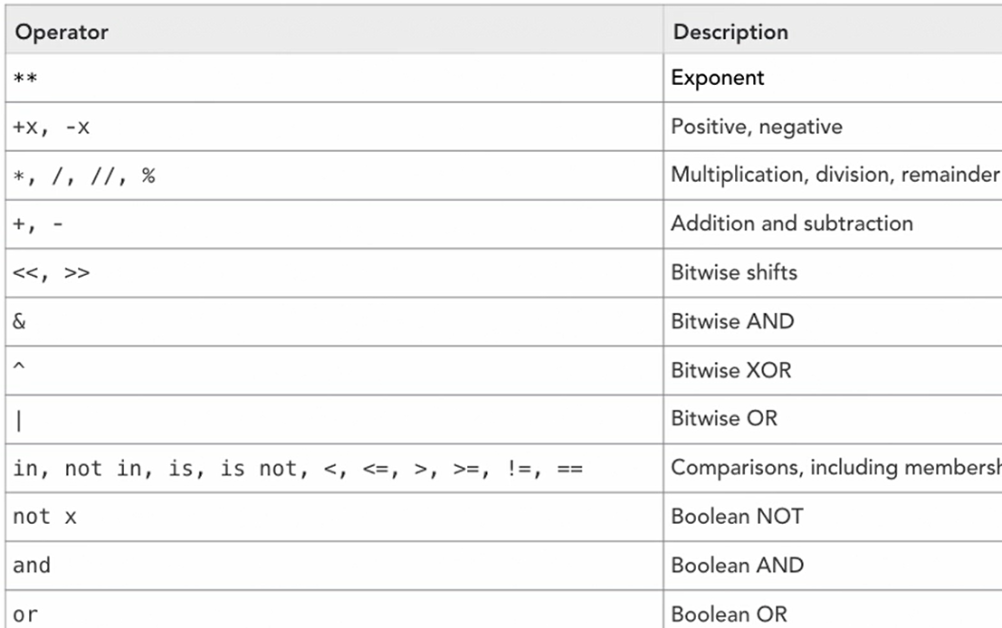
If ‘local_none’ == None: print(‘Is defined None’)
If ‘local_var’ in globals(): print(‘Is defined’)

------ ------- ------ -------
try: p; print(1);
except Exception as ex: print(2, ex)
# 2 name ‘p’ is not defined
------ ------- ------ -------
Difference b/w is and ==
An ‘is’ expression evaluates to True if two variables point to the same (identical) object. compares the references
An ‘==’ expression evaluates to True if variables are equal (have the same contents).
a = [1,2]; b=[1,2]
c = list(a)
k = a
k is a # True
a is k # True
a == b # True
a is b # False
a is not b # True
k[0]=4 # reference point for a and k are same
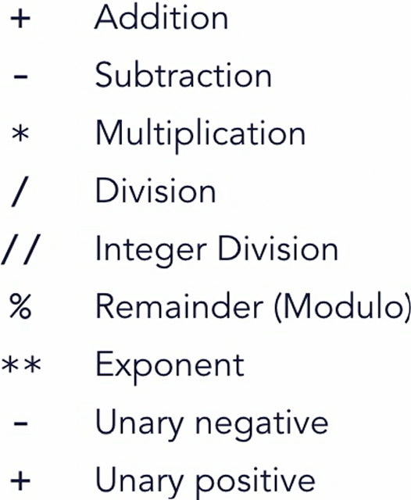
print(a) # [4, 2]
print(k) # [4, 2]

isinstance(k, list) # True

// 401 Conditional Syntax
// 402 Conditional Operators
1 in a # True
3 in a # False
2 not in a # False

a is b # False
a is not b # True
// 403 Conditional assignment
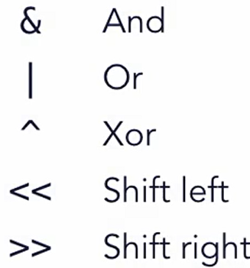
# Itenary Operator or short-hand if condition
ab = True
cb = ‘1’ if ab else 2
# else clause is must

// 501 Arithmetic Operators
// 502 Bitwise Operators
& | ^ << >>
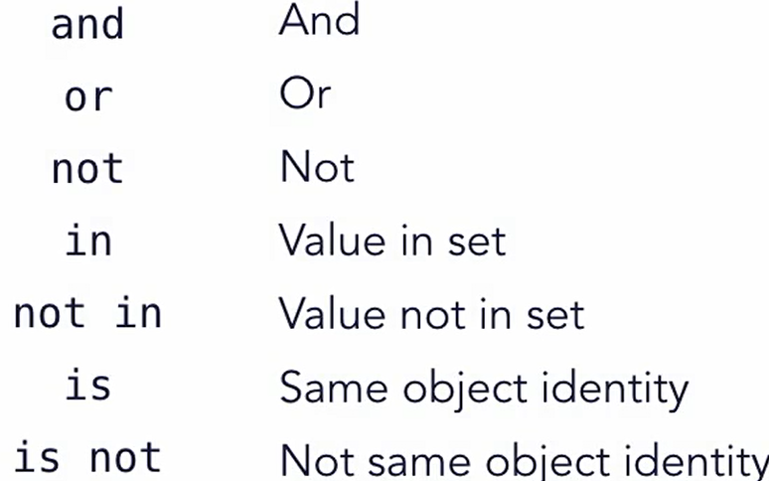
// 503 Comparison

// 504 Boolean Operators

// 505 Operator precedence

// 601 Loops // 602 While // 603 For loop
// 604 Loop controls
continue; break; else;
------ ------- ------ -------
# else get triggered when loop ends without break
count = 0; p = False; max_count = 5
while p == False:
count += 1
print(‘p is not False’)
if count > max_count: break
if count == 3: continue # will skip cycle
if count == 4: p = True # satisfy loop and trigger else
else: # using else with while loop
print(‘count reached to 3’) # trigger after loop ends

# If break terminates loop then else will not trigger
------ ------- ------ -------
# similar behaviour of else in for loop
animals = ( 'bear', 'bunny', 'dog', 'cat', 'velociraptor' )
for pet in animals:
if pet == 'bunny': continue
# if pet == 'cat': break
print(pet)
else: print(0)

c = 0; max_c = 5
while c != 9:
c += 1
# if c == max_c: break
if c == 3: continue
print(c)
else: print(0)

// 701 Defining a function
// 702 Func arguments with default value
call by value for int, string variables
def main():
x = 5; print(id(x)); kitten(x); print('x', x)
def kitten(a):
print(id(a)); a = 3; print(id(a)); print('Meow.', a)

sequence types are call by reference, such as list and dict

// 703 Argument Lists
def kitten(*args):
print(type(args)) # <class ‘typle’>
print(isinstance(args, tuple)) # True
for s in args: print(s)
kitten('meow', 'grrr', 'purr', ‘he’, ‘she’) # passing tuple
x = ('meow', 'grrr', 'purr', ‘he’, ‘she’)
kitten(*x)
// 704 Keyword Arguments
def kitten(**kwargs):
print(type(kwargs)) # <class ‘dict’>
print(isinstance(kwargs, dict)) # True
if len(kwargs):
for k in kwargs:
print('Kitten {} says {}'.format(k, kwargs[k]))
else: print('Meow.')
def main():
kitten(Buffy = 'meow', Zilla = 'grr')
x = { Buffy = 'meow', Zilla = 'grr'}
kitten(**x)
y = dict(Buffy = 'meow', Zilla = 'grr')
kitten(**y)

// 705 return value
// 706 Generator – return stream of values
def inclusive_range(*args): # generator
start = 0; step = 1; stop = args[0]
i = start
while i <= stop:
yield i # yield came to python later than Iterator
i += step

for i in inclusive_range(5): print(i, end = ', ')
# 0, 1, 2, 3, 4, 5

// 707 Decorator
# General decorator pattern
def f1(f):
def f2(): print(‘before call’); f(); print(‘after call’);
return f2
------ ------- ------ -------
def f3(): print(‘f3’)
x = f1(f3); x() # plain way pattern
------ ------- ------ -------
@f1 # decorator pattern
def f3(): print(‘f3’)
===== ===== ===== =====
import time # second example of decorator use
def elapsed_time(f):
def wrapper():
t1 = time.time(); f(); t2 = time.time()
print(f'Elapsed time: {(t2 - t1) * 1000} ms')
return wrapper
@elapsed_time
def big_sum():
num_list = []
for num in (range(0, 10000)): num_list.append(num)
print(f'Big sum: {sum(num_list)}')
big_sum()
// 801 Basic data structure
Set is ordered unique values
set_a = {1, 2, 3}
print(set_a) # { 1, 2, 3 }
set_b = { 1, 1, 2, 2, 3, 4, 3, 3, 4 } // unique value gets store only
print(set_b) # { 1, 2, 3, 4 }

// 802 List operations
a_list = [ ‘a’, ‘b’, ‘c’, ‘d’, ‘e’, ‘f’ ]
print(a_list[1:6:2]) # [ ‘b’, ‘d’, ‘f’ ]
append, insert, remove, pop,
del a_list[1:2] # [‘a’, ‘c’, ‘d’, ‘e’, ‘f’] // removed only ‘b’
a_list.remove(‘d’) # [‘a’, ‘c’, ‘e’, ‘f’]

// 803 Dictionary
a_dict = dict(a=’a1’, b=’b1’, c=’c1’)
print(a_dict[‘a’]) # a1
a_dict[‘a’] = ‘a2’
print(‘found’ if ‘b’ in a_dict else ‘nope’)
print(a_dict.get(‘b’)) # b1

// 804 Set
Set allow only unique value
The values in set can be sorted

def print_set(o):
print('{', end = '')
for x in o: print(x, end = '')
print('}')

a = set("We're gonna need a bigger boat.")
b = set("I'm sorry, Dave. I'm afraid I can't do that.")
print_set(a)
print_set(sorted(b))
print(a – b) # items which are in a but not in b
print(a | b) # items which are in one or both a and b
print(a & b) # items which are in both a and b
print(a ^ b) # items which are in a or b and not in both
# do not take items which are in both a and b

// 805 List Comprehension
seq = range(11)

seq2 = [x * 2 for x in seq]
seq3 = [ x for x in seq if x % 3 != 0]

seq4 = [(x, x**2) for x in seq] # square of x = x**2
# (0,0),(1,1),(2,4),(3,9),(4,16),(5,25)….

seq5 = {x for x in ‘superduper’ if x not in ‘pd’}
# u s e r # only condition passing items passed to result
// 806 Mixed structure
def disp(o):
global dlevel
dlevel += 1

if isinstance(o, list): print_list(o)
elif isinstance(o, range): print_list(o)
elif isinstance(o, tuple): print_tuple(o)
elif isinstance(o, set): print_set(o)
elif isinstance(o, dict): print_dict(o)
elif o is None: print('Nada', end=' ', flush=True)
else: print(repr(o), end=' ', flush=True)

dlevel -= 1
if dlevel <= 1: print() # newline after outer

def print_list(o):
print('[', end=' ')
for x in o: disp(x)
print(']', end=' ', flush=True)

def print_tuple(o):
print('(', end=' ')
for x in o: disp(x)
print(')', end=' ', flush=True)

def print_set(o):
print('{', end=' ')
for x in sorted(o): disp(x)
print('}', end=' ', flush=True)

def print_dict(o):
print('{', end=' ')
for k, v in o.items():
print(k, end=': ' )
disp(v)
print('}', end=' ', flush=True)

#global
dlevel = 0 # manage nesting level

def main():
r = range(11)
l = [ 1, 'two', 3, {'4': 'four' }, 5 ]
t = ( 'one', 'two', None, 'four', 'five' )
s = set("It's a bird! It's a plane! It's Superman!")
d = dict( one = r, two = l, three = s )
mixed = [ l, r, s, d, t ]
disp(mixed)

// 901 Class
// 902 Object Instance // 903 Class methods
class Animal:
def __init__(self, **kwargs):
self._type = kwargs['type'] if 'type' in kwargs else 'kitten'
self._name = kwargs['name'] if 'name' in kwargs else 'fluff'
self._sound = kwargs['sound'] if 'sound' in kwargs else 'ra'

def type(self, t = None):
if t: self._type = t
try: return self._type
except AttributeError: return None
def name(self, n = None):
if n: self._name = n
try: return self._name
except AttributeError: return None
def sound(self, s = None):
if s: self._sound = s
try: return self._sound
except AttributeError: return None

def __str__(self):
return f'{self.type()} "{self.name()}" says "{self.sound()}".'

class Duck(Animal): # single inheritance
def __init__(self, **kwargs):
self._type = 'duck'
if 'type' in kwargs: del kwargs['type']
super().__init__(**kwargs)
class Kitten(Animal):
def __init__(self, **kwargs):
self._type = 'kitten'
if 'type' in kwargs: del kwargs['type']
super().__init__(**kwargs)

def print_animal(o):
if not isinstance(o, Animal):
raise TypeError('print_animal(): requires an Animal')
print(f'{o.type()} named "{o.name()}" says "{o.sound()}"')

def main():
a0 = Kitten(name = 'fluffy', sound = 'rwar')
a1 = Duck(name = 'donald', sound = 'quack')
print_animal(a0); print_animal(a1)
print_animal(Animal(type=‘t’,name=’n’,sound=’hello’))
print(Animal()) # will pick default values
print(a1) # will use __str__ from Animal
https://docs.python.org/3/reference/datamodel.html#special-method-names
Note: Python do not have private variable, instead python naming convension use _var This variable should be called directly from object instance.
// 904 Object data
print(a0._name) # not a class level variable bind to self
Variables at class level are shared with all objects, means change in value of class variables can be seen in all instance objects. This is also known as Encapsulation. Example:
class Animal:
x = [1, 2, 4] # this is class variable and shared among all instac
def __ini__(self): …
a_anim = Animal(); b_anim = Animal()
a_anim.x[2] = 3
print(b_anim.x[2]) # 3 # all object from class share this value

// 905 Class Inheritance
class RevStr(str):
def __str__(self): return self[::-1] # return str in reverse
def main():
hello = RevStr('Hello, World.')
print(hello) # .dlroW ,olleH

// 906 Interator Objects
# something like generator but without using yield
class inclusive_range:
def __init__(self, *args):
numargs = len(args)
self._start = 0; self._step = 1

if numargs < 1:
raise TypeError(f'expected at least 1 argument, got {numargs}')
elif numargs == 1:
self._stop = args[0]
elif numargs == 2:
(self._start, self._stop) = args
elif numargs == 3:
(self._start, self._stop, self._step) = args
else: raise TypeError(f'expected at most 3 arguments, got {numargs}')
self._next = self._start

def __iter__(self): return self
def __next__(self):
if self._next > self._stop:
raise StopIteration
else:
_r = self._next
self._next += self._step
return _r
def main():
for n in inclusive_range(25):
print(n, end=' ')
print()
// 1001 Handling Exceptions
X = inet(‘asdf’) # NameError
X = int(‘asdf’) # ValueError
X = 5/0 # ZeroDivisionError
import sys
try: x = 5/0
except ValueError: print('value error')
# except ZeroDivisionError: print('zero division error')
except: # default catcher
print(f'unknown error: {sys.exc_info()}')
else: print('good job')

// 1002 Reporting Error raise TypeError(‘…’);
// 1101 Overview String objects
upper lower capitalize swapcase title
‘Hello’.swapcase() # hELLO
‘Hello {}’.format(42 * 7) # Hello 294
# strings are first-class objects in python

// 1102 Common String methods
.casefold // more aggressive than lower, is usable for unicode
str_1 = ‘Hello’
print(id(str_1)) != print(id(str_1.lower()))
- Read docs for more such methods in python3

// 1103 String Formatting
print(‘ {xx} {b} {a} ‘.format(a=1,b=2,xx=3)) # 3 2 1
print(‘ {0} {2} {1} {2}‘.format(1,2,3)) # 1 3 2 3

> # right justify n number of character
< # left justify n number of character

print(‘ {0:<5},{2:<05},{1:>5},{2:>05}‘.format(1,2,3))
# 10000,30000,00002,00003
print(‘ {0:+}={2:+05}={1:,}‘.format(1,232423,3))
# +1=+0003=2,32,423
n = 23456; print(‘{:,}’.format(x).replace(‘,’,’=’)) # 23=435
print(‘{:.3f}’.format(n)) # 23456.000
print(‘{:f}’.format(n)) # 23456.00000
m = 42; print(f‘{m:.3f}’) # 42.000
print(f’{m:x}’) # 2a // hexadecimal value for 42
print(f’{m:o}’) # 52 // octal value for 42
print(f’{m:b}’) # 101010 // binary value for 42
# f strings started from py 3.6

// 1104 Split and Join Strings
a_str = ‘a b c d’; print(a_str.split()) # [‘a’,’b’,’c’,’d’]
a_list = a_str.split(); print(‘:’.join(a_list)) # a:b:c:d
// 1201 Opening Files // 1202 Text vs Binary Files
// 1203 Text Files // 1204 Binary Files
[ files handling is skipped as it has less usecase ]
// 1301 Numeric Func
a = ‘44’; print(int(a))
print(float(a)) # 44
b = -4.4 ; print(abs(b)) # 4.4
print(divmod(a, 3)) # (14, 2) # return quotient and remainder
print(a + 23j) # (44+23j) # complex number
print(complex(a, 23)) # (44+23j)
- Read docs for more Built-in Functions

// 1302 String Func
repr, ascii, chr, ord # less used func skipped
// 1303 Container Func
len, reversed, list, sum, max, min, any, all, zip,

for i, v in enumerate(x): print(i, v)

// 1304 Object Class Func
type, isinstance, id

// 1401 Using standard modules
sys, os, random, datetime
sys.version_info
sys.platform # not os, darwin
os.name # ‘posix; for mac
os.getenv(‘PATH’)
os.getcwd()
os.urandom(25).hex() # 25 bits random converted to hex
random.randint(1, 100) # random int b/w 1 and 100
random.shuffle(a_rand_int_list)
nw = datetime.datetime.now()
now.year, now.month, now.day, now.hour

// 1402 Creating a modules
import module // here module is filename only
# On default class, methods, variable defined in file are loaded as item on filename
# There is no keyword used in module file to export specific things, everything is exposed to whoever import this file as module
Example:
import saytime
saytime.__version__
saytime.test2()
saytime_instance = saytime.numwords(20)
To run main func defined in module, need to call it explicitly
saytime.main()
// 1501 Python DB Api // 1502 db interface
# Using sqlite3 modules // skipped
// 1503 Example short URL project using sqlite3 db

// 1601 Wrap up
Lyn: Python Object-Oriented Programming [ Joe Marini ]
// 101 OOPS refresher
- Objects classes
- Modules
- Organize and structure code
- Inheritance
- Composition: build complex obj out of other objects

// 102 Basic class // 103 Instance method and attributes
If not 1 in (2, 3, 4): raise ValueError(‘not found’)
// 104 Checking instance types
// 105 Class method members
class Book:
# Properties defined at class level are shared by all instances
BOOK_TYPES = ("HARDCOVER", "PAPERBACK", "EBOOK")
# double-underscore properties hidden from other classes
__booklist = None

# static methods do not receive class or instance arguments
# and usually operate on data that is not instance- or
# class-specific
@staticmethod
def getbooklist():
if Book.__booklist == None:
Book.__booklist = []
return Book.__booklist

# class methods receive a class as their argument and
# can only operate on class-level data
@classmethod
def getbooktypes(cls):
return cls.BOOK_TYPES
….

print("Book types: ", Book.getbooktypes())
b1 = Book("Title 1", "HARDCOVER")
b2 = Book("Title 2", "PAPERBACK")
# Use the static method to access a singleton object
thebooks = Book.getbooklist()
thebooks.append(b1); thebooks.append(b2)
print(thebooks)

Static methods are also useful for namespace
https://peps.python.org/pep-0318/
https://wiki.python.org/moin/Decorators
https://www.geeksforgeeks.org/top-python-built-in-decorators-that-optimize-python-code-significantly/
https://www.kdnuggets.com/8-built-in-python-decorators-to-write-elegant-code

// 201 Inheritance // 202 Abstract base classes
abstract method works as idea only where definition need to be defined by extended classes
# using ABC modules for abstractmethod
ABC is Abstract Base Class

from abc import ABC, abstractmethod
# Inheriting from ABC indicates makes it abstract base class
class GraphicShape(ABC):
def __init__(self): super().__init__()
# declare method as abstract require subclass to implement
@abstractmethod
def calcArea(self): pass

class Circle(GraphicShape):
def __init__(self, radius): self.radius = radius
def calcArea(self): return 3.14 * (self.radius ** 2)

# Abstract classes can't be instantiated themselves
# g = GraphicShape() # this will error: TypeError

c = Circle(10); print(c.calcArea())

// 203 Multiple Inheritance
class A:
def __init__(self): super().__init__()
self.foo = "foo"; self.name = "Class A"
class B:
def __init__(self): super().__init__()
self.bar = "bar"; self.name = "Class B"

class C(B, A):
def __init__(self): super().__init__()
def showprops(self):
print(self.foo); print(self.bar); print(self.name)

# create the class and call showprops()
c = C(); print(C.__mro__)

# __mro__ prints the order of inheritance in tuple as:
# (<class '__main__.C'>, <class '__main__.B'>, <class '__main__.A'>, <class 'object'>)
# priority wise, c has higher over b and vice-versa

c.showprops() # foo from A, bar from B, name from B
# MRO : Method Resolution Order

// 204 Interface
Not natively present in Python, but achieved via
Multi inheritance and abstract classes
It is a promise by class to provide certain functionality
class JSONify(ABC):
@abstractmethod
def toJSON(self): pass
# GraphicShape from 201
class Circle(GraphicShape, JSONify):
def __init__(self, radius): self.radius = radius
def calcArea(self): return 3.14 * (self.radius ** 2)
def toJSON(self): return f"{{ \"square\": {str(self.area())} }}"

c = Circle(10); print(c.calcArea()); print(c.toJSON())

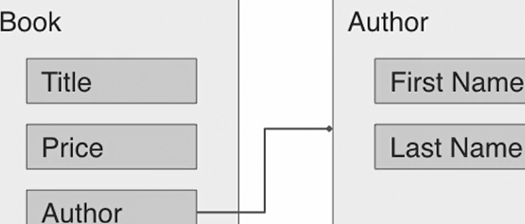
// 205 Composition
In below example for composition, we are using Chapter and Author to achieve complete functionality for book:
class Author:
def __init__(self, fname, lname):
self.fname = fname
self.lname = lname
def __str__(self): return f"{self.fname} {self.lname}"
class Chapter:
def __init__(self, name, pagecount):
self.name = name
self.pagecount = pagecount

class Book:
def __init__(self, title, price, author=None):
self.title = title
self.price = price
# Use references to other objects, like author and chapters
self.author = author
self.chapters = []
def addchapter(self, chaptr): self.chapters.append(chaptr)

auth = Author("Leo", "Tolstoy")
b1 = Book("War and Peace", 39.95, auth)
b1.addchapter(Chapter("Chapter 1", 104))

# * How Book using both Author and Chapter class instance ?
# This is composition

// 301 Magic Methods
- User to customize obj behaviour and integrate with lang
- Define how objects are represented as strings
- Control access to attribute values, both for get and set
- Build in comparison and equality testing
- Allow objects to be called like functions
// 302 String representation
__str__ , __repr__
# The __str__ function is used to return a user-friendly string
def __str__(self): return f"{self.titl} by {self.auth}"

# The __str__ function return a developer-friendly string
def __repr__(self): return f"title={self.titl},author={self.auth}"

# use str() and repr()
print(str(b1)); print(repr(b2))

// 303 Equality Comparison
# the __eq__ method checks for equality between two objects
def __eq__(self, value): # b1 == b3
return (self.title == value.title and
self.author == value.author and
self.price == value.price)
# the __ge__ establishes >= relationship with another obj
def __ge__(self, value): # b1 >= b3
return self.price >= value.price
# the __lt__ establishes <= relationship with another obj
def __lt__(self, value): # b1 <= b3
return self.price < value.price

print(b1 == b3); print(b1 == 42) # Check for equality
# Check for greater and lesser value
print(b2 >= b1); print(b2 < b1); print(b3 >= b2)
books = [b1, b3, b2, b4] # Now we can sort them
books.sort(); print([book.title for book in books])

// 304 Attribute access
# Called when an attribute is retrieved. you can't directly
# access the attr name otherwise a recursive loop is created
def __getattribute__(self, name):
if (name == "price"):
p = super().__getattribute__("price")
d = super().__getattribute__("_discount")
return p - (p * d)
return super().__getattribute__(name)

# __setattr__ called when an attribute value is set. Don't set
# attr directly here otherwise a recursive loop causes a crash
def __setattr__(self, name, value):
if (name == "price"):
if type(value) is not float:
raise ValueError("The 'price' attribute must be a float")
return super().__setattr__(name, value)

# __getattr__ called when __getattribute__ lookup fails - you
# can pretty much generate attributes on fly with this method
def __getattr__(self, name): return name + " is not here!"
b1 = Book("War and Peace", "Leo Tolstoy", 39.95)
# Try setting and accessing the price
b1.price = 38.95; print(b1)
b1.price = float(40) # using an int will raise an exception

# If an attribute doesn't exist, __getattr__ will be called
print(b1.randomprop)

// 305 Callable Object – call objects as function
# the __call__ method used to call the object like a function
def __call__(self, title, author, price):
self.title = title
self.author = author
self.price = price
…
b1 = Book("War and Peace", "Leo Tolstoy", 39.95)
# call the object as if it were a function
print(b1)
b1("Anna Karenina", "Leo Tolstoy", 49.95)
print(b1)

// 401 Define Data Class
// starting from 3.7 @dataclass, read more on docs
REPLACEING BELOW CODE:
class Book:
def __init__(self, title, author, pages, price):
self.title = title; self.pages = pages; self.price = price

WITH:
from dataclasses import dataclass
@dataclass
class Book:
title: str = “default title”
pages: int = 0
price: float = 0.0
…. # Other things as before in normal classes

b1 = Book("War and Peace", 1225, 39.95)
b3 = Book("War and Peace", 1225, 39.95)
print(b1 == b3) # True

// 402 Using Post initialization for @dataclass
# __post_init__ func lets us customize additional properties
# after the object has been initialized via built-in __init__

…. # prev code from 401
def __post_init__(self):
self.description = f"{self.title} {self.pages} pages"

b1 = Book("War and Peace", "Leo Tolstoy", 1225, 39.95)
print(b1.description) # use the description attribute
// 403 Using default values for @dataclass
Note: if attribute without default value,
mixed with attributes with values
Then, it should come first
before the attributes with default value. Example:
@dataclass
class Book:
price: float # this is correct way
pages: int = 0
title: str = “default title”

# if this pattern is not followed then an error get raised as:
TypeError:non-default argument ‘…’ follow default argument
------ ------- ------ -------
Now, to pass random/generated default value for any field
from dataclasses import dataclass, field
import random

def price_func(): return float(random.randrange(20, 40))

@dataclass
class Book:
# you can define default values when attributes are declared
title: str = "No Title"; author: str = "No Author"
pages: int = 0
price: float = field(default_factory=price_func)
# it could be field(default_factory=10.0)

// 404 Immutable dataclasses
from dataclasses import dataclass

# "The "frozen" parameter makes the class immutable
@dataclass(frozen=True)
class ImmutableClass:
value1: str = "Value 1"; value2: int = 0

def somefunc(self, newval): self.value2 = newval

obj = ImmutableClass()
print(obj.value1)

# attempting to change the value of an immutable class
# throws an exception
# dataclasses.FrozenInstanceError: cannot assign to field ..
obj.value1 = "Another value"
print(obj.value1)

# Frozen classes can't modify themselves either
obj.somefunc(20) # raise FrozenInstanceError again

// 501 Next Step
Lyn: 2019 Python Essential Libraries

// 101 3rd party libraries
pypi.org // portal for 3rd party libaries
Install pip // similar to npm repo portal, backed by github
// 102 pip overview
// pre-installed from 3.4
pip list --outdated # find outdated packages on your system
pip install --upgrade <package-name>
pip uninstall lxml
pip install packagename=version-number
pip install Django=4.2.11 # installing specific version of packg
pip show packagename # packg info command
# shows package dependencies

// 201 Pendulum – datetime library // skip
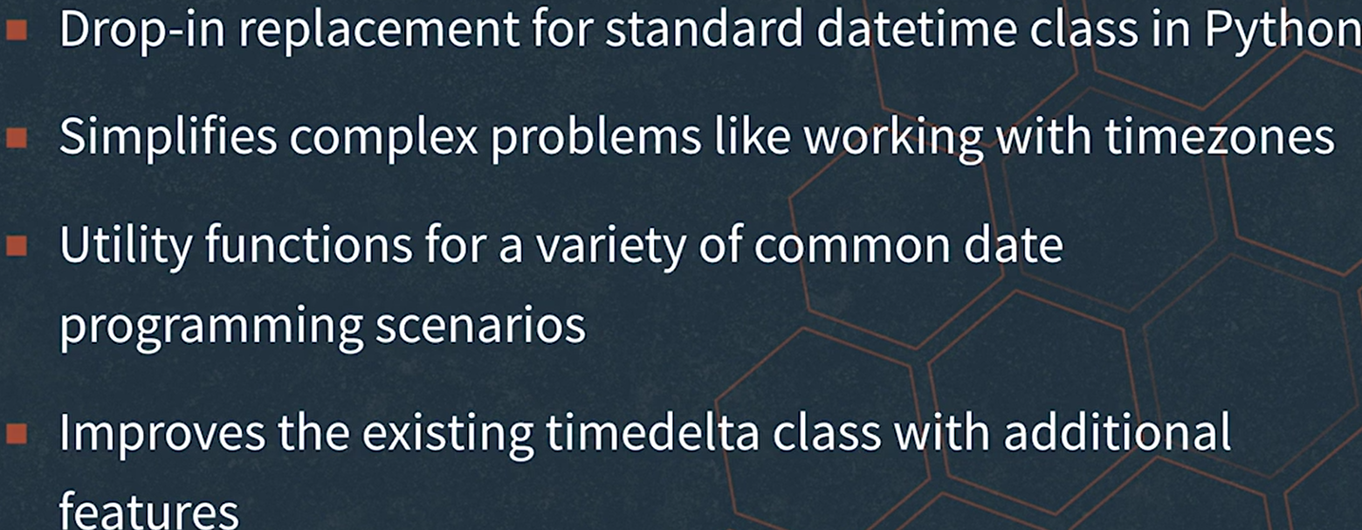
# something like moment.js

// 301 Intro to Request library // 302 Basic Requests
# Simple http library for py, axios for js
import requests
import json
# create a basic request for data
resp = requests.get("http://httpbin.org/xml")
print(resp.status_code); print(resp.text)
# create a request using parameters
args = {"key1": 1, "key2": "two", "key3": False}
resp = requests.get("http://httpbin.org/get", params=args)
print(resp.text); print(resp.url);
# create a request using POST
resp = requests.post("http://httpbin.org/post", data={"key": "value"})
print(resp.text)
# create a request using custom headers
heads = {"my-custom-header": "This is a custom header"}
resp = requests.get("http://httpbin.org/get", headers=heads)
print(resp.text)

// 203 Working with response
import requests # work with status codes

# resp = requests.get('https://httpbin.org/status/404')
resp = requests.get('https://httpbin.org/status/200')
print(resp.status_code)
resp.raise_for_status() # raise exception for http error codes
# examine response encoding
resp = requests.get('https://httpbin.org/html')
print(resp.encoding)
# the text property accesses decoded text content
print(resp.text)
# the content property provides access to raw bytes
print(resp.content)

# To read JSON content, use the json() function
resp = requests.get('https://httpbin.org/json')
print(resp.json())
print(resp.headers)
print(resp.headers['content-type'])

// 204 Using Authentication
import requests from requests.auth
import HTTPDigestAuth
# define user and password values
user = "theuser"; passwd = "thepass";
d = “https://httpbin.org/”

# use the basic authentication method
url = f"{d}basic-auth/theusr/thepas"
resp = requests.get(url, auth=(user, passwd))
print(resp.status_code); print(resp.text)

# use the digest authentication method
url = f"{d}digest-auth/auth/theuser/thepass"
resp = requests.get(url, auth=HTTPDigestAuth(user, passwd))
print(resp.status_code)’ print(resp.text)

// 305 Advanced features
import requests
# use a timeout value for a request
resp = requests.get(f"{d}delay/0.5", timeout=1.0)
print(resp.status_code)

# introspect the redirection history
resp = requests.get("http://github.com")
print(resp.url); print(resp.history)
orig = resp.history.pop()
print(orig.status_code); print(orig.url); print(orig.reason)

# Use a session object to group requests and settings
# create the session
sess = requests.Session()
# use the session to persist a cookie across requests
sess.get(f'{d}cookies/set/sample/123456789')
resp = sess.get('https://httpbin.org/cookies')
print(resp.text)

# Customize the user-agent to simulate different browsers
# Set the user-agent to be Firefox
sess.headers.update({
"User-Agent": "Mozilla/5.0 (X11; Ubuntu; Linux x86_64; rv:68.0) Gecko/20100101 Firefox/68.0"
})
resp = sess.get("http://google.com")
print(len(resp.content))

# Set the user-agent to be an iPhone
sess.headers.update({
"User-Agent": "Mozilla/5.0 (iPhone; CPU iPhone OS 13_1 like Mac OS X) AppleWebKit/605.1.15 (KHTML, like Gecko) relesys_web_client/1.3.10.0 (RelesysApp/1.3.43 net.relesysapp.nettoenterprise)"
})
resp = sess.get("http://google.com")
print(len(resp.content))

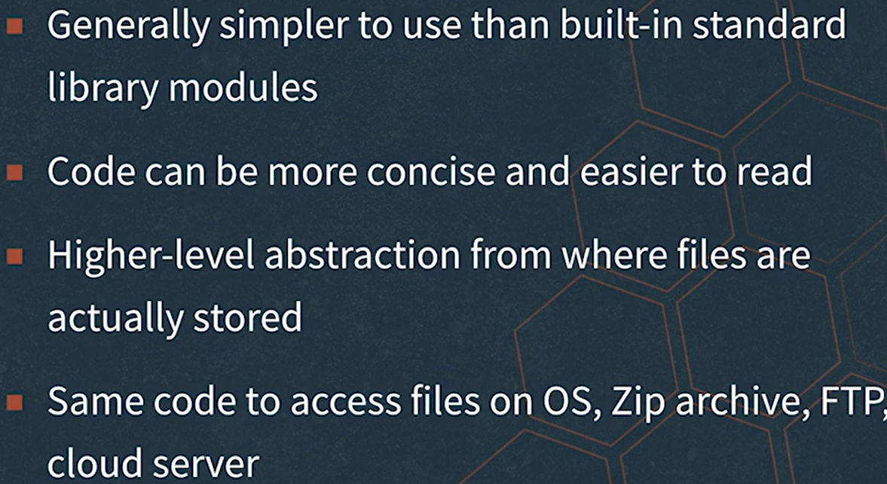
// 401 Overview PyFilesystem // skipped completely
- python install fs

// 501 Overview Pillow // skipped completely
Python image library forked from PIL

Lyn: Learning the Python 3 Standard Library

// 004 Standard library python
Can be used on any machine, includes built-in functions and built-in imported modules

// 101 Logical Operator
If not True: print(‘not true’)
// 102 Comparison Operator // 103 Calc Length
// 104 range and list
list takes input as tuple
range(start, stop, end)
// 105 min max min(1, 2, 3) # 1
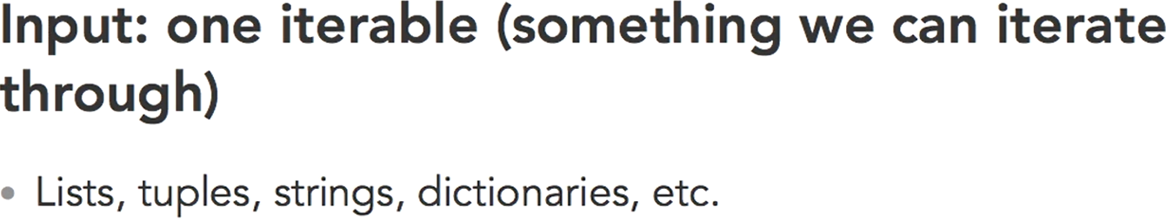
// 106 round absolute exponents
a = 2.3; b = round(a) # 2
a = -2.3; b = abs(a) # 2.3
pow(2, 3) # 8
// 107 Sorted func
# Alphabetically
children = ["Sue", "Jerry", "Linda"]
print(sorted(children))
print(sorted(["Sue", "jerry", "linda"]))

# Key Parameters
print(sorted("My favorite child Linda".split(), key=str.upper))
# sort case-insensitive manner putting key=str.upper

leaderBoard = {231: "CKL", 123:"ABC", 432:"JKC"}
print(sorted(leaderBoard, reverse=True))
print(leaderBoard.get(432))

students = [ ('alice', 'B', 12), ('eliza', 'A', 16), ('tae', 'C', 15)]
print(sorted(students, key=lambda student:student[0]))
print(sorted(students, key=lambda student:student[1]))

// 108 Type Functions type, isinstance
// 201 Trignometry ceiling floor constants # math lib
# read docs for more on math
// 202 factorial Sqrt gcd radians degress via math
// 203 random
random.random, randrange, sample, choice, shuffle
// 204 Statistics
import statistics
.mean, .mode, .median, .variance, .stdev

// 205 Iterators with itertools
import itertools
# Infinite Counting, second parameter is step size
for x in itertools.count(50, 5): # count start from 50
print(x) # 50 55 60 …..
if x == 80: break;

x = 0;
# Infinite Cycling
for c in itertools.cycle([1, 2, 3, 4]):
print(c)
x = x + 1
if x > 50: break; # break after 50 cycles

# Infinite Repeating
for r in itertools.repeat(True):
print(r)
x = x + 1
if x > 100: break; # break after 100 cycle
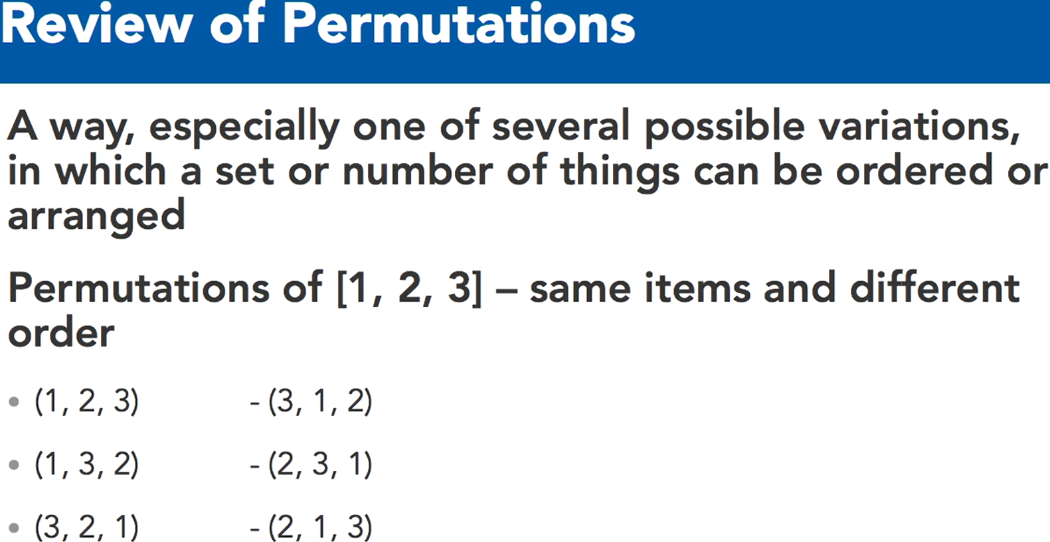
// 206 Iterators with Permutation combinations
# Permutations: Order matters - some copies with same inputs but in different order
election = {1: "Barb", 2:"Karen", 3:"Erin"}
for p in itertools.permutations(election):
print(p) # (1,2,3) (1,3,2) …..

for p1 in itertools.permutations(election.values()): print(p1)

# Combinations: Order does not matter - no copies with same inputs
colorsForPainting = ["Red", "Blue", "Purple", "Orange", "Yellow", "Pink"]
for c in itertools.combinations(colorsForPainting, 3): print(c)

// 301 Command line arguments
# py script.py arg1 arg2 arg3 …
import sys
# Print Arguments
print("Number of arguments: ", len(sys.argv), ' arguments.')
print("Arguments ", sys.argv)
# Remove Arguments
sys.argv.remove(sys.argv[0])

// 302 Input Output // 303 File file writing // 304 File seeking
// 305 Iterative files // 306 Temp Files // skipped
// 307 Manipulate zip files # Zipfile Module
import zipfile
zip = zipfile.ZipFile('Archive.zip', 'r') # Open and List
print(zip.namelist()) # print list of file names in zip

# Metadata in the zip folder
for meta in zip.infolist(): print(meta) # file properties
info = zip.getinfo("purchased.txt"); print(info)

# Access to files in zip folder
print(zip.read("wishlist.txt"))
with zip.open('wishlist.txt') as f: print(f.read())

# Extracting files
zip.extract("purchased.txt")
zip.extractall()
zip.close() # Closing the zip
// 401 Current time // 402 Format date time # skipped
// 403 Calculate future times # timedelta skipped
// 404 Timer # time module
time.sleep(1)
// 405 HTML parser # skipped
// 406 Text Wrap # textwrap module
import textwrap

websiteText = """ Learning can happen anywhere with our apps on your computer,
mobile device, and TV, featuring enhanced navigation and faster streaming
for anytime learning. Limitless learning, limitless possibilities."""

print("No Dedent:"); print(textwrap.fill(websiteText))

print("Dedent") # remove common leading whitespaces
dedent_text = textwrap.dedent(websiteText).strip()
print(dedent_text)
# strip remove space at begin and end of string, also /n
print("Fill"); print()
print(textwrap.fill(dedent_text, width=50))
print(textwrap.fill(dedent_text, width=100))

print("Controlling Indent")
print(textwrap.fill(dedent_text, initial_indent=" ", subsequent_indent=" "))

print("Shortening Text")
short = textwrap.shorten("LinkedIn.com is great!", width=15, placeholder="...")
print(short)

// 407 Http package urllib and json
import urllib.request
import json
import textwrap

with urllib.request.urlopen("https://www.googleapis.com/books/v1/volumes?q=isbn:1101904224") as f:
text = f.read()
decodedtext = text.decode('utf-8')
print(textwrap.fill(decodedtext, width=50))

print()

obj = json.loads(decodedtext)
print(obj['kind'])
print(obj['items'][0]['searchInfo']['textSnippet'])
Lyn: Python Standard Library Essential Training
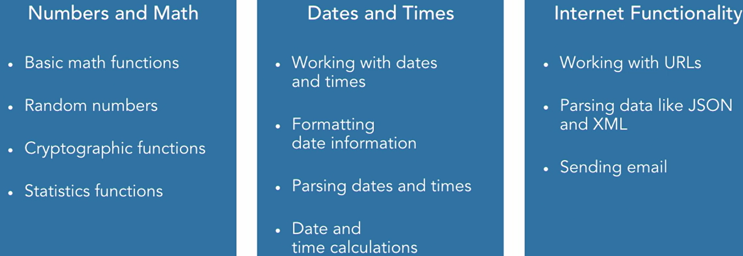
// 003 Overview

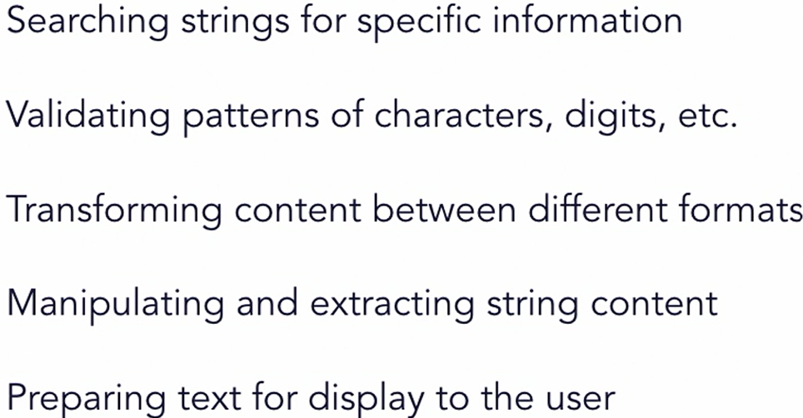
// 101 Text Processing

// 102 Basic string operations
import string
# predefined string constants used in common scenarios
print(string.ascii_letters); print(string.digits)
print(string.hexdigits); print(string.punctuation)

# Use the constants to filter information out
t_str1 = "The quick brown fox jumps over the lazy dog on the 1st of December"
t_str2 = "Supercalifragilistic"; t_str3 = "90210"

print("".join([c for c in t_str1 if c in string.ascii_letters]))
# String testing methods
print(t_str1.isalnum()); # False
print(t_str2.isalpha()) # True
print(any([c.isalpha() for c in t_str1])); # True
print(t_str3.isnumeric()) # True

// 103 Searching String for specific data
sampleStr = "The the quick brown fox jumps over the lazy dog"
# startsWith and endsWith functions
print(sampleStr.startswith("the")) #False
print(sampleStr.endswith("dog")) #True
# the find and rfind functions
print(sampleStr.find("the")) # 4
print(sampleStr.rfind("the")) # 35
print("the" in sampleStr) # True
# using replace
newStr = sampleStr.replace("lazy", "tired");
# counting instances of substrings
print(sampleStr.count("over")) # 1
// 104 String manipulate
test_string1 = "The quick brown fox jumps over the lazy dog on the 1st of December"

# Use the split and join functions
result = test_string1.split(" ")
print(result)

letters = ["a", "b", "c", "d", "e"]; print(", ".join(letters))
# use justification functions to align strings
# ljust, center, rjust
names = ["Amy", "John", "George", "Michael", "Penelope"]
biggest = max(len(name) for name in names)

for name in names:
print(name.ljust(biggest+2, "-") + ":")
print(name.center(biggest+2, "-") + ":")
print(name.rjust(biggest+2, "-") + ":")

# Use a translation table to replace characters
sample_str = "The quick brown fox jumped over the lazy dog"

trans_table = str.maketrans("abegilostz", "4636110572")
print(sample_str)
print(sample_str.translate(trans_table))

// 105 String Formating // 106
# String formatting methods and best practices
from string import Template
import datetime
# Using Template strings
the_str = "The quick brown $animal $action over the lazy dog"
the_template = Template(the_str)
output_str = the_template.substitute(animal="fox", action="jumped"); print(output_str)

args = { "animal": "cow", "action": "walked" }
output_str = the_template.substitute(args); print(output_str)

foo = "foo"; bar = 123
print("Output: {var2:x}, {var2:X}, {var1}".format(var1=foo, var2=bar))

# Using interpolation with f-strings in Python 3.6
product = "Widget"; price = 19.99; tax = 0.07
nyd = datetime.datetime(2019, 1, 1)
print(f"{product} has a price of {price}, with tax {tax:.2%} the total is {round(price + (price * tax), 2)}")
# 19.99, with tax 7.00% the total is 21.39
print(f"But only on: {nyd:%B %d, %Y}")
# But only on: January 01, 2019
// 201 sorted func
testScores = [82, 67, 94, 73, 79, 86, 58, 91, 89, 71, 88, 77, 84]
sortedScores = sorted(testScores) # descending order default
# explicitly declare a sort order - ascending and descending
sortedScores = sorted(testScores, reverse=True) # ascend

// 202 sorting with key params
# the key parameter can be used to sort complex objects
class Product():
def __init__(self, name, price, weight, discount):
self.name = name; self.price = price
self.weight = weight; self.discount = discount
def __repr__(self):
return repr((self.name, self.price, self.weight))
def discountPrice(self):
return self.price - (self.price * self.discount)

prodList = [ Product("Widget", 50, 10, 0.05),
Product("Doohickey", 40, 8, 0.15),
Product("Thingamabob", 35, 12, 0.0) ]

# use the key parameter to select a field to sort on
def prodsort(product):
return product.price

print(sorted(prodList, key=prodsort)) # ascend order default
# use the key parameter to select a field to sort on
print(sorted(prodList, key=lambda p: p.price))
# the key parameter can also call a method on the object
print(sorted(prodList, key=lambda p: p.discountPrice()))

// 203 Sorting Stability
# sort by two different keys, taking advantage of stability
result = sorted(prodList, key=lambda p: p.weight)
print(sorted(result, key=lambda p: p.price, reverse=True))
# when key used then reverse will make order descending

// 204 Sort Operators
# the operator module functions provide easy ways to select fields attrgetter() retrieves a given attribute or property from an object itemgetter() retrieves an item at a given index in a collection methodcaller() calls the given method on the object
print("Using the attrgetter method:")
print(sorted(prodList, key=attrgetter("weight"), reverse=True))

print("Using methodcaller to invoke a method:")
print(sorted(prodList, key=methodcaller("discountPrice")))
# Use itemgetter to retrieve an index
invent = [("WidA", 5), ("WidB", 2), ("WidC", 4), ("WidD", 7)]
print(sorted(invent, key=itemgetter(1)))
// 205 Sort Efficient using array
# The array type can hold homogeneous data types and operate on them more efficiently while using less memory
from array import array
from sys import getsizeof

# Create an array of integer numbers
arr1 = array('i', [2, 4, 6, 8, 10, 12, 14, 16, 18, 20])
print(arr1.typecode) # i
print(arr1.itemsize) # 4

# Add additional items to the array
arr1.insert(3, 0) # push at [3] index value 0
arr1.append(22) # push to arr1
arr1.extend([24, 26, 28]) # push to arr1
print(arr1)

# iterate over the array content like any other list
for i, elem in enumerate(arr1):
arr1[i] = elem*2
print(arr1)

# Try to add a non-integer number to the array
# arr1.insert(0, 1.25)
# TypeError: ‘float’ object cannot be interpreted as an integer

# Create an array to hold bytes instead of ints
arr2 = array('B', [18, 102, 182, 56, 89, 5, 254, 32, 64, 50])
print(arr2.typecode) # B
print(arr2.itemsize) # 1

# try to add an item that's out of range
# arr2.append(300)

# Convert an array to a list
list1 = arr2.tolist()
print(list1); print(getsizeof(list1)) # 136

// 206 Sort Bisect #functions to maintain a list in sorted order
import bisect
values = [5, 7, 13, 20, 25, 31]

# exercise the left and right bisection routines
print(bisect.bisect(values, 20)) # 4 # default right
print(bisect.bisect_right(values, 20)) # 4
print(bisect.bisect_left(values, 20)) # 3
# use insort to insert new items
bisect.insort_right(values, 20) # will insert to the right
print(values) # 5, 7, 13, 20, 20, 25, 31]
bisect.insort_left(values, 13) # will insert to the left
print(values) # 5, 7, 13, 13, 20, 20, 25, 31]
// My understanding, that bisect function to identify cutoff points where the new element should be entered to keep things sorted in final output array. Example:
# bisect can be used as an array lookup using breakpoints
breakpoints = [60, 70, 80, 90]
gradeLetters = 'FDCBA'
scores = [81, 68, 53, 91, 90, 82, 76, 71, 84]

def calcGrade(score):
# bisect function to identify cutoff points for the letter grades
i = bisect.bisect(breakpoints, score)
return gradeLetters[i]
results = [calcGrade(score) for score in scores]
print(results) # ['B', 'D', 'F', 'A', 'A', 'B', 'C', 'C', 'B']

// 301 Basic file operations # skipped
// 302 Create temporary file and directory
// 303 Reading CSV files // 304 Writing CSV
import csv # Inbuilt-module with py to read/write csv
# Reading and writing Comma Separate Values files
# list the dialects that are available to use
print(csv.list_dialects())
# Open a CSV file and read each row of data
def readerSample():
with open("StockQuotes.csv") as dataFile:
reader = csv.reader(dataFile)
for row in reader:
print(row)
# Use the CSV module Sniffer to see what dialect of CSV this is
def useSniffer():
with open("StockQuotes.csv") as csvfile:
dialect = csv.Sniffer().sniff(csvfile.read(1024))
csvfile.seek(0)
hasHeader = csv.Sniffer().has_header(csvfile.read(1024))
csvfile.seek(0)
print("Headers found: " + str(hasHeader))
print(dialect.delimiter)
print(dialect.escapechar)
print(dialect.quotechar)
# Write data to a CSV file
def writerSample():
with open("SampleData.csv", mode="w") as csvfile:
# create a csv writer
csvWriter = csv.writer(csvfile)
# write the header
csvWriter.writerow(["Name", "Department", "Location"])
# write a few rows
csvWriter.writerow(["John Doe", "Accounting", "San Francisco CA"])
csvWriter.writerow(["Jane Dae", "Engineering", "Seattle WA"])
// 305 Working with Zip files
// 306 Configuration files
# read the contents of configuration files
import configparser
# Create the configuration parser
parser = configparser.ConfigParser()
parser.read("config.cfg") # Read the configuration file
# print the sections
print(parser.sections()) # ['Section 1', 'Section 2']
print(parser.has_section("Section 1")) # True

# Access one of the default values
using_time_travel = bool(parser['DEFAULT']['UseTimeTravel'])
print(using_time_travel) # True
print(type(using_time_travel)) # <class ‘bool’>
# Demonstrate the getXXX convenience functions
opd = parser['DEFAULT'].getboolean('ObeyPrimeDirective')
print(opd) # False
speed = parser['DEFAULT'].getfloat('Ship Speed')
print(speed) # 56324.586

# Access a non-existent value
try:
title = parser['Section 3']['Title']; print(title)
except KeyError as err: print("Whoa! There is no ", err)

// 401 random numbers
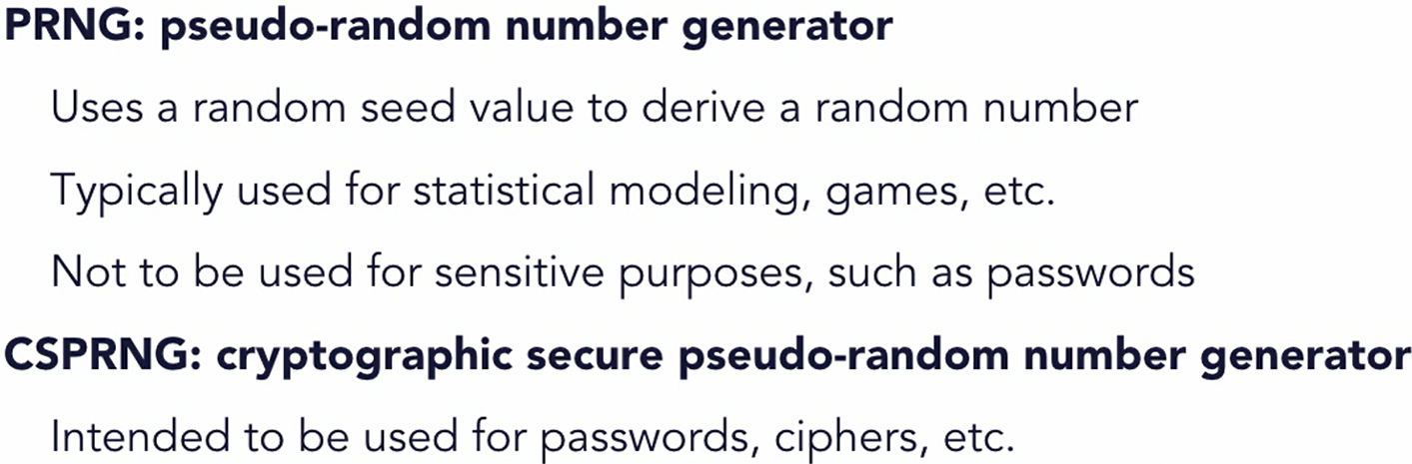
There are types of random number

# demonstrate using random module to create numbers
import random
# implement a coin toss function
for i in range(10):
if (random.random() <= 0.5): print("Heads")
else: print("Tails")

# get a random number within a range
print(random.uniform(1, 100)) # 50.987…

# generate random integers within a given range
print(random.randint(1, 100)) # 17

# generate random integers with a step function
# this example chooses from 0 to 100 stepped by 5
print(random.randrange(0, 101, 5)) # 95
# Use the seed function to position the generator
random.seed(1)
print(random.random()) # 0.134….
print(random.random()) # 0.847…
print("----------------")
random.seed(1) # will result the same as above
print(random.random()) # 0.134….
print(random.random()) # 0.847…

// 402 random sequence operations
import string
# Use the choice function to randomly select from a sequence
moves = ["rock", "paper", "scissors"]
print(random.choice(moves))

# Use the choices function to create a list of random elements
roulette_wheel = ["black", "red", "green"]
weights = [18, 18, 2]
print(random.choices(roulette_wheel, weights, k=10))
# k means run 10 times and get 10 choices
# without weight it will be random
# with weight we are giving priority to items for random selection
------ ------- ------ -------
# chosen items are not reselected in output
chosen = random.sample(string.ascii_uppercase, 6)
print(chosen)
# The shuffle function shuffles a sequence in place
players = ["Bill", "Jane", "Joe", "Sally", "Mike", "Lindsay"]
random.shuffle(players); print(players)

# shuffle an immutable sequence, use sample function first
result = random.sample(string.ascii_uppercase, k=len(string.ascii_uppercase))
random.shuffle(result)
print(''.join(result))

// 403 random cryptographical secure // from 3.6
# Using cryptographic methods to generate random data
# that may be sensitive. secrets module in Python 3.6
import os
import secrets
# the urandom() in OS module produce random numbers that
# are cryptographically safe to use for sensitive purposes
result = os.urandom(8); print([hex(b) for b in result])
# secrets.choice is same as random.choice but more secure
moves = ["rock", "paper", "scissors"]; print(secrets.choice(moves))

# secrets.token_bytes generates random bytes
result = secrets.token_bytes(); print(result)
# secrets.token_hex creates a random string in hexadecimal
result = secrets.token_hex(); print(result)
# secrets.token_urlsafe generate character that can be in URLs
result = secrets.token_urlsafe(); print(result)

// 404 Temporary password
# Create a temporary password using Python
import secrets import string
# Function to return a temporary password given a length
def generateTempPass(numChars=8):
potentialChars = string.ascii_letters + string.digits + "+=?/!@#$%*"
result = ''.join(secrets.choice(potentialChars) for i in range(numChars))
return result
# Function to return a temporary password and enforce 1 number and 1 uppercase
def generateBetterPass(numChars=8):
potentialChars = string.ascii_letters + string.digits + "+=?/!@#$%*"
while True:
result = ''.join(secrets.choice(potentialChars)
for i in range(numChars))
# if the password has at least one number and one uppercase char we can stop
# else the loop will keep on generating random secret
if (any(c.isupper() for c in result)
and any(c.isdigit() for c in result)):
break
return result
# create a temporary password
print(generateTempPass(10))
# create a stronger temporary password
print(generateBetterPass(10))

# create a temporary, hard-to-guess URL
resultUrl = "https://my.example.com?reset="
resultUrl += secrets.token_urlsafe(15)
print(resultUrl)

// 405 Unique Identifier # Generating unique identifiers
import uuid
# use the uuid4 function to create a random sequence using
# the underlying os.urandom() function
# 128-bit string value
resl = uuid.uuid4()
print("UUID4: "); print(resl); print(resl.hex); print(resl.urn)
# create a UUID using uuid5, which takes a namespace and
# name value. Note that this version is not crypto-safe
res = uuid.uuid5(uuid.NAMESPACE_DNS, "example.com")
print("UUID5: "); print(res); print(res.hex); print(res.urn)
// 406 Statistics function # for median, average, mean
# for basic operation built-in library works // skipped
# for advance operation use 3rd party like numpy, etc.

// 501 Basic dates times # skip
// 502 Date_time format // 503 calc dates_times # skip

// 601 Working with URLs # urllib
import urllib.parse # Using the URL parsing functions
sample_url = "http://server.example.com:8080/example.html?val1=1&val2=Hello+World"
# parse a URL with urlparse()
result = urllib.parse.urlparse(sample_url)
print(result)
print(result.scheme, result.hostname, result.path)
print(result.geturl())

# quote() replaces special characters for use in URLs
sample_string = "Hello El Niño"
print(urllib.parse.quote(sample_string))
print(urllib.parse.quote_plus(sample_string))
# Use urlencode() to convert maps to parameter strings
query_data = {
'Name': "John Doe", "City": "Anytown USA", "Age": 37 }
result = urllib.parse.urlencode(query_data); print(result)

// 602 Retrieving internet data # skip
import urllib.request
// 603 HTML # skip
from html.parser import HTMLParser

// 604 JSON # working with JSON data
import urllib.request; import json
req = urllib.request.urlopen("http://httpbin.org/json")
data = req.read().decode('utf-8'); print(data)
obj = json.loads(data); print(obj["slideshow"]["author"])
for slide in obj["slideshow"]["slides"]: print(slide["title"])
# python objects can also be written out as JSON
objdata = { "name": "Joe Marini", "author": True, "titles": [ "Learning Python", "Advanced Python", ]}
with open("jsonoutput.json", "w") as fp:
json.dump(objdata, fp, indent=4)

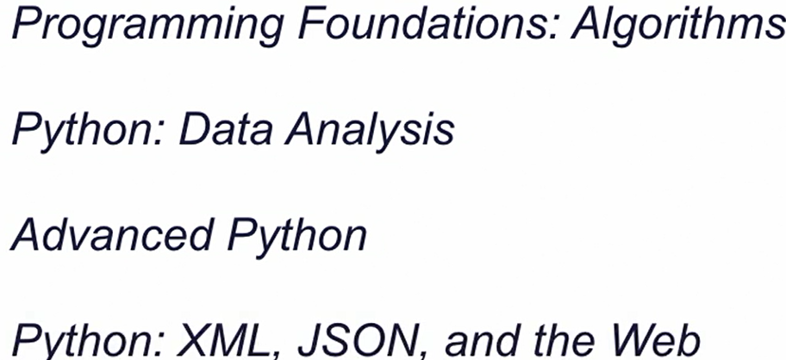
// 701 Next

