**Lyn: Ai Foundations Thinking Machines**

**// 101 Intro**

AI: Any system that exhibits behavior that could be interpreted as human intelligence

There’s no one standard for human intelligence.

A Game is perfect pattern for AI:

* Set rules
* Certain possibilities
* Easy pattern matching for possible answers

**// 102 GPS**

Physical Symbol System Hypothesis (1996):

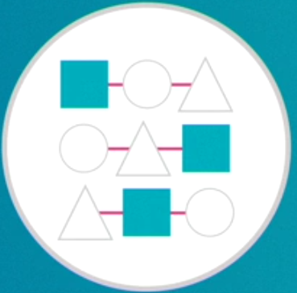If we can connect symbols than we can achieve an intelligent machine.

Combinatorial explosion: matching pattern and producing result. Patterns recorded by expert also names as expert system

**// 103 Strong AI vs Weak AI**

Strong: Display all person-like behaviour

Weak or Narrow: Machine is confined to a very narrow task

It will assist you for narrow tasks.

**// 104 Planning**

Expert system as now named as Planning AI, how to match your symbols with heuristic reasoning. *Google map uses it.*

Symbolic system and Planning AI works well for some apps.

**// 201 Machine Learning**

Machine learn, where we make computer to learn its pattern and generate solution by itself. It is better than Expert system, because ML can improve by each new content pattern increment.

**// 202 ANN: Artificial Neural Network**

It tries to mimic biological brain. Large scale trial and errors.

**// 203 Perceptions**

ML started with symbolic system and has taken a pause.

Perceptrons are initial ANN. First machine name is **Mark 1 Perception**

1990’s Deep Learning: because there are many hidden layer b/w input and output generated, works on back propagation

Clustering is allowing categorisation

**// 301 Match Patterns**

ML is better over Symbolic reasoning

**// 302 Data**

Which approach for ML should we taken?

* **Symbolic reasoning** = Abstract problem, but know steps
  + Long setup and no outside data
* **Machine learning** = Look for patterns
  + Lots of data that needs regular self-tweaking

Or a mix ratio of two

**Deep learning** example to train for fan recognition:

* Fill data in form of image, videos for fan
* Fill sounds of fan
* Fill and train fan rotation sensor detection

**ML advantages:**

* Zero in on perfect pattern match
* Flexible and No human reliance

**// 303 Unsupervised**

Supervised Learning

* Giving training set
* Human intervention

Unsupervised Learning

* No Human intervention while training

**// 304 Back Propagation or Error correction**

**// 305 Regression analysis for training**

Relation b/w dependent and independent variables

Classification (Sorting) vs Regression (Connecting)

ANN will only show the patterns of input, not any answer

**// 401 Robotics: works on physical tasks**

**// 402 NLP Natural Language Processing**

**// 403 IOT**

**// 501 Big Data**

ML requires training and frameworks

Data mining uses broader tools without required training

**// 502 Data Science**

Programming, Data, Math, Statistics, Hacking

**Finding why in data pattern**

**// 601 Pitfalls**

Does the program require abstract reasoning or detailed pattern matching?

Symbolic Reasoning:

Decisions, Actions, Symbols

Machine Learning:

ANN for key pattern recognition

**Lyn: Elastic Search Essential Training**

**// 101 Origins**

Started from Lucene 1999

Moved to Compass 2004

Now as Elasticsearch 2010

**// 102 Elastic the company**

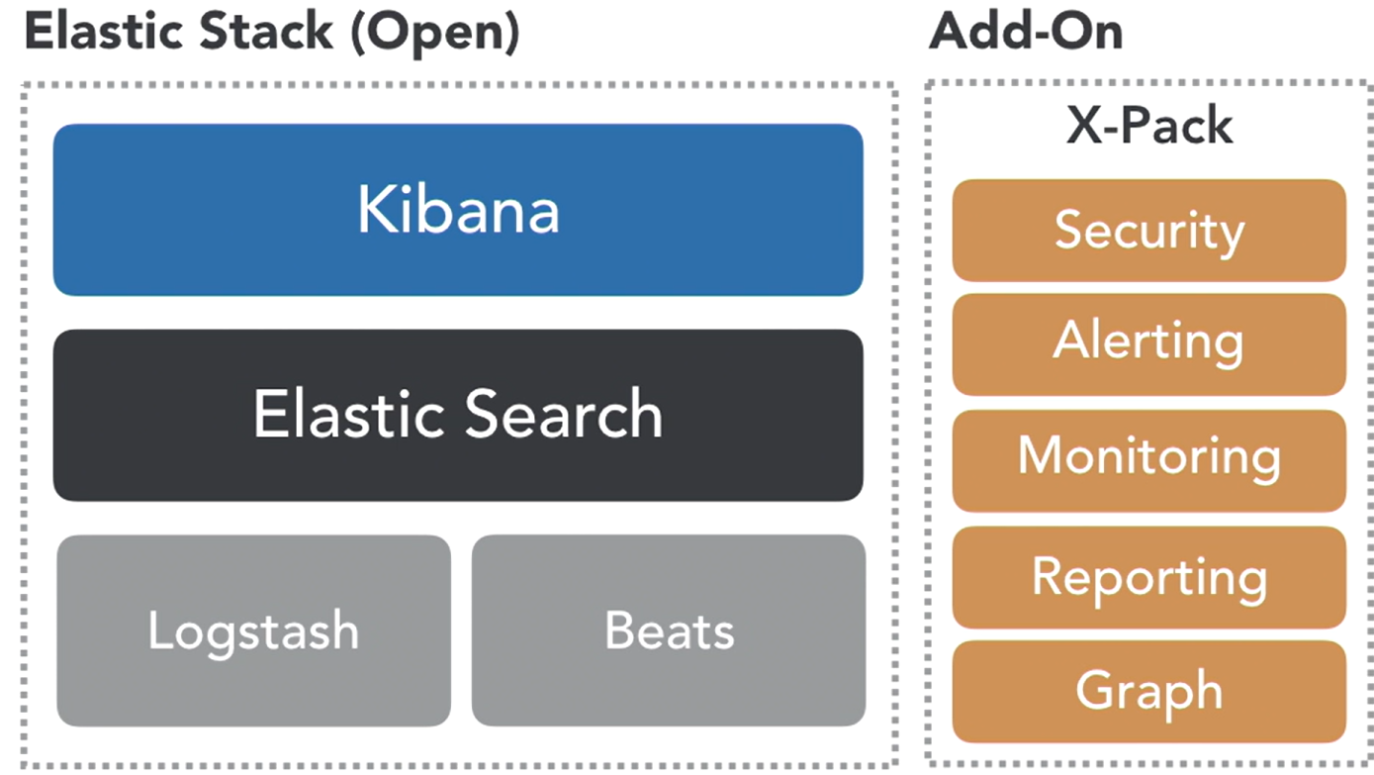**// 103 Elastic Overview**

* Scalability, Near Real-Time
* NoSQL platform, Schema less
* Advance Query Language

**// 104 Use cases**

* Security / Log analytics
* Marketing - Search - Operations

**// 105 Elastic Cluster**

Cluster 🡪Node 🡪Index (table)

🡪Type (partitioner) 🡪Document (json)

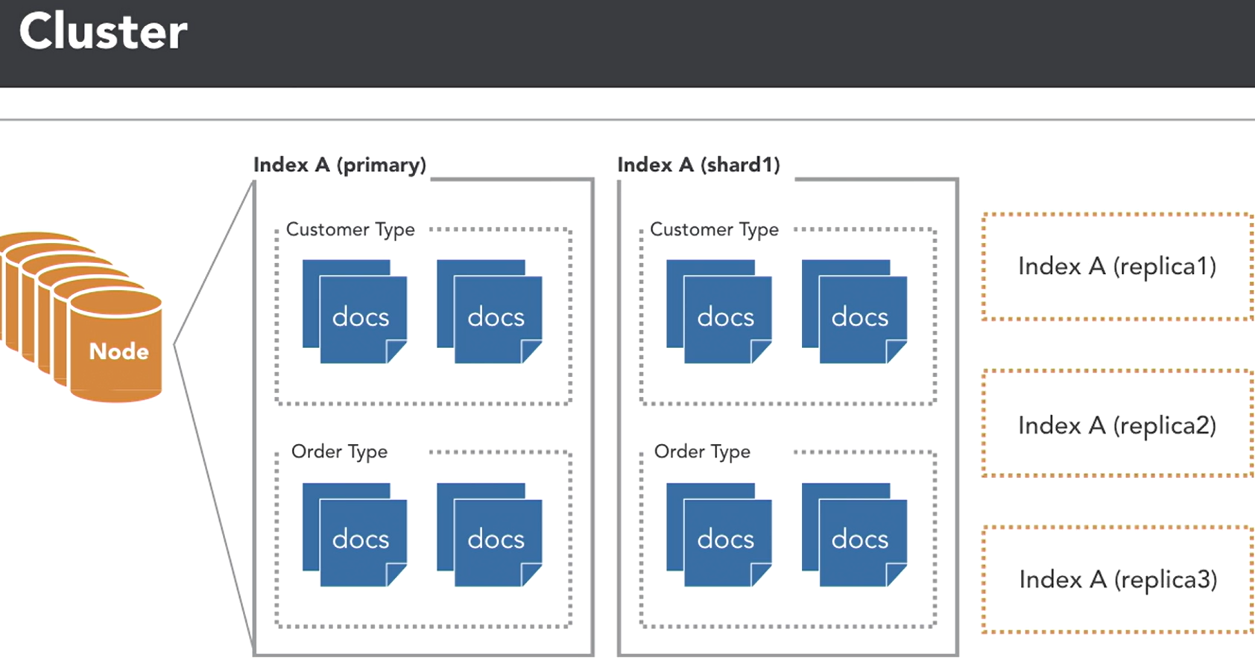🡪Shard / Replica

**// 201 Elastic Cloud**

*// basic cloud account setup high level*

**// 202 Install Elastic locally with Kibana (java)**

**// 203 Explore cluster**

**// 301 Bulk loading data**

**// 302 Load sample data**

**// 303 Data types**

Core, Complex, Geo, Specialized

**// 401 Simple Queries**

# show me everything

GET bank/account/_search

# find CA accounts only

GET bank/account/_search

{ "query": {

"match": { "state": "CA" } } }

# find "Techade" accounts in CA only

GET bank/account/_search

{ "query": {

"bool": {

"must": [ { "match": {"state": "CA"} },

{ "match": {"employer": "Techade"} } ] } } }

# find non "Techade" accounts outside of CA

GET bank/account/_search

{"query": {

"bool": {

"must_not": [ { "match": {"state": "CA"} },

{ "match": {"employer": "Techade"} } ] } } }

# Boost results for Smith

GET bank/account/_search

{"query": {

"bool": {

"should": [ { "match": {"state": "CA"} },

{ "match": {"lastname": { "query": "Smith","boost": 3 }

} } ] } } }

**// 402 AWS Glacier**

**// 403 AWS Glacier**

**// 501 AWS Glacier**

**// 502 AWS Glacier**

**// 503 AWS Glacier**

**// 601 AWS Glacier**

**// 602 AWS Glacier**

**// 603 AWS Glacier**

**// 701 AWS Glacier**

**Lyn: TypeScrg**

https://catalog.workshops.aws/stepfunctions/en-US

**// 201 A**

**// 202 A**

**// 203 A**

**// 204 A**

**// 05 A**

**// 06 A**

**// 201 A**

**// 202 A**

**// 203 A**

**// 204 A**

**// 05 A**

**// 06 A**

**// 201 A**

**// 202 A**

**// 203 A**

**// 204 A**

**// 05 A**

**// 06 A**

**// 201 A**

**// 202 A**

**// 203 A**

**// 204 A**

**// 05 A**

**// 06 A**

**// 201 A**

**// 202 A**

**// 203 A**

**// 204 A**

**// 05 A**

**// 06 A**

**// 201 A**

**// 202 A**

**// 203 A**

**// 204 A**

**// 05 A**

**// 06 A**

**// 201 A**

**// 202 A**

**// 203 A**

**// 204 A**

**// 05 A**

**// 06 A**

**// 201 A**

**// 202 A**

**// 203 A**

**// 204 A**

**// 05 A**

**// 06 A**

**Lyn: TypeScrg**

https://catalog.workshops.aws/stepfunctions/en-US

**// 201 A**

**// 202 A**

**// 203 A**

**// 204 A**

**// 05 A**

**// 06 A**

**// 201 A**

**// 202 A**

**// 203 A**

**// 204 A**

**// 05 A**

**// 06 A**

**// 201 A**

**// 202 A**

**// 203 A**

**// 204 A**

**// 05 A**

**// 06 A**

**// 201 A**

**// 202 A**

**// 203 A**

**// 204 A**

**// 05 A**

**// 06 A**

**// 201 A**

**// 202 A**

**// 203 A**

**// 204 A**

**// 05 A**

**// 06 A**

**// 201 A**

**// 202 A**

**// 203 A**

**// 204 A**

**// 05 A**

**// 06 A**

**// 201 A**

**// 202 A**

**// 203 A**

**// 204 A**

**// 05 A**

**// 06 A**

**// 201 A**

**// 202 A**

**// 203 A**

**// 204 A**

**// 05 A**

**// 06 A**

**Lyn: TypeScrg**

https://catalog.workshops.aws/stepfunctions/en-US

**// 201 A**

**// 202 A**

**// 203 A**

**// 204 A**

**// 05 A**

**// 06 A**

**// 201 A**

**// 202 A**

**// 203 A**

**// 204 A**

**// 05 A**

**// 06 A**

**// 201 A**

**// 202 A**

**// 203 A**

**// 204 A**

**// 05 A**

**// 06 A**

**// 201 A**

**// 202 A**

**// 203 A**

**// 204 A**

**// 05 A**

**// 06 A**

**// 201 A**

**// 202 A**

**// 203 A**

**// 204 A**

**// 05 A**

**// 06 A**

**// 201 A**

**// 202 A**

**// 203 A**

**// 204 A**

**// 05 A**

**// 06 A**

**// 201 A**

**// 202 A**

**// 203 A**

**// 204 A**

**// 05 A**

**// 06 A**

**// 201 A**

**// 202 A**

**// 203 A**

**// 204 A**

**// 05 A**

**// 06 A**

**Lyn: TypeScrg**

https://catalog.workshops.aws/stepfunctions/en-US

**// 201 A**

**// 202 A**

**// 203 A**

**// 204 A**

**// 05 A**

**// 06 A**

**// 201 A**

**// 202 A**

**// 203 A**

**// 204 A**

**// 05 A**

**// 06 A**

**// 201 A**

**// 202 A**

**// 203 A**

**// 204 A**

**// 05 A**

**// 06 A**

**// 201 A**

**// 202 A**

**// 203 A**

**// 204 A**

**// 05 A**

**// 06 A**

**// 201 A**

**// 202 A**

**// 203 A**

**// 204 A**

**// 05 A**

**// 06 A**

**// 201 A**

**// 202 A**

**// 203 A**

**// 204 A**

**// 05 A**

**// 06 A**

**// 201 A**

**// 202 A**

**// 203 A**

**// 204 A**

**// 05 A**

**// 06 A**

**// 201 A**

**// 202 A**

**// 203 A**

**// 204 A**

**// 05 A**

**// 06 A**

**Lyn: TypeScrg**

https://catalog.workshops.aws/stepfunctions/en-US

**// 201 A**

**// 202 A**

**// 203 A**

**// 204 A**

**// 05 A**

**// 06 A**

**// 201 A**

**// 202 A**

**// 203 A**

**// 204 A**

**// 05 A**

**// 06 A**

**// 201 A**

**// 202 A**

**// 203 A**

**// 204 A**

**// 05 A**

**// 06 A**

**// 201 A**

**// 202 A**

**// 203 A**

**// 204 A**

**// 05 A**

**// 06 A**

**// 201 A**

**// 202 A**

**// 203 A**

**// 204 A**

**// 05 A**

**// 06 A**

**// 201 A**

**// 202 A**

**// 203 A**

**// 204 A**

**// 05 A**

**// 06 A**

**// 201 A**

**// 202 A**

**// 203 A**

**// 204 A**

**// 05 A**

**// 06 A**

**// 201 A**

**// 202 A**

**// 203 A**

**// 204 A**

**// 05 A**

**// 06 A**

**Lyn: TypeScrg**

https://catalog.workshops.aws/stepfunctions/en-US

**// 201 A**

**// 202 A**

**// 203 A**

**// 204 A**

**// 05 A**

**// 06 A**

**// 201 A**

**// 202 A**

**// 203 A**

**// 204 A**

**// 05 A**

**// 06 A**

**// 201 A**

**// 202 A**

**// 203 A**

**// 204 A**

**// 05 A**

**// 06 A**

**// 201 A**

**// 202 A**

**// 203 A**

**// 204 A**

**// 05 A**

**// 06 A**

**// 201 A**

**// 202 A**

**// 203 A**

**// 204 A**

**// 05 A**

**// 06 A**

**// 201 A**

**// 202 A**

**// 203 A**

**// 204 A**

**// 05 A**

**// 06 A**

**// 201 A**

**// 202 A**

**// 203 A**

**// 204 A**

**// 05 A**

**// 06 A**

**// 201 A**

**// 202 A**

**// 203 A**

**// 204 A**

**// 05 A**

**// 06 A**

**Lyn: TypeScrg**

https://catalog.workshops.aws/stepfunctions/en-US

**// 201 A**

**// 202 A**

**// 203 A**

**// 204 A**

**// 05 A**

**// 06 A**

**// 201 A**

**// 202 A**

**// 203 A**

**// 204 A**

**// 05 A**

**// 06 A**

**// 201 A**

**// 202 A**

**// 203 A**

**// 204 A**

**// 05 A**

**// 06 A**

**// 201 A**

**// 202 A**

**// 203 A**

**// 204 A**

**// 05 A**

**// 06 A**

**// 201 A**

**// 202 A**

**// 203 A**

**// 204 A**

**// 05 A**

**// 06 A**

**// 201 A**

**// 202 A**

**// 203 A**

**// 204 A**

**// 05 A**

**// 06 A**

**// 201 A**

**// 202 A**

**// 203 A**

**// 204 A**

**// 05 A**

**// 06 A**

**// 201 A**

**// 202 A**

**// 203 A**

**// 204 A**

**// 05 A**

**// 06 A**