**TEAM01NOV16**

* **Web Site Access: http://10.250.0.9/team01nov16/** **ProjectFinalStage/index.php**
* **GitHub Link : https://github.com/githins/team01nov16.git**

PROJECT REPORT

KAO-PIO

TEAM MEMBERS:

* GITHIN SHAJI
* ABHISHIKTH KOUNDINYA KALLURU
* AVINASH RAJEEV
* RAVI TEJA KAMBALA

**PROJECT CONCEPT & OBJECTIVES**

The Kao Pio is a website developed for a restaurant in Brisbane and the main idea behind the website is to provide the necessary information to the valued customers. The website is designed d in such a way that it is simple and very clear for the users to identify each and every information for the website,

The website has also concentrated on easiness and to reduce the text content so that it can give a good feeling for the users while browsing. Another main objective of the website was to provide maximum information regarding the dishes available in the restaurant, for that we added a special field to provide the information of recipes in the menu page.

Each and every page of the website is title do that user can easily identify currently which page he is. Also each and every page is linked to each other, ie from any page of the website it is possible to navigate to any other part of the website.

Moreover, the website is embedded with google maps to provide the information regarding the location. Also the user is able to search for menu items and a user is having a privilege of becoming a registered user by registering into the website. Once registered the user can login and continue using the website with special privileges.

**PROJECT WEB 2.0 FEATURES**

* Social Media Links
* Responsive to all pages
* Viewable on multiple devices
* Use of pictures in websites
* Login/logout
* Registration

**FEATURES IMPLEMENTED**

* New user can register into KAO PIO.
* User can login/logout.
* User can search for dishes.
* User can view menu which has multi cuisines.
* User can find the address and contact information.
* User can navigate through each and every page because all the pages are interlinked.

**FEATURES PLANNED BUT NOT IMPLEMENTED**

* Take away page
* Delivery page

**POTENTIAL IMPROVEMENT**

* User can know the current page he is on
* Change of menu page with clicks and pictures
* Fixing of small errors on home pages on small devices.
* Improvement in about us page
* Fixes in login/logout page

**FRAMEWORK AND TECHNOLOGIES ADOPTED**

Front end requirements: HTML5, CSS, JAVASCRIPT.

Back end requirements: PHP.

Tools: Dreamweaver, Photoshop, oracle.

**TEAM INDIVIDUAL CONTRIBUTION**

Githin Shaji: Home Page, Search, CSS

Abhishikth Kalluru: Login/Logout, Registration

Ravi Teja Kambala: Menu Page, Documentation, Data Collection

Avinash Rajeev: About Us Page, Social Media Links

**OUR WEBSITE GIVES A GLANCE OF THE FOLLOWING PAGES:**

* 1. Home page: It gives an introduction to our service where visitor can explore further about our services
  2. About: It gives a glance about the location information of the restaurant.
  3. Registration: It registers the new user when he provides the details.
  4. Menu: It shows the variety of food items where customer can select favourite food.
  5. Search: Enables user to search for the preferred food item with price details.
  6. Login: This page will allow the existing user to login.

**TARGETED USERS**

* Primary users

We are targeting every food lover who have an access to internet and those who like to try different cuisines just a click away.

* Secondary users

Database Administrator

**CONCEPTUAL FEATURES OF THE WEBSITE**

* Responsive web pages will fit into wide range of devices.
* Feature for registration.
* Login and Logout options
* Search for menu items from the website

**Actual implementation schedule**

Week 6: Blue print & Website Visual Design layout.

Week 8: Designing of all the following pages and assembling their database.

Week 9: Linking the Home, Menu and Login Register and other pages.

Week 10: Final Website.

**Project Setup Instructions**

**10.250.0.9/team01nov16/ProjectFinalStage/index.html**

**BLUEPRINT**

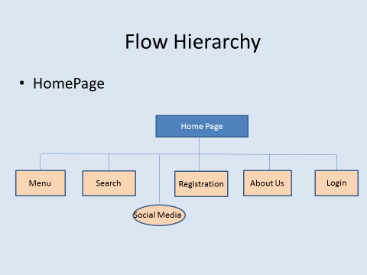

1. Home Page

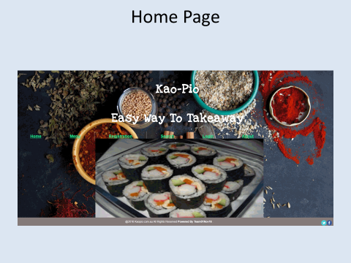

1. Registration Page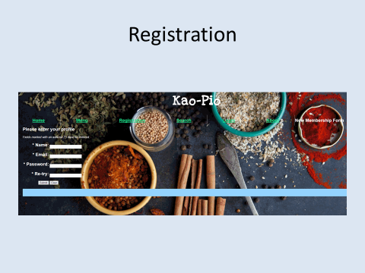
2. About Page

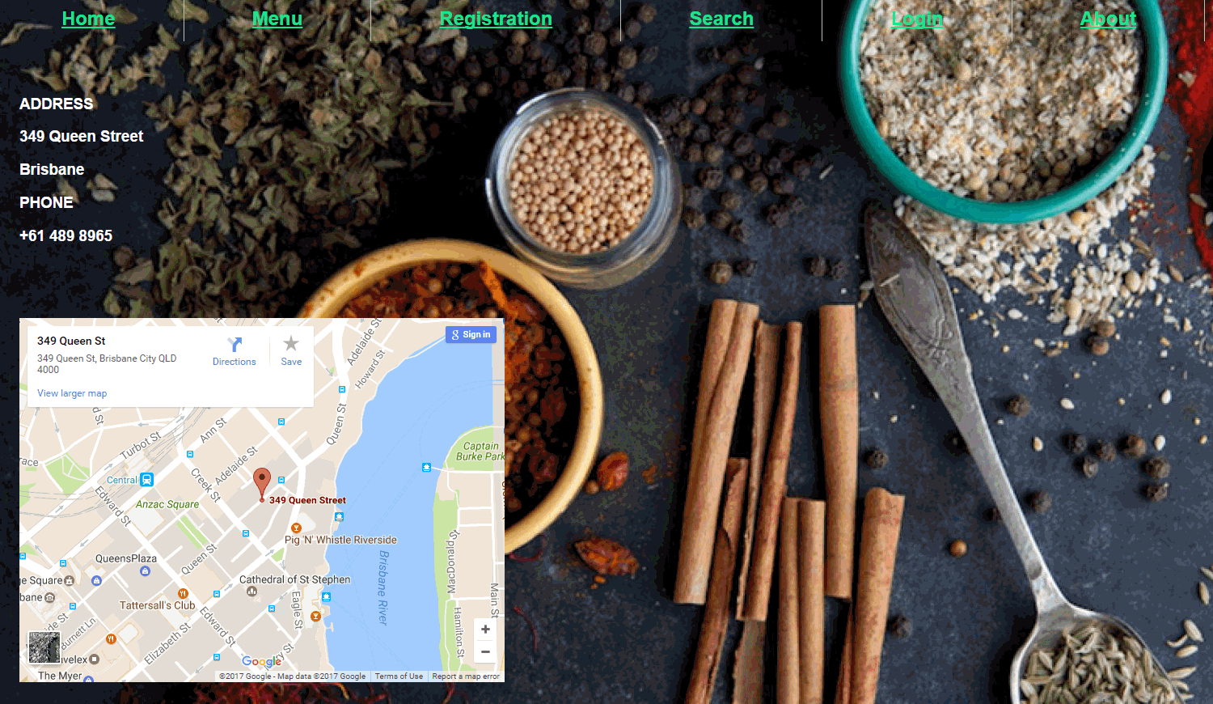

1. Login Page

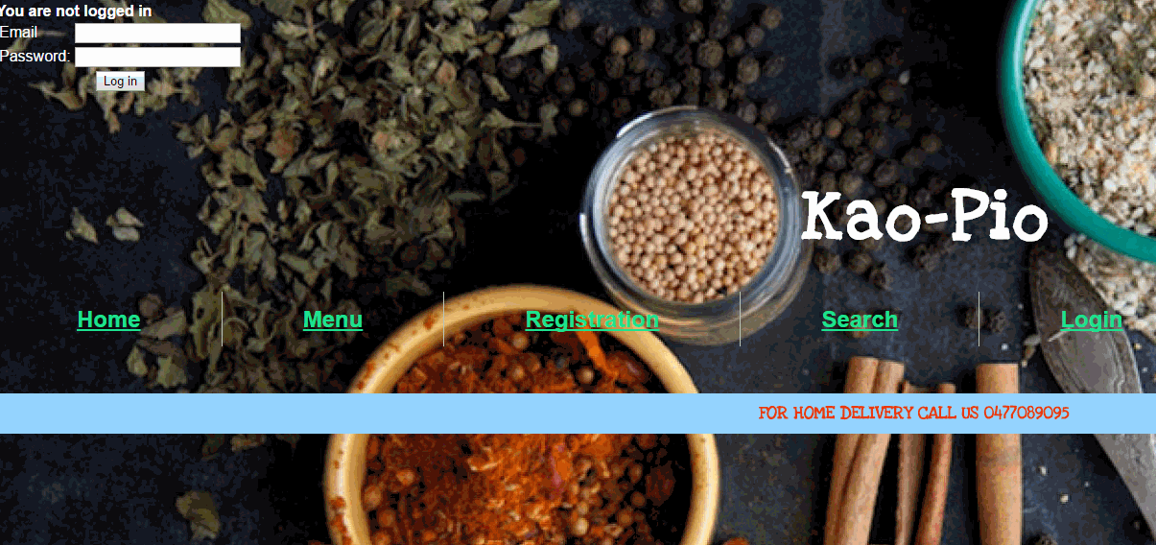

6) Menu Page

