Step 1: Launch the Application under test

* Go to github URL <https://github.com/Simplilearn-Edu/SportyShoes.git>
* Click on Green button which has Code written on it. Click on Download Zip
* The download zip file will be in your download folder
* Extract all the files in downloads folder

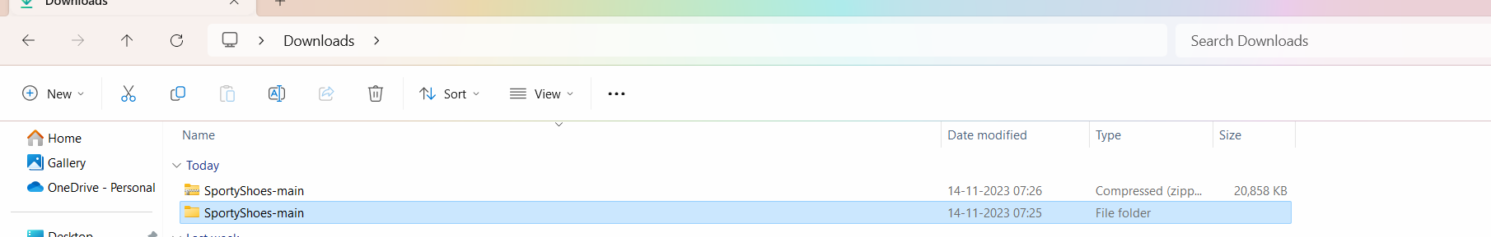

Go inside the folder SportyShoes-main and then again go in the folder SportyShoes-main

Go inside the folder where you see the sporty-shoes-v1 jar file

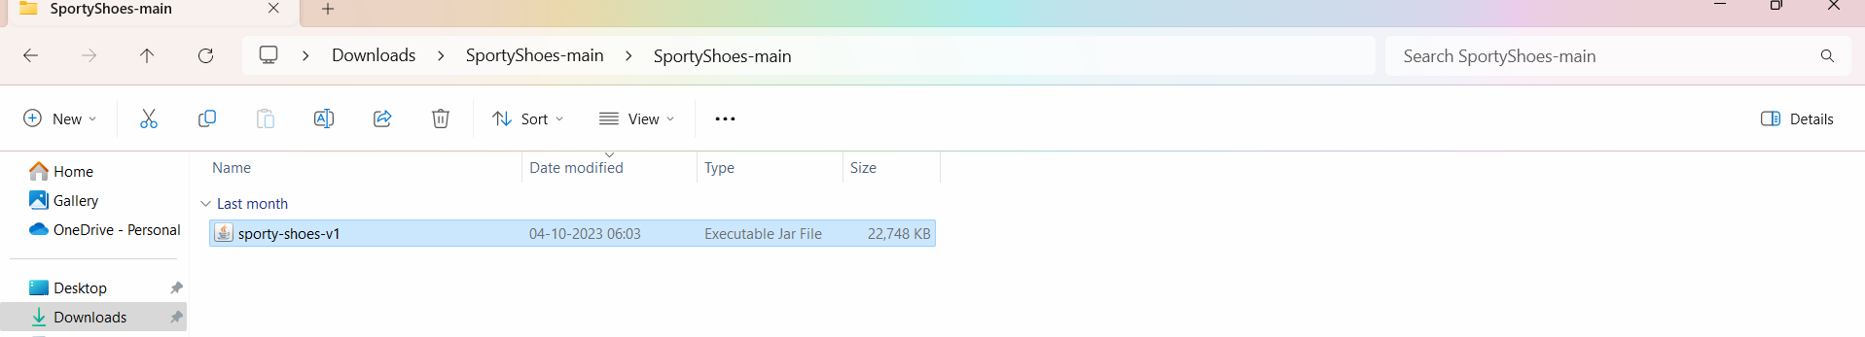

Start cmd prompt in the same folder

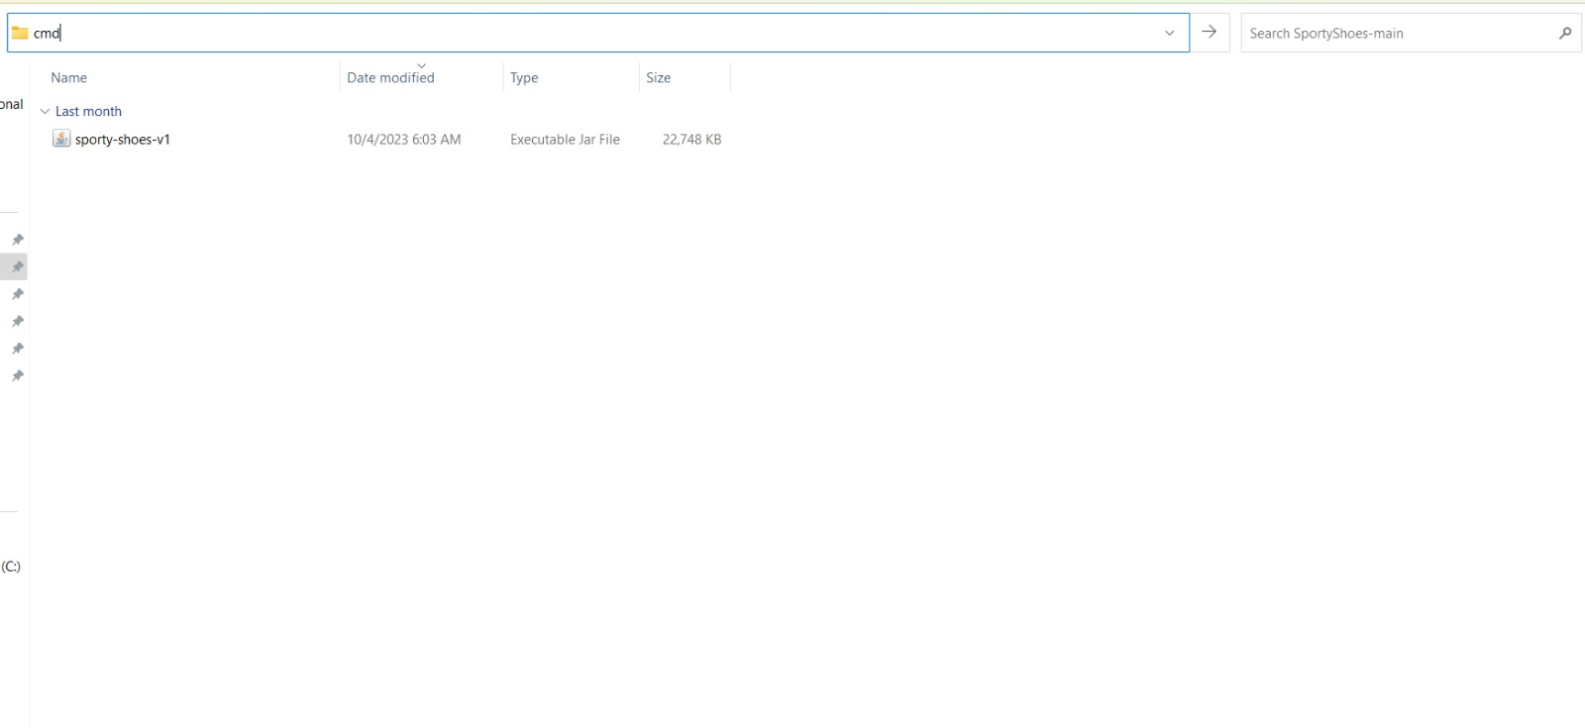

Execute the java command to run the jar file and deploy the application

java -jar sporty-shoes-v1.jar

OR

java -jar -Dserver.port=8100 sporty-shoes-v1.jar

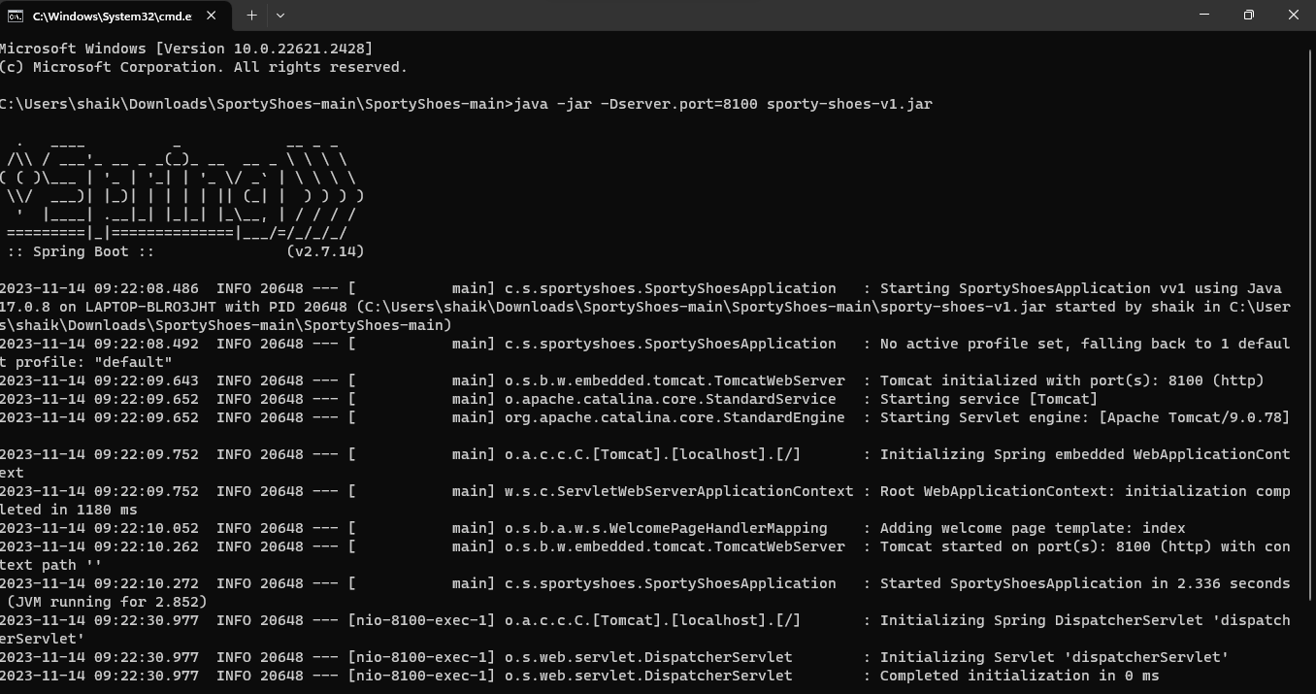

Implementing Postman steps:

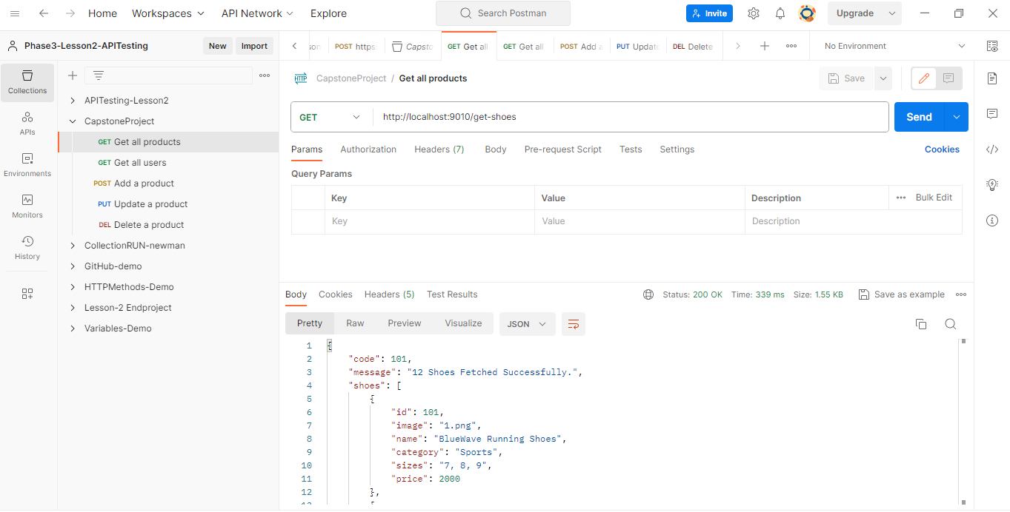

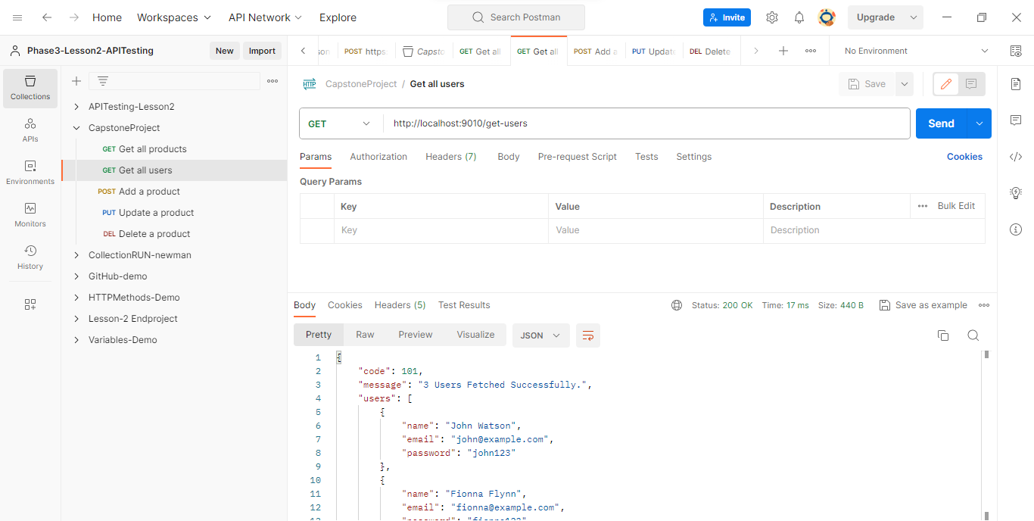

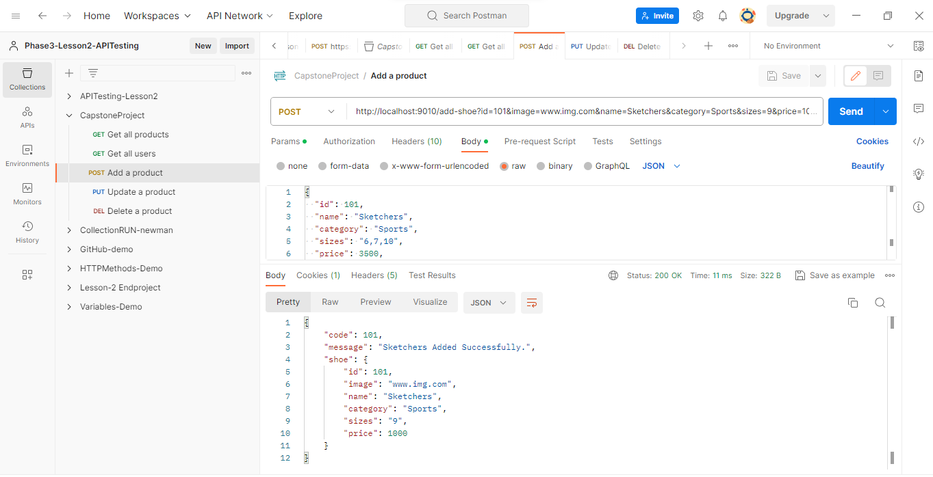

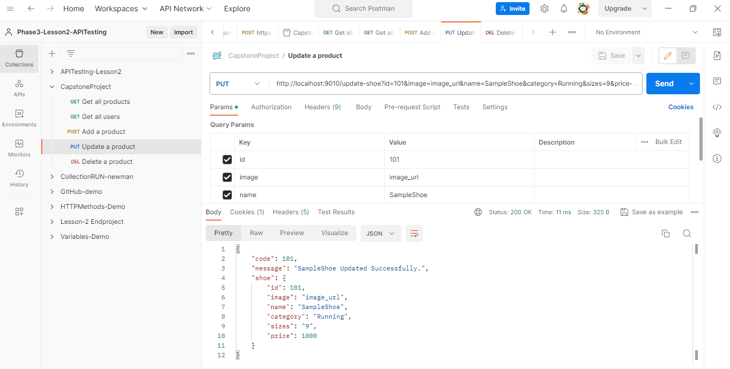

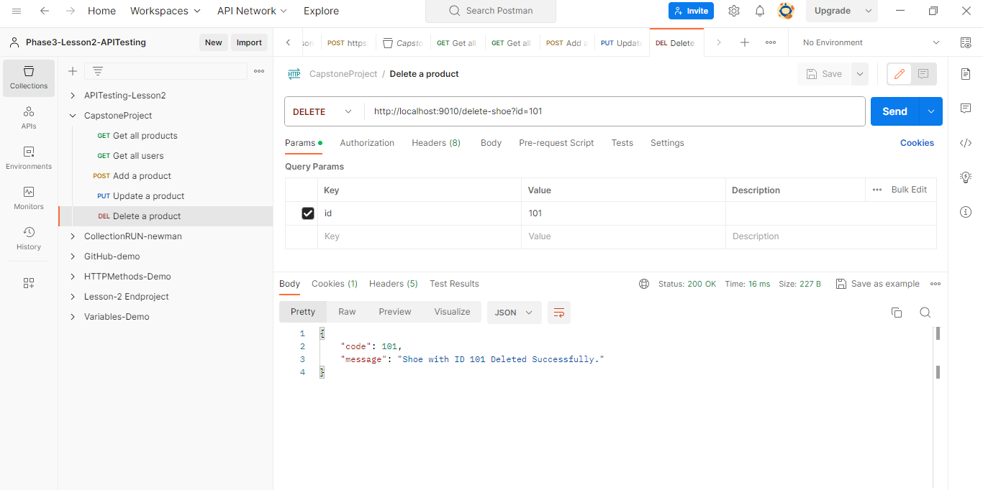

Rest Assured Demo:

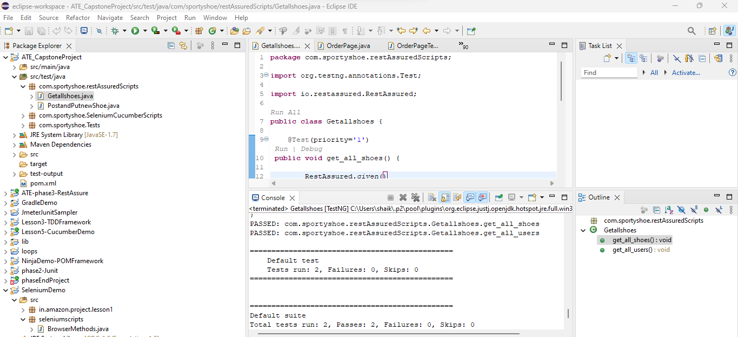

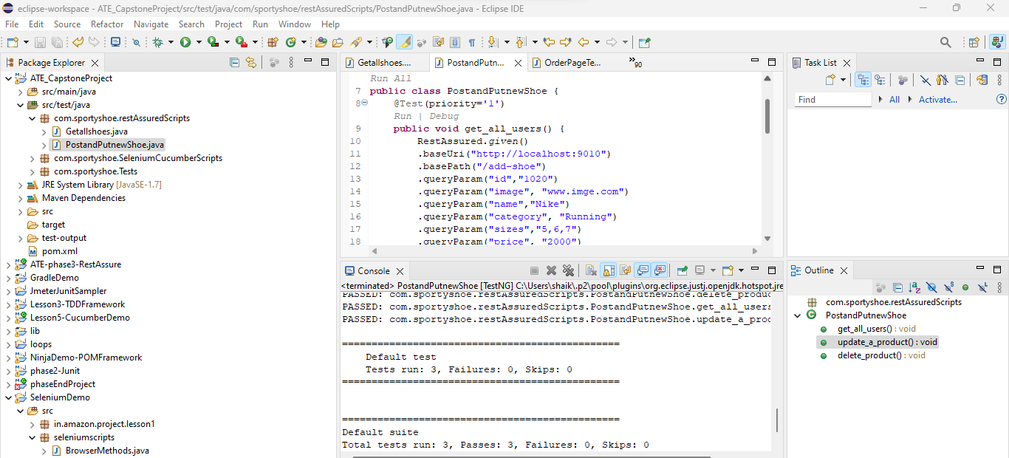

Selenium scripts:-

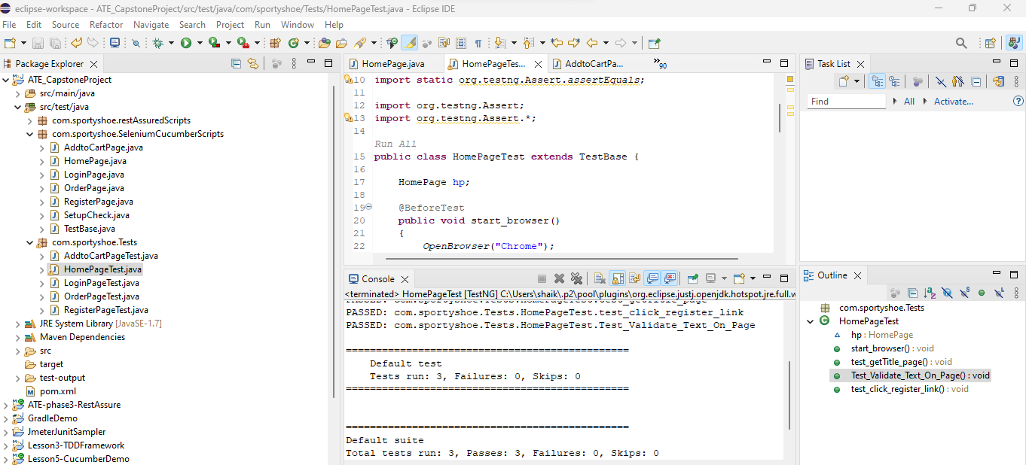

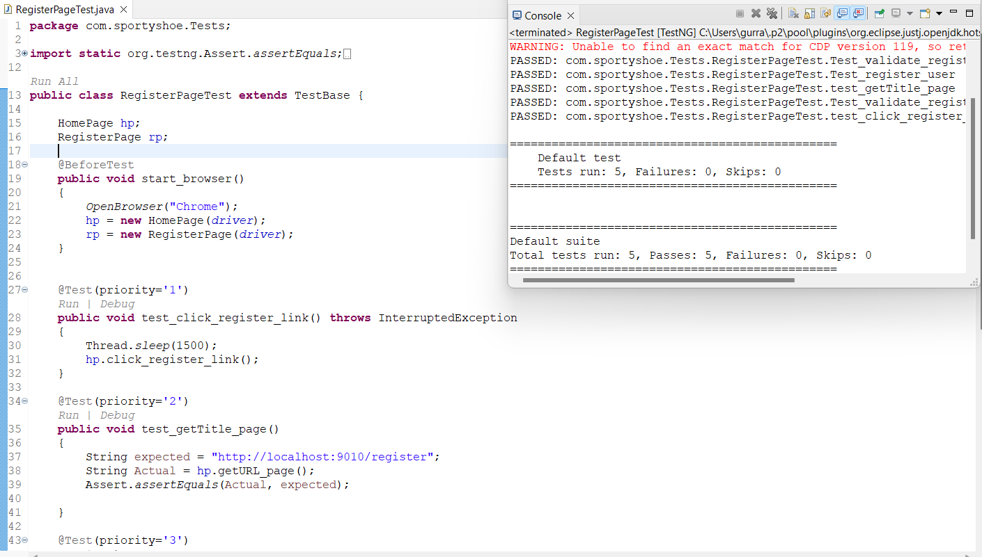

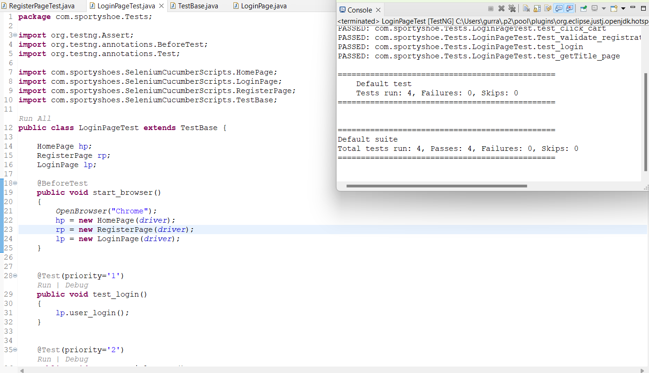

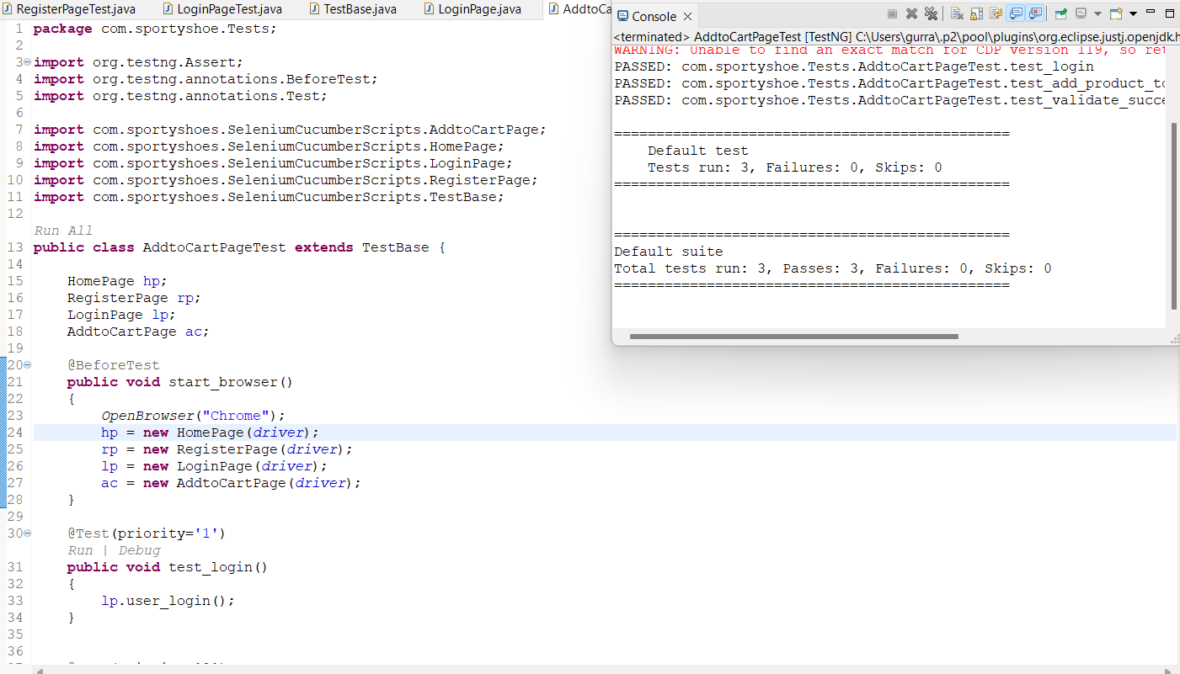

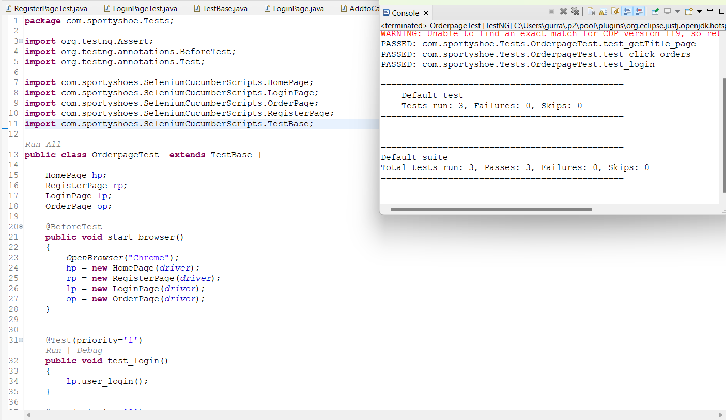

JMeter:

