Variables and there scope in Postman:-

Create a collection 🡪 create a new request 🡪 get methods🡪 Openweather API:

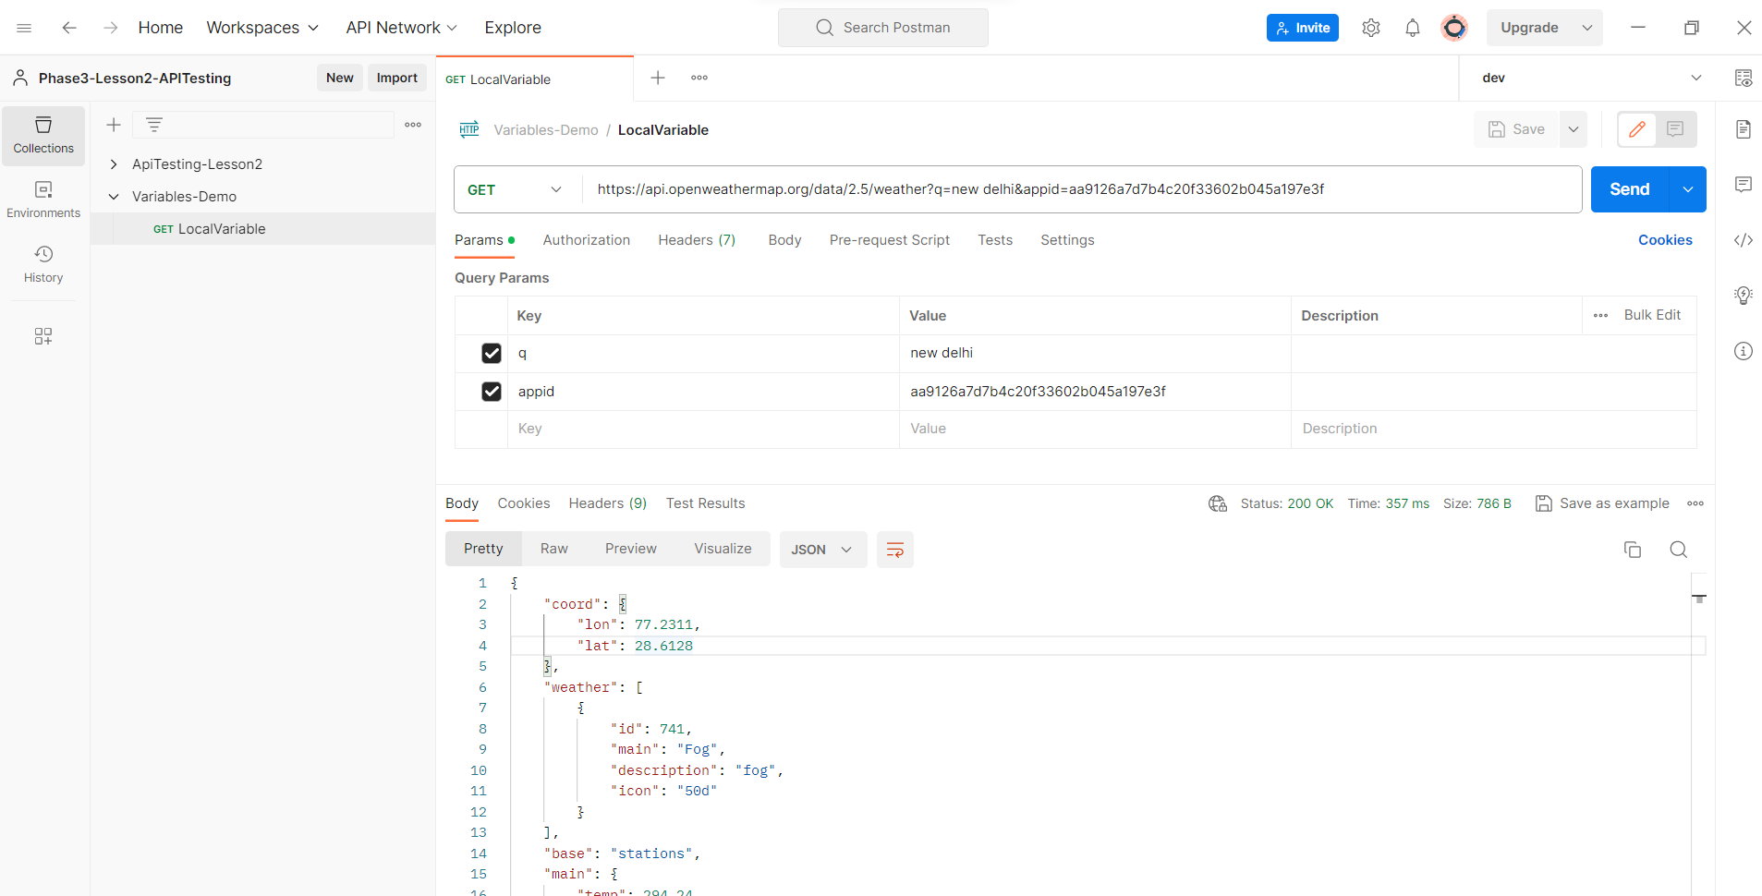

Add the variable in request and select the environment.

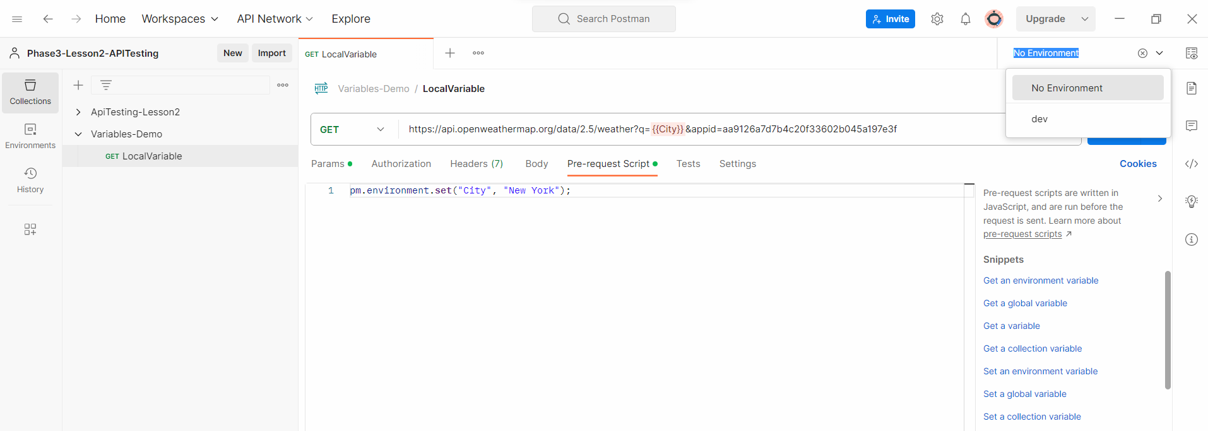

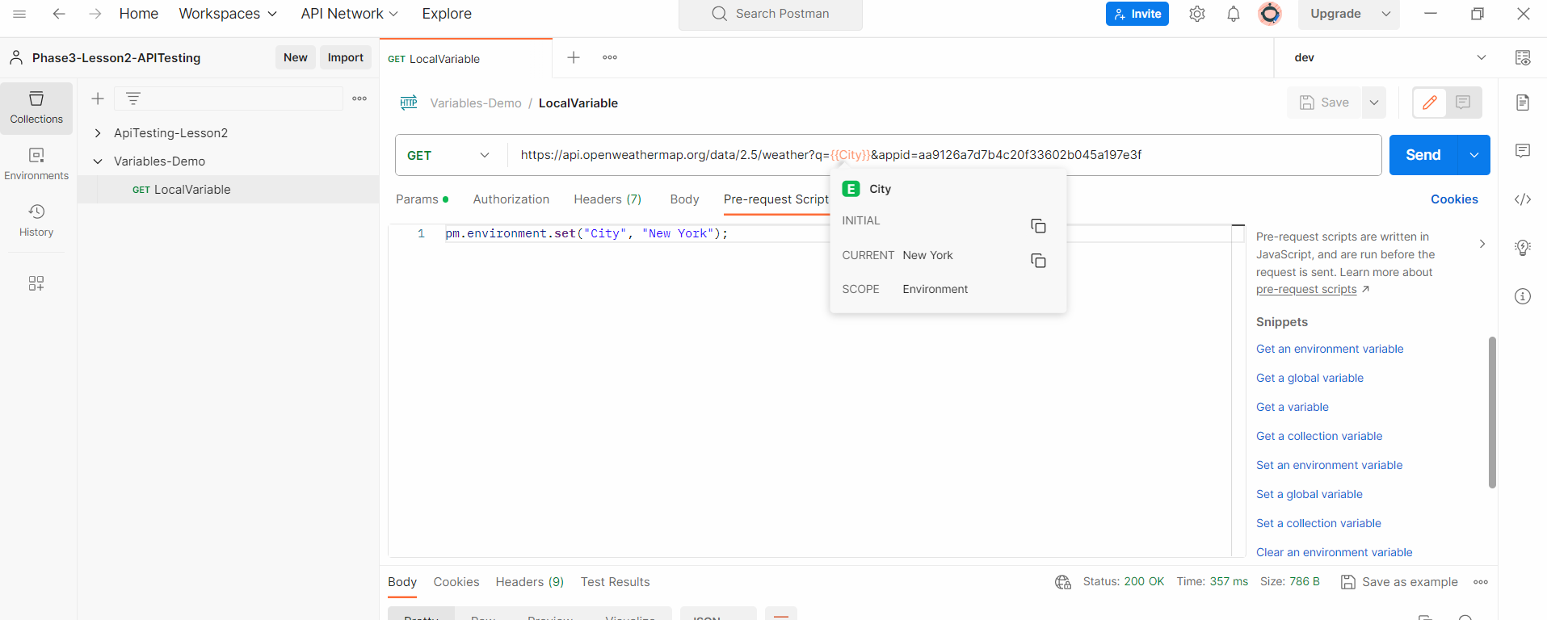

Environment variables:-

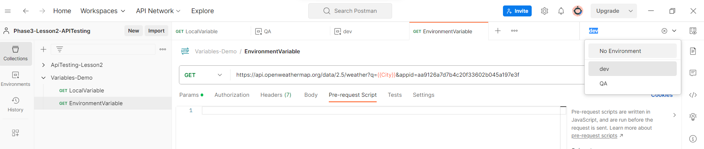

Change environment to QA

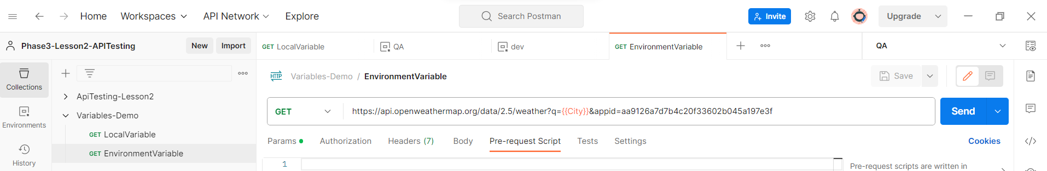

Collection variables: -> Collection level variable.

A variable that will be available by default to every request in that collection only. This variable will be applicable even if you have not selected any environment.

Collection variable will always be created on collection dashboard.

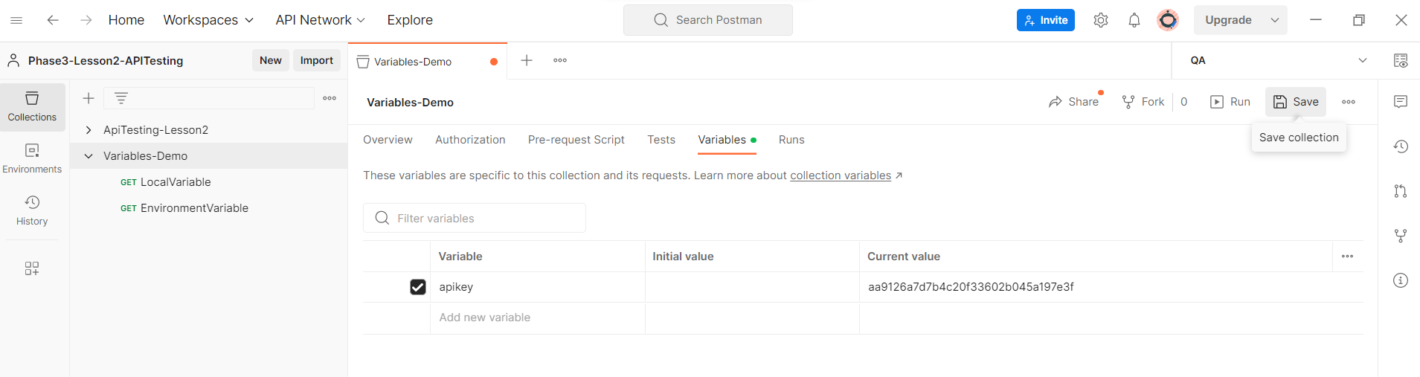

Global variables:-

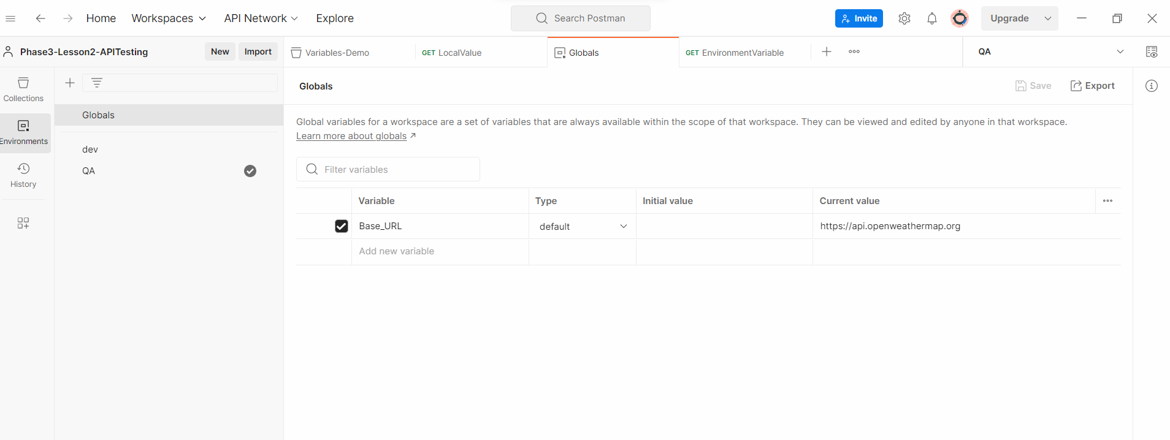

HTTP methods:-

Get method:

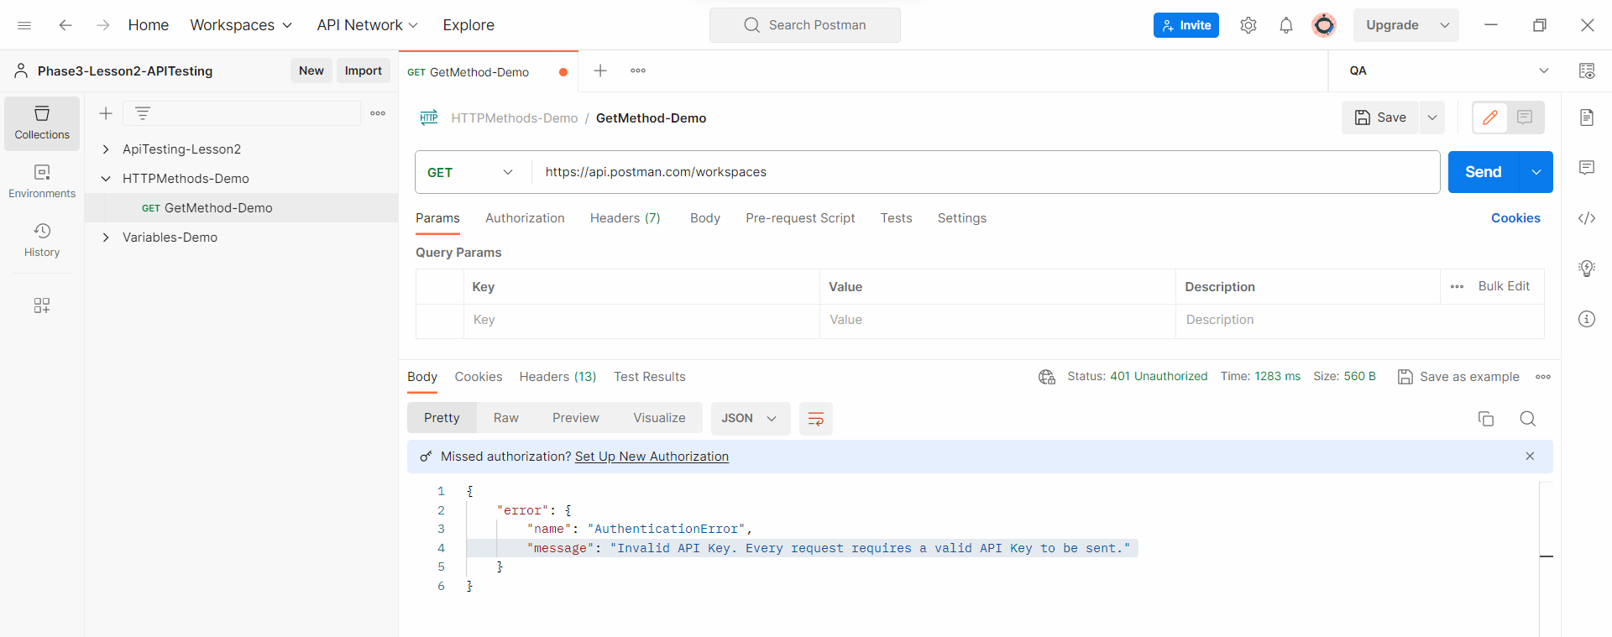

Fetch the API key and add in request:-

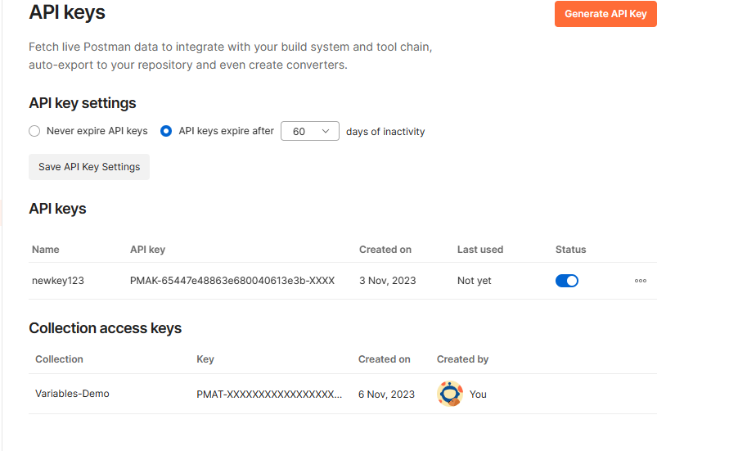

click on generate Api key and generate a new APIkey and copy the key in a notepad, as you will not be able to see the key again.

Now add the API key under Headers tab on the request.

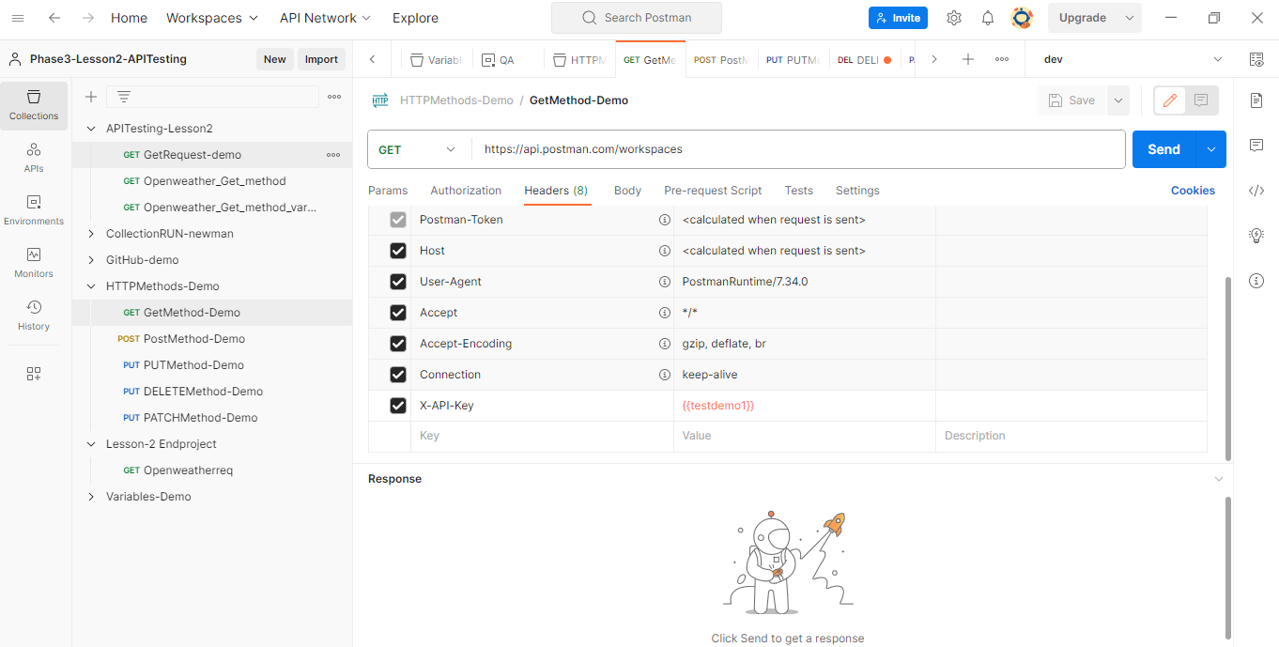

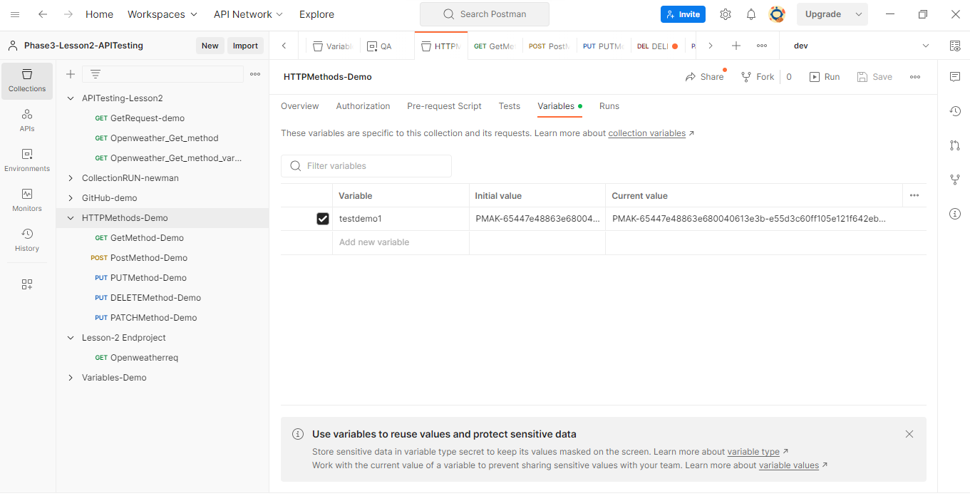

POST method:-

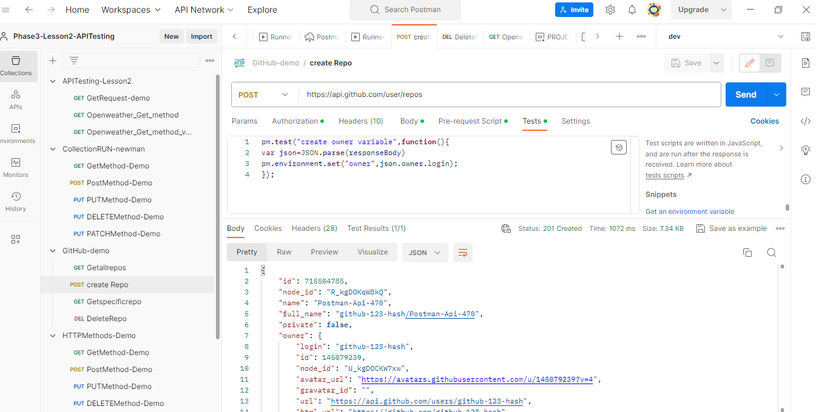

PUT request:-

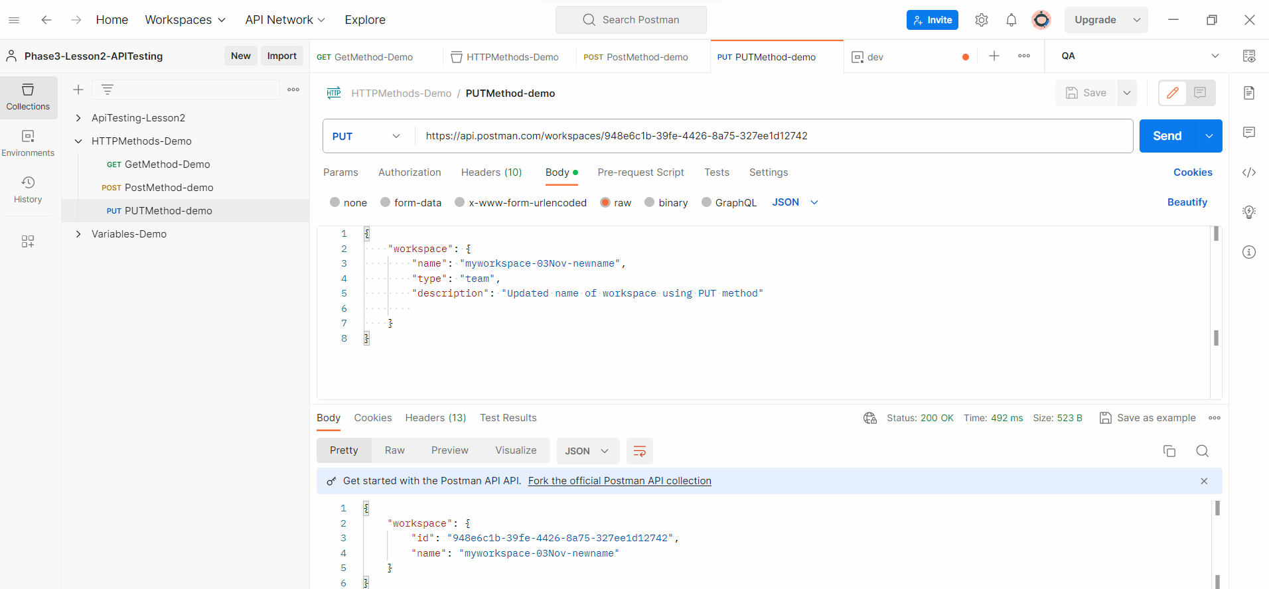

Delete method request:-

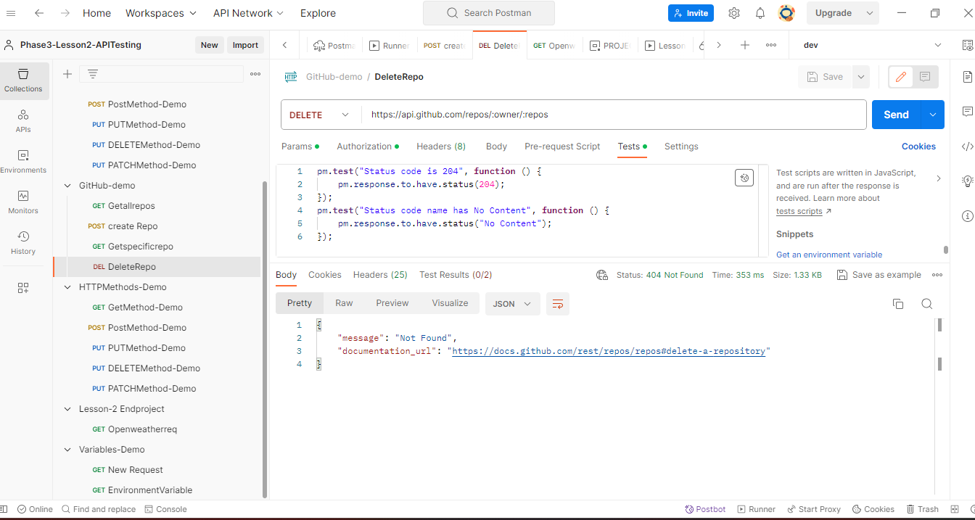

PATCH method:-

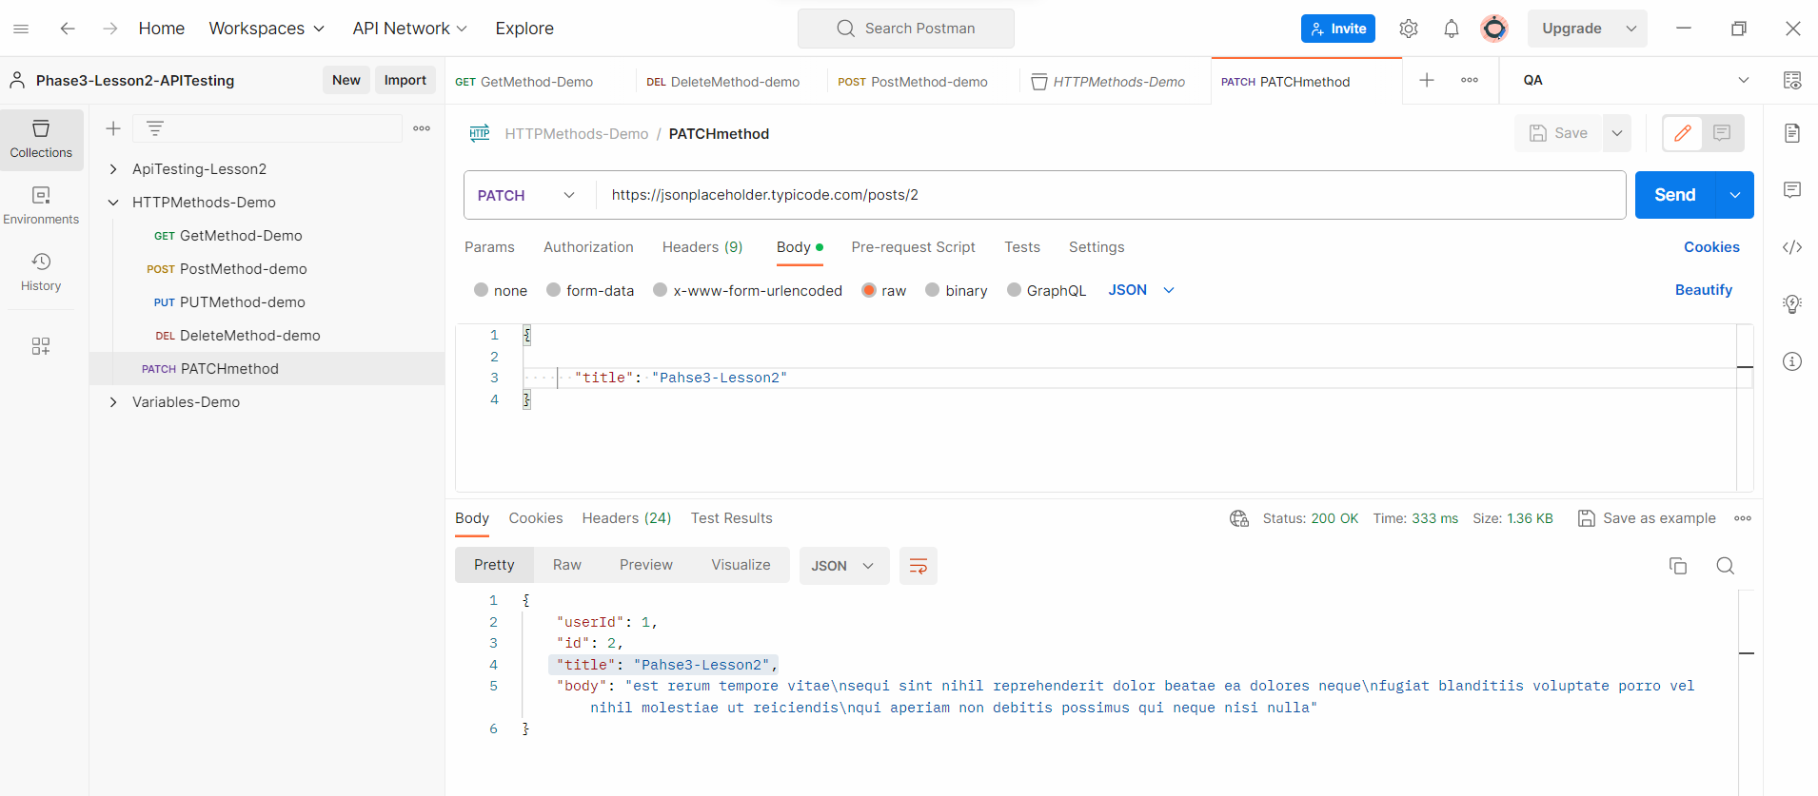

HEAD method:

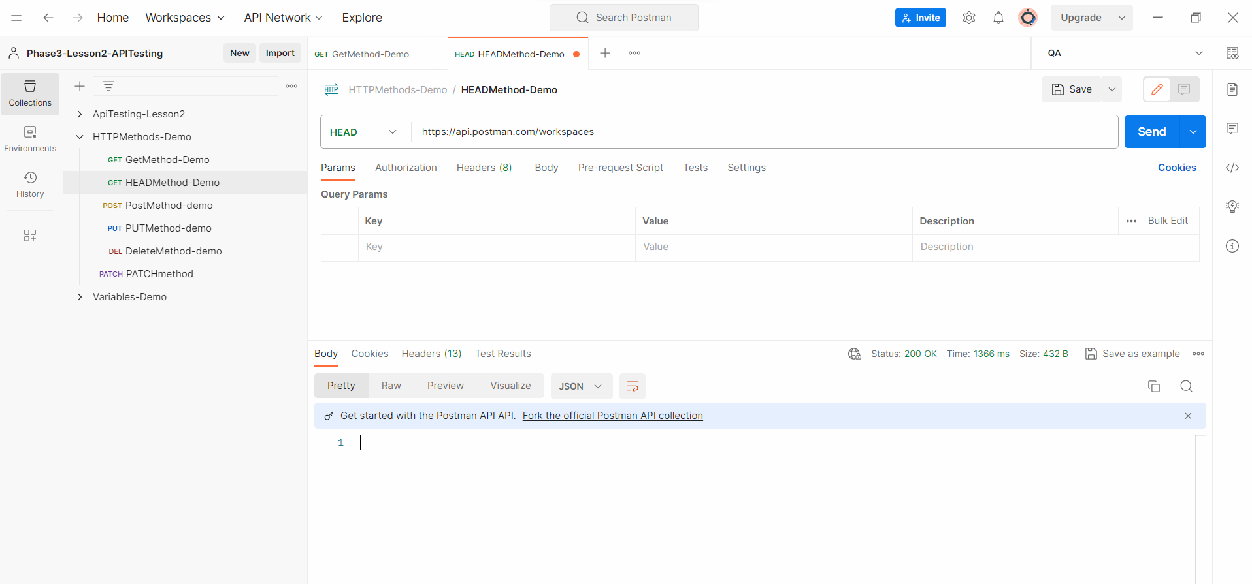

Execute Collection using Runner:-

