Setup GUIDE

FOR

Ruby Installation and Project

**Install Ruby for Development / Testing Purpose**

Prerequisite:

1. Install Java
2. Install Ruby 2.0.0-p648
   1. Windows
      * [installer](http://dl.bintray.com/oneclick/rubyinstaller/rubyinstaller-2.0.0-p648.exe) exe

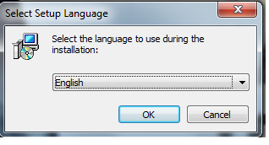

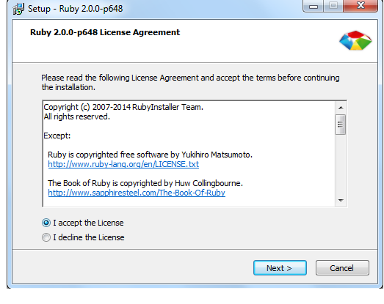

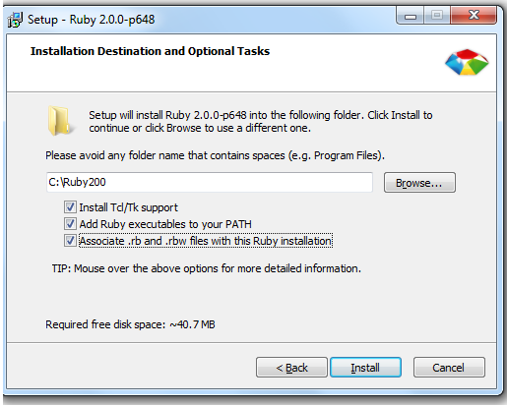

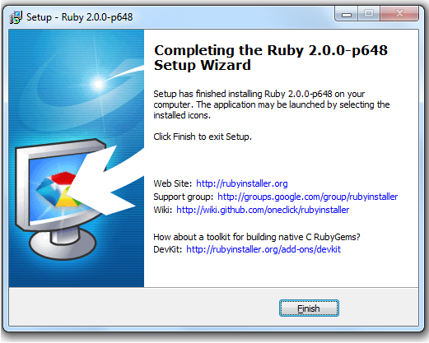

* 1. Mac / Unix
     + Install RVM using command
       - \curl -sSL https://get.rvm.io | bash
     + Install Ruby using RVM
       - rvm install 2.0.0-p648
     + Verify the rvm installed Ruby using command
       - rvm list

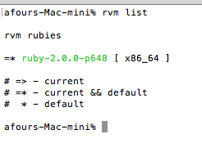

* + - Create a gemset using rvm using command
      * rvm gemset create gemset_name
    - Use the created gem set using command
      * rvm gemset use gemset_name

1. Install Devkit ( only for windows)

Required to setup ruby development envirnoment for Development / Testing purpose

* 1. [Download](http://dl.bintray.com/oneclick/rubyinstaller/DevKit-mingw64-32-4.7.2-20130224-1151-sfx.exe)
  2. Create folder “DevKit” inside default created ruby installation folder

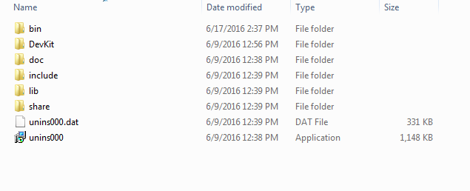

* 1. Open Command prompt, Navigate to created DevKit folder
  2. Execute command
     + ruby dk.rb init
     + ruby dk.rb install

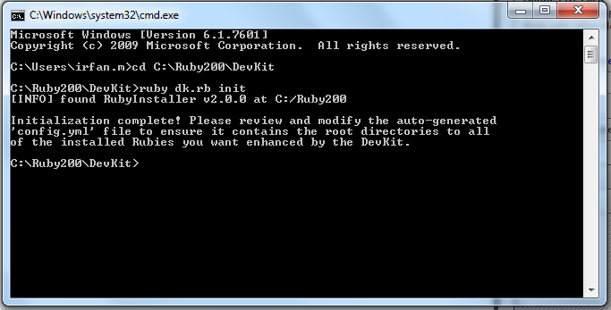

1. Install GIT
   1. Windows
      * Git [installer](https://git-scm.com/download/win)
   2. ubuntu / Debian based OS
      * Open terminal
      * Execute command

sudo apt-get install git-all

* 1. MAC
     + Git [installer](https://git-scm.com/download/mac)

1. Install bundler gem
   1. Open the command prompt Execute command
      * gem install bundler

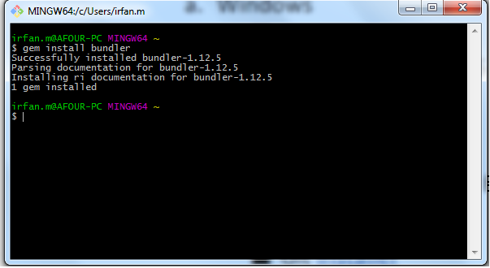

Note*

Bundler : It provide the consistent environment for Ruby projects, it also helps in maintaining the dependencey.

1. Project Setup
   1. Open the Terminal / Command prompt

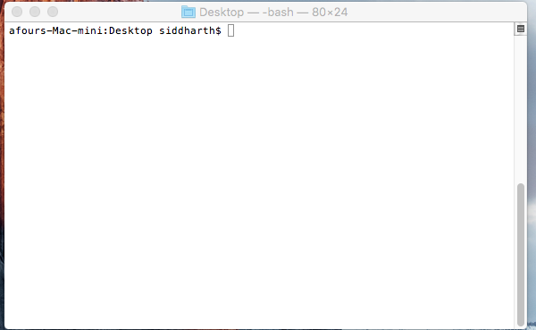

* 1. Navigate to path where you want to put the project
  2. Execute command to clone project
     + git clone <http://ec2-54-173-216-70.compute-1.amazonaws.com/Vanilla/vanilla_ruby_cucumber.git>

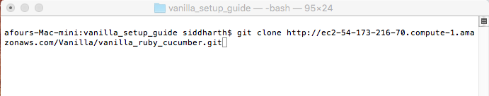

* + - After successful clone of project navigate to project directory

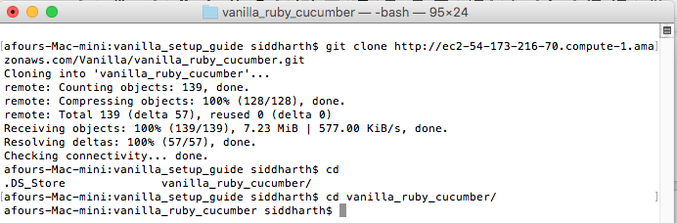

* 1. Execute command inside project directory
     + bundle update

Note* : it helps in fetching and updating all dependency