User GUIDE

FOR

Ruby Cucumber Automation Project

**Project Setup and Test Case writing**

1. Project Setup
   1. Open the Terminal / Command prompt

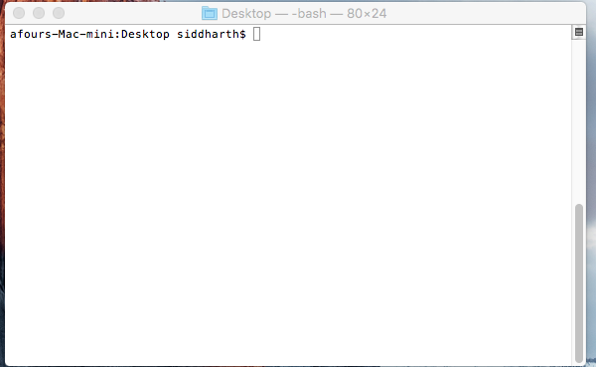

* 1. Navigate to path where you want to put the project
  2. Execute command to clone project
     + git clone <http://ec2-54-173-216-70.compute-1.amazonaws.com/Vanilla/vanilla_ruby_cucumber.git>

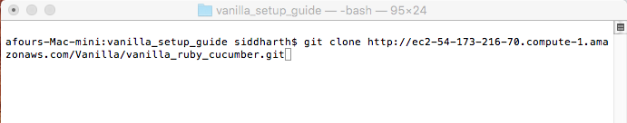

* + - After successful clone of project navigate to project directory

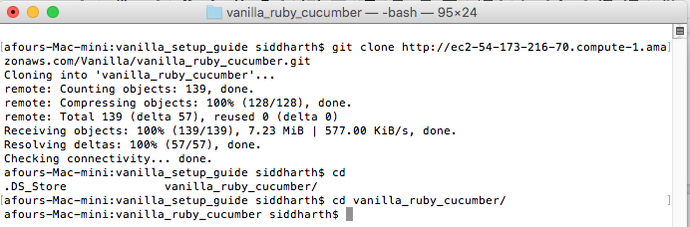

* 1. Execute command inside project directory
     + bundle update

Note* : it helps in fetching and updating all dependency

Adding Test Case

**Framework Structure**

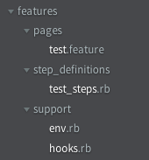

**Brief Explanation of folders**

* **features** : it contains all the test feature file, step_definitions directory, support directory
* **step_definitions** : It contains the respective steps ( Regular Expressions ) and following methods defined in feature file
* **support** : It contains the configuration file
  + env.rb
  + hooks.rb
* **pages** : it contains the feature file ( Directory format can vary from user to user )

**How to write feature file**

Test case has to be added in feature file

Feature file is written in plain text format ( Gherkin format )

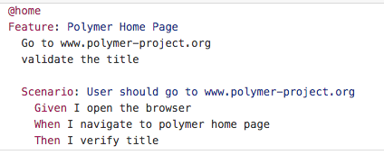

Reference : <https://cucumber.io/>

**How to write step_definition for respective file**

Step definitions are the regular expression followed by the method calls for the respective statement in feature file

Eg :

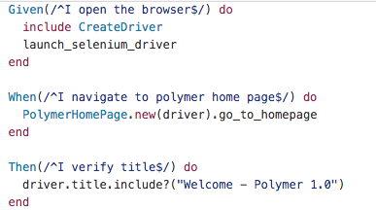

Note* : The method followed in example can be differen in the defined automation framework

**How to Execute the cucumber test**

Navigate to the project directory in terminal or command prompt

* To execute all test, execute command
  + cucumber



* Execute single group test cases, execute command
  + cucumber --tag @tag_name

It will execue all test with tag @tag_name

* Not Execute single groups test case, execute command
  + cucumber --tag ~@tag_name

It will execute all test which are not defined in tag @tag_name

* Logically ANDing : it will exectute the test which matches all tags
  + cucumber --tag @tag1 @tag2 @tag3

It will only execute the test which is followed by tag @tag1 @tag2 and @tag3

* Logically ORing: it will execute the test which matches any tag
  + cucumber --tag @tag1,@tag2