USER GUIDE

FOR

Vanilla Ruby Cucumber Usage

This document provides details of the Cucumber framework can be used with Vanilla Ruby framework with logging and allure reporing

**Framework Structure**

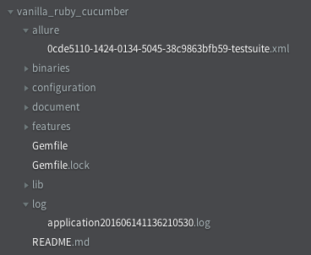

**Brief Explanation for log and allure directory**

* **allure :** It contains the allure type report which is in XML format
* **log** : It contains the log file of application appended with current date time and seconds

**How to Execute the cucumber test using allure**

Navigate to the project directory in terminal or command prompt

* To execute all test, execute command
  + cucumber --format AllureCucumber::Formatter



* Execute single group test cases, execute command
  + cucumber --tag @tag_name --format AllureCucumber::Formatter

It will execue all test with tag @tag_name

* Not Execute single groups test case, execute command
  + cucumber --tag ~@tag_name --format AllureCucumber::Formatter

It will execute all test which are not defined in tag @tag_name

* Logically ANDing : it will exectute the test which matches all tags
  + cucumber --tag @tag1 @tag2 @tag3 --format AllureCucumber::Formatter

It will only execute the test which is followed by tag @tag1 @tag2 and @tag3

* Logically ORing: it will execute the test which matches any tag
  + cucumber --tag @tag1,@tag2 --format AllureCucumber::Formatter