USER GUIDE

FOR

Ruby IDE

**Install IDE for Development / Testing Purpose**

Currently the "open source" IDE don’t have good community support.

But few can be used

1. Netbeans for ruby by adding few plugins { Plugins were available before Netbeans 6 }
   1. Plugins can be downloaded from

https://drive.google.com/a/afourtech.com/folderview?id=0BwZPk8bdohAvSWZhQnNyV09wSW8&usp=sharing

1. Aptana Community support has been ended.
2. Eclipse ( Setup for the same given below )

If for above IDE has been setup for Ruby Development, Using the **debugger** would always be issue {Sometime supported sometime not}

Open Source text editors can also be used

1. Atom
2. Bracket

Paid IDE / Text Editor for Ruby ( Recommended )

1. RubyMine (Licenced for personal and commercial purpose)
2. Sublime Text Editor ( Licenced for commercial purpose)

**Setup for Ruby Eclipse**

1. Download and install latest eclipse
2. Navigate to eclipse market place
3. Search for Ruby

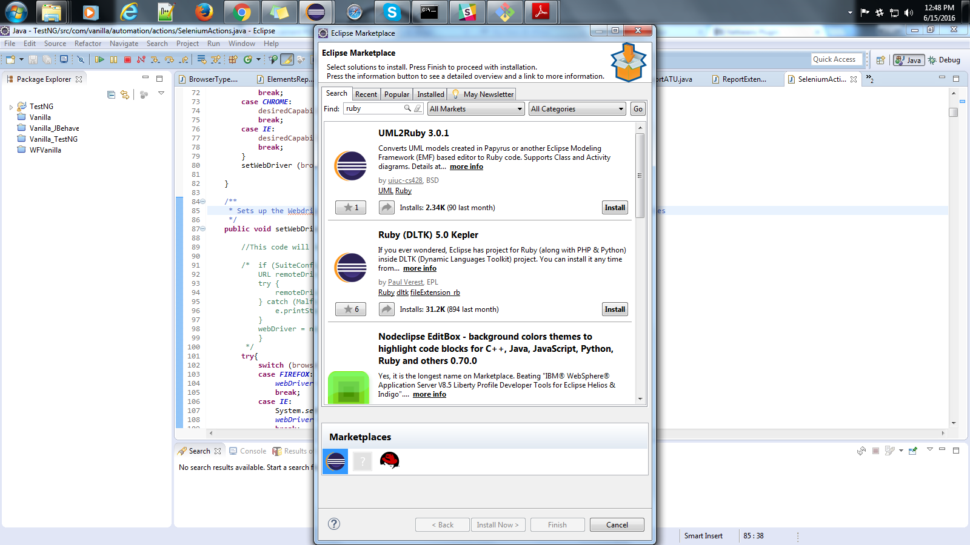

1. Install Ruby (DLTK) 5.0 Kepler
2. Select and Install the package
3. Restart the IDE

