**OPSTREE-DAY4 ASSIGNMENT**

**Setup the LAMP Server & Host a wordpress site on it.**

To Setting up the LAMP Server, following are the pre-requisites :-

**1 :- Linux Machine (up & running mode)**

2:- Apache

3:- MySQL Database

4:- PHP

Below is the step by step installation of all components:-

**1:- Linux Machine**:- You can install any linux flavour on your machine which is feasible to you as per your requirement.

Install VirtualBox & proceed further with (.iso) file or any other possible method for doing same.

**2:- Apache/HTTPD:-**

Apache as a webserver is a must requirement, following are the steps to install Apache on the Linux Machine.

**A**:- Run following command for apache installation:-

**$sudo apt-get update**

**$sudo apt-get install apache2**

**B**:- Set the ServerName globally inside /etc/apache2/apache2.conf, to suppress warning message.

apache2: Could not reliably determine the server's fully qualified domain name, using 127.0.1.1. Set the 'ServerName' directive globally to suppress this message

Syntax OK

**ServerName** **server_domain_or_IP**

**C**:- Now, just need to restart the apache to implement the changes:-

**$sudo systemctl restart apache2**

**D** :- Next step is to enable the http & https traffic, this can be done by enabling the firewall.

**$sudo ufw enable**

**E**:- Check whether your apache is successfully running or not

**$**[**http://your_server_IP_Address**](http://your_server_IP_Address)

**3:- Install MySQL**

For installing mysql on linux machine, following are the steps:-

**A**:- Install mysql using command.

**$sudo apt-get install mysql-server**

**B**:- When the installation is complete, we want to run a simple security script that will remove some dangerous defaults and lock down access to our database system a little bit. Start the interactive script by running:

**$mysql_secure_installation**

You will be asked to enter the password you set for the MySQL root account. Next, you will be asked if you want to configure the VALIDATE PASSWORD PLUGIN.

After enabling this, you will get some more prompts for setting up another steps.

**C**:- You can check your recently installed MySql using below command or login in to the database using below command:-

**$mysql –u root –p**

It will prompt for password for logging in.

**D**:- For checking version of installed MySql, run below command:-

**$mysql –version**

**4:- Install PHP**

**A**:- Download the latest tarball of php from below link:-

**$wget** [**http://in1.php.net/get/php-7.2.10.tar.gz/from/this/mirror**](http://in1.php.net/get/php-7.2.10.tar.gz/from/this/mirror)

**B:-** Untar the above downloaded package using below command:-

**$tar –xvzf php-7.2.10.tar-gz**

**$cd <package_name>**

**C**:- Next step is to configure the php using below step:-

|  |
| --- |
| **$./configure --prefix=/usr/local/php7 \** |
|  | **--with-config-file-path=/etc/php7/apache2 \** |
|  | **--with-config-file-scan-dir=/etc/php7/apache2/conf.d \** |
|  | **--enable-mbstring \** |
|  | **--enable-zip \** |
|  | **--enable-bcmath \** |
|  | **--enable-pcntl \** |
|  | **--enable-ftp \** |
|  | **--enable-exif \** |
|  | **--enable-calendar \** |
|  | **--enable-sysvmsg \** |
|  | **--enable-sysvsem \** |
|  | **--enable-sysvshm \** |
|  | **--enable-wddx \** |
|  | **--enable-intl \** |
|  | **--with-curl \** |
|  | **--with-mcrypt \** |
|  | **--with-iconv \** |
|  | **--with-gmp \** |
|  | **--with-pspell \** |
|  | **--with-gd \** |
|  | **--with-jpeg-dir=/usr \** |
|  | **--with-png-dir=/usr \** |
|  | **--with-zlib-dir=/usr \** |
|  | **--with-xpm-dir=/usr \** |
|  | **--with-freetype-dir=/usr \** |
|  | **--with-t1lib=/usr \** |
|  | **--enable-gd-native-ttf \** |
|  | **--enable-gd-jis-conv \** |
|  | **--with-openssl \** |
|  | **--with-pdo-mysql=/usr \** |
|  | **--with-gettext=/usr \** |
|  | **--with-zlib=/usr \** |
|  | **--with-bz2 \** |
|  | **--with-recode=/usr \** |
|  | **--with-apxs2=/usr/bin/apxs \** |
|  | **--with-mysqli=/usr/bin/mysql_config \** |
|  | **--with-ldap \** |
|  | **--with-xdebug** |

**D**:- Next step is to compile all the libraries:-

**$make**

**$sudo make install**

Above step will install the php libraries and you can check the installed php’s version using this:-

**$php –v**

## 5:- Download WordPress

Change into a writable directory and then download the compressed release by typing:

**$cd /tmp;**

**$wget** [**https://wordpress.org/latest.tar.gz**](https://wordpress.org/latest.tar.gz)**;**

Extract the compressed file to create the WordPress directory structure:

**$tar xzvf latest.tar.gz;**

We will be moving these files into our document root momentarily. Before we do, we can add a dummy .htaccess file and set its permissions so that this will be available for WordPress to use later.

Create the file and set the permissions by typing:

**$touch /tmp/wordpress/.htaccess**

**$chmod 660 /tmp/wordpress/.htaccess**

We'll also copy over the sample configuration file to the filename that WordPress actually reads:

**$cp /tmp/wordpress/wp-config-sample.php /tmp/wordpress/wp-config.php**

Now, we can copy the entire contents of the directory into our document root. We are using the -a flag to make sure our permissions are maintained.

**$sudo cp -a /tmp/wordpress/. /var/www/html**

## Configure the WordPress Directory

**$sudo chown -R sammy:www-data /var/www/html**

Now, open the WordPress configuration file:

**$/var/www/html/wp-config.php**

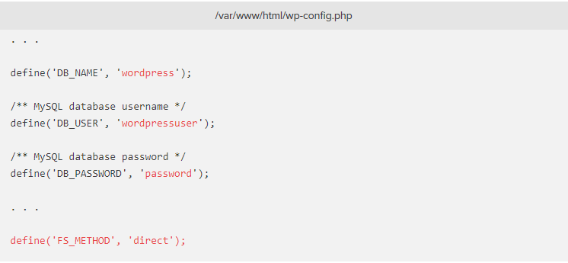

## Complete the Installation Through the Web Interface

In your web browser, navigate to your server's domain name or public IP address:

**http://server_domain_or_IP**

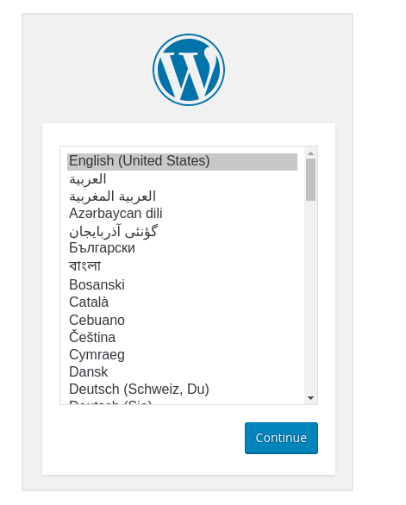

Next, you will come to the main setup page.

Once you log in, you will be taken to the WordPress administration dashboard:

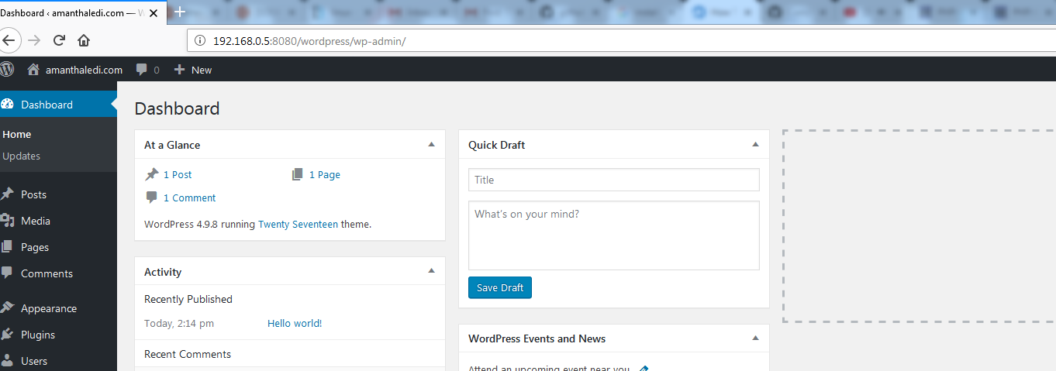

Wordpress has been successfully installed.

