Tool Usage Summary – Data Analyst (Interview Ready)
This document explains how SQL, Python, and Power BI are used together in a real-world Data Analyst project. It is written from an analyst’s perspective, assuming that raw data is already available in a database managed by the data engineering team.

1. SQL – Data Access, Storage & KPI Calculation
SQL is used as the primary data layer and single source of truth. As a Data Analyst, I work with raw and cleaned tables already present in the database. SQL is used to extract data, create analytical fact and dimension tables, and calculate KPIs using joins, aggregations, and filters.

2. Python – Data Cleaning & Transformation
Python is used when data available in SQL is not analysis-ready. Using Pandas and NumPy, I perform data cleaning, reshaping (wide to long), feature engineering, handling missing or suppressed values, and data validation. After cleaning, the transformed data is written back to SQL for reporting.

3. Power BI – Visualization & Business Reporting
Power BI is used as the visualization and reporting layer. It connects directly to cleaned analytical tables in SQL to build dashboards, define DAX measures, enable drilldowns, and present insights to business stakeholders.

Typical Analyst Workflow
- Extract raw data from SQL into Python
2. Clean and transform data using Python
3. Load cleaned data back into SQL
4. Calculate KPIs using SQL
5. Connect Power BI to SQL for dashboards and reporting

FINAL PROJECT STRUCTURE (WE WILL STRICTLY FOLLOW THIS)
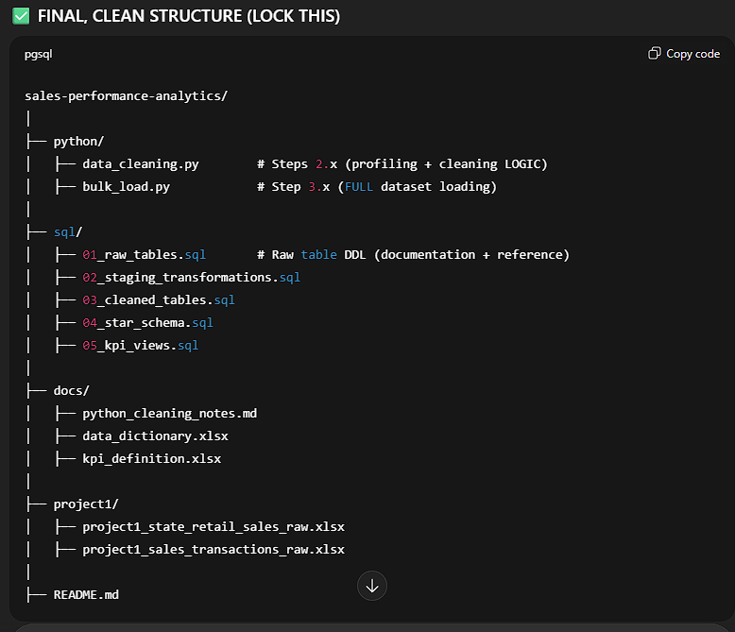
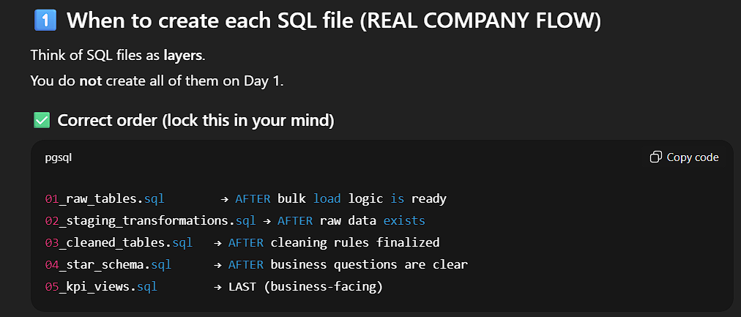
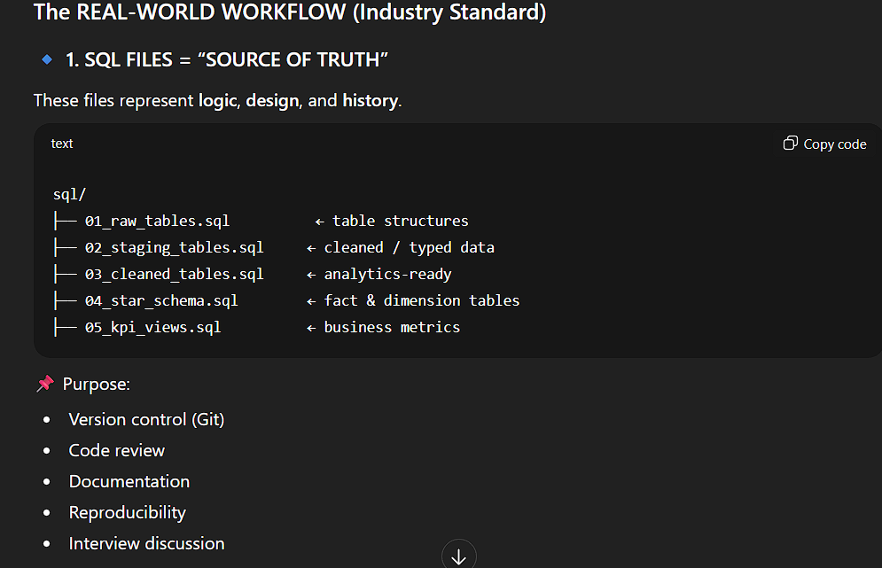

🔑 Key Rule (INTERVIEW GOLD)
Python = heavy cleaning, parsing messy files
SQL = modeling, validation, analytics, KPIs
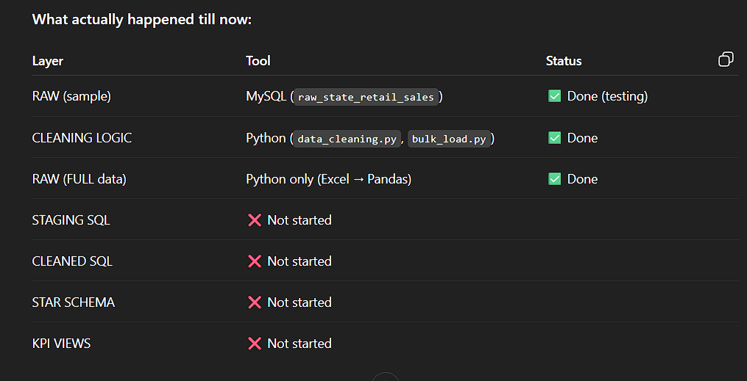
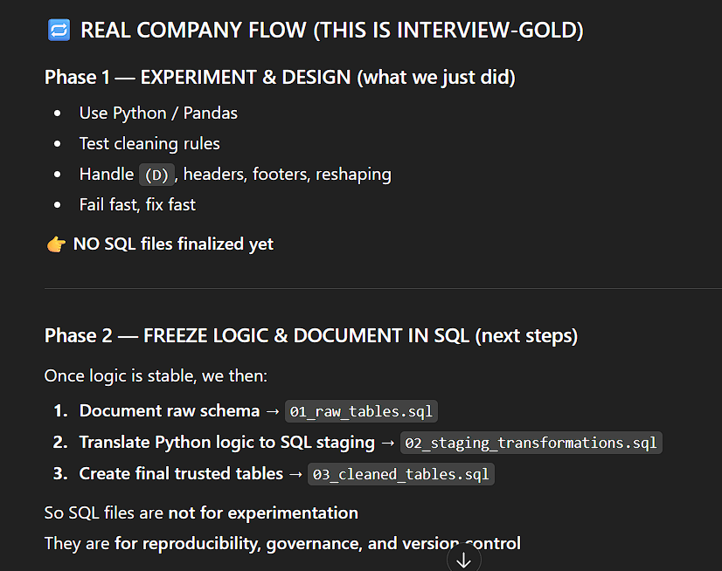
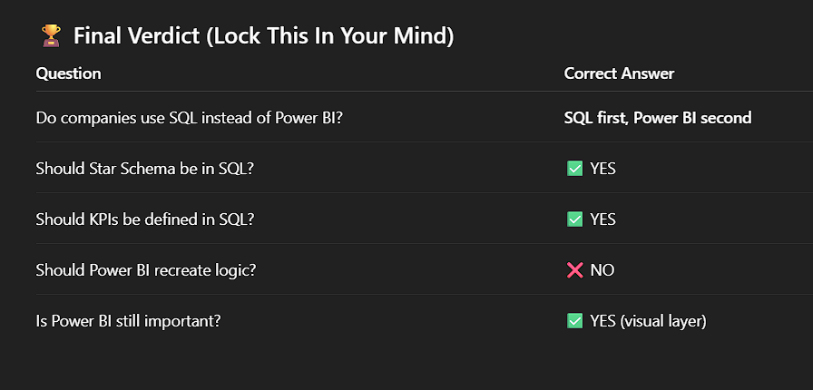
🧠 Correct Mindset (Interview-Ready Answer)
If an interviewer asks:
“Do you prefer SQL KPIs or DAX KPIs?”
🎯 Perfect Answer:
“In real projects, we always define KPIs in SQL using views or fact tables so that business logic remains centralized and consistent. Power BI is mainly used for visualization and light calculations.”

