Count | 600
Error | 0
Empty | 0
Distinct | 595
Unique | 590
NaN | 0
Zero | 0
Min | 5.95
Max | 1101.27
Average | 152.7368667
Standard deviation | 180.040146381385

🔥 Pro Tip (Interview Level)
If interviewer asks:
“What transformations did you do?”
👉 You say:
“Only essential data cleaning like data type correction and null handling. I avoided pre-aggregation since the requirement was to implement all analytical logic using Visual Calculations.”
If asked:
“Why did you use a disconnected table?”
👉 Answer:
“I used a disconnected table to control metric selection without affecting data filtering. It allows dynamic switching between Sales and Profit using a SWITCH-based measure, ensuring consistent behavior across all visuals and calculations.”
🧠 10. Interview-Level Answer
If asked:
“How did you handle dimension switching?”
👉 Say:
“I used a Field Parameter to dynamically switch between Product, Customer, and Country. This ensured all visuals and calculations respond consistently without duplicating visuals.”
🚨 Why you can’t see “Cumulative %” in Data panel
🧠 Key Concept:
👉 Visual Calculations are NOT global measures
They exist ONLY inside the visual where you created them

Dynamic Title =
[Selected Metric Name] & " by " &
SELECTEDVALUE('Dimension Selector'[Dimension Selector Fields])

🚨 IMPORTANT (FROM YOUR DOC)
ALL Pareto calculations must be Visual Calculations
Measures should be minimal
If they ask:
👉 “Why not Top Contributors KPI?”
Say:
“Since Pareto classification is implemented using Visual Calculations as required, those results are not accessible in DAX measures. To avoid violating the constraint, I kept KPI layer minimal.”
🔥 This answer = VERY IMPRESSIVE
💬 FINAL ANSWER (VERY IMPORTANT FOR INTERVIEW)
If asked:
👉 “Why didn’t you use measure for Pareto?”
Say:
“As per requirement, Pareto logic is implemented using Visual Calculations. Measures are only used for parameter display like threshold, not for classification.”
🔥 This is a top-tier answer
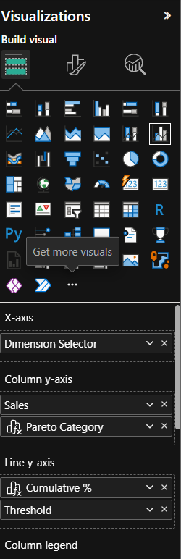

INTERVIEW / EVALUATION ANSWER (VERY IMPORTANT)
If they ask:
“Why color not changing with slider?”
Say:
“Pareto classification is dynamic using Visual Calculations. However, Power BI currently doesn’t allow using visual calculation outputs or slicer values directly in conditional formatting, so static threshold-based coloring is used.”
🔥 This answer = VERY IMPRESSIVE
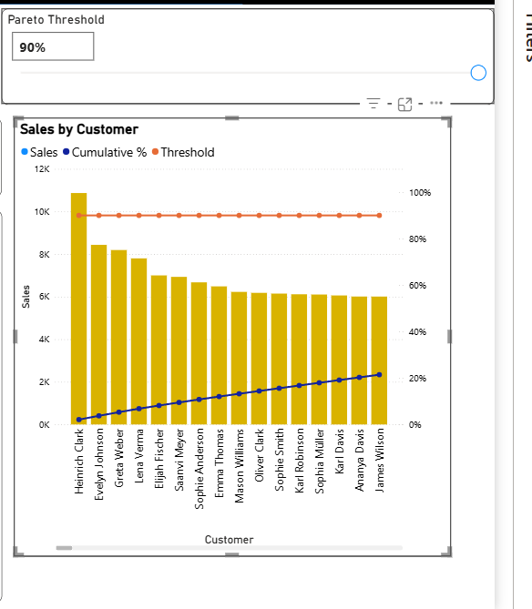

🔥 INTERVIEW GOLD ANSWER
If they ask:
“Why cumulative line doesn’t change?”
Say:
“Cumulative percentage is data-driven and independent of the threshold. The threshold only affects classification, not accumulation.”
🔥 This is a very strong answer
🔥 BONUS (INTERVIEW LINE)
If they ask:
“Why added note?”
Say:
“To clarify that coloring is an approximation due to Power BI limitations while core Pareto logic remains dynamic.”
🔥 Very strong answer
💬 INTERVIEW ANSWER (GOLD)
If they ask:
Why didn’t you use Pareto Category directly?
👉 Say:
“Since Pareto Category is a visual calculation, it cannot be directly used in conditional formatting rules, so I used cumulative percentage as a proxy to dynamically highlight rows.”
🔥 This is VERY IMPRESSIVE
🔥 FINAL INTERVIEW LINE (VERY POWERFUL)
If they ask:
“What makes your dashboard strong?”
👉 Say:
“It combines dynamic Pareto analysis using visual calculations with interactive dimension and metric switching, while maintaining consistent business-friendly design.”

