**CYPHER SAMPLE QUERIES**

**Note**:

**Blue** cirle: User

**Red** circle: Repository.

**Queries**:

1. **Show all Repos, each is showed with 5 users who starred it:**

MATCH (:Person)-[:STARRED]->(r:Repo)

CALL {

WITH r MATCH (r)<-[:STARRED]-(p)

RETURN p

LIMIT 5

}

RETURN r, p

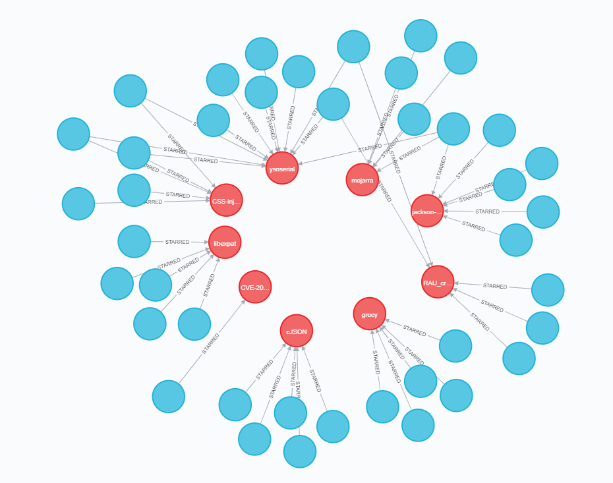

1. **Query 5 People who starred the most number of Repos:**

MATCH (n)-[s:STARRED]->(r:Repo)

RETURN n, count(s) AS repos_starred

ORDER BY repos_starred desc

LIMIT 5

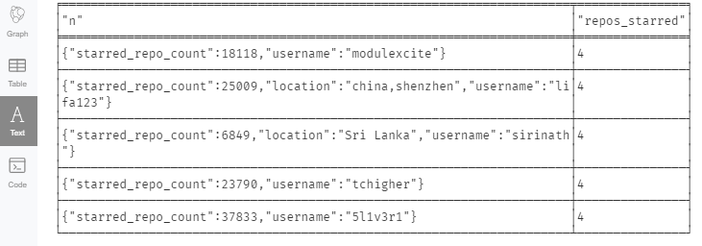

1. **Show 5 People who starred the most number of Repos and their starred Repos**

MATCH (n)-[s:STARRED]->(Repo)

WITH n, count(s) AS repos_starred

ORDER BY repos_starred desc

LIMIT 5

MATCH (n)-[:STARRED]->(r:Repo) return n,r

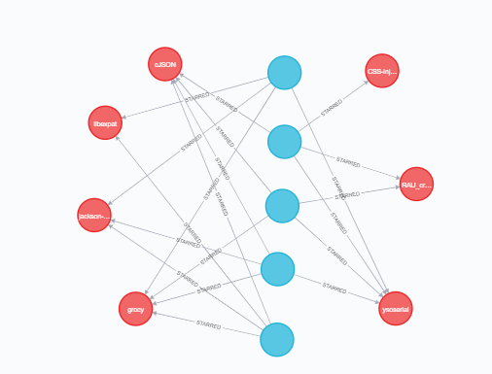

1. **Show all CVE repos, 5 of users who stared those CVE repos and has highest number of created repos, and 5 of created repos by each of those users**

MATCH (r:Repo)

WHERE r.type="cve_l0"

CALL {

WITH r

MATCH (r)<-[:STARRED]-(p:Person) RETURN p

}

CALL {

MATCH (p)-[s:CREATED]->(:Repo)

RETURN p as p1, count(s) AS repos_starred

ORDER BY repos_starred desc

LIMIT 5

}

CALL{

WITH p1

MATCH (r1:Repo)<-[:CREATED]-(p1)

RETURN r1 LIMIT 5

}

RETURN r, p1, r1

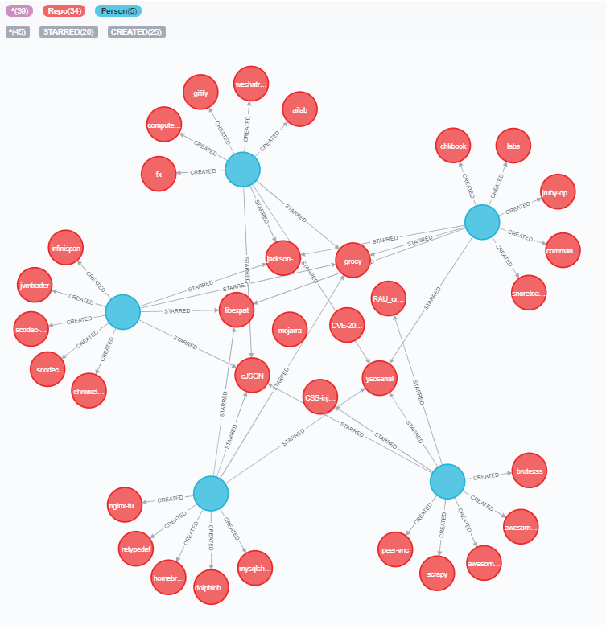

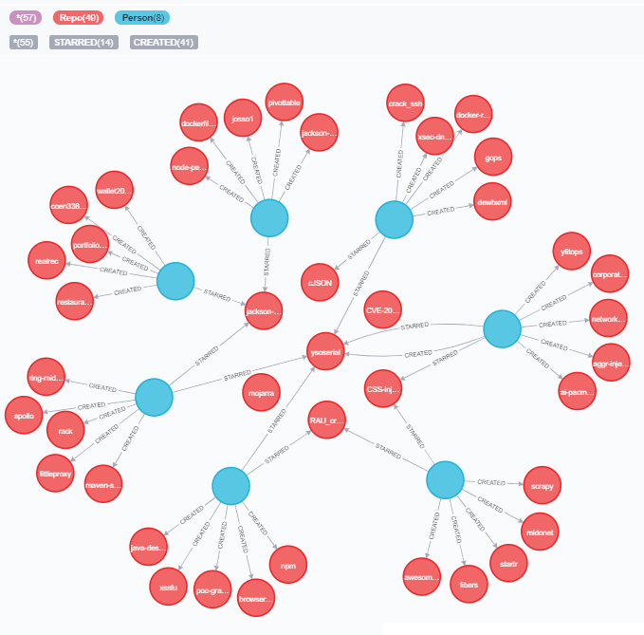

1. **Show all repos and people but slimit 5 connection between them**

MATCH (:Person)-[]->(r:Repo) CALL { WITH r MATCH (r)<-[]-(p) RETURN p LIMIT 5 } CALL { WITH p MATCH (r2)<-[]-(p) RETURN r2 LIMIT 5 } RETURN r2, p

