DonateKart - A Web-Based Donation Management System
Software Requirements Specification
Version: 1.0

Document Version Control
Document Name: | DonateKart Requirements Specification
Version Number: | 1.0
Date: | 6th May 2021

Author: |  |  |  | Reviewer: |  |  |  | Approver:
Signature |  |  |  | Signature |  |  |  | Signature
Electronic copies valid without signature

Change History
Version | Issue Date | Author | Reason for Change

Table of Contents

1 Purpose 4
2 Intended Audience 4
3 Project Scope 4
4 References 4
5 Business Process Flow 5
6 System Feature 6
6.1 Use Case Diagram……………………………………………………………………………………………………………..8
6.2 Fields Specifications…………………………………………………………………………………………………………..9
7 Deployment Environment 11
8 Development Environment 11
9 Assumptions 11
10 Dependencies 11

Purpose
The requirement specification document will detail the functionalities of DonateKart – a web-based Donation Management System that will enable the design & development of donation management System.

Intended Audience
This document will cater the following audience:
- Stakeholders/ Mentor
- Development Team

Project Scope
The scope of the project is to develop Donation Management System to make donations an easy process for needy receivers and interested donors.

References
Document Name/URL Title | Version | Location

Business Process Flow

Proposed Business Process Flow Diagram
The domain diagram below explains the proposed implementation of Donation Management System.

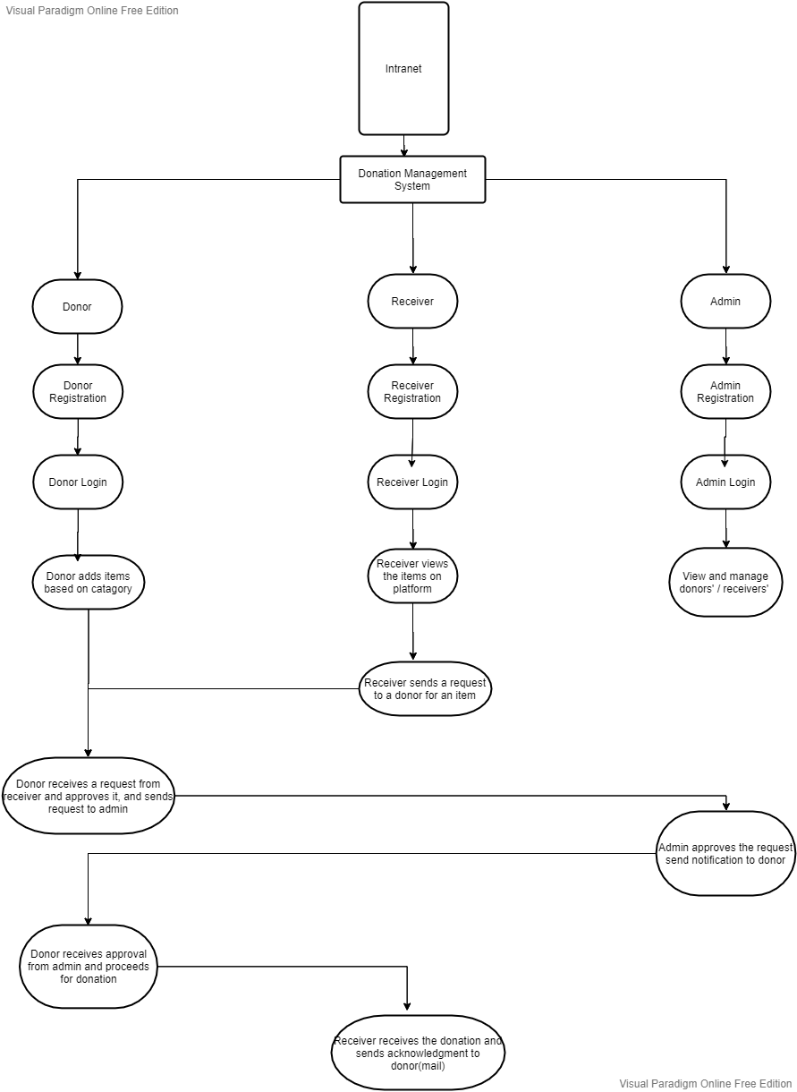

This Donation Management System will facilitate donors to add items for donation on the platform after registration. Receivers will view the items according to categories and send a request to donor for donation. The donor approves the request and sends it to admin for further authorization. Once admin approves the request and sends notification to donor, donor will proceed to donate the item according to the details of receiver (mobile number, address).

System provides the feature for editing the profile to donors/receivers/admins. Admin can delete the accounts of both donor and receiver. Admin can analyze the donation process according to types of items on monthly/ quarterly or yearly basis. The lead admin can authorize and approves the registration process of other admins.

System Features

As visible in domain diagram above, Donation Management System will support the above features on each of the documents related to the following modules.

  - Donor

Sr. No. | Module Name | Module Description
1 | RegistrationDonor | Registration of donor
2 | LoginDonor | Login of Donor
3 | ForgotPasswordDonor | Password reset of Donor
4 | EditAccountDonor | Change the fields in the account of Donor
5 | AddDonationItem | Add items to be donated according to its category set with the count of same category items, upload image if any.
6 | ViewEditRemoveDonatedItems | View all the items to be donated, edit, or remove
7 | ApproveDonationRequestByReceiver | Approve the request sent by a receiver for a particular item with count and sends to admin for acknowledgement
8 | ViewDonationHistoryDonor | View all the donations made before

  - Receiver

Sr. No. | Module Name | Module Description
1 | RegistrationReceiver | Registration of receiver
2 | LoginReceiver | Login of Receiver
3 | ForgotPasswordReceiver | Password reset of Receiver
4 | EditAccountReceiver | Change fields in the account of Receiver
5 | ViewAllItems | View all items with count put by donor to donate
6 | ViewSelectedItemsByCategory | View only the items with count in a selected category
7 | SendRequestForAnItemToDonor | Send a request to the Donor for a selected item with count
8 | AcknowledgeReceivedItem | When an item has been donated to Receiver, send an acknowledgement to the Donor in the form of email or message.
9 | ViewDonationHistoryReceiver | View all the donations received by a Receiver

  - Admin

Sr. No. | Module Name | Module Description
1 | AdminRegistration | Registration of Admin
2 | AdminLogin | Login of Admin
3 | ViewManageDonors | View, delete Donors’ donations, account
4 | ViewManageReceivers | View, delete Receivers’ donations, account
6 | ApproveRequestFromDonor | Admin will approve the request from donor and sends notification via email/message to proceed for donation.

  - Some Common Functionalities

Sr. No. | Module Name | Module Description
1 | SendEmail | Sending an email
2 | SendMessage | Sending an SMS
3 | ExportToExcel | Export a table to Excel
4 | GeneratePDF | Generate PDF from table view
5 | IntegrateCharts | Integrate chart functionality for admin
6 | ChatBox | Integrate chat box

User Case Diagram
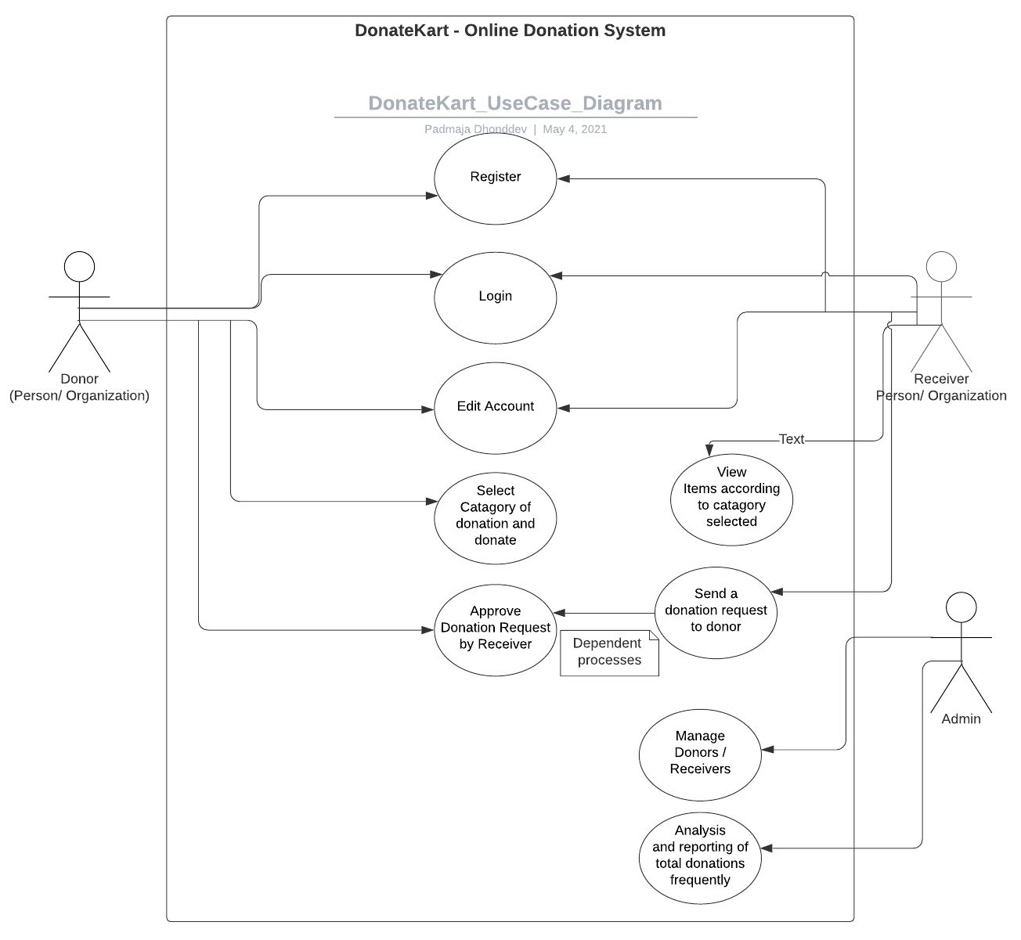

Fields Specifications

- Donor:
 | Field Description | Data Type | Control Type | Length | Mandatory | Identity, Unique
DonorID | Unique ID for Donor | Numeric | Text Box | 30 | Yes | (1,1)
DonorUsername | Username for Donor | Text | Text Box | 20 | Yes | Unique
DonorName | Name of Donor | Text | Text Box | 100 | Yes
DonorEmail | Email ID od donor | Text | Text Box | 100 | Yes | Unique
DonorMobileNo | Mobile Number of Donor | Text | Text Box | 10 | Yes | Unique
DonorAddressCountry | Country of donor | Text | DropDown List | 50 | Yes
DonorAdressState | State of donor | Text | DropDown List | 50 | Yes
DonorAddressCity | City of donor | Text | DropDown List | 50 | Yes
DonorAddressPincode | Pin code of donor | Text | Text Box | 10 | Yes
DonorAddressLine | Address line for more specification | Text | Text Box | 500 | Yes

- Receiver

 | Field Description | Data Type | Control Type | Length | Mandatory | Identity, Unique
ReceiverID | Unique ID for Donor | Numeric | Text Box | 30 | Yes | (1,1)
ReceiverUsername | Username for Donor | Text | Text Box | 20 | Yes | Unique
ReceiverName | Name of Donor | Text | Text Box | 100 | Yes
ReceiverEmail | Email ID od donor | Text | Text Box | 100 | Yes | Unique
ReceiverMobileNo | Mobile Number of Donor | Text | Text Box | 10 | Yes | Unique
ReceiverAddressCountry | Country of donor | Text | DropDown List | 50 | Yes
ReceiverAdressState | State of donor | Text | DropDown List | 50 | Yes
ReceiverAddressCity | City of donor | Text | DropDown List | 50 | Yes
ReceiverAddressPincode | Pincode of receiver | Text | Text Box | 10 | Yes
ReceiverAddressLine | Address line for more specification | Text | Text Box | 500 | Yes

- Admin
 | Field Description | Data Type | Control Type | Length | Mandatory | Identity, Unique
AdminID | Unique ID for Admin | Numeric | Text Box | 30 | Yes | (1,1)
AdminUsername | Username for Admin | Text | Text Box | 20 | Yes | Unique
AdminName | Name of Admin | Text | Text Box | 100 | Yes
AdminEmail | Email ID od Admin | Text | Text Box | 100 | Yes | Unique
AdminMobileNo | Mobile Number of Admin | Text | Text Box | 10 | Yes | Unique
AdminAddressLine | Address line for more specification | Text | Text Box | 500 | Yes

Deployment Environment
The Deployment environment will consist of the following software components:
- Windows Server 2008 with service pack & IIS 7.0.
- .Net Framework 4.0.
- Sql-Server 2019 Database.
- VS 2019.
Note: The hardware and software needs to be provided for deployment.

Development Environment
The Development environment will consist of the following software components:
- Windows Server 2008 with service pack & IIS 7.0.
- .Net Framework 4.0.
- Sql-Server 2008 Database.
- VS 2010.
Note: The hardware and software of development environment in support phase to be provided by CLIENT.

Assumptions
- Items that are added by the donors should be as per the donation’s aspects.

Dependencies
- Donation Management System Will be integrated with CLIENT Intranet System
- Only users connected in CLIENT intranet, will have access to Donation Management System.

