Ex1:

* **What is Boolean:** Boolean values are the two constant objects True and False
* **3 different expression that results a Boolean types:**

+ 5 == 6: False

+ (5 < 6) || (7 < 6): True

+ (5 < 6) || (5 > 6): False

Ex2:

* **What is flow chart:** Flow chart is a type of graph that visualizes an algorithm, workflow,...

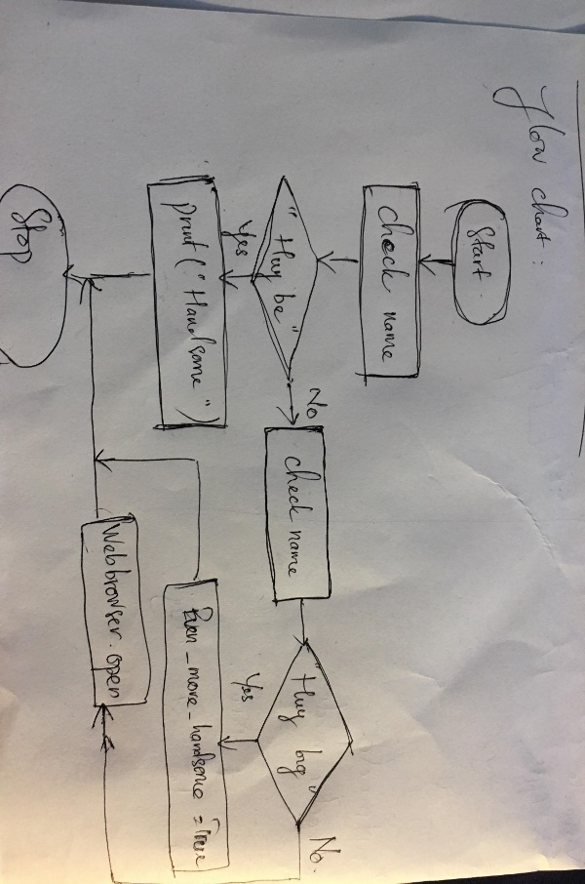

Ex3: **What is nested conditionals:** A nested if is an if statement that is the target of another if statement

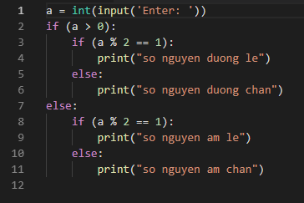Code: