Marketing Video Agent
How the application works: what it does, what it is built with, and why
1. What is happening
The application turns a one-line request (a topic or a link) into a finished vertical marketing video, and can post it to Instagram. It is a multi-agent pipeline: a chain of small, specialised AI steps, each doing one job, with a human approving at the two points that matter.
- Understands the ask. Classifies the request into one of six intents (product promo, explainer, how-to, brand story, announcement, entertainment) with audience, tone and key message. Photos, video or audio the user sends are read first and shape the look.
- Researches and writes. Gathers facts and hooks, then writes a model-agnostic screenplay (timed shots, camera, action, dialogue, sound). A critic scores it and sends it back for rewrites until it is good enough.
- Renders the prompt in code. The LLM writes content; plain code applies the exact prompt syntax Veo requires, so a bracket or timestamp can never be forgotten.
- Asks before spending. The user reads the exact prompts for free (Gate 1). Only then is the video generated (about $1.50 to $2.30 per 15 s reel). The saved video is shown (Gate 2) and posted to Instagram only on a yes.
2. Tech stack
Layer | Technology | Role in this app
Language and data | Python 3.10+ (built on 3.14), Pydantic 2 | Typed state objects (Brief, Screenplay, Critique, Media) passed between steps
Orchestration | LangGraph 1.x, LangChain 1.x | State graph, conditional routing, human pause points (interrupt), resumable runs. LangChain supplies the tool-using research agent and structured LLM output
Text LLMs | AWS Bedrock via langchain-aws; Claude Haiku 4.5 and Claude Sonnet 4.6 | Haiku (fast, cheap): classify, dialogue, reply interpreter. Sonnet (strong): research, writer, critic. One model per node, set in .env (defaults shown are from .env.example)
Upload understanding | Gemini 2.5 Flash on Vertex AI, Pillow | Reads photos, video and audio natively. Colours are measured from pixels with Pillow, not guessed by the model
Video generation | Veo 3.1 Fast on Vertex AI (google-genai), Google Cloud Storage, ffmpeg | 9:16 clips with native audio: 8 s base plus 7 s extensions, trimmed to the exact length (4 to 30 s)
Web research | Bright Data MCP (langchain-mcp-adapters) | Search and page extraction, free tier only, rate limited. Optional
Interfaces | CLI, FastAPI + uvicorn, WhatsApp Cloud API webhook | Same pipeline three ways. API is a job API (start, poll, approve, download); WhatsApp is free-text chat
Publishing | Instagram Graph API (httpx); optional S3 | Creates, uploads and publishes the Reel. Resumable upload sends bytes straight to Meta, no public hosting
Persistence and tests | SQLite checkpointer, pytest + respx | A run paused at a gate survives a restart. 380 tests run on fakes: no model, cloud or Instagram call

3. Framework and why it was chosen
- LangGraph, because the process is a graph, not a script. It has a loop (writer and critic), branches (reject, approve, error) and long human waits. LangGraph gives all three as built-in features, and its SQLite checkpoints let a run wait for a person for hours and resume after a restart.
- A different model per step. Cheap models do the simple steps and strong ones do research, writing and critique. A node with no model configured fails loudly instead of silently using a default nobody chose.
- Video behind a provider interface. Three video models were retired in one week of September 2026, so Veo is one replaceable provider. A Seedance 2.5 prompt format is built; its API is not available yet, so it runs against a stub.

4. End-to-end flow
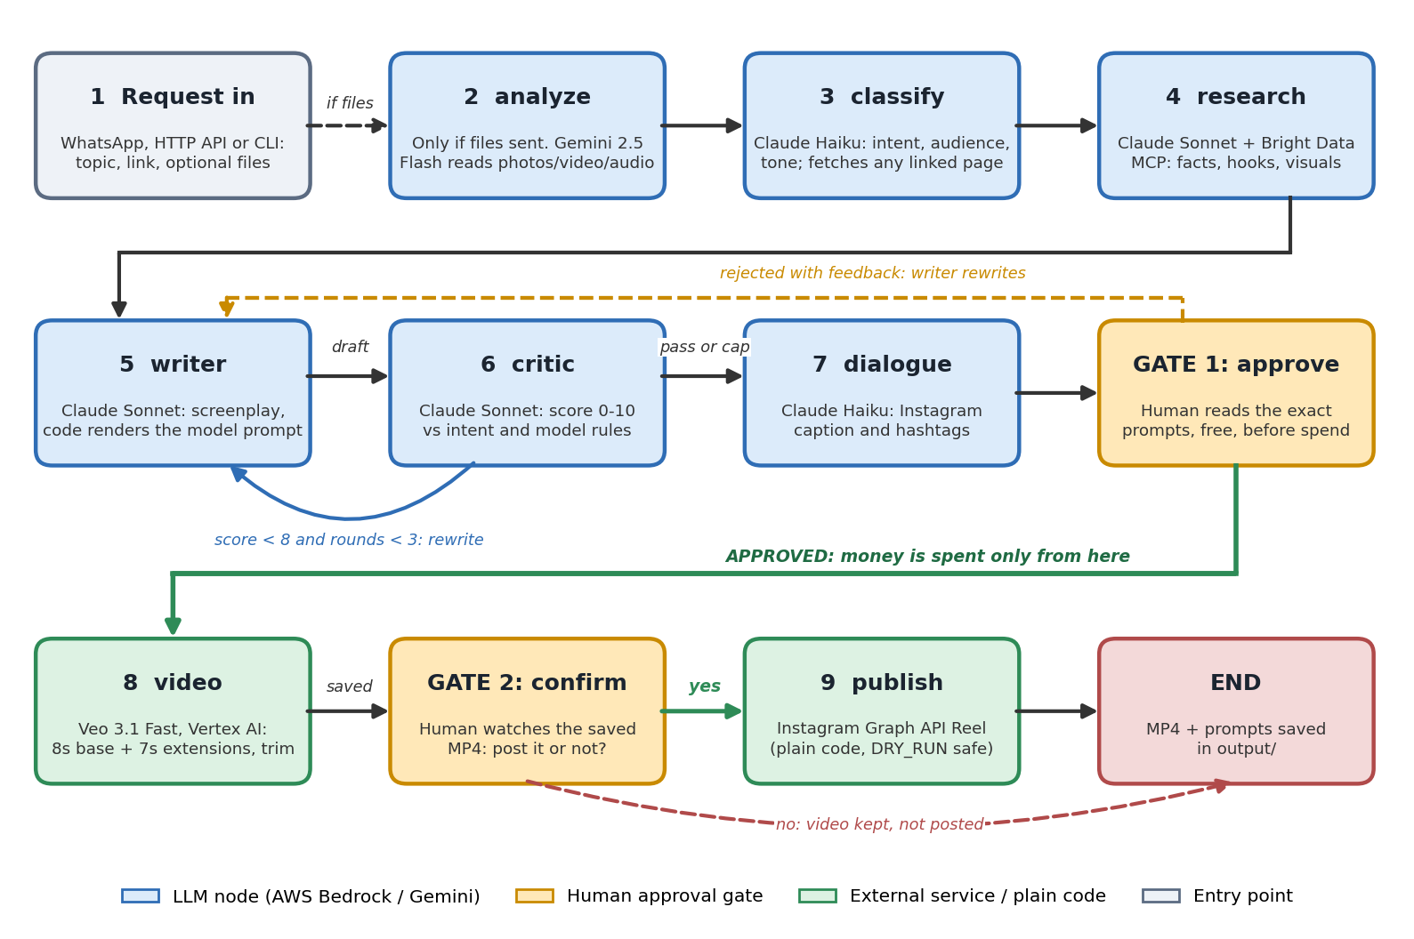
Failures stop the run early: an unusable request ends after classify, and a failed generation skips Gate 2 so nobody is asked to approve a video that does not exist. Declining Gate 1 without feedback also ends the run.
5. Modes used, and why
Mode | What it means here | Why
Dry run (default) | DRY_RUN=true: the Instagram call is skipped entirely. Setting false really posts. | A real post is public and cannot be quietly undone. Safe by default; going live is a deliberate act
Stub vs live video | No Google project and bucket: an ffmpeg placeholder 720x1280 15 s MP4 is made. Both set: real Veo 3.1 Fast. | The whole pipeline can be developed and tested for free, with only text-model access needed
Video model | VIDEO_MODEL=veo (live) or seedance (prompt format only; runs on the stub). Override with --model. | Each model has its own prompt syntax and length limits, so the writer renders for the chosen one
Human-in-the-loop | Two gates: approve the exact prompts, then approve posting the saved video. | Prompt review is free but generation is not, so money is spent only on text a person has read
Interface | CLI (y/n), HTTP API (X-API-Key), WhatsApp (free text, allow-listed numbers, daily cap). | On WhatsApp a small LLM reads each reply as the answer to the open question. Hedging counts as unclear, so a vague reply can never spend money or post
Length | 4 to 30 s, 15 s default, chosen per request. Out of range is clamped and the user is told. | Veo only makes 4/6/8 s bases plus 7 s extensions, so code plans the generations and trims to the length asked

6. Design principles
- LLMs write content, code enforces rules: prompt syntax, timeline repair and approval routing are deterministic and tested.
- Cost and safety first: free review before paid generation, blocked Veo generations are retried without billing, files are deleted when a run ends.
- Degrade, do not crash: if upload analysis or a critic call fails, the run continues from the written request or hands the draft to the human.

