WRITEWISE PORTAL

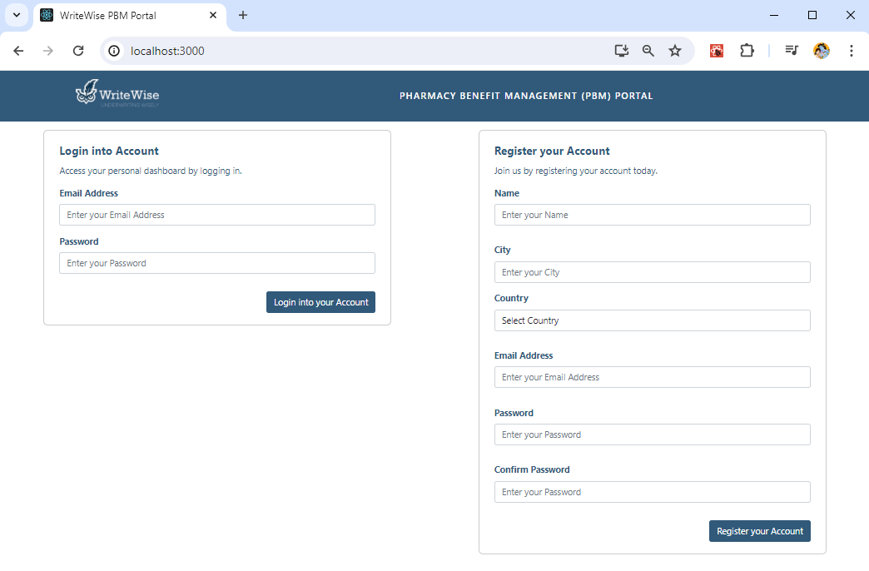

Login and Registration credentials are stored in S3 Bucket (ww-auth) in the form of JSON for each user. The Email Address of user is encrypted and kept as JSON File Name for each user and stores the user information in ww-auth Bucket. In this way, Authentication of the Portal is managed.

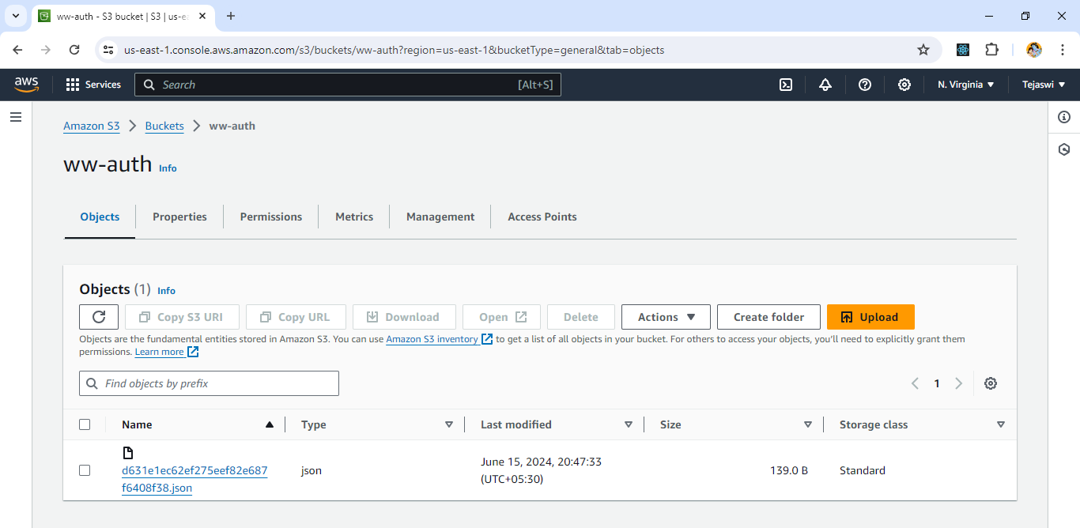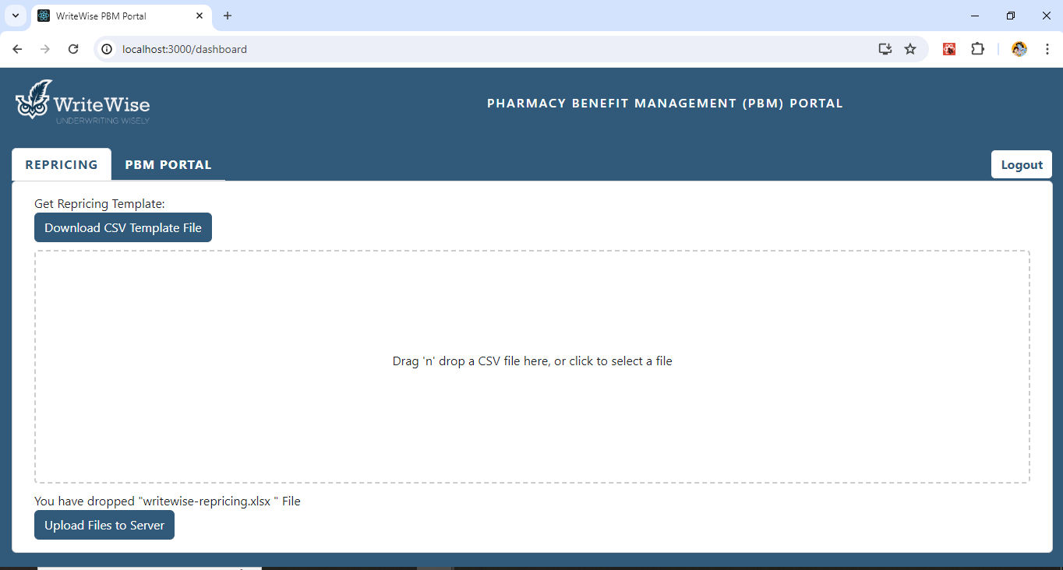

A CSV TEMPLATE can be downloaded to add the Repricing values and upload back into S3 Server.

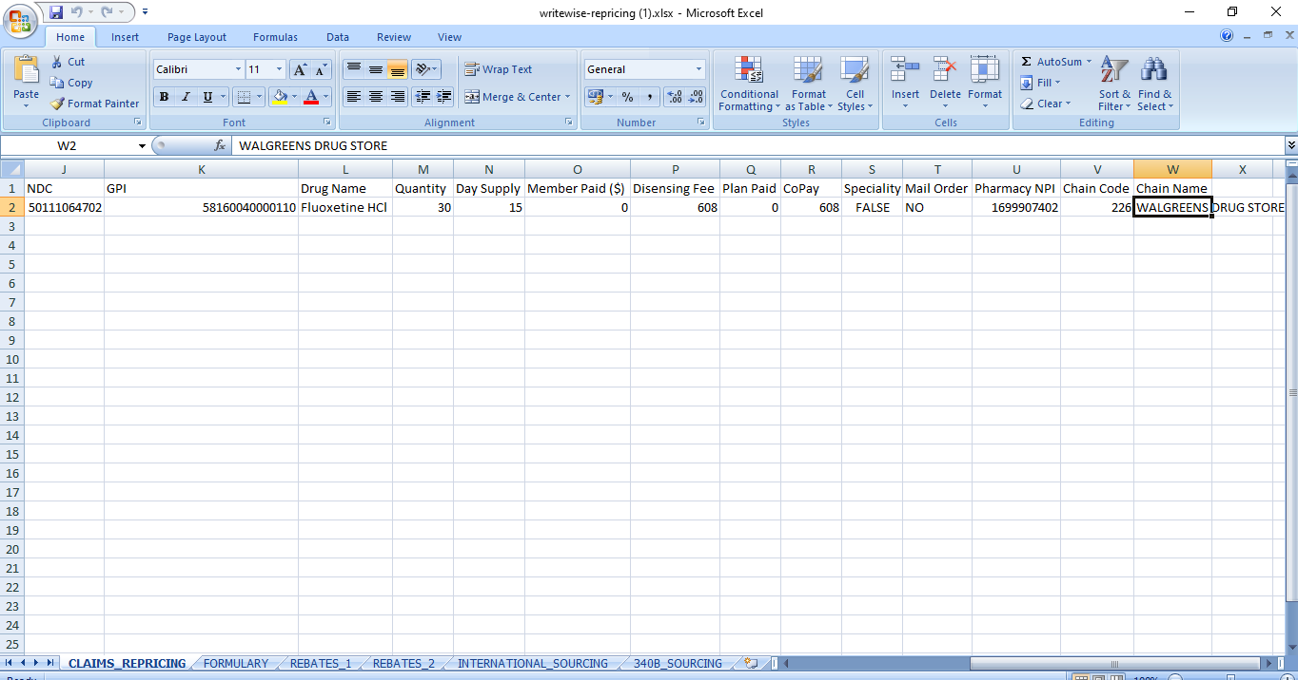

The Upload Files are stored in ww-fs Bucket in S3 and a Mail is sent to Authenticated User (Current User). To Send Emails, we have used Amazon Simple Email Service. As My Account is Free Tier, by default, Amazon Simple Email Service is on Sandbox Environment. So, I can send emails only to verified Identities. So, to send and receive emails, I have verified my identity at AWS SES.

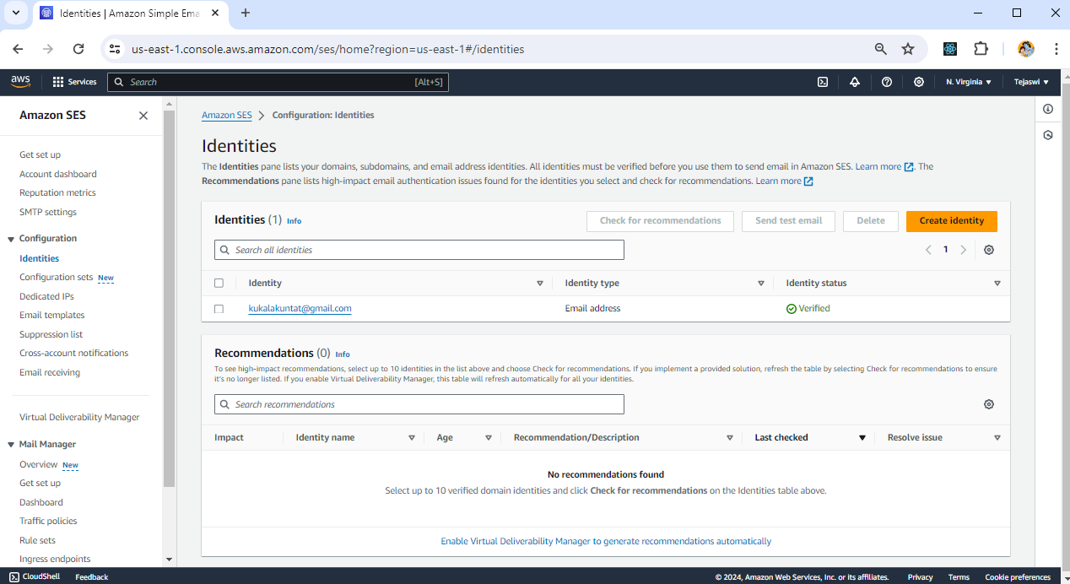

This Email connected to IAM User under Authorization Tab by creating a Policy.

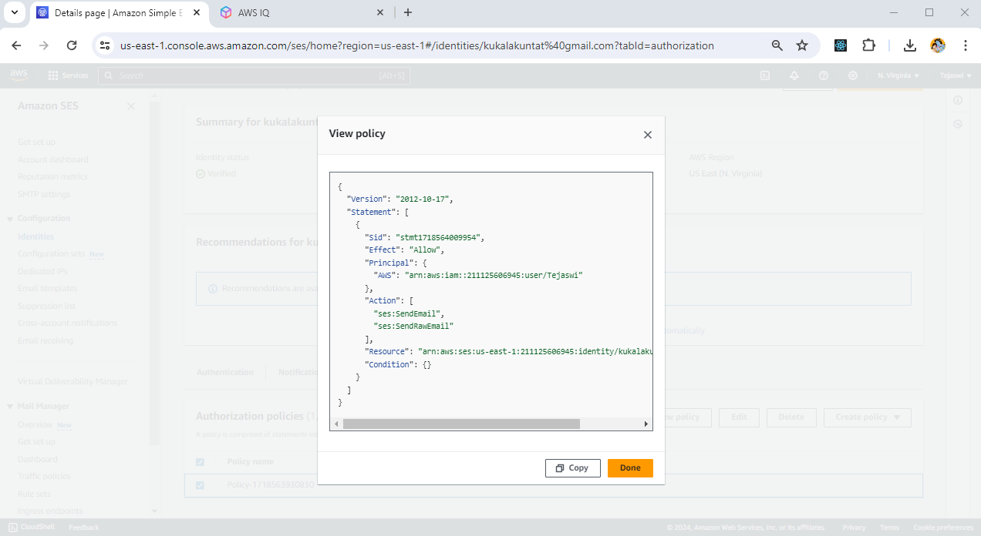

Now, for the IAM User, I have provided Full Access for Amazon SES and Amazon S3.

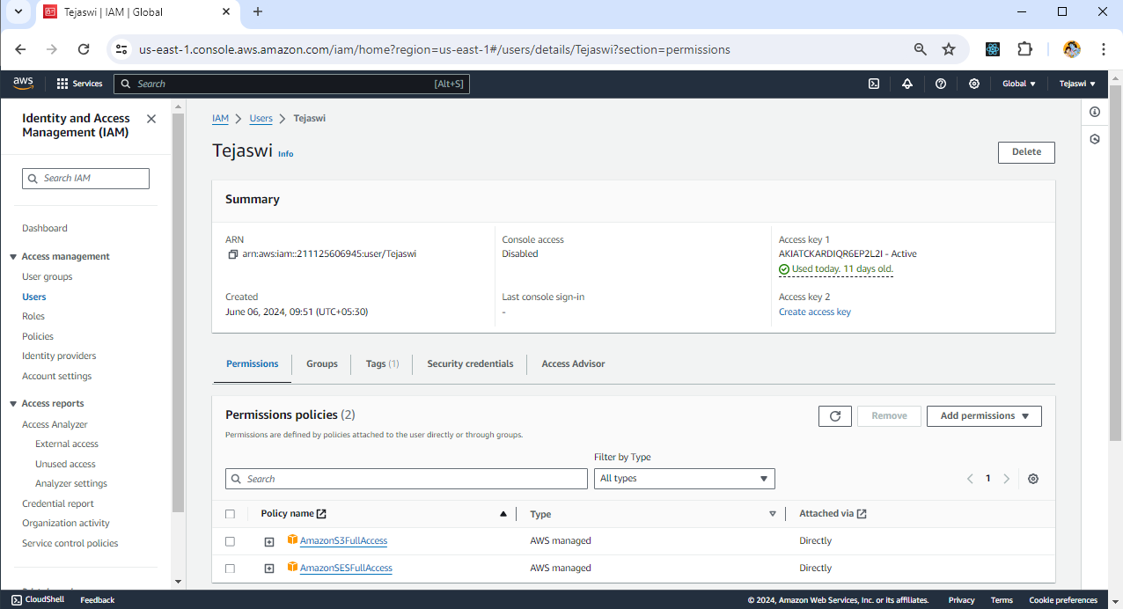

Now, using IAM User’s accessKey and secretAccesskey and using AWS SDK, I was able to upload data into S3 and can trigger Email Notification through Amazon SES.

Next PBM Portal, The uploaded Excel Files Data are stored into a writewise-data.json File and they are displayed into PBM Portal Tab.

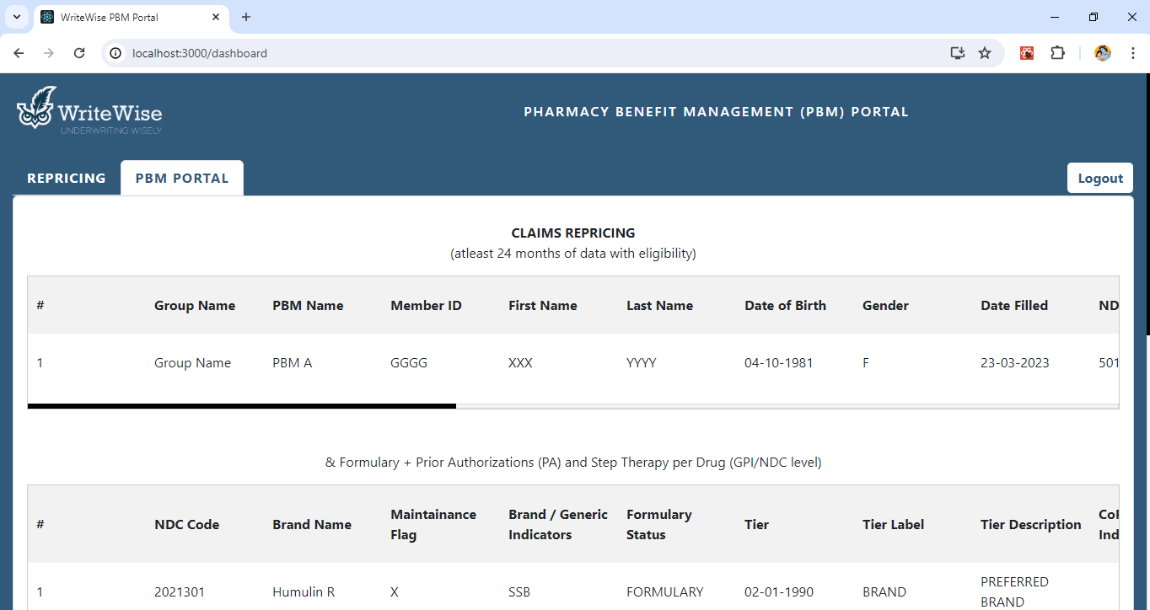

I am able to do, inline Edit and Save data to update JSON in S3.

