**Chep 9: Monitoring and Control**

***1: Introduction***

***2: Creating the framework***

***3: Collecting tha data***

***4: Review***

***5: Visulazing progress***

***6: Cost monitoring***

***7: Earned value analysis***

***8: Prioritizing monitoring***

***9: Getting the project back to target***

***10: Change control***

***11: Software configuration management(SCM)***

***I: Introduction* :**

• Once the work schedules have been published and the project has begun, the focus must be on progress.

This necessitates monitoring what is happening, comparing actual achievement to the schedule, and revising plans and schedules as needed to bring the project as close to completion as possible.

**II: Creating the framework *:***

• Controlling a project and ensuring that goals are met requires regular monitoring. • There could be a mismatch between the expected and actual outcomes.

• So, replanning may be required to get the project back on track or target date can be revised.

• Projects face four types of shortfalls namely delay in meeting target dates, quality, inadequate functionality and costs going over the target.

**1.RESPONSIBILITY :**

• The overall responsibility for ensuring satisfactory progress on a project is often the role of the project steering board.

**2.ASSESSING PROGRESS :**

• This information has to be objective and tangible whether or not or now no longer a specific report has been delivered.

**3.SETTING CHECKPOINTS :**

• They help in identify the important risks, issues, and out of tolerance conditions.

**4.TAKING SNAPSHOTS :**

• Weekly collection of information and its assessment is usually preferred.

**III: Collecting tha data *:***

• Managers try to decompose long activities in more controllable tasks than one or two weeks.

• It will still be necessary to collect information on partially completed activities and, in particular, the prevention of the remaining amount of work.

• It can be difficult to make such predictions precisely.

• But in case of series of products, it is easy to estimate the partial completion of activities.

**1.PARTIAL COMPLETION REPORTING :**

• The staff time booked to a task demonstrates the work did and the charges to the undertaking.

**2.RAG (RED/AMBER/GREEN) REPORTING :**

• This scheme overcomes by asking the likelihood of meeting the planned target date.

**IV: Review :**

• Review of work items is a significant mechanism for checking the advancement of a project and guaranteeing the quality of the work items.

**1.UTILITY OF REVIEW :**

• A review usually aids in identifying any deviations from standards, as well as issues that may affect the software's maintenance.

**2.CANDIDATE WORK PRODUCT FOR REVIEW :**

• Apart from final work items and end products, other items are also reviewed such as requirements specification documents, user interface specification and design documents, architectural, highlevel and detailed design documents, test plan and the designed test cases and lastly project management plan and configuration management plan

**3.REVIEW ROLES :**

• The moderator plans and organises meetings, distributes review materials, and leads and moderates review sessions.

**4. REVIEW PROCESS :**

**• Planning -** The input to the planning phase is the work products which is ready for review. The project manager appoints moderator and with his consultation nominates the review team.

**• Preparation -** To initiate the review process, a brief preparation meeting is scheduled and copies of work products are handed over to team. Author presents overview of work.

**• Review Meeting –** The reviewer presents their observations and author along with other reviewers respond to it and moderator ensures discussions are focussed and productive.

**• Rework and follow-up –** The author raise all issues by team and brings in relevant modification. A rejoinder is prepared against the defect log.

**5.DATA COLLECTION :**

• The Review Preparation Log is prepared by reviewer which contains data about defects, location, criticality and time spent in doing review.

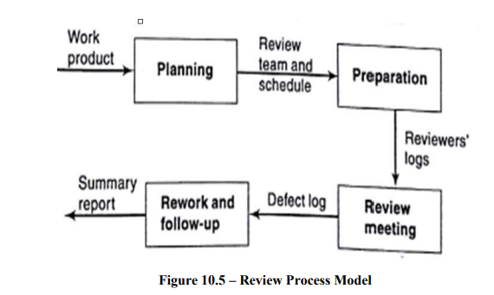

***V:* Visulazing progress *:***

• After gathering data on project progress, a manager must find a way to effectively present that data.

• Some of these methods provide a static image, a single snapshot, while others attempt to demonstrate how the project has progressed and changed over time.

**• GANTT CHART**

• The Gantt chart is the most basic and oldest technique for tracking project progress.

**• SLIP CHART**

• It is a very equivalent alternative that some project managers prefer.

**• TIMELINE**

• The timeline chart is a method of recording and displaying how targets have changed over the course of a project.

**VI)** **COST MONITORING:**

• Expenditure control is a vital component of project control not only because it provides an indication of the effort that has taken into a project, but also because it delivers an indication of the effort that has gone into a project.

• A project may be completed on time but over budget due to the addition of additional resources.

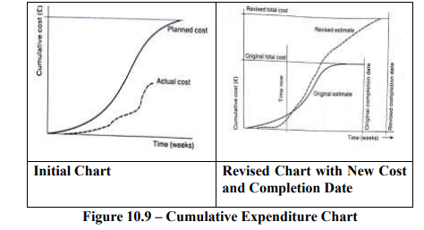

**VII)** **EARNED VALUE ANALYSIS:**

• Earned value analysis has attracted increasing attention in recent years and can be thought of as a refinement of cost monitoring.

• It is rooted on assigning a 'value' to each task or work package based on the initial expenditure forecasts.

1. **BASELINE BUDGET:**

• It is the first stage in setting up earned value analysis.

• It is based on the project plan and depicts the projected increase in earned value over time.

1. **MONITORING EARNED VALUE:**

• The following task is to track earned value as the project progresses after having created the baseline budget.

• This is accomplished by tracking the completion of tasks, the start of activities, and the achievement of milestones.

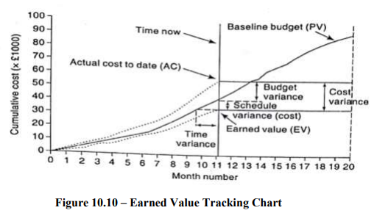

1. **SCHEDULE VARIANCE:**

• Schedule variance is expressed in cost terms as EV-PV and indicates the extent to which the value of completed work differs from that anticipated.

• A negative SV indicates that the project is running behind schedule.

**4 .TIME VARIANCE:**

• It denotes the time difference between when the specified EV should have been reached and when it was actually reached.

**5.COST VARIANCE:**

• The difference between the earned value or budgeted cost and the actual cost of completed work is calculated as EV-AC.

**6 .PERFORMANCE RATIOS:**

• Two commonly traced ratios are considered as ‘value-for-money’ namely Cost Performance Index (CPI) = EV / AC and Schedule Performance Index (SPI) = EV / PV.

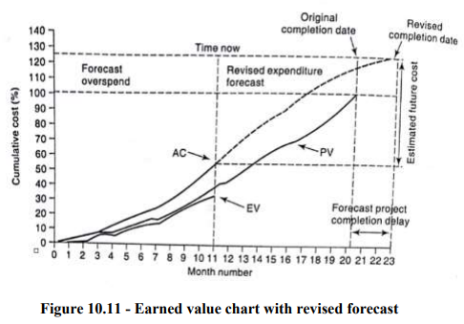

**VIII) PRIORITIZING MONITORING:**

• Critical path activities – They can cause delay in project completion date and so requires high priority close monitoring.

• Activities with no free float – They may cause delay in subsequent activity which might not affect project completion date but availability of resources could be a hitch which could be an area of concern. • Activities with less than a specified float – They may be taken care by regular monitoring.

• High risk activities – They must be identified at initial stages as they may cause overrun or overcost as they may have high variance.

• Activities using critical resources - They are highly expensive as they consume staff resources if not controlled on time.

**VIII: PRIORITIZING MONITORING:**

• Critical path activities – They can cause delay in project completion date and so requires high priority close monitoring.

• Activities with no free float – They may cause delay in subsequent activity which might not affect project completion date but availability of resources could be a hitch which could be an area of concern. • Activities with less than a specified float – They may be taken care by regular monitoring

. • High risk activities – They must be identified at initial stages as they may cause overrun or overcost as they may have high variance.

• Activities using critical resources - They are highly expensive as they consume staff resources if not controlled on time.

**IX:GETTING THE PROJECT BACK ON TARGET :**

• Reducing the critical path – This can be handled by adding resources especially staff, increase use of current resources, reallocate staff to critical activities, reduce scope and finally reduce quality. This way we can control the timescales and cost of critical activities. Shortening the critical path may cause some other paths to become critical which should be taken care off.

• Changing the requirements for activity precedence - Consider the constraints that force some activities to be postponed while others are completed. Divide an activity into two parts: one that can begin immediately and one that must wait. It is obviously critical to be aware that quality may be compromised. It is also critical to evaluate the extent to which changes in work practises increase risk.

**1 .MAINTAINING THE BUSINESS CASE:**

• The project sponsor's main concern when making decisions about project management is whether the project's business case has been preserved.

• If costs rise, the value of the benefits at the end of the project falls.

**2. EXCEPTION PLANNING :**

• The project manager is usually allowed to change the specifics of a plan as long as the agreed-upon project outcomes are delivered on time and within budget

. • A few changes to the plan may have a repercussion on the project's delivery date, scope, or costs.

• These, in turn, may have an impact on the business case

**X.CHANGE CONTROL:**

• When developing a document, such as user requirements, many different forms of the document may be created as it goes through development and review cycles.

• At this juncture, any change management process would be very informal and adaptable.

• It is expected that the final version will be created at some point.

1. **CHANGE CONTROL PROCEDURES:**

• The steps involved are

• Step 1 - A change may be perceived as necessary by one or more users.

• Step 2 - User organization considers that the change is valid and noteworthy, and it is forwarded to development management.

Step 3 - A developer is tasked with determining the feasibility and cost of implementing the change.

• Step 4 - Development management reports the cost of the change to user management, and user management decides whether to proceed.

• Step 5 - A smaller group (Change Control Board) will be tasked with finalising changes up to a certain amount of expenses. 223

• Step 6 - One or maybe more developers are authorised to duplicate Monitoring and Control components that will be altered.

• Step 7 - The Copies have been altered.

• Step 8 - Following initial testing, a test version may be made available to users for acceptance testing.

• Step 9 - When all users are satisfied, the operational release is authorised, and master copies of configuration items are replaced.

1. **CHANGES IN SCOPE OF A SYSTEM:**

• This is referred to as software creep.

• The size of the system progressively increasing is a common phenomenon in IS development projects.

1. **CONFIGURATION LIBRARIAN’S ROLE:**

• The configuration librarian alternatively called project librarian or configuration manager is responsible for control of changes and documentation.

**XI. SOFTWARE CONFIGURATION MANAGEMENT:**

• When we consider changes occurring on all work products and when there are numerous variants of the product, the manual change management process becomes overburdened.

• SCM is involved with tracking and controlling software changes.

1. **CONTEXT IN WHICH CONFIGURATION**:

• Work products are altered as development actions are performed out during the development phase.

• The work products change during the maintenance phase due to different types of enhancements and adjustments, including bug fixes.

1. **FEW TERMINOLOGIES:**

• Configuration – The state of various work products under configuration control.

• Version – The configuration of a software product changes as development and maintenance activities are performed on it. It is frequently necessary to refer to the configuration that existed at a specific point in time. A version is thus a configuration that existed at a specific point in time.

• Revision – It is a numbering scheme used to identify the current state of a configuration item. • Baseline – A software configuration that has been formally reviewed and agreed upon and serves as the foundation for future development.

• Variant – These are versions that are meant to coexist with one another.

1. **PURPOSE OF SOFTWARE CONFIGURATION MANAGEMENT:**

• Proper configuration of work items is essential and if not carried out properly then it can lead to several problems such as

• Problems associated with concurrent access-

• Undoing Changes –

• System accounting –

• Handling variants-

• Accurate determination of project status-

• Preventing unauthorized access to the work products -

1. **CONFIGURATION MANAGEMENT PROCESS:**

• It is accomplished through two primary activities: Configuration Identification and Configuration Control.

• Typically, project managers divide the work products associated with a software development process into three categories: controlled, pre-controlled, and uncontrolled.

• Controlled work products are those that have been configured.

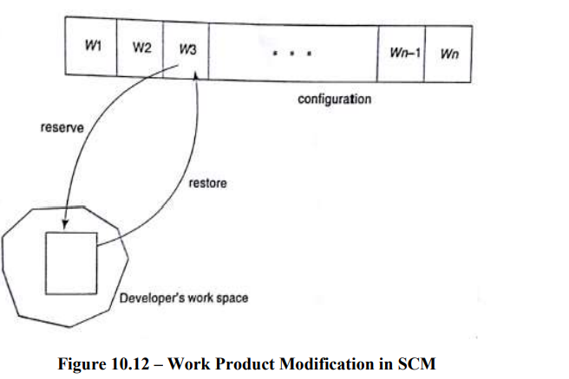

1. **MODIFICATIONS TO WORK PRODUCT UNDER Monitoring and Control CONFIGURATION CONTROL:**

• When a developer needs to make a change to a work product, they first submit a reserve request.

• A team member's reserve request is honored only if the project manager has granted that member appropriate authorization for the specific work product.

1. **RELEASE MANAGEMENT:**

• It is preferable for a software development project to implement an appropriate release management process.

• It systematizes the work done by developers to include a new release of software, as well as the work done by users to obtain and use a new release smoothly and effortlessly

**7 .OPEN-SOURCE CONFIGURATION MANAGEMENT TOOLS :**

• SCCS and RCS are popular configuration management tools found on nearly all UNIX systems.

• It can be used to control and manage multiple versions of text files.

• They do not work with binary files.