Admin Server Manual Failover

Table of Contents

Administration Server Failover 3

Create a machine for Admin Server 3

Verify the IP’s 7

Manually Failing Over the Administration Server to ComputeNode2 11

Failing back to ela1cn15 17

# Administration Server Failover

## Create a machine for Admin Server

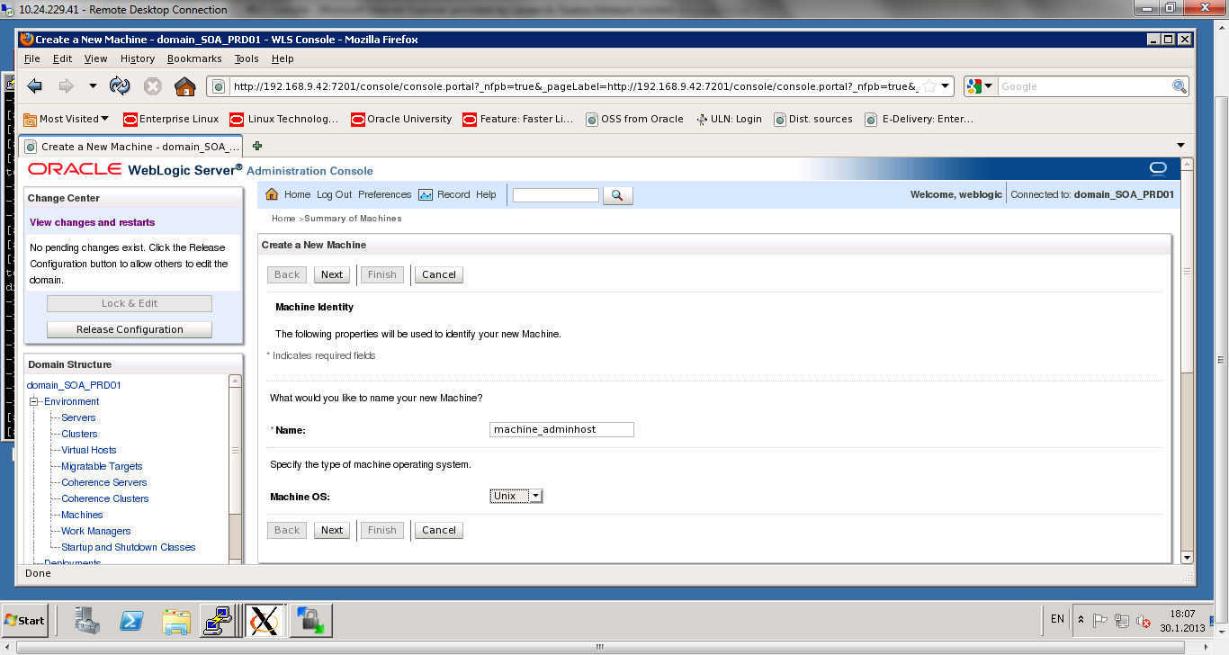

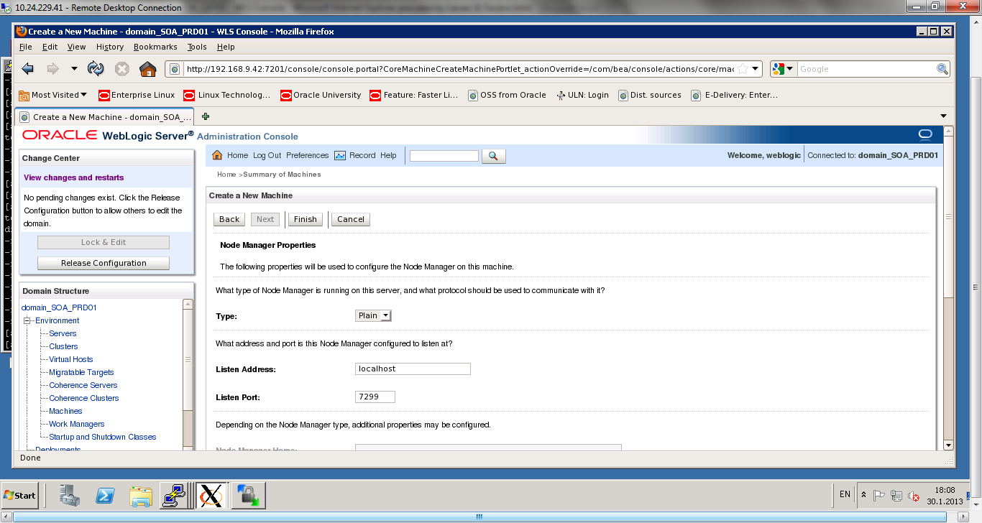

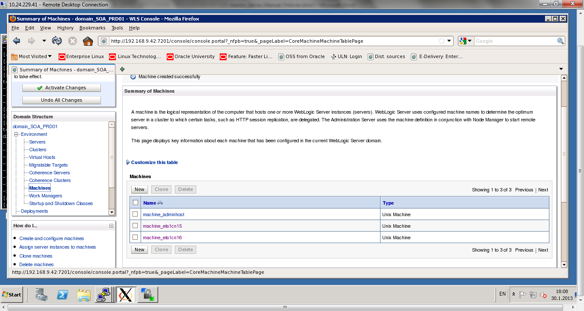

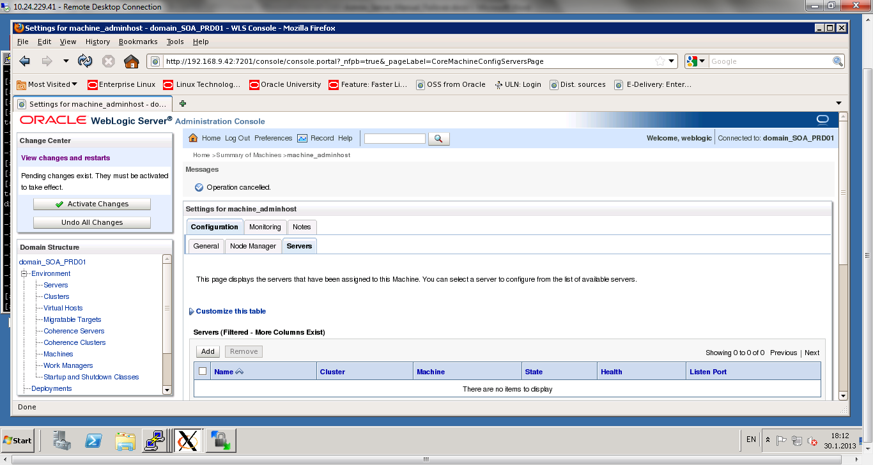

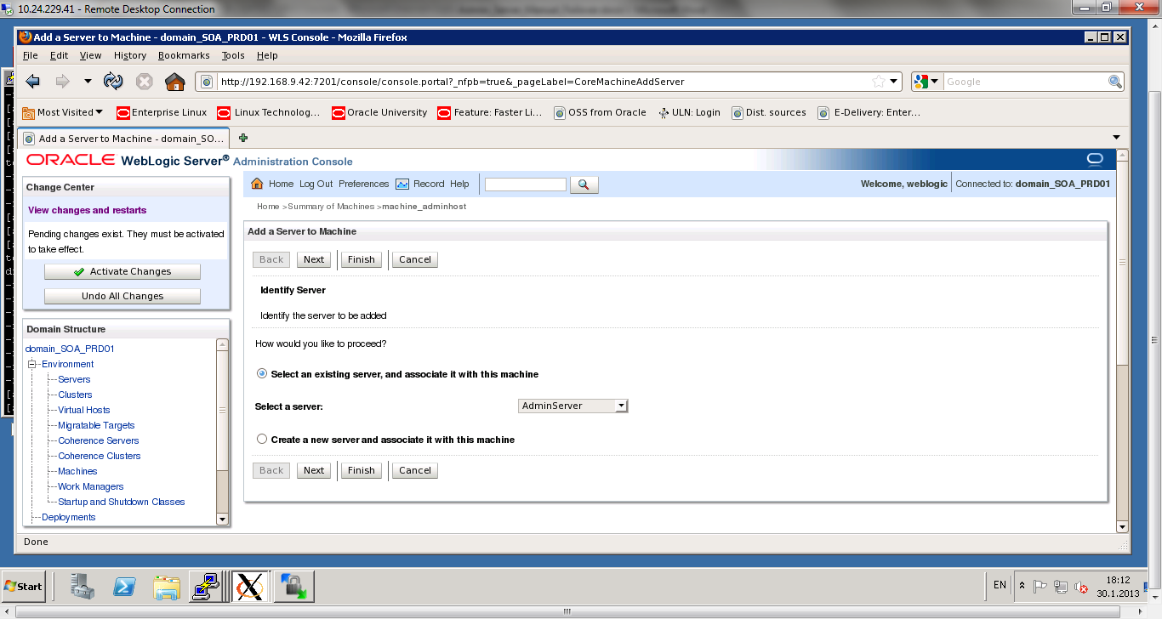

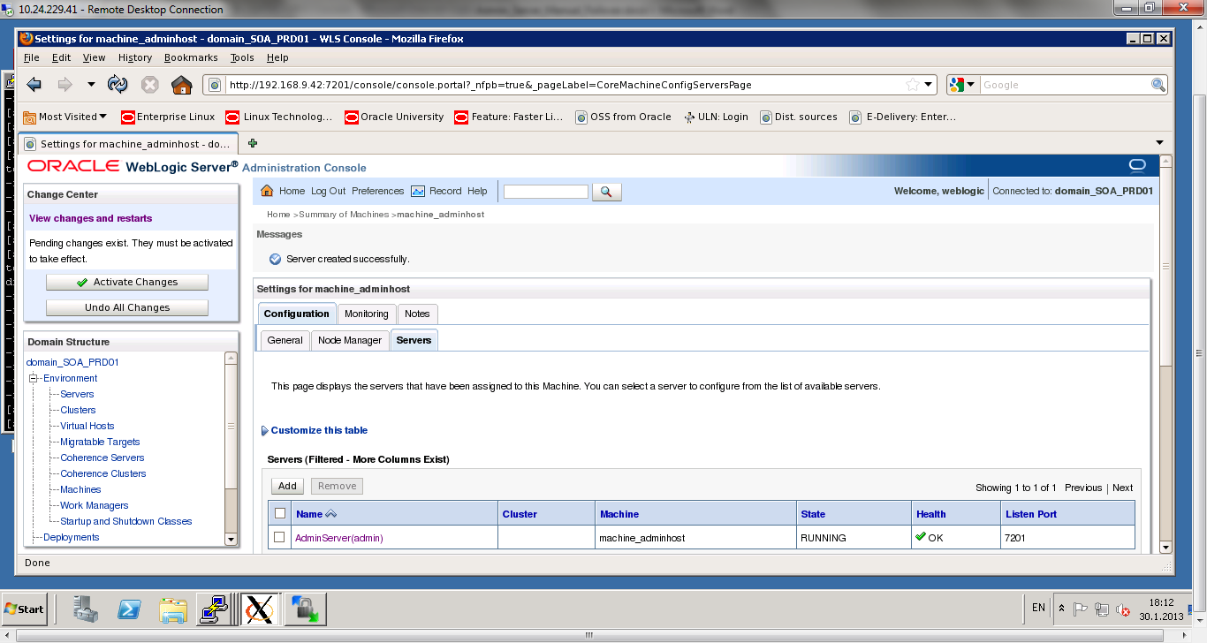

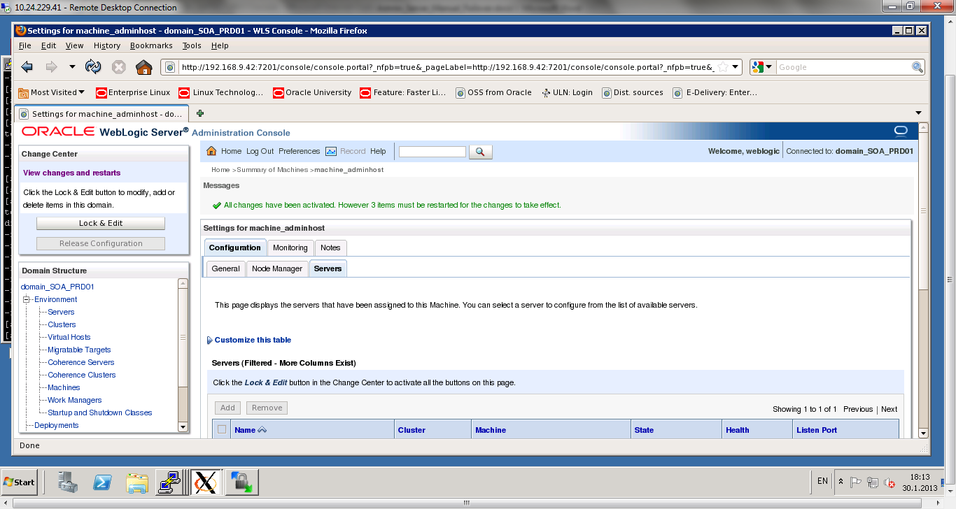

## Verify the IP’s

ELA1CN15

Login to ela1cn15 and run the following command:  
/sbin/ifconfig –a | less

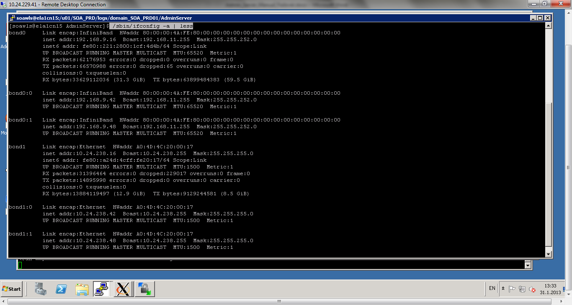

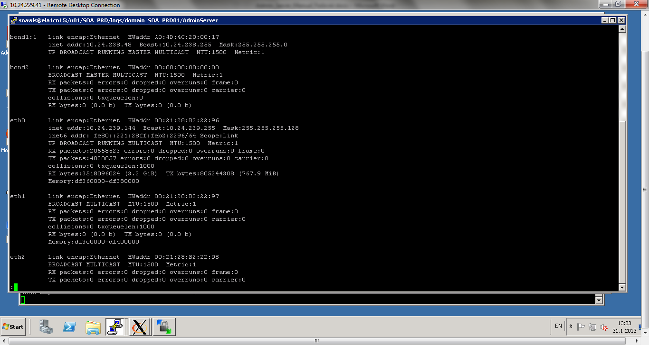

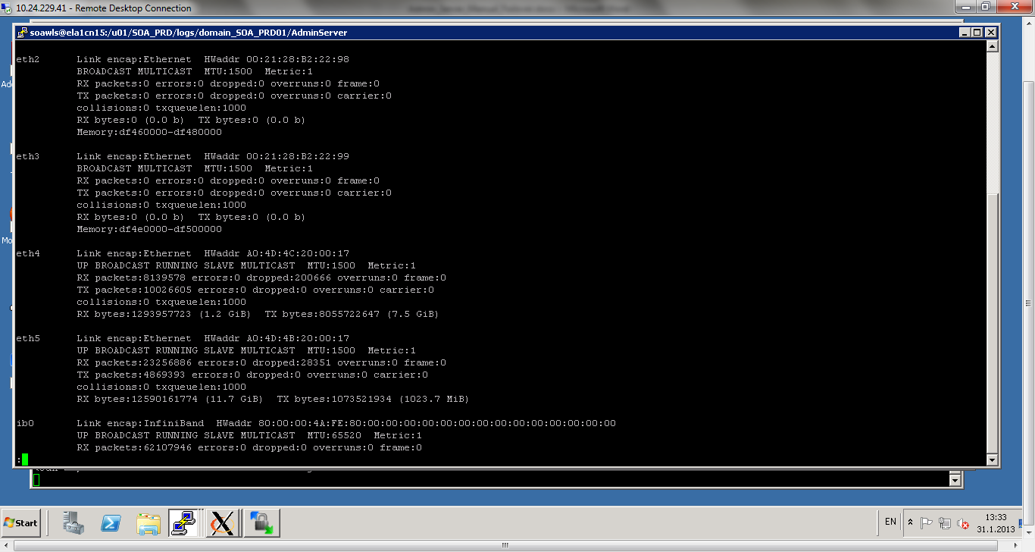

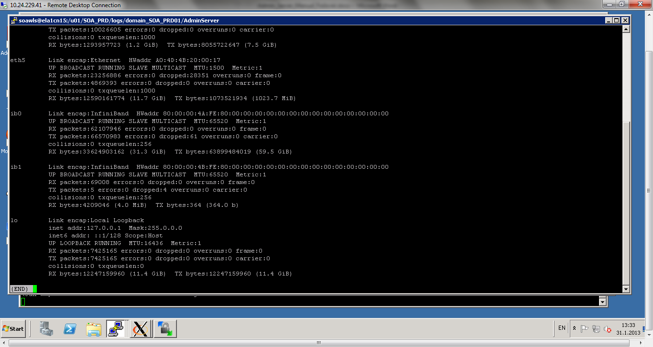

Bond0:0  
IP : 192.168.9.42 (Virtual IP)  
Mask : 255.255.252.0

Bond1:0  
IP: 10.24.238.42 (Virtual IP)  
Mask : 255.255.255.0

ELA1CN16

Login to ela1cn16 and run the following command:  
/sbin/ifconfig -a | less

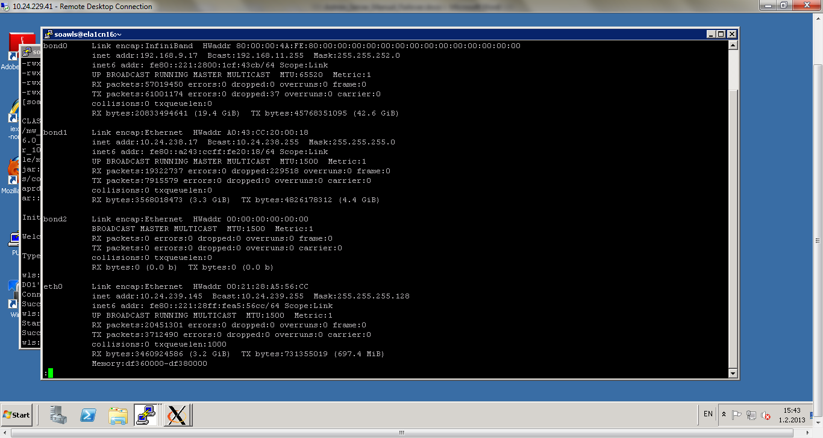

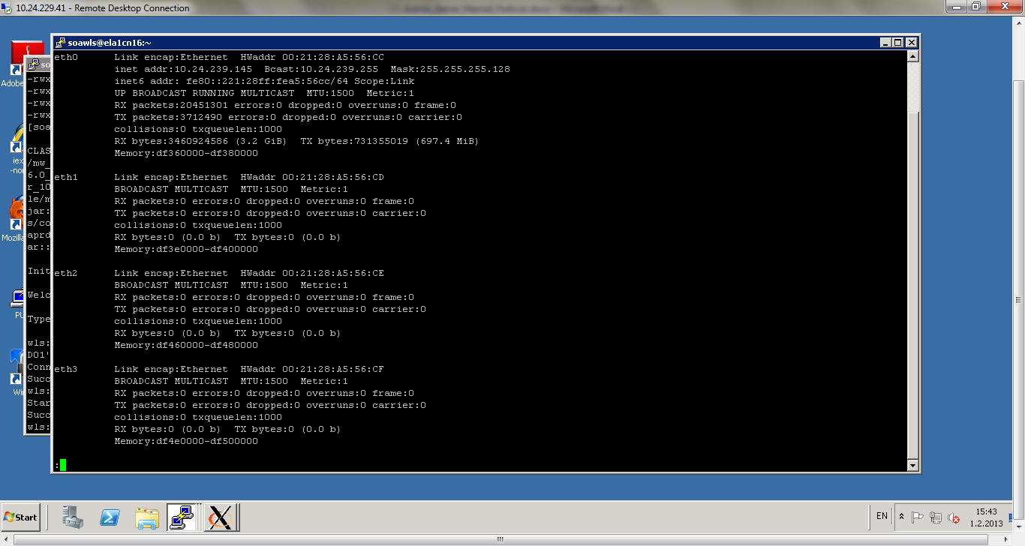

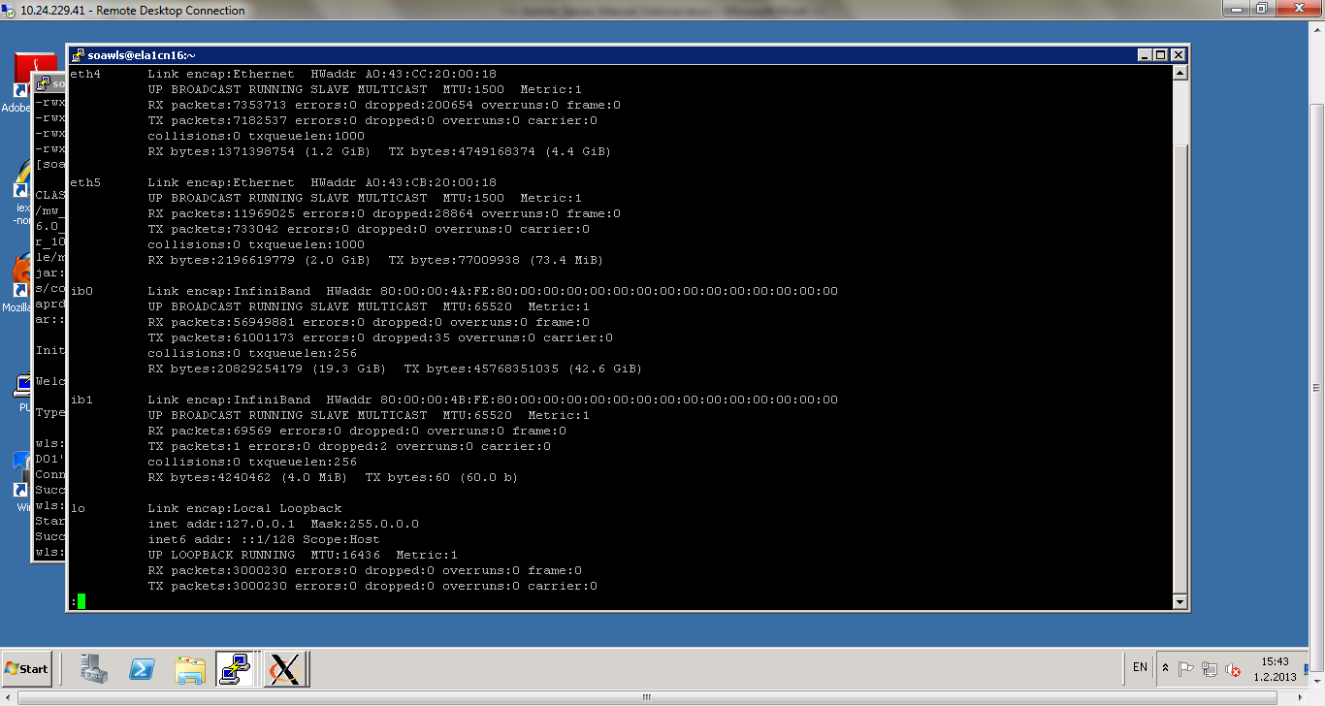

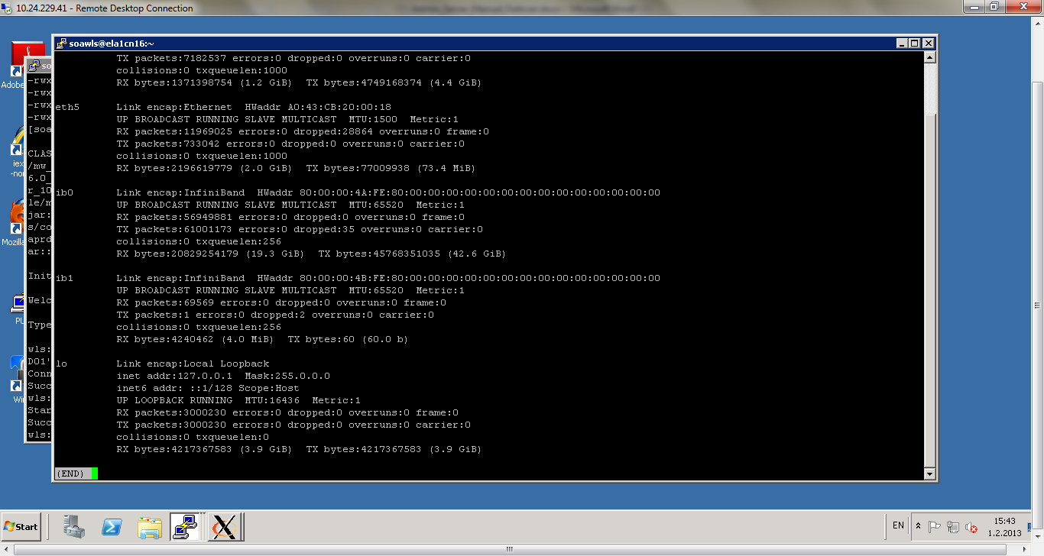

## Manually Failing Over the Administration Server to ComputeNode2

The following procedure shows how to fail over the Administration Server to a different node (ComputeNode2), but the Administration Server will still use the same WebLogic Server machine (which is a logical machine, not a physical machine).

Stop the Administration Server  
Migrate IP to the second node

Run the following command on ComputeNode1 (where bond0:Y is the current interface used by ADMINVHN1):  
ComputeNode1> /sbin/ifconfig bond0:Y down

/sbin/ifconfig -a | less  
[soawls@ela1cn15 ~]$ sudo /sbin/ifconfig bond0:0 down  
[soawls@ela1cn15 ~]$ sudo /sbin/ifconfig bond1:0 down  
/sbin/ifconfig -a | less

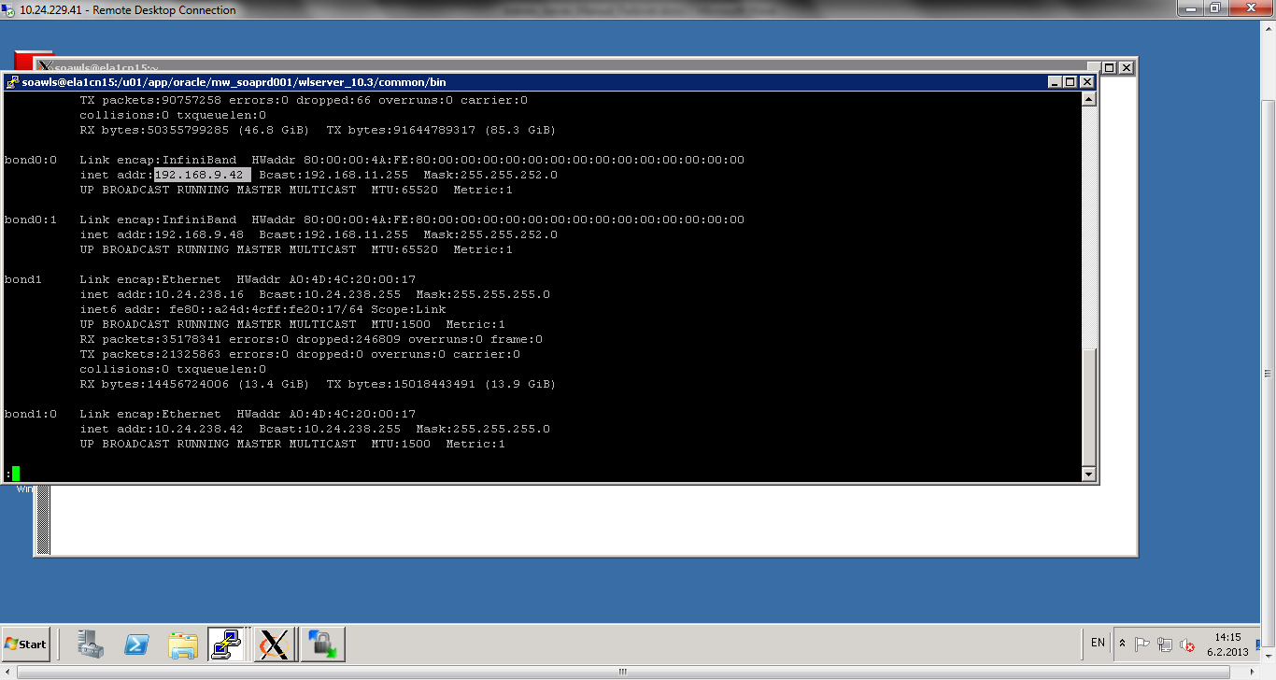

/sbin/ifconfig -a | less

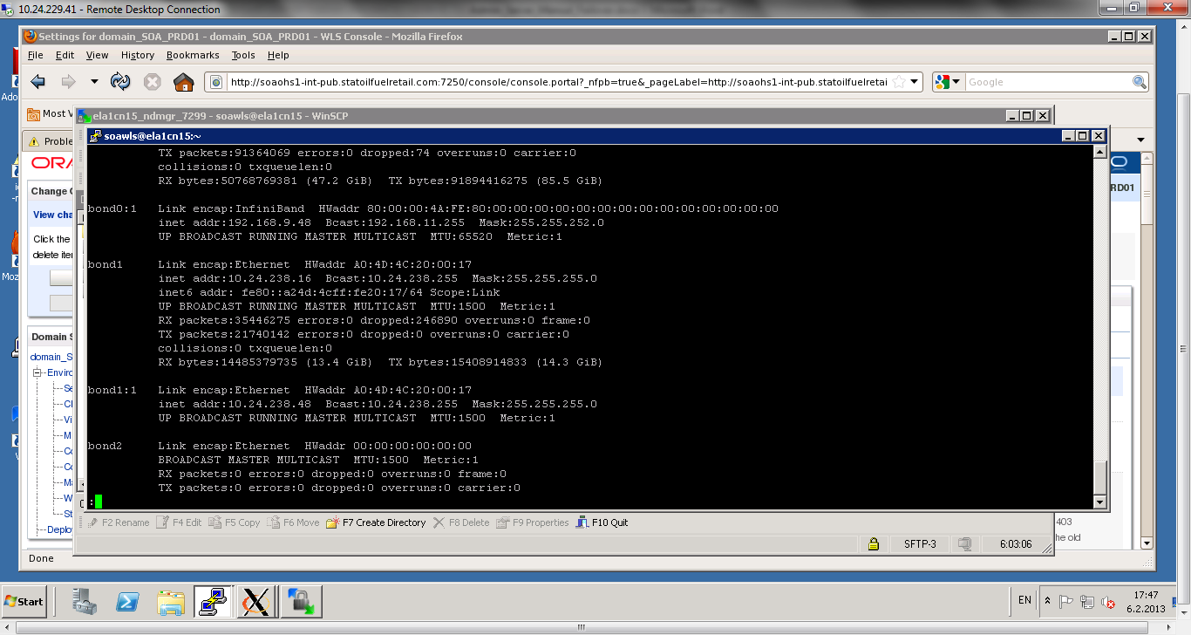

The values for bond0:0 and bond1:0 should be not available

Run the following command on ComputeNode2:

ComputeNode2> /sbin/ifconfig <interface:index> <IP_Address> netmask <netmask>  
For example: /sbin/ifconfig bond0:1 10.0.0.17 netmask 255.255.255.0

/sbin/ifconfig -a | less

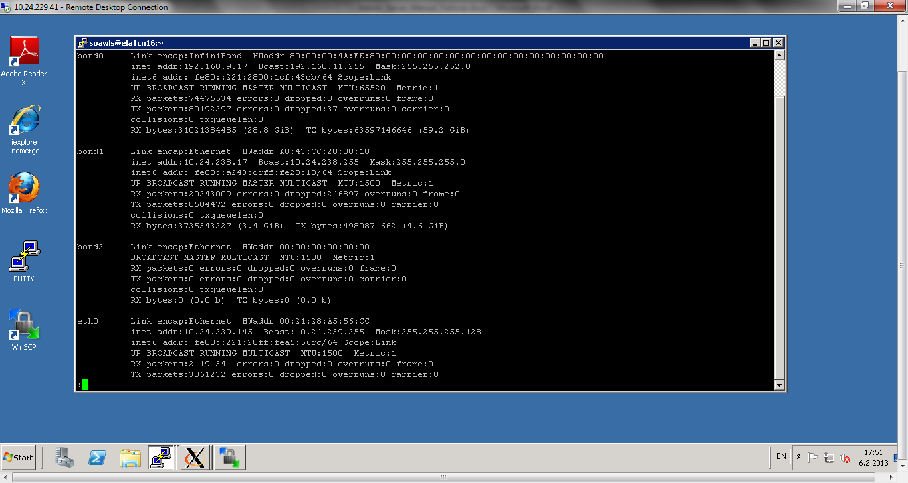  
[soawls@ela1cn16 ~]$ sudo /sbin/ifconfig bond0:0 192.168.9.42 netmask 255.255.252.0

[soawls@ela1cn16 ~]$ sudo /sbin/ifconfig bond0:0 up

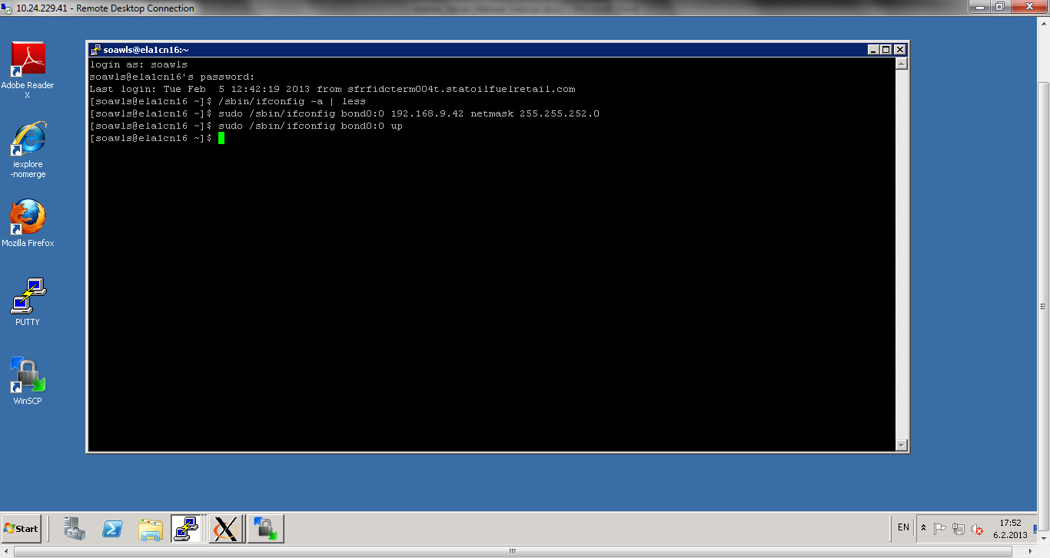  
[soawls@ela1cn16 ~]$ sudo /sbin/ifconfig bond1:0 10.24.238.42 netmask 255.255.255.0

[soawls@ela1cn16 ~]$ sudo /sbin/ifconfig bond1:0 up

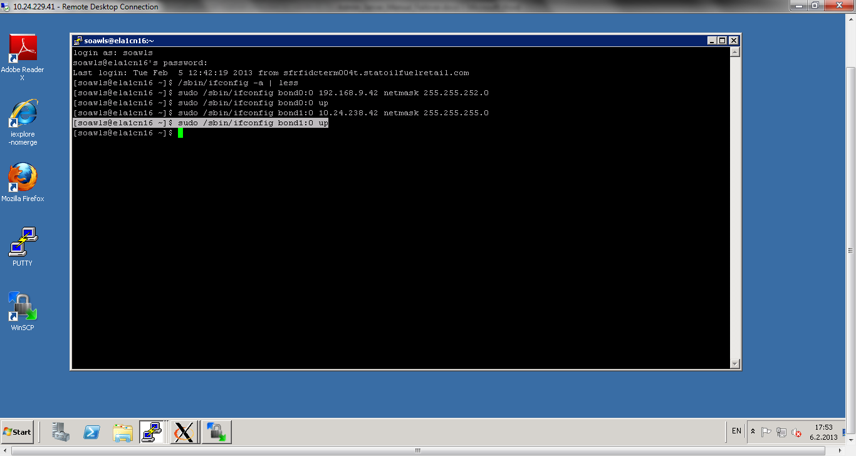

/sbin/ifconfig -a | less

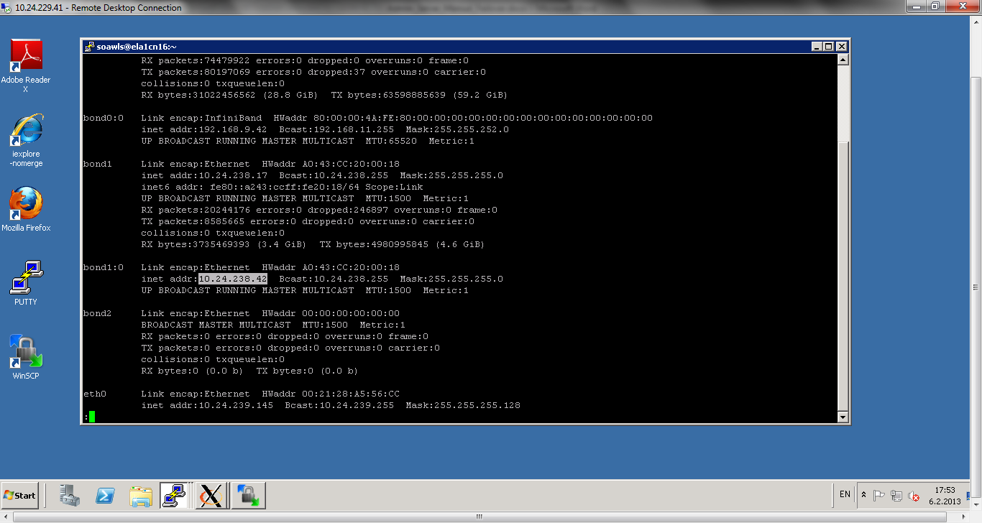

**Note**: Ensure that the netmask and interface to be used to match the available network configuration in ComputeNode2.

On Linux, update routing tables through arping, for example:  
ComputeNode2> /sbin/arping -b -A -c 3 -I bond0 10.0.0.17 netmask 255.255.255.224

[soawls@ela1cn16 ~]$ sudo /sbin/arping -q -U -c 3 -I bond1 10.24.238.42  
[soawls@ela1cn16 ~]$ sudo /sbin/arping -q -U -c 3 -I bond0 192.168.9.42

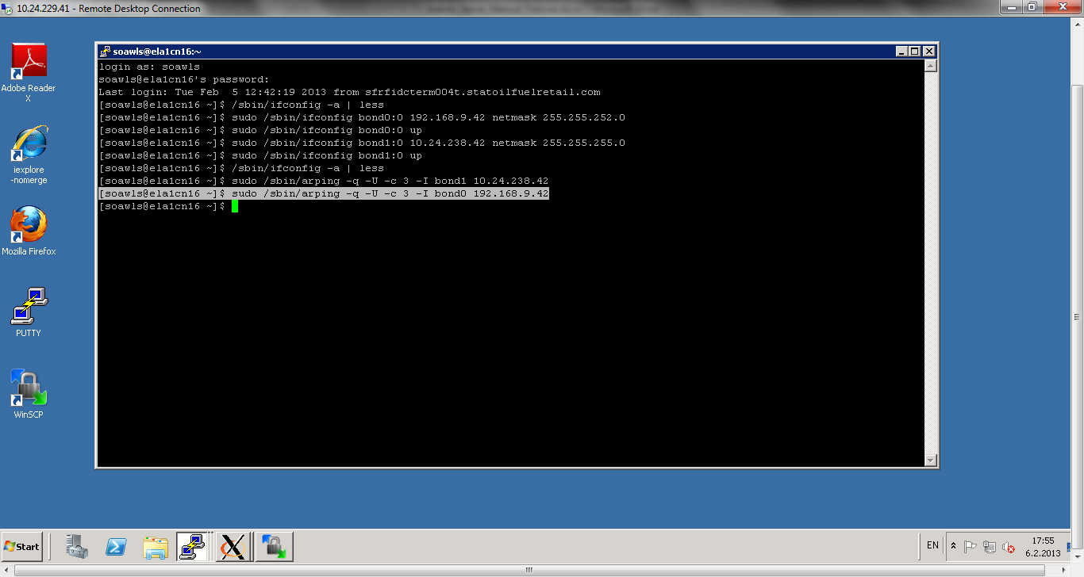

Start the Administration Server on ComputeNode2 using the startWebLogic.sh script

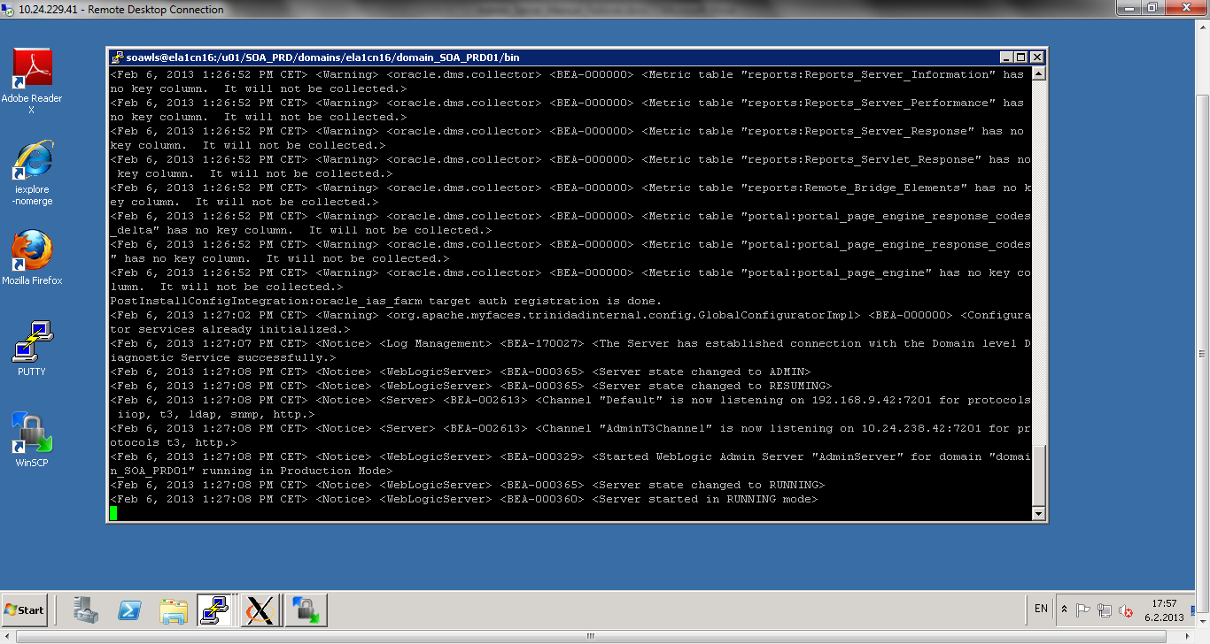

Test that you can access the Administration Server on ComputeNode2 as follows:  
 Ensure that you can access the Oracle WebLogic Server Administration Console at <http://10.0.0.17:7001/console>.

<http://soaohs1-int-pub.statoilfuelretail.com:7250/console>

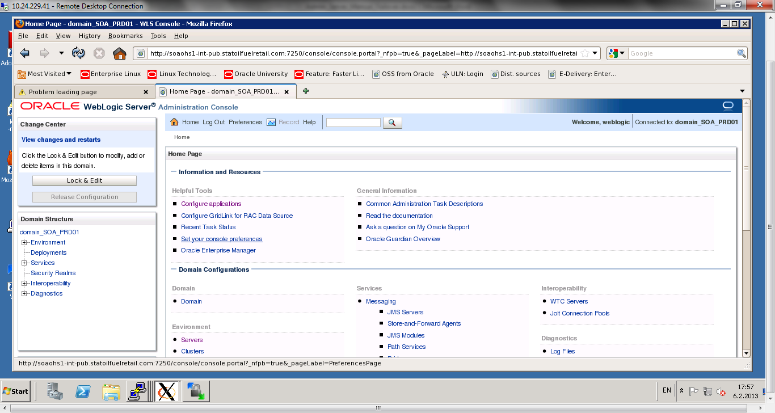

Check that you can access and verify the status of components in the Oracle Enterprise Manager at http://ADMINVHN1:7001/em

<http://soaohs1-int-pub.statoilfuelretail.com:7250/em>

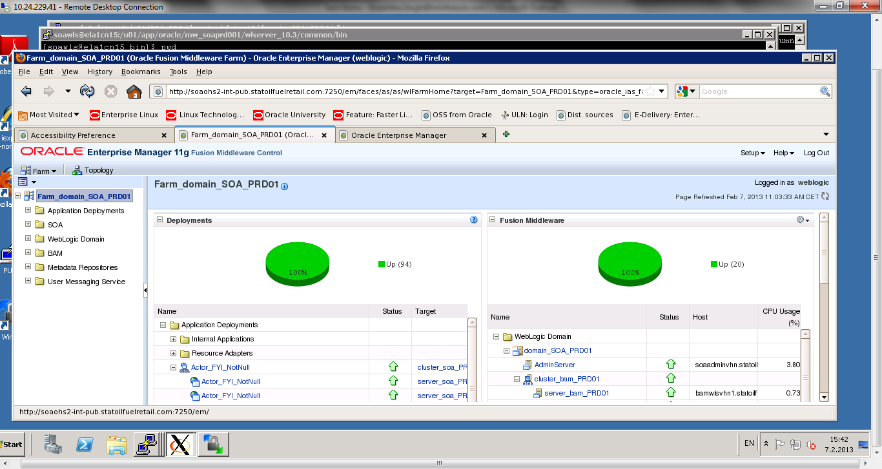

**Note:**

The Administration Server does not use Node Manager for failover. After a manual failover, the machine name that appears in the Current Machine field in the Administration Console for the server is ComputeNode1, and not the failover machine, Compute Node2. Since Node Manager does not monitor the Administration Server, the machine name that appears in the Current Machine field, is not relevant and you can ignored it.

If you created a boot.properties file for the Administration Server on ComputeNode1, the username and password values in the file get encrypted. When the Administration Server is failed over to ComputeNode2, you must edit the username and password values in the boot.properties file on ComputeNode2 manually.

# Failing back to ComputeNode1 (ela1cn15)

1. Stop the Admin server on compute Node 2 (ela1cn16)
2. Run following commands

[soawls@ela1cn16 bin]$ sudo /sbin/ifconfig bond0:0 down

[soawls@ela1cn16 bin]$ sudo /sbin/ifconfig bond1:0 down

These commands will unbind the Compute Node2 (ela1cn16) from virtual host or IP.

/sbin/ifconfig –a | less

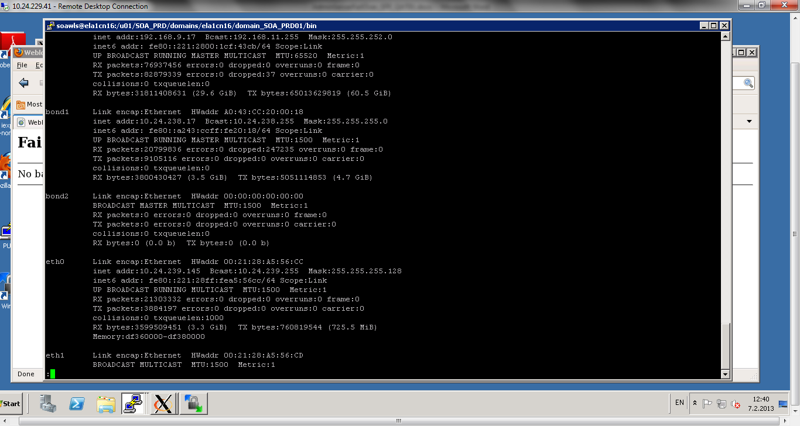

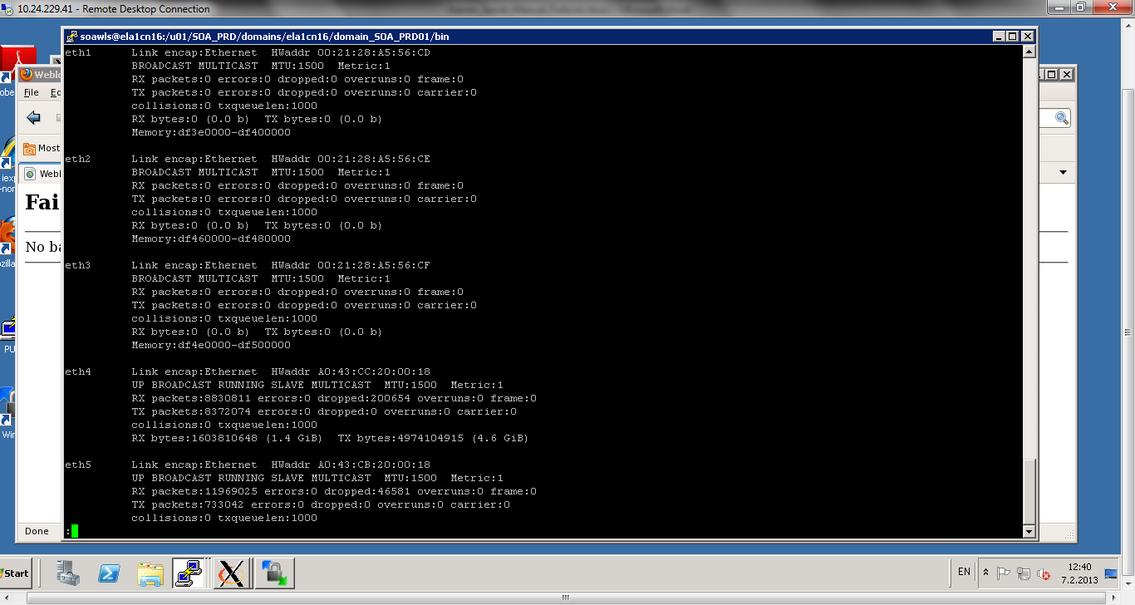

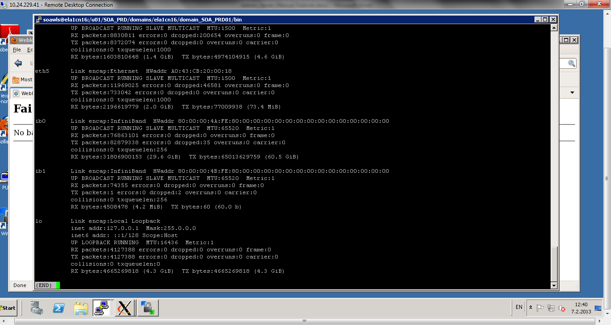

Run following commands on Compute Node1 (ela1cn15)

[soawls@ela1cn15 domain_SOA_PRD01]$ sudo /sbin/ifconfig bond0:0 192.168.9.42 netmask 255.255.252.0  
[soawls@ela1cn15 domain_SOA_PRD01]$ sudo /sbin/ifconfig bond0:0 up  
[soawls@ela1cn15 domain_SOA_PRD01]$ sudo /sbin/ifconfig bond1:0 10.24.238.42 netmask 255.255.255.0  
 [soawls@ela1cn15 domain_SOA_PRD01]$ sudo /sbin/ifconfig bond1:0 up  
  
/sbin/ifconfig –a | less  
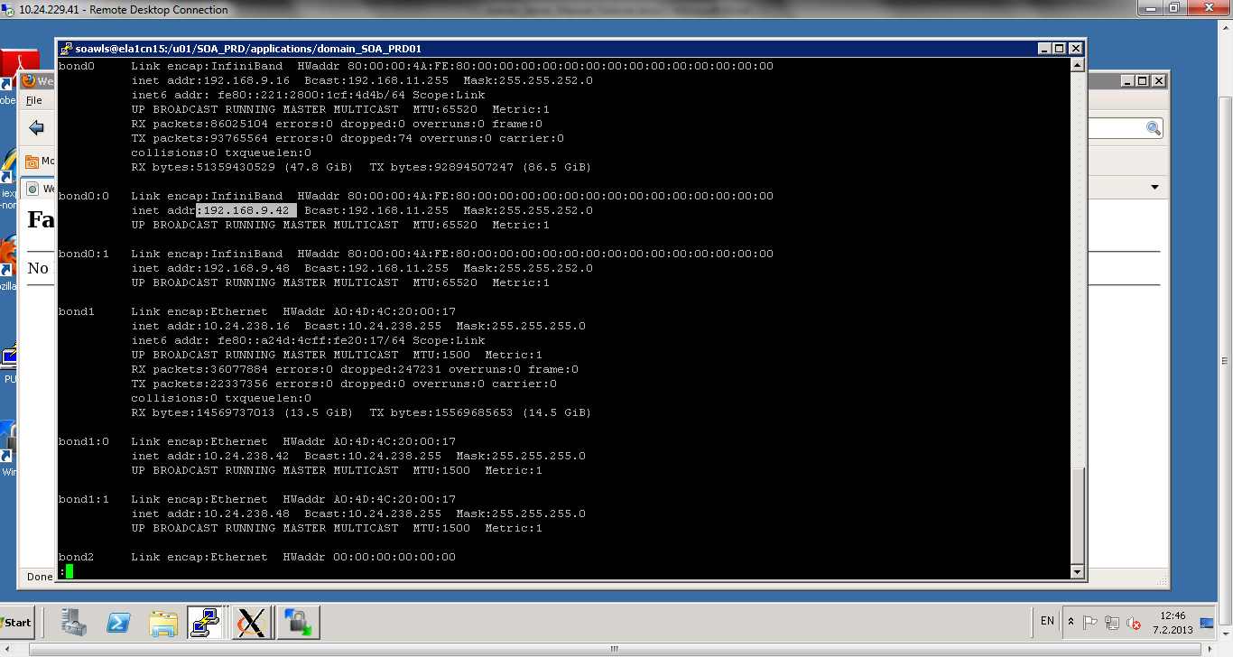

[soawls@ela1cn15 domain_SOA_PRD01]$ sudo /sbin/arping -q -U -c 3 -I bond1 10.24.238.42  
[soawls@ela1cn15 domain_SOA_PRD01]$ sudo /sbin/arping -q -U -c 3 -I bond0 192.168.9.42

These commands will bind the Compute Node1 (elb1cn15) to virtual host or IP.

After this start admin server Compute Node 1 (ela1cn15)

Invoke the wlst.sh (location = /u01/app/oracle/mw_soaprd001/wlserver_10.3/common/bin/)

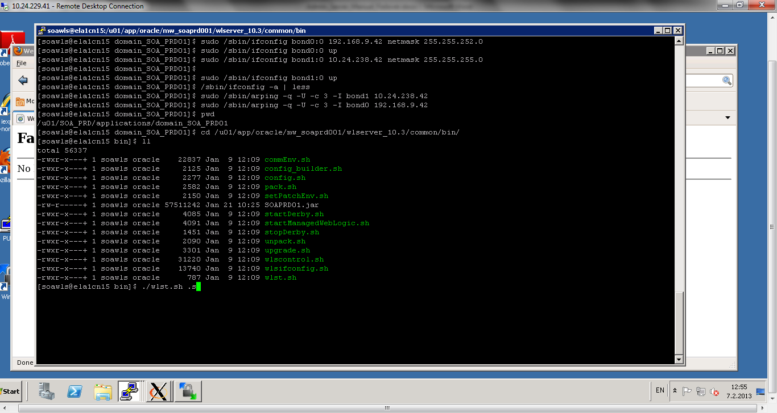

wls:/offline> nmConnect('ndmgr','ndmgr1','ela1cn15-priv','7299','domain_SOA_PRD01','/u01/SOA_PRD/domains/ela1cn15/domain_SOA_PRD01','plain')

wls:/nm/domain_SOA_PRD01> nmStart('AdminServer')