**Weblogic Server 10.3.6.0 ::**

**Software Installation**

**Package Installer**

**Generic Package installer**—Does not include the Java Runtime.

You may select a Generic Package installer that includes WebLogic Server and Oracle Coherence, or a Generic Package installer that includes WebLogic Server and Oracle Coherence.

**OS-specific Package installer**—Includes the Java Runtime specific to the operating system on which WebLogic Server is supported. The installers for Windows and Linux platforms include both the Sun JDK and Oracle JRockit JDK.

You may select a Generic Package installer that includes WebLogic Server and Oracle Coherence, or a Generic Package installer that includes WebLogic Server, and Oracle Coherence.

-----------------------------------------------------------------------------------------------------------------

**Upgrade Installer**

--Upgrade software is for upgrade the software(For example 10.3.1,2,3,4,5 to 10.3.6)

**Generic Upgrade installer**

The generic Upgrade installer does not include the Java Runtime. You should already have a suitable Java Runtime available in your environment.

**OS-specific Upgrade installer**

An Upgrade installer specific to each operating system on which WebLogic Server is supported is available that includes the Java Runtime for that operating system.

**Important Notes About the Package Upgrade Installer**

The following lists important notes about the package upgrade installer:

* The upgrade installer only updates files installed by the WebLogic Platform installation program.
* The package upgrade installer replaces the JVM in the current installation with the JVM that is bundled with the package upgrade installer. For example, if your current installation uses the Sun JVM and you upgrade your installation using a package upgrade installer that is bundled with the WebLogic JRockit JVM, the resulting installation will use the WebLogic JRockit JVM.
* If you are not using the JVM that was bundled with the WebLogic Platform installation and you have edited your scripts to reference the new JVM location, the upgrade installer will not update all of the edited scripts appropriately unless you edit the scripts to restore the original JVM values.

To avoid manual editing in the future, it is recommended that you rename the non-bundled JVM to match the directory structure of the bundled JVM, as described in "Switching JVMs in WebLogic Platform" in the WebLogic Platform Release Notes at the following URL:

* The upgrade installer does not update any user-created files, or directories created using the Configuration Wizard (user_projects by default).
* Temporary patches are not compatible across service packs. If you installed a temporary patch and updated your classpath to reference the patch, you may need to remove any references to the patch from your classpath.

**Important Note If You Use the Node Manager in a Clustered Environment**

If you are using Node Manager to manage your servers in a clustered environment, you should back up the following directory and files on all machines that are running the Node Manager before upgrading your installations:

**Windows**:  
WL_HOME\common\nodemanager  
WL_HOME\server\bin\startNodeManager.cmd

**UNIX**:  
WL_HOME/common/nodemanager  
WL_HOME/server/bin/startNodeManager.sh

In these pathnames, WL_HOME is the root directory of your WebLogic Platform installation, for example, c:\bea\weblogic700.

Once the upgrade installation is complete, you should restore these files.

-----------------------------------------------------------------------------------------------------------------------------------------

**Installing Patches**

**We can Install patch in two ways :**

**Single Patch**

To install a single patch, download the patch from My Oracle Support, and then use Smart Update to apply it

**Patchset**

To install a patch set release, download an Upgrade installer from My Oracle Support, and run the installer to upgrade your existing WebLogic Server 10.3.x installation to the latest available WebLogic Server 10.3.x version. For example, you can use an Upgrade installer to upgrade from WebLogic Server 10.3.0 to WebLogic Server 10.3.6.

If you have an existing WebLogic Server 10.3.0, 10.3.1, or 10.3.2 installation that includes Workshop for WebLogic, and you want to use an Upgrade installer to upgrade that installation, you must uninstall Workshop for WebLogic before running the Upgrade installer

**Installing** **Service Packs and Rolling Patches Using Smart Update**

Smart Update upgrades your Windows installation to use the Sun Java 2 SDK and your Linux installation to use the WebLogic JRockit SDK. If you want to use a different SDK, you should use a WebLogic Platform upgrade installer that is bundled with the appropriate SDK or change the SDK, as described in "Switching JVMs in WebLogic Platform"

**To install service packs or rolling patches using Smart Update, follow these steps:**

**(Note Current Patch Info command as given below**

1. bsu -view -prod_dir=C:\Oracle\Middleware\wlserver_10.3 -status=downloaded -verbose
2. bsu -report -patch_id_mask=6.*)

**Step 1**: Shut down any servers that are running. Hot installation of a service pack or rolling patch is not supported.

**Step 2**: Start Smart Update as described

**Windows :**

**From the Start Menu:**

* + Choose Start—>Programs—>BEA WebLogic Platform 7.0—>Smart Update

**From an MS-DOS command prompt window:**

1. Go to the BEA_HOME/utils directory, where BEA_HOME is the BEA Home directory in which you installed WebLogic Server.

2. Enter the following command at the prompt:

bsu.cmd

The BEA Smart Update window is displayed.

**UNIX**

**Note:** To run Smart Update on a UNIX system, your console must support a Java-based GUI.

1. Log in to the UNIX system.

2. Open a command shell and change to the BEA_HOME/utils directory.

3. Enter the following command:

bsu.sh

The BEA Smart Update window is displayed.

**Step 3:** In the left pane of the Smart update window, select the release for the product you want to update. Available service packs or rolling patches, if any, are displayed in the Upgrade Options section of the window.

**Step 4:** In the Upgrade Options pane, select the service pack or rolling patch to install and click OK.

The Enter BEA eSupport Identification dialog box is displayed.

**Step 5**: Enter your valid username and password and click Verify.

**Note:** You must have a valid eSupport account to install a service pack or rolling patch using Smart Update. You can register for an account at [http://support.bea.com](http://support.bea.com/).

The BEA Installation Program Welcome window is displayed.

**Step 6:** Click Next to proceed with the installation. You may cancel the installation at any time by clicking Exit.

The Downloading Archive Information window is displayed briefly, followed by the Specify Download Options window.

**Step 7:** Indicate your preferences for downloading the software as follows:

* + Specify a storage directory to which you want to download the software upgrade source files.
  + Indicate whether you want to delete the downloaded files after the installation is complete by selecting the appropriate check box. If you do not select this check box, the downloaded files are saved to the storage directory you specify.
  + Indicate whether you want to use an HTTP Proxy server for the download by selecting the appropriate check box. To use an HTTP Proxy server, you must provide the following information:

Host—enter the name or IP address of the proxy server

Port—enter the port number of the proxy server.

**Step 8**: Click Next.

The Archive Download window is displayed.

**Step 9**: Indicate whether you want to proceed with the installation automatically after the

download is complete by selecting or clearing the appropriate check box. This check

box is selected by default. If you clear it, you need to click Next when the download is

complete to proceed with the installation.

When the download is complete, the Archive Integrity Check window is displayed

while it verifies the integrity of the upgrade archive files you downloaded.

When the archive verification is complete, the Confirm Product Directory window is

displayed, which contains the path to the BEA home directory and to the product

directory in which the WebLogic Server software will be updated.

**Step 10**: Click Next to proceed with the upgrade installation.

A status window displays the progress of the installation.

Click Done on the Installation Complete window.

How to create a JMS Server in Cluster configuration

-------------------------------------------------------------------------------------------------------

**How to set Different JVM Heap Sizes for Admin and Managed Servers in Weblogic**

As per performance tuning guidelines it is good practice to start your Admin server with lower JVM heap size than your other managed servers because the Admin server doesn't required much resources.  
By doing this you can utilize the free memory with others where it is needed (This makes sense when you are running Admin and Managed servers on same host)

**Problem:**  
As i mentioned above our requirement is to use different JVM heapsize for Adminserver and only specific webcenter WLS_Spaces servers of a cluster.  
  
*One way to change the heap size is to set in weblogic admin console.*

In the example i will set JVM heap size -Xms and -Xmx values to1MB for AdminServer and 2MB each for WLS_Spaces managed servers of a cluster.

**Solution:**  
  
1. Shutdown Admin and Managed servers  
  
2. Add the following line of code in **setDomain.env** file. you can find the file under **bin** directory of weblogic domain home  
  
*Make sure you add these lines at-least after* ***"export XMX_JROCKIT_32BIT****" so it will override any other default settings.*  
  
e.g. /u01/Oracle/Middleware/user_projects/domains/myDomain/bin

((****** # Set 1024MB for AdminServer

if [ "${SERVER_NAME}" == "AdminServer" ] ; then

      USER_MEM_ARGS="-Xms1024m -Xmx1024m"

    export USER_MEM_ARGS

fi

#Set 2MB if server name contains WLS_Spaces ( it will cover WLS_Spaces1,2,3,4..)

if [[ "${SERVER_NAME}" == *WLS_Spaces* ]] ; then

    USER_MEM_ARGS="-Xms2048m -Xmx2048m"

    export USER_MEM_ARGS

fi******))

1. Start Adminserver to verify if your change is working (if ok then start all others)  
     
   4. Verify by check the JVM heapsize using Jrockit mission control or Linux process  
   e.g. $ ps -ef|grep AdminServer.

[**How to Switch From JRockit to JDK in WebLogic**](https://pitss.com/us/2013/10/09/how-to-switch-from-jrockit-to-jdk-in-weblogic/)**.**

If you have configured Oracle WebLogic Server (whether as a standalone product or as a part of Oracle Fusion Middleware) to use JRockit, you can use these steps to configure your WebLogic environment to switch from Oracle JRockit to Oracle JDK (formerly Sun JDK).

**NOTE: Please make a backup of all configuration files that will be updated.**

**NOTE: The Oracle Middleware home will represented by the environment variable %MW_HOME% in this article. Also, we will use JDK 1.6.0_45 (64-bit) installed in C:\Program Files\Java\jdk1.6.0_45 as an example.**

1. Edit the file %MW_HOME%\wlserver_10.3\common\bin\commEnv.cmd
   1. Look for “set  JAVA_HOME=…” and change the path so that it reads “set  JAVA_HOME=C:\Program Files\Java\jdk\1.6.0_45” (or in whichever directory your JDK is installed)

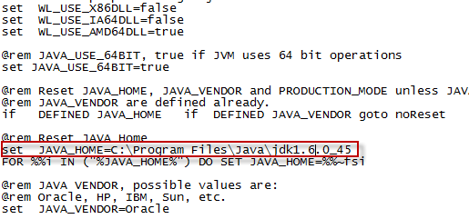

1. Edit the file %MW_HOME%\user_projects\domains\%DOMAIN%\bin\setDomainEnv.cmd for each of your WebLogic domains (which you wish to move from JRockit to JDK)
   1. Look for “set BEA_JAVA_HOME=…”. Unset this variable so that it reads “set BEA_JAVA_HOME=”.
   2. Look for “set SUN_JAVA_HOME=” right below it and change the path so that it reads “set SUN_JAVA_HOME=C:\Program Files\Java\jdk1.6.0_45” (or in whichever directory your JDK is installed)
   3. Not far below, look for “set JAVA_VENDOR=Oracle”. Change this to “set JAVA_VENDOR=Sun”.
   4. Look for “set JAVA_HOME=…” right below it and change the path so that it reads “set JAVA_HOME=C:\Program Files\Java\jdk1.6.0_45” (or in whichever directory your JDK is installed)

**5.** 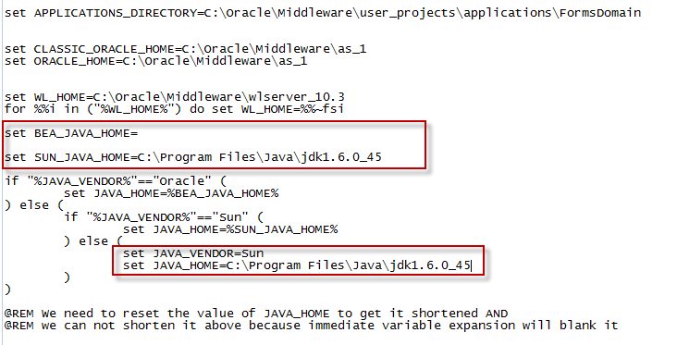

6.

1. Edit the file %MW_HOME%\wlserver_10.3\common\nodemanager\nodemanager.properties
   1. Look for any set parameters called “JavaHome” and change the parameter’s value to “JavaHome=C\:\\PROGRA~1\\Java\\JDK16~1.0_4\\jre”

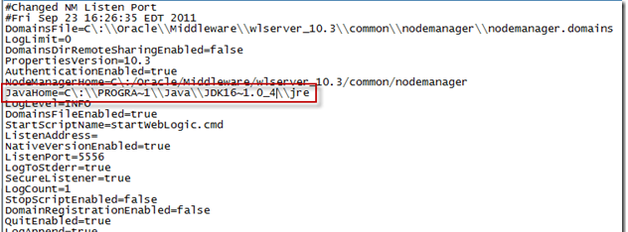

2. Edit the file %MW_HOME%\utils\bsu\bsu.cmd

Look for the line “set JAVA_HOME=…” and change the path so that it reads “set JAVA_HOME=C:\Program Files\Java\jdk1.6.0_45” (or in whichever directory your JDK is installed).

3.Edit the file %MW_HOME%\utils\quickstart\quickstart.cmd

Look for the line “set JAVA_HOME=…” and change the path so that it reads “set JAVA_HOME=C:Program Files\Java\jdk1.6.0_45” (or in whichever directory your JDK is installed).

4.Edit the file %MW_HOME%\utils\uninstall\uninstall.cmd

Look for the line “set JAVA_HOME=…” and change the path so that it reads “set JAVA_HOME=C:Program Files\Java\jdk1.6.0_45” (or in whichever directory your JDK is installed).

5.Restart all WebLogic servers.

Your WebLogic servers should now be using the JDK instead of JRockit.

---------------------------------------------------------------------------------------------------------

[**Resetting Admin UserName And Password**](http://middlewaremagic.com/weblogic/?p=323)

**Step1).** open a Command Prompt and then run “setDomainEnv.sh” or “setDomainEnv.cmd”.

**Step2).** Just for Safety Take a Backup of (C:bea103user_projectsdomains7001_Domainsecurity*DefaultAuthenticatorInit.ldift*) file …because in the Next Command which we are going to run is going to Create a New File “DefaultAuthenticatorInit.ldift”.

**Step3).** In the Command Window Move inside your Domain’s Security Directory…And then Run the Following Command:

Example: C:bea103\user_projects\domains\7001_Domain\security>**java weblogic.security.utils.AdminAccount newAdmin newPassword** .

**NOTE:-** There is a . (DOT) at the end of the Above command which represents the Current Directory. Here you can see that after this command Executes A new “DefaultAuthenticatorInit.ldift” file will be created in the Current Directory.

**IMPORTANT STEP   [This Step 3-A) U Need Not to Follow If you Already Forgot your Admin Credentials]**

**Step3-A).  Login to Admin Console**

**Security Realms—> myrealm(Your realm Name)—> Migration(Tab)—> Export (Tab)**

Here please provide a Directory location for “Export Directory on Server:”

TextBox(Example:C:UserData

Click on “Save” button…you will find that in the Directory which you have specified you will get :

DefaultAuthenticator.dat  
DefaultCredentialMapper.dat  
exportIndex.dat  
XACMLAuthorizer.dat  
XACMLRoleMapper.dat

**Step 4).** In the Same command prompt Move inside the admin Server folder inside your domain. And then Just remname the “data” folder to something else ….like “data_OLD” this is a way of taking safe backup….

Example: C:bea103\user_projects\domains\7001_Domain\servers\AdminServer> **rename data data_OLD**

**Step 5).** Now Similarly rename the boot.properties as well to an other File….

Example: C:bea103user_projectsdomains7001_DomainserversAdminServersecurity> rename boot.properties boot.properties_OLD

**Step 6).** Make sure that “boot.properties” file exists….If yes then Now start The Admin Server….

While starting it will ask for the UserName and Password to be entered as ..we havenot created any “boot.properties” file at present. But it is always recommended that u create the “boot.properties” file on your own …to prevent WebLogic Prompting you for Admin Username & Passwords while starting the Server.

————> At the End Login to Admin Console with the New Useraname and Password—–> Check the Users in Security realms …you will not find any user with name “weblogic” There….

This is most important Step:  Because Sometimes we face this kind of issue if you have provided a Wrong format in your “boot.properties” file there should be NO Special Charachers (UTF or Invisible sharacters) Or NO Space in your “boot.properties” file …except below two Lines:

Please edit this File very carefully….better use Noteopad kind of Simple Editors.  
Use **“ls” (Unix command)** or **“dir” Windows Command** to Make Sure that the File Extension is “boot.properties” only…and not “boot.properties.txt” or something else.

**Note:** There should be No Heading Or Trailing SPACE character in these two Lines.

**Step 7).  To import other User Data back Please do the following:**

Login to Admin Console  
Security Realms—> myrealm(Your realm Name)—> Migration(Tab)—> Import (Tab)

Now provide the folder Name where u have all the above files:  
DefaultAuthenticator.dat  
DefaultCredentialMapper.dat  
exportIndex.dat  
XACMLAuthorizer.dat  
XACMLRoleMapper.dat