minimizes error {the difference between the true measurements and their associated matches generated from the map using the guessed pose.

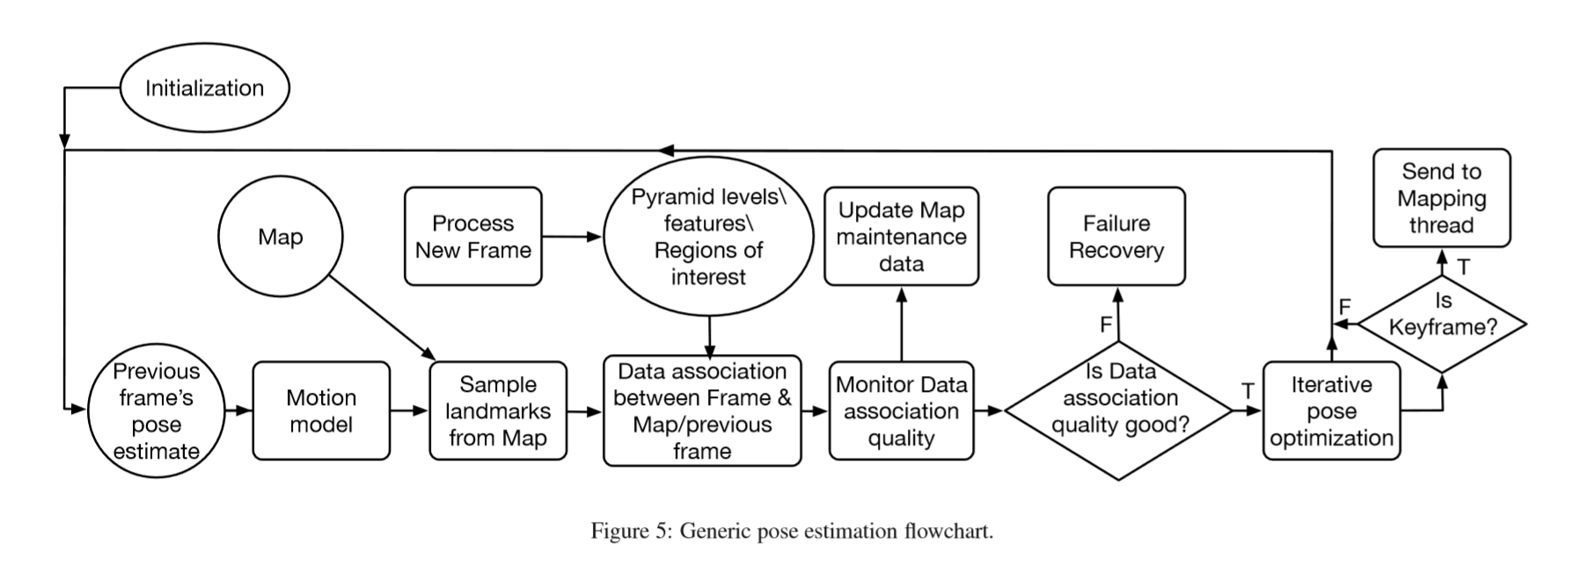

The first step of pose estimation is to use a motion model to predict a “prior” based on the previous frame’s pose.

* Most systems use a constant velocity motion model, which uses the two previously tracked frames and assumes constant motion to predict the current frame’s pose.
* Some systems assume no significant motion between consecutive frames and assign the prior for the pose of the current frame to be the same as the previously tracked one.

The prior frame helps by:

The pose of the prior frame is used to guide the data association procedure in several ways. It helps determine a potentially visible set of features from the map in the current frame, thereby reducing the computational expense of blindly projecting the entire map. Furthermore, it helps establish an estimated feature location in the current frame, such that feature matching takes place in small search regions, instead of across the entire image. Finally, it serves as a starting point for the minimization procedure, which reﬁnes the camera pose.