optimizes the map using either Bundle Adjustment or Pose Graph Optimization.

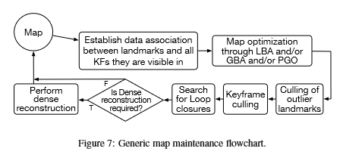

* New 3D landmarks are triangulated based on camera pose estimates.
* Map maintenance establishes data association between keyframes in the map one of two ways:
  + Global Bundle Adjustment (GBA) using the entire set of keyframes in the map
  + Local Bundle Adjustment (LBA, also known as windowed optimization) using a subset of keyframes in the map
  + ^^^These two methods both jointly optimize for both keyframe poses and 3D structure.
  + Pose Graph Optimization (PGO) optimizes only for the keyframe poses and accordingly adjusts the 3D structure of the landmarks. PGO returns inferior results to GBA but is also much faster. PGO is often used in loop closure because it is often not a good idea to try to do large-scale loop closure with standard bundle adjustment. However, pose graph optimization may not yield optimal result if the errors over the loop are distributed along the entire map, leading to locally induced inaccuracies in regions that were not originally wrong.
* Outlier landmarks flagged during optimization are culled (removed).
* Redundant keyframes are also culled to boost performance.

**Bundle Adjustment:**

Cost function: 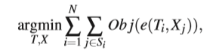where Ti is a keyframe pose estimate, N is the number of keyframes in the map or in the subset of the map, Si Is the set of 3D landmarks observed in keyframe I, and e(Ti,Xj) is the reprojection error of a landmark Xj on a keyframe Ti.

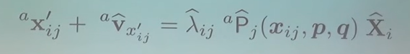

Coordinates of a point i in an image j. The a means that there is an arbitrary coordinate system, meaning it’s not restricted to calibrated cameras.

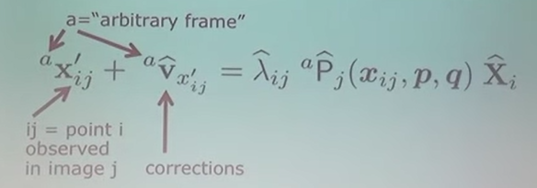v is the corrections. All of these are in homogeneous coordinates. Xi is the 3D location of the point i in the world. That is mapped into the camera image through the projection matrix P. p (lower case) are the projection parameters (Ex: the rotation matrix of the camera, or the camera constant => the intrinsic and extrinsic parameters). p will be an 11 dimensional vector, with 6 for extrinsics and 5 for the intrinsics. Parameter q encodes the nonlinear corrections that may need to be applied. Lambdaij is the scale factor.

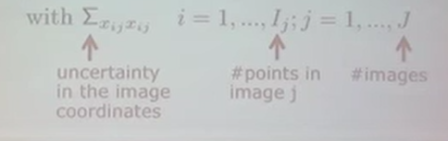

^^^^Uncertainty of the measured image coordinates in the image.

The bundle adjustment equation does two things:

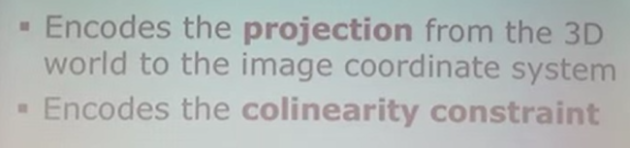

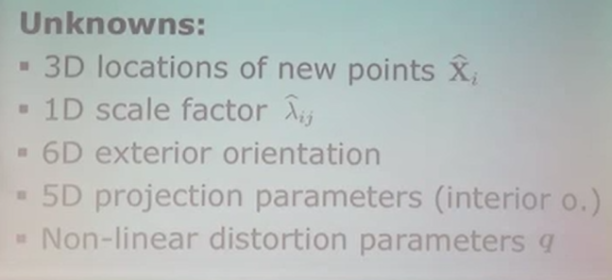

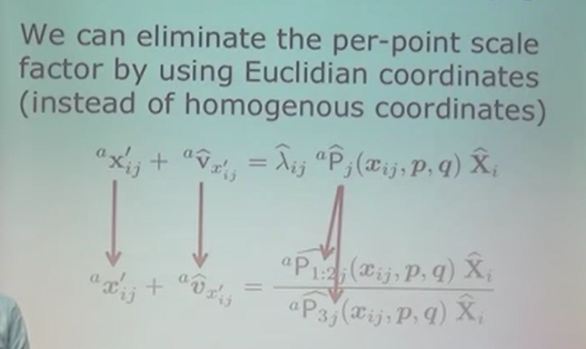



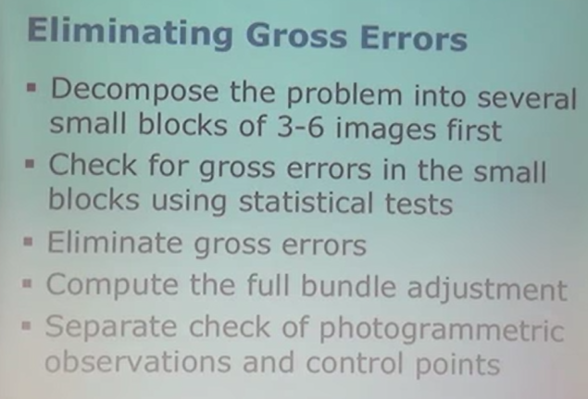

Question for bundle adjustment: how do we obtain an initial guess?

**Pose Graph Optimization:**

Cost function: 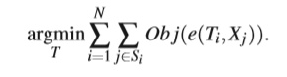This explicitly distributes the accumulated drift along the entire map.

**LSD SLAM** runs a third parallel thread that continuously optimizes the map in the background by a generic implementation of a pose graph optimization using the g2o-framework [46]. This however leads to an inferior accuracy when compared to other methods. Outliers are detected by monitoring the probability of the projected depth hypothesis at each pixel of being an outlier or not. To make the outliers detection step possible, LSD SLAM keeps records of each successfully matched pixel during the tracking thread, and accordingly increases or decreases the probability of it being an outlier.