handles situations in which the minimization of error diverges or the data association fails. These failures can happen when the camera moves suddenly and creates motion blur. They can also happen if the camera is observing a featureless region, like a white wall. Thus, the SLAM algorithm needs a way to recover from these failures.

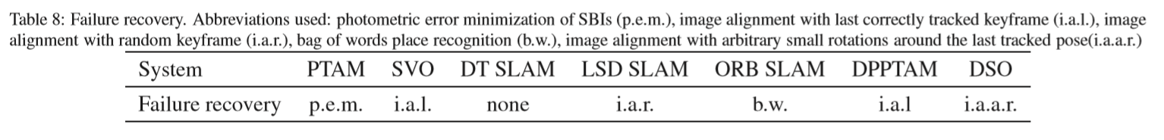**LSD SLAM** does failure recovery by choosing a keyframe from the graph at random that has more than two neighboring keyframes. It then tries to align the lost keyframe to it. If the outlier-to-inlier ratio is large, the chosen keyframe is discarded and another one is chosen at random. Otherwise, the neighbors of the chosen keyframe are tested. If the number of neighbors with a large inlier-to-outlier ratio is larger than the number of neighbors with a large outlier-to-inlier ratio, or if there are more than ﬁve neighbors with a large inlier-to-outlier ratio, the neighboring keyframe with the largest ratio is set as the active keyframe, and regular tracking resumes.