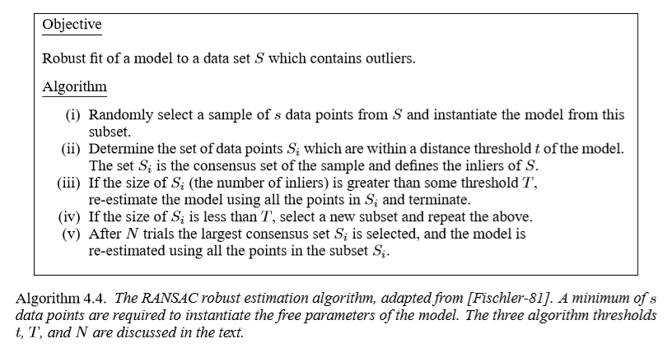

Source: MultipleViewGeometryTextbook