minimizes error {the difference between the true measurements and their associated matches generated from the map using the guessed pose.

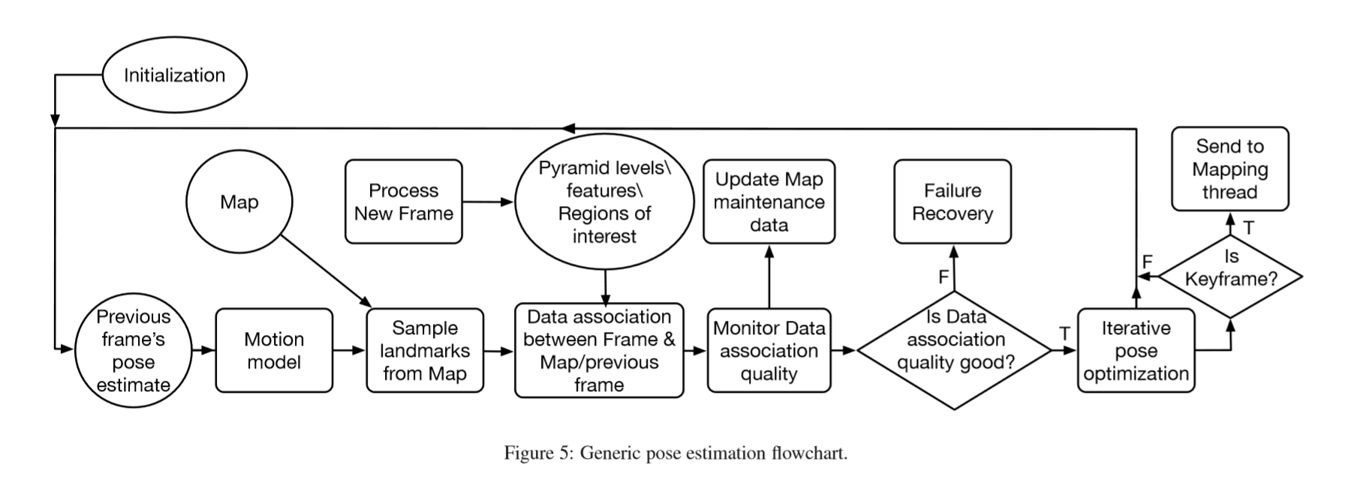

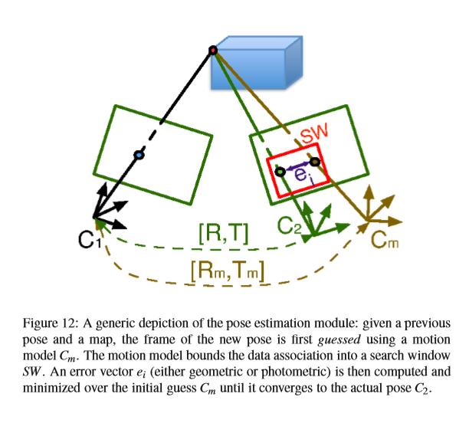

The first step of pose estimation is to use a motion model to predict a “prior” based on the previous frame’s pose. On mobile, the motion model can take into account odometry from the motion sensors on the phone.

* Most systems use a constant velocity motion model, which uses the two previously tracked frames and assumes constant motion to predict the current frame’s pose. (ORB)
* Some systems assume no significant motion between consecutive frames and assign the prior for the pose of the current frame to be the same as the previously tracked one. (LSD)

The prior frame helps by guiding

the data association procedure in several ways.

* It helps determine a potentially visible set of features from the map in the current frame, thereby reducing the computational expense of blindly projecting the entire map.
* It helps establish an estimated feature location in the current frame, such that feature matching takes place in small search regions, instead of across the entire image.
* It serves as a starting point for the minimization procedure, which reﬁnes the camera pose.

The tracking thread in **LSD SLAM** is responsible for estimating the pose of the current frame with respect to the currently active keyframe in the map, using the previous frame pose as a prior (no motion model). The required pose is represented by an SE(3) transformation, and is found by an iteratively re-weighted Gauss-Newton optimization that minimizes the variance normalized photometric residual error, as described in [78]. A keyframe is considered active if it is the most recent keyframe accommodated in the map. To minimize outlier effects, measurements with large residuals are down-weighted from one iteration to the next.

Pose estimation in **ORB SLAM** is established through a constant velocity motion model prior, followed by a pose reﬁnement using optimization. As the motion model is expected to be easily violated through abrupt motions, ORB SLAM detects such failures by tracking the number of matched features; if it falls below a certain threshold, map points are projected onto the current frame, and a wide-range feature search takes place around the projected locations. In an effort to make ORB SLAM operate in large environments, a subset of the global map, known as the local map, is deﬁned by all landmarks corresponding to the set of all keyframes that share edges with the current frame, as well as all neighbors of this set of keyframes from the pose graph. The selected landmarks are ﬁltered out to keep only the features that are most likely to be matched in the current frame. Furthermore, if the distance from the camera’s center to the landmark is beyond the range of the valid features, the landmark is also discarded. The remaining set of landmarks is then searched for and matched in the current frame, before a ﬁnal camera pose reﬁnement step.

