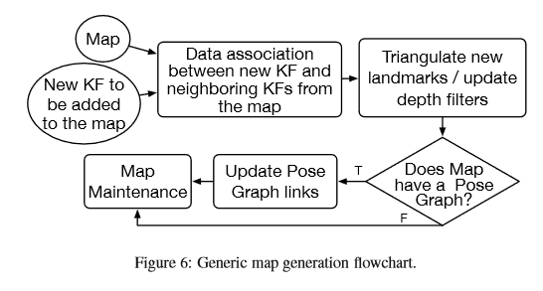

Topological maps forfeit geometric information to increase computational speed.

The conversion from a topological to a metric map is not always trivial, and for this reason, recent monocular SLAM systems employ hybrid maps, which are locally metric and globally topological.