TM notes:

Patch-Based Optimization for Image-Based Texture Mapping

Global energy function codifies to main properties: target images should be similar to corresponding source images and the projected target images should be photometrically consistent.

Overview:

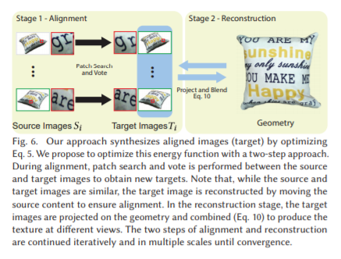

There are two steps: alignment and reconstruction.