Football Jersey Product Catalogue 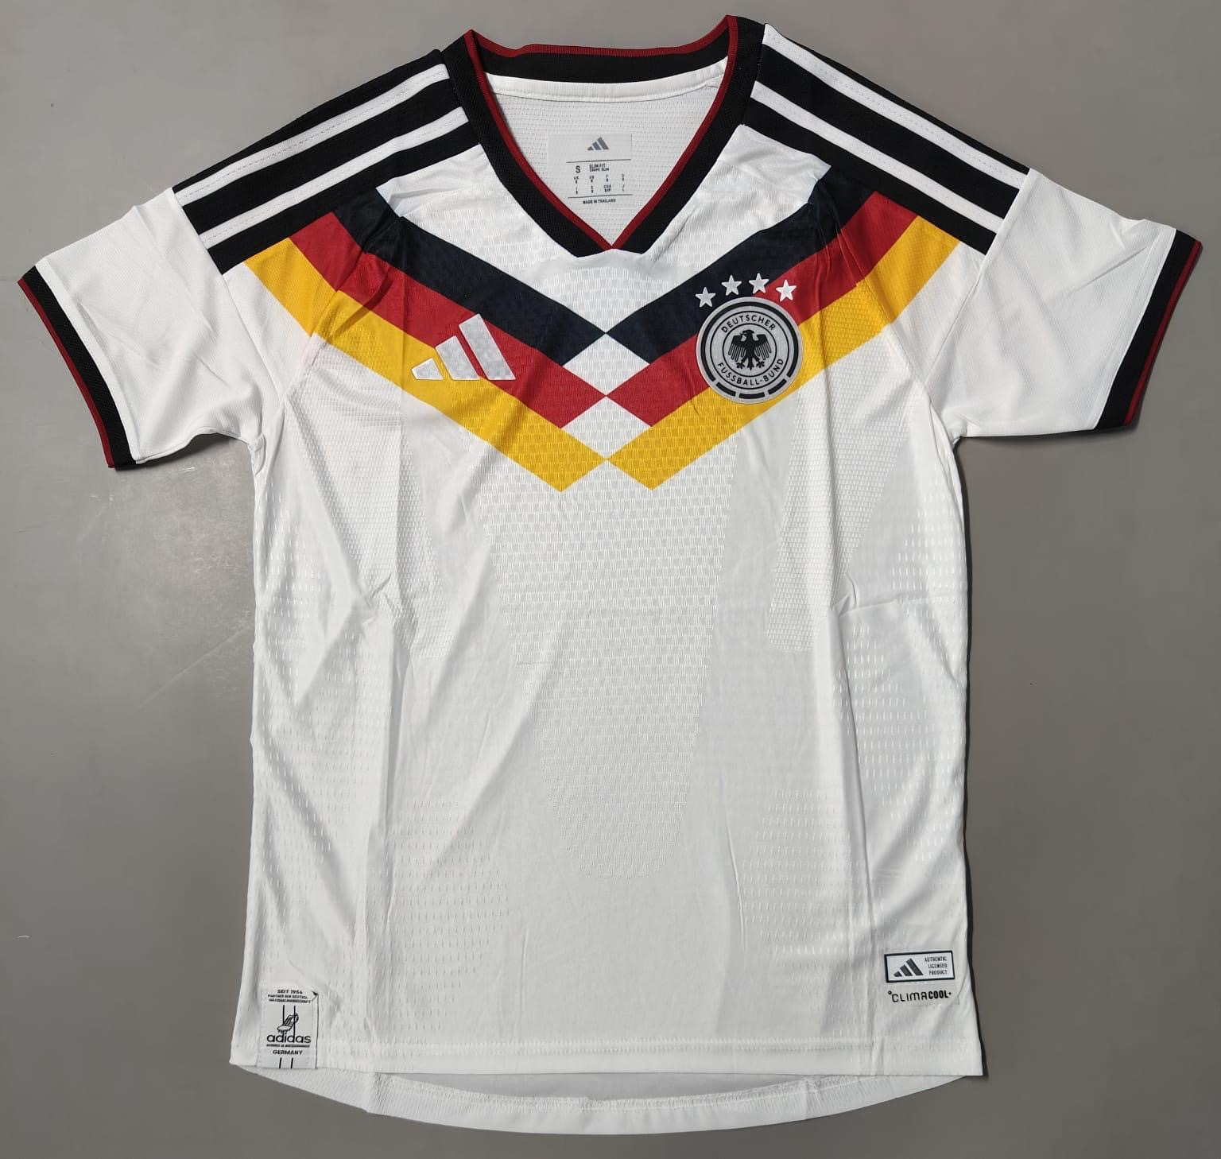
Product Name: Germany 2026 Home Player Version
Price: ₹ 949
--------------------------------------------------

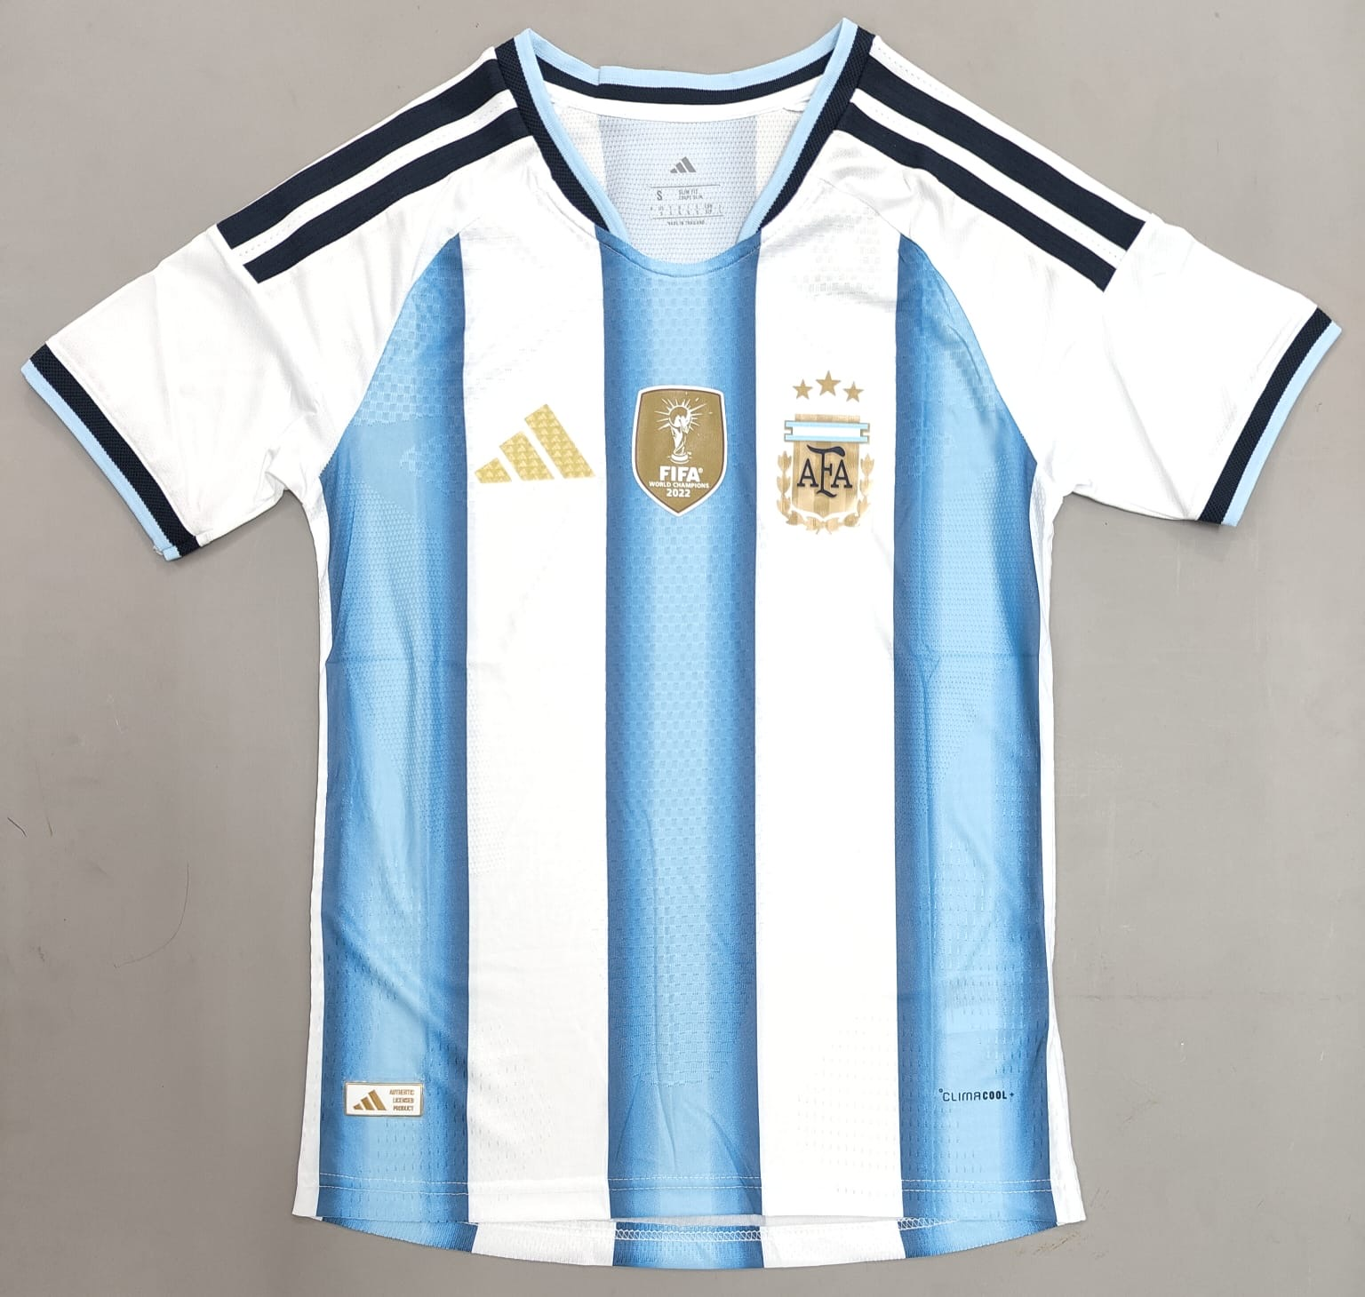
Product Name: Argentina 2026 Home Player Version
Price: ₹949
--------------------------------------------------

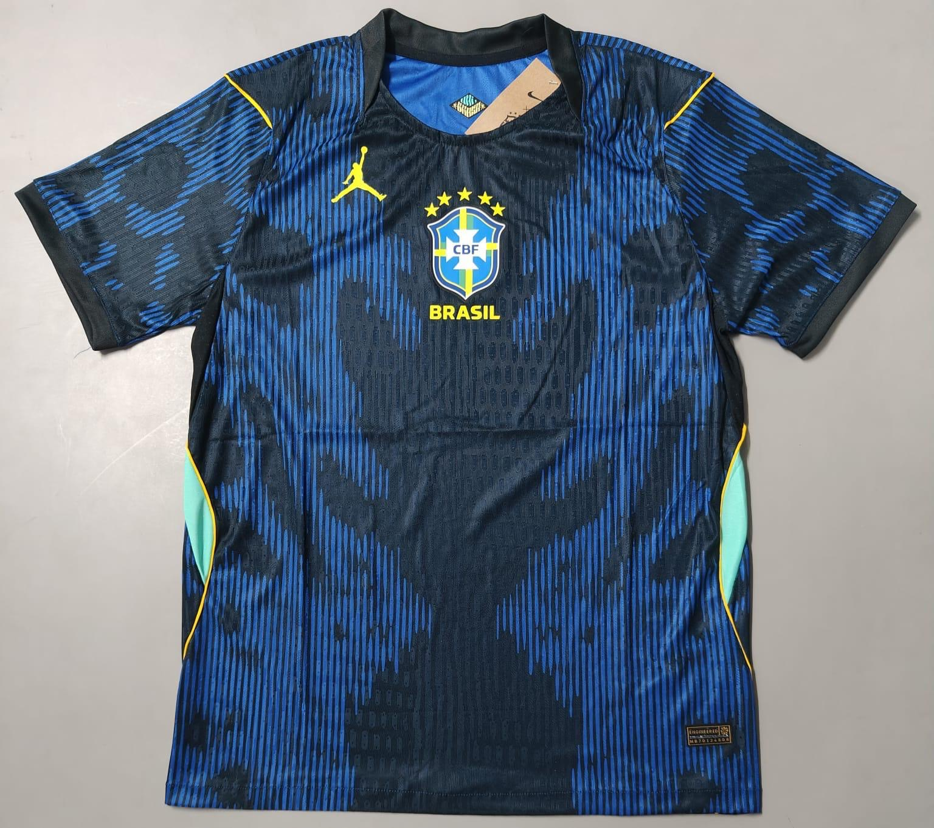
Product Name: Brazil 2026 Away Player Version
Price: ₹949
--------------------------------------------------

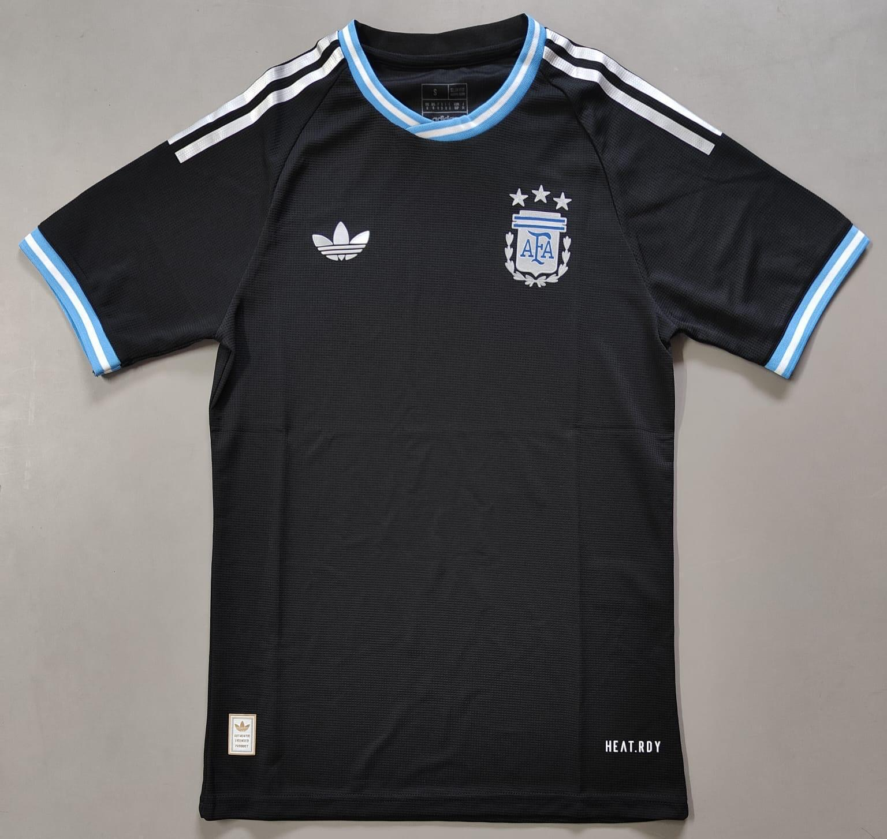
Product Name: Argentina 2026 Black Edition Player Version
Price: ₹949
--------------------------------------------------

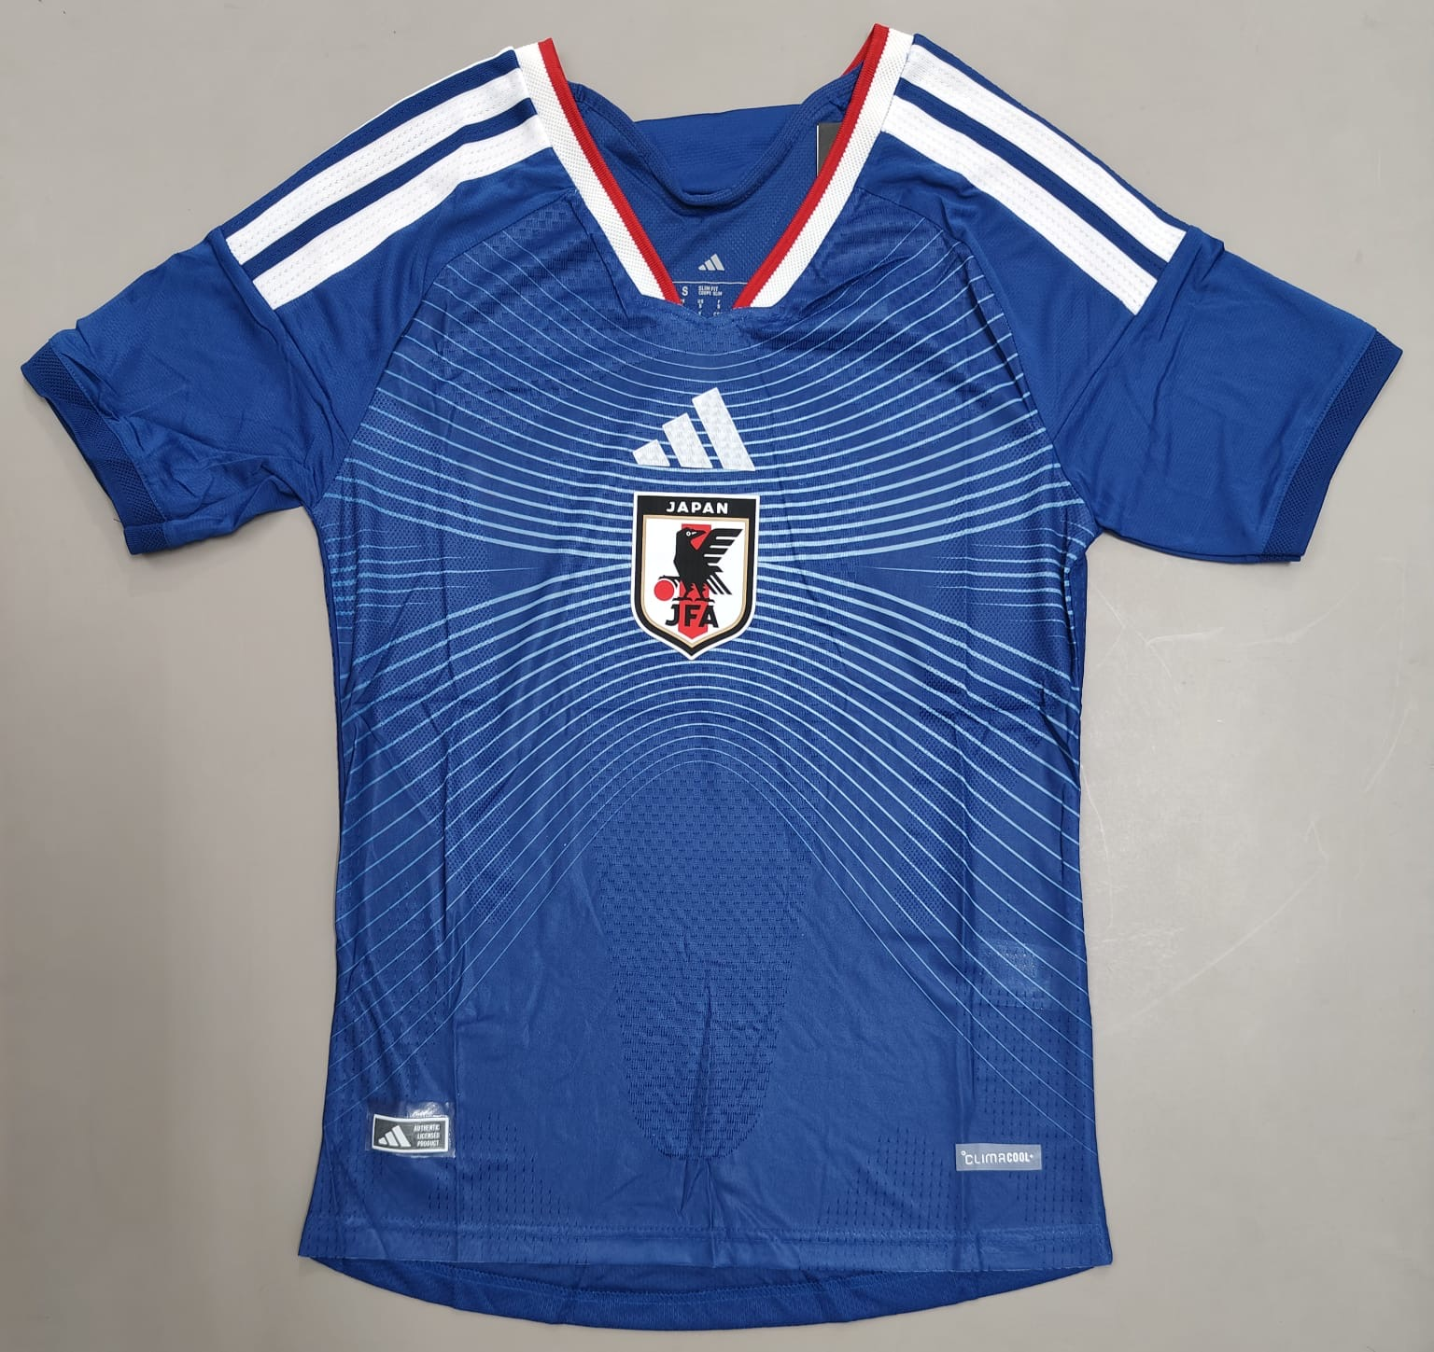
Product Name: Japan 2026 Home Player Version
Price: 949

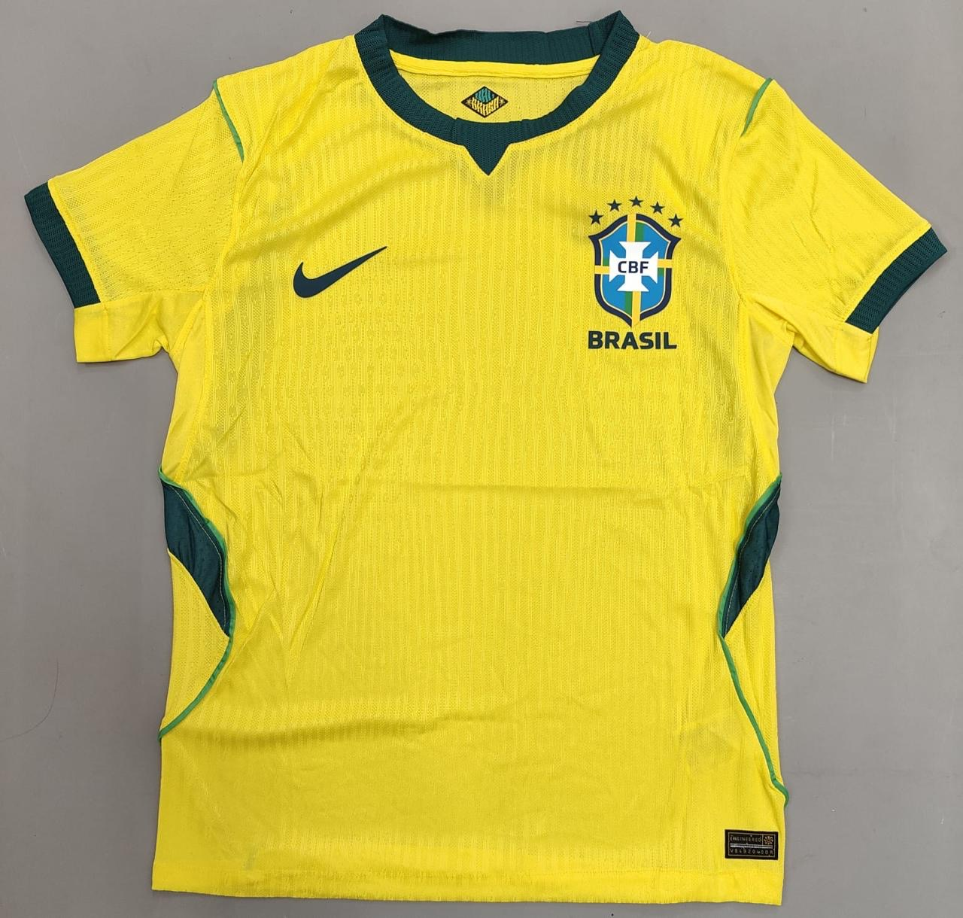
Product Name: Brazil 2026 Home Player Version
Price: ₹949
--------------------------------------------------

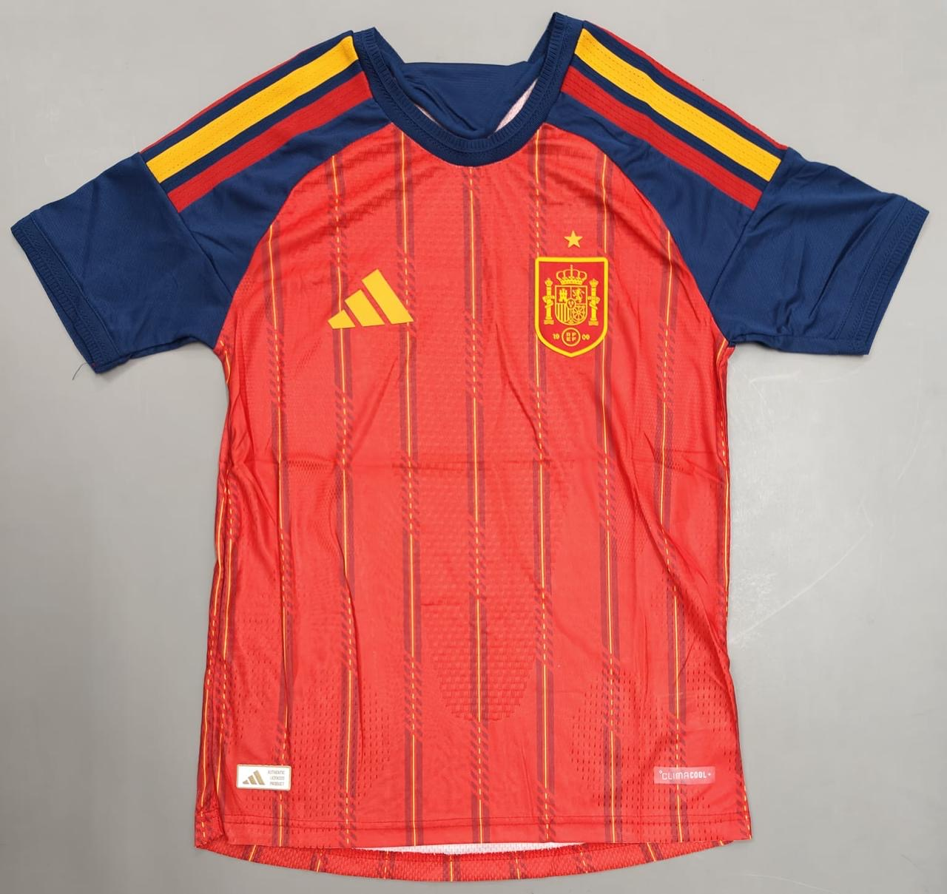
Product Name: Spain 2026 Home Player Version
Price: ₹949
--------------------------------------------------

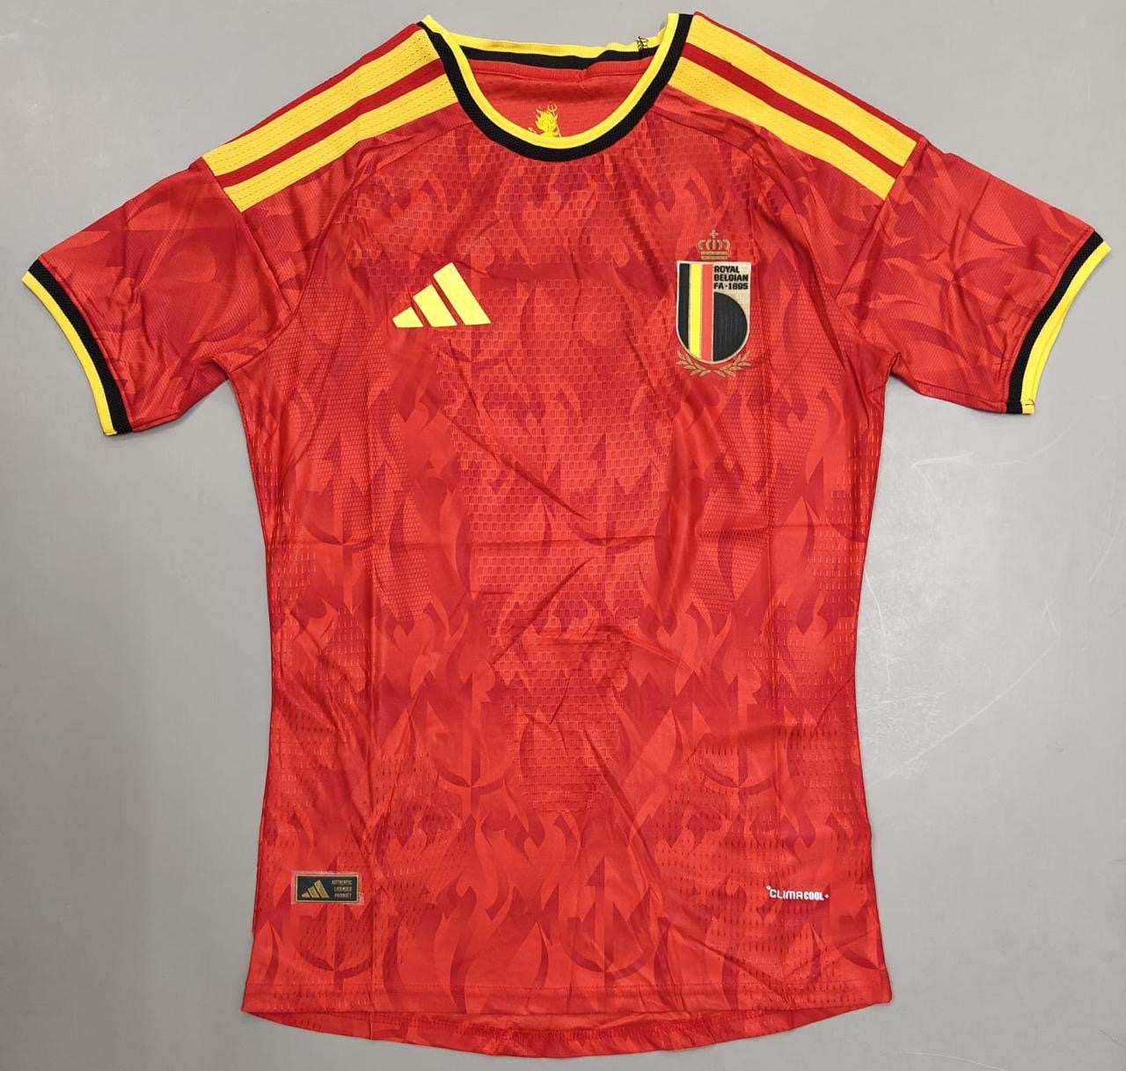
Product Name: Belgium 2026 Home Player Version
Price: 949

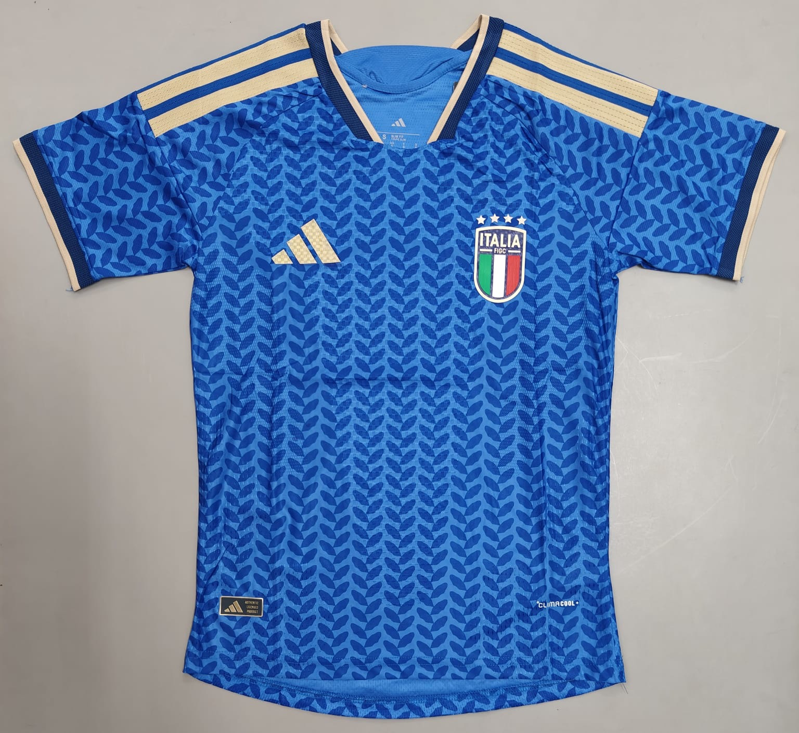
Italy 2026 Home Player Version
Price: 949

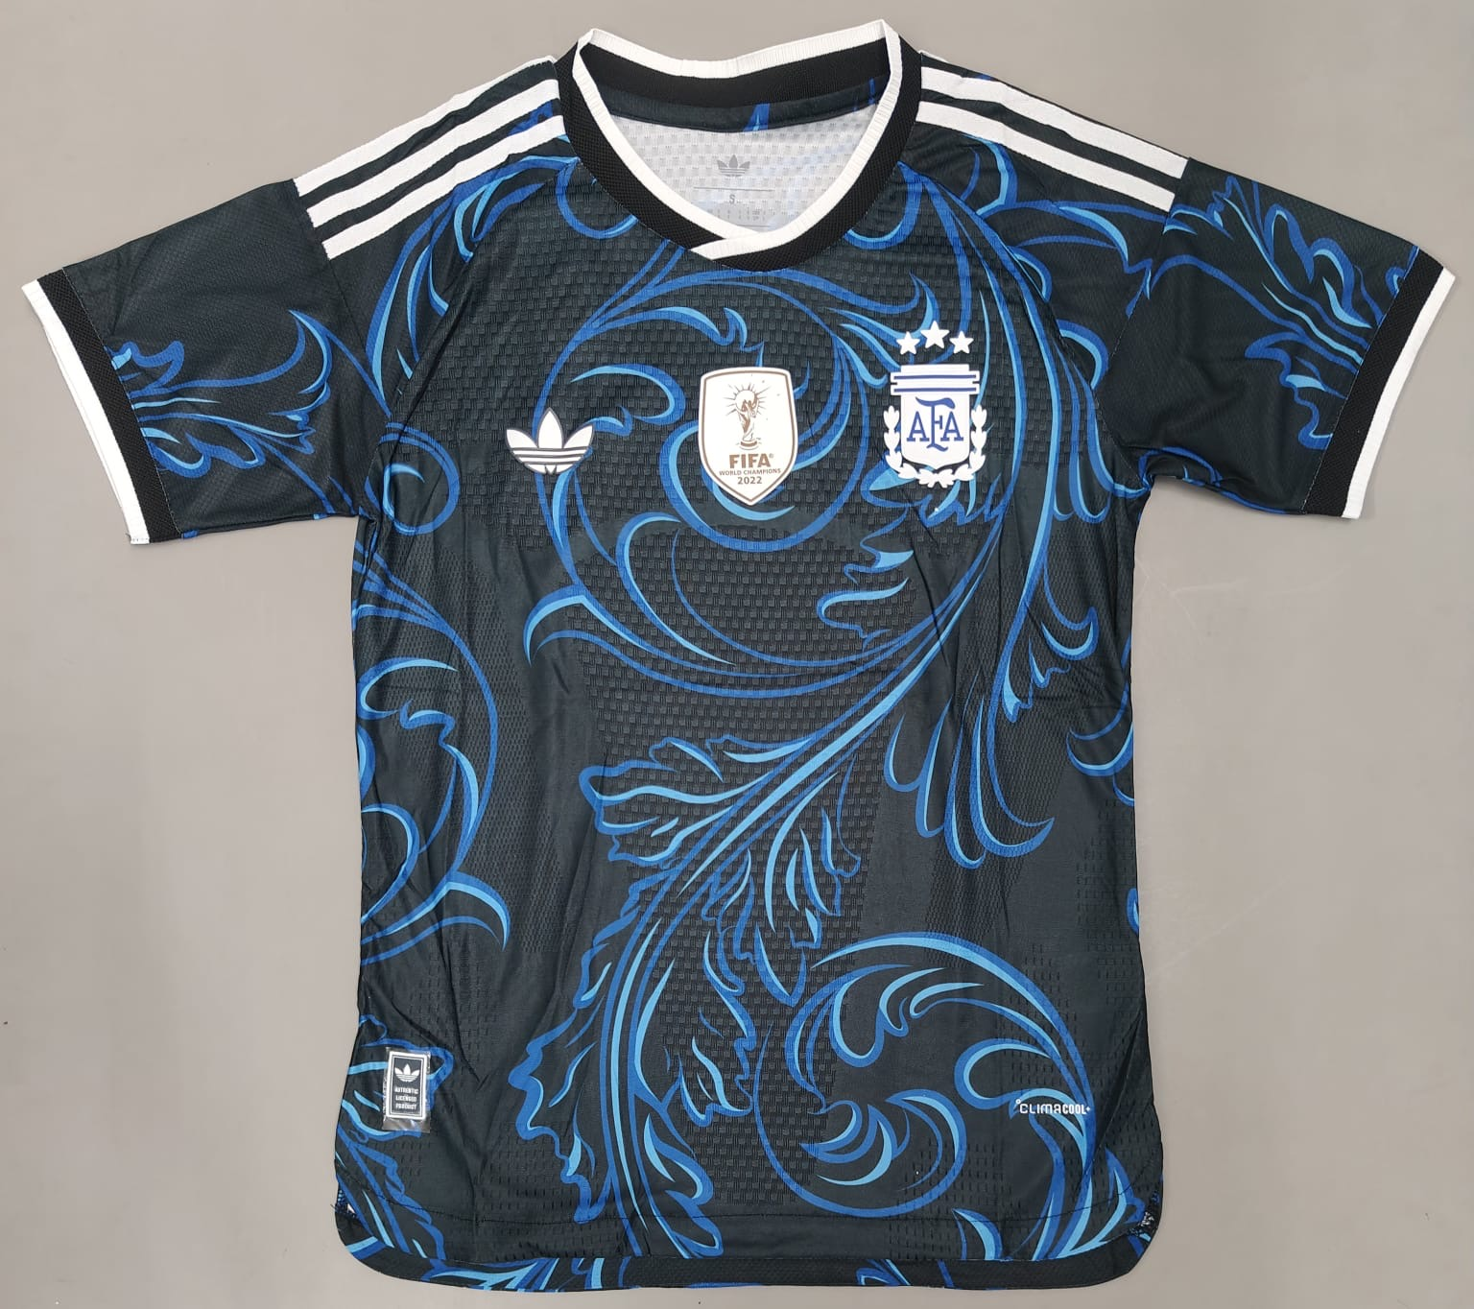
Argentina 2026 Away Player Version
Price: ₹999

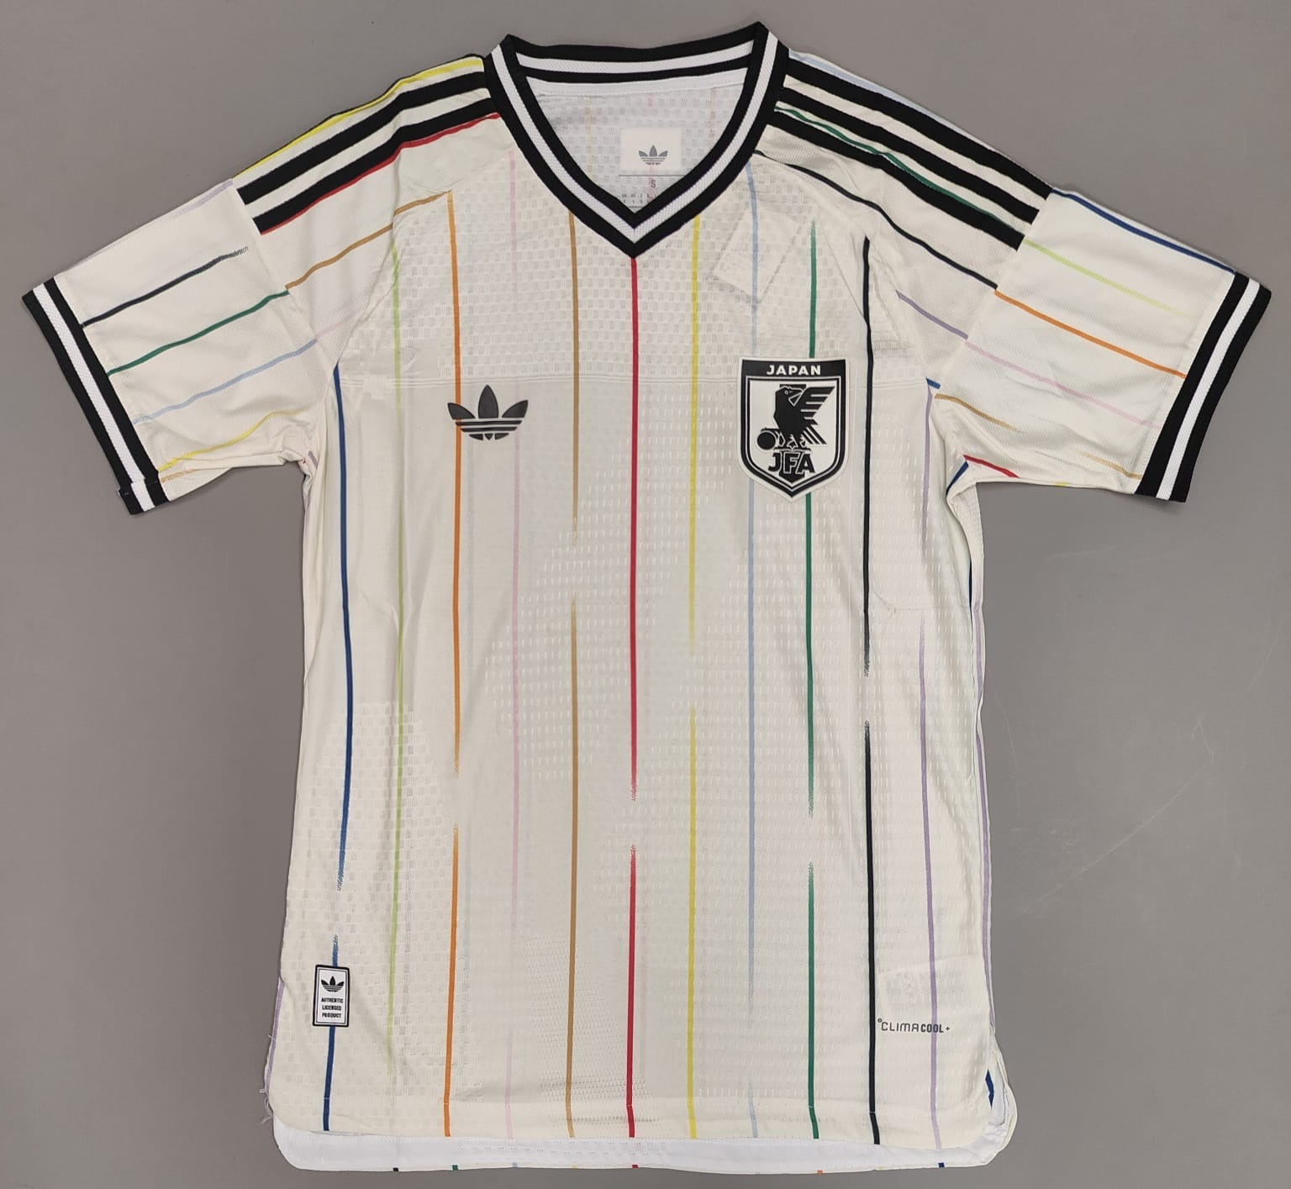
Japan 2026 Away Player Version
Price ₹949

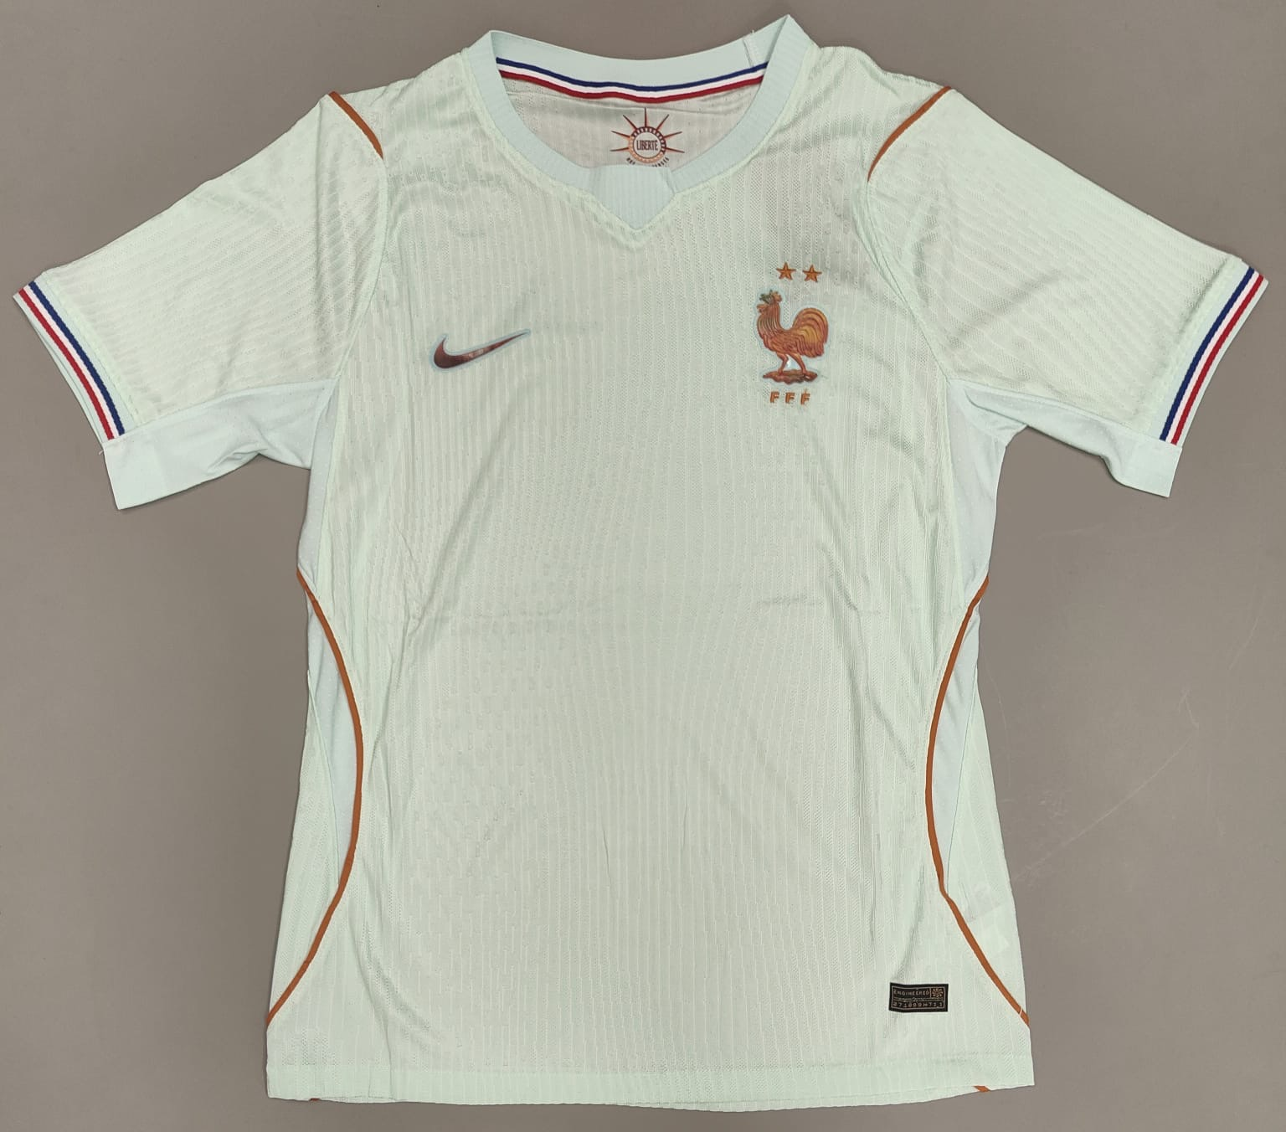
France 2026 Away Player Version
₹949

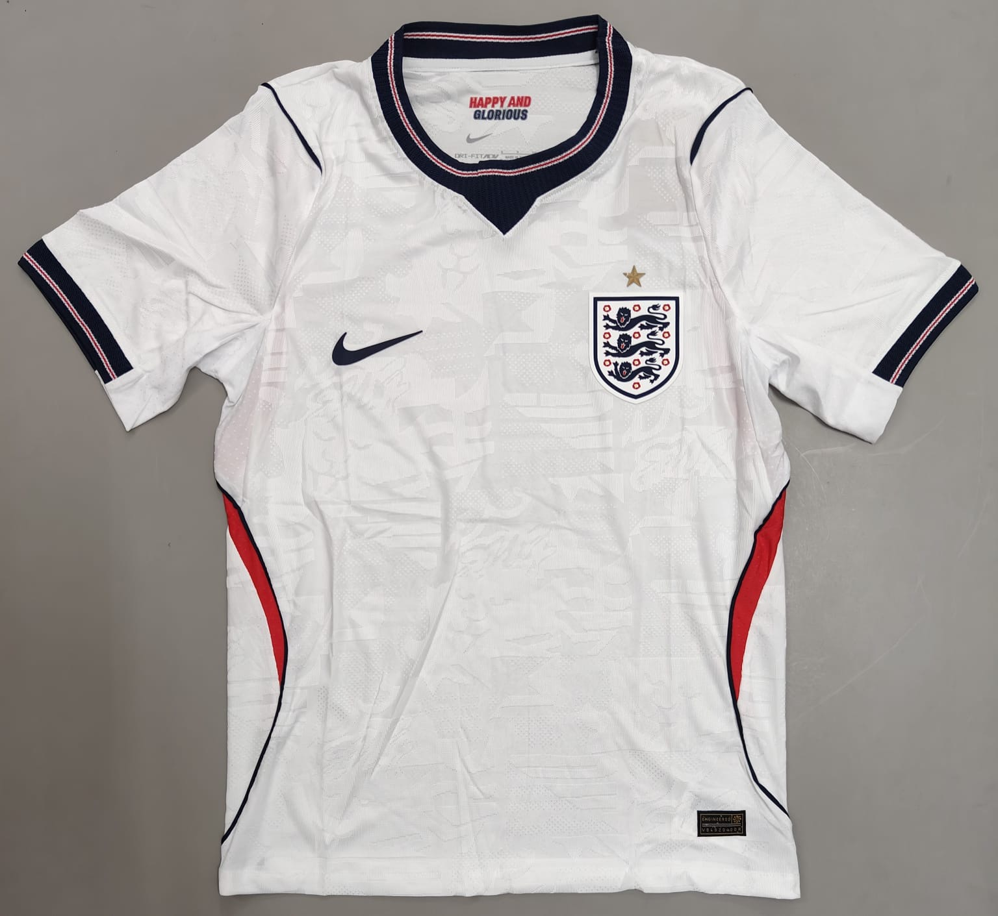
England 2026 Home Player Version
₹949

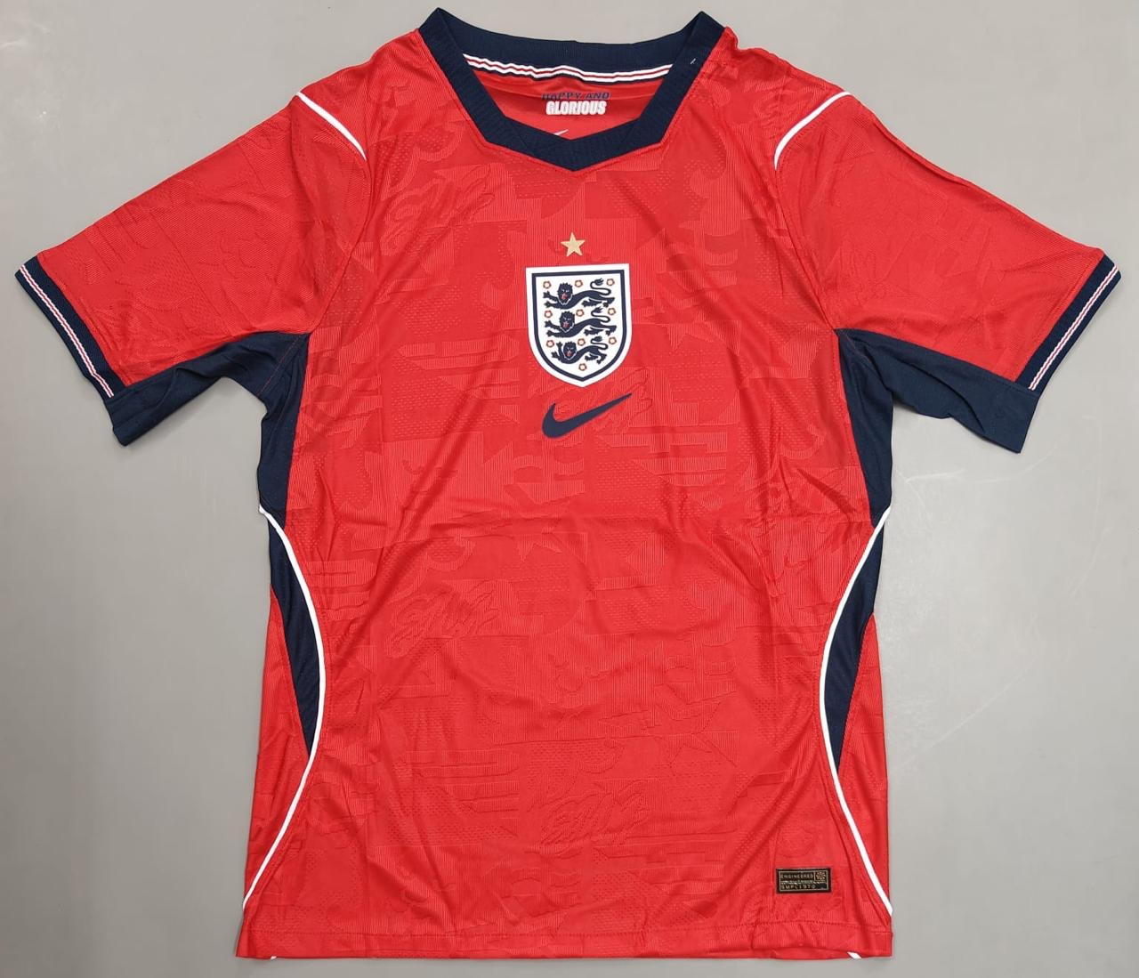
England 2026 Away Player Version
₹949

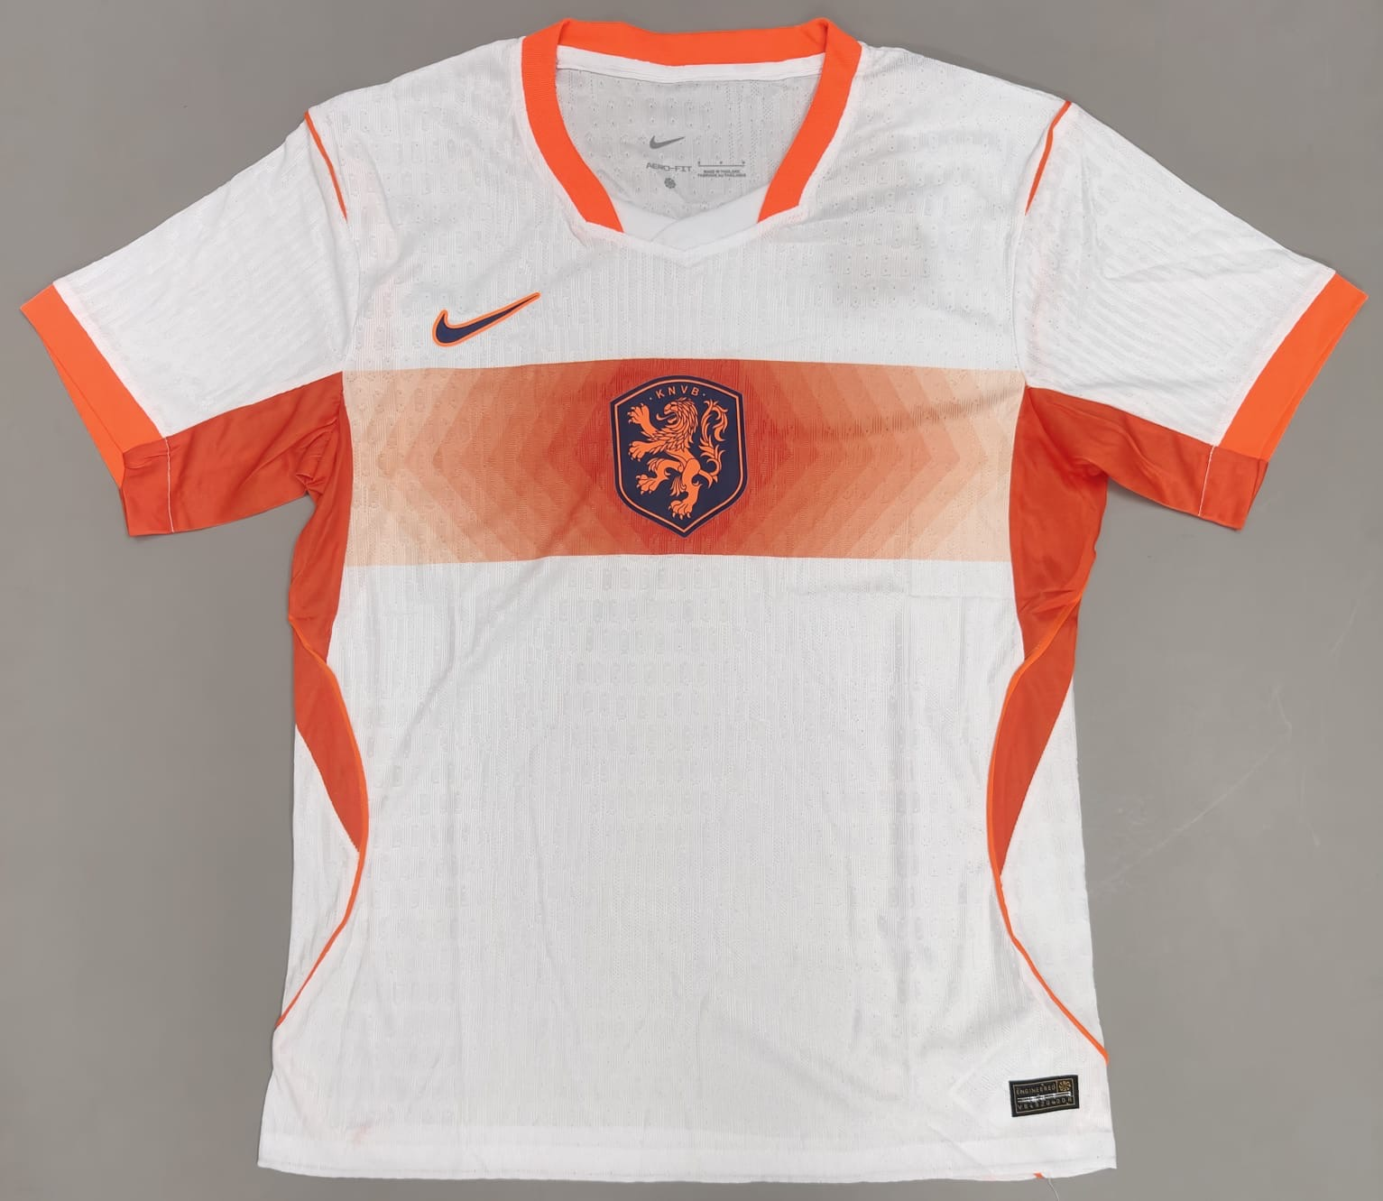
Netherlands 2026 Away Player Version
₹949

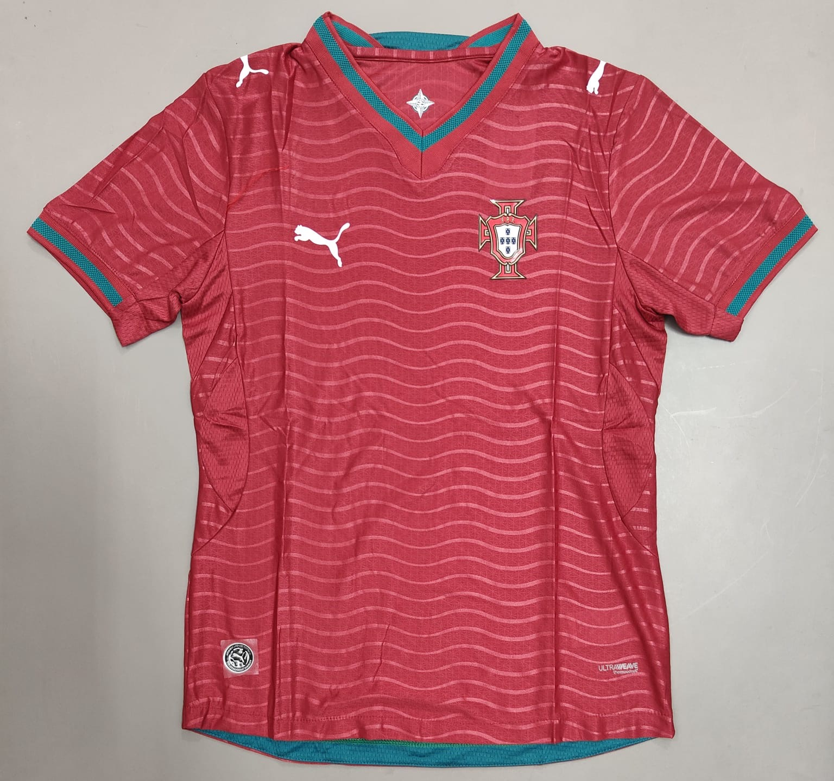
Portugal 2026 Home Player Version
₹949

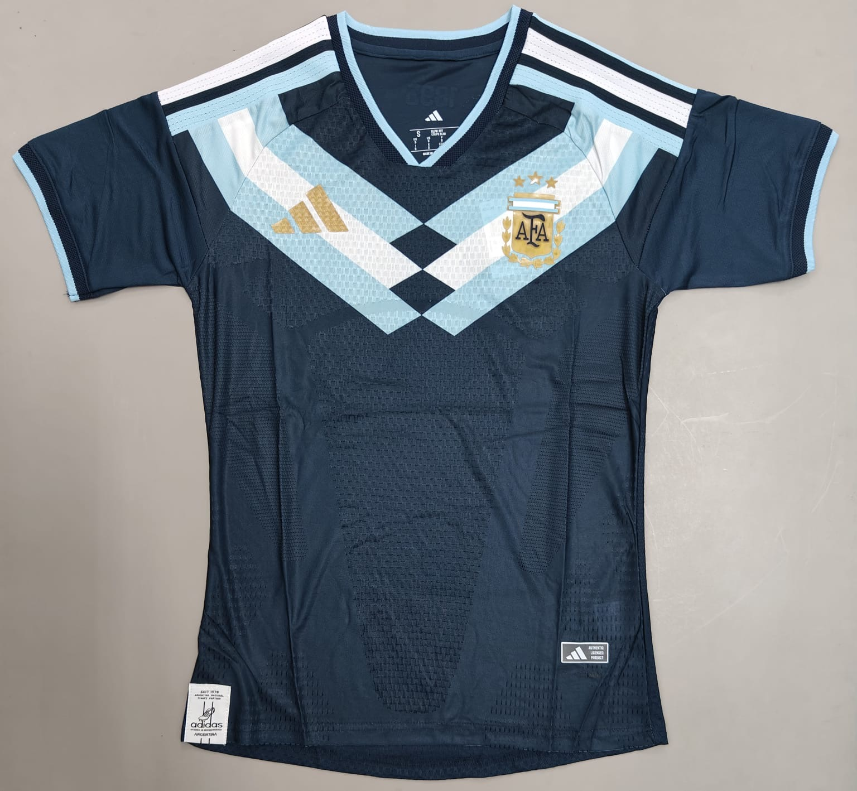
Argentina 2026 Navy Blue Concept Player Version
₹949

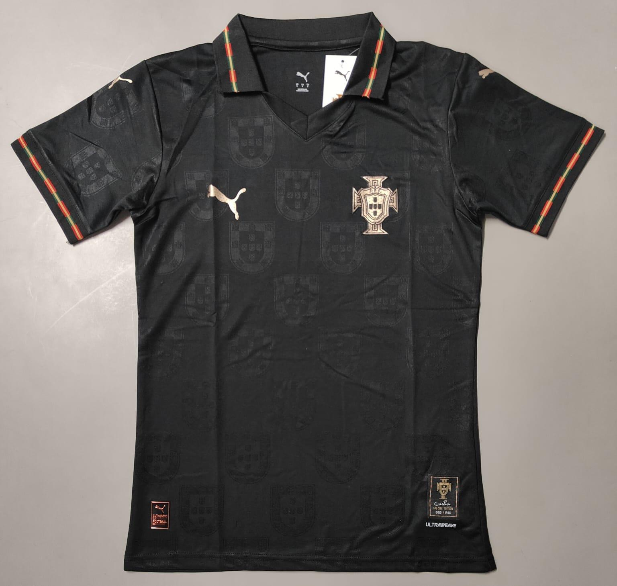
Portugal 2026 Black Special Edition Player Version
₹949
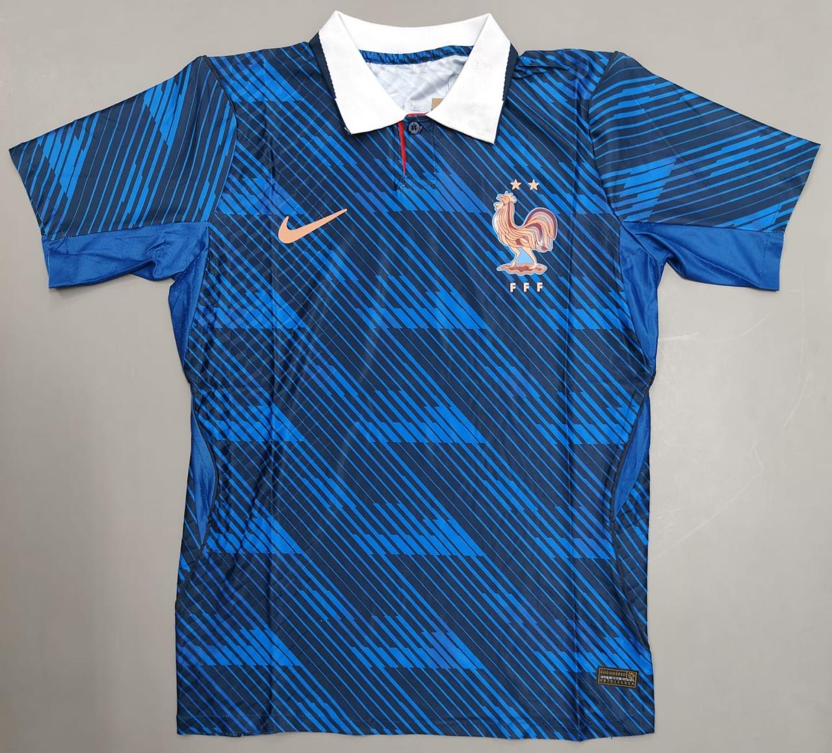
Product Name: France 2026 Home Player Version
Price: ₹949
--------------------------------------------------

