RTSP Streaming Server Architecture

Version 1.0
2007/11/23


www.vivotek.com

RTSP Streaming Server
© 2026 VIVOTEK INC. All Right Reserved

VIVOTEK may make changes to specifications and product descriptions at any time, without notice.

The following is trademarks of VIVOTEK INC., and may be used to identify VIVOTEK products only: VIVOTEK. Other product and company names contained herein may be trademarks of their respective owners.

No part of this publication may be reproduced or utilized in any form or by any means, electronic or mechanical, including photocopying and microfilm, without permission in writing from VIVOTEK INC.

Revision History
Version | Issue date | Editor | Comment
1.0 | 2007/11/23 | Louis | Initial creation of this document

Table of Contents

Introduction 4
Feature 5
Architecture 6
1. Architecture Block Diagram 6
2. Program Flow 7
3. Program Usage 11
3.1 Return Code 12
3.2 Handled Signals 12
3.3 Configuration File Structure 12
4. Related Libraries 15
5. Resource Usage 15

Introduction
The RTSP streaming server is capable of delivering streaming media to RTSP client. The RTSP streaming server is based on RTSP spec and need to be run with audio/video encoders to provide streaming media. It should also run with Boa server to provide HTTP mode operation.

Feature
- Support multiple streams as source
- Support multiple connections
- Support UDP multicast/ UDP always multicast mode operation
- Support UDP/TCP/HTTP mode operation
- Support mechanism (Symmetric RTP) to counter NAT problem

Architecture
The architecture of the RTSP Streaming Server is shown in sub-modules.

Architecture Block Diagram
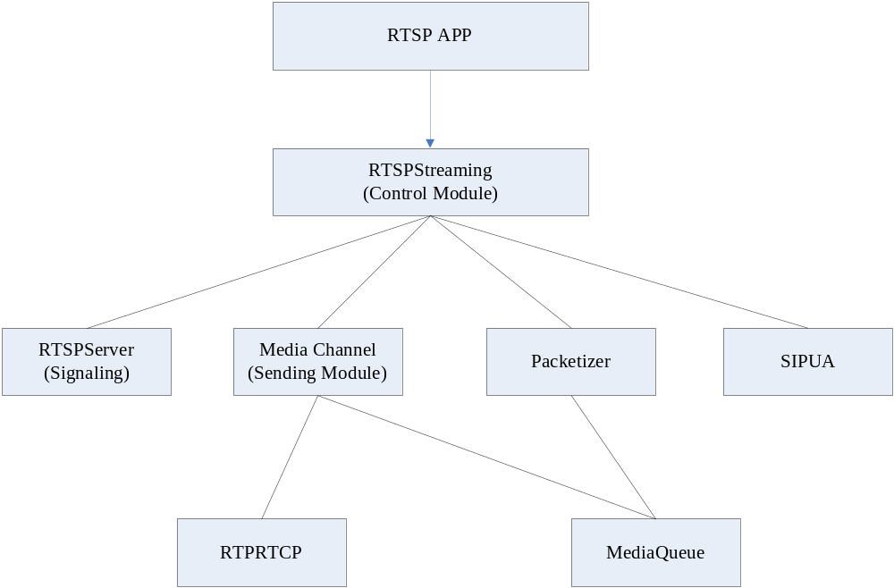
Figure 1.1. Architecture of RTSP Streaming Server

- •Rtsps – application which use RTSPStreaming Module. Rtsps is also responsible for unix-socket communication.
- •RTSPStreaming – central control module of the whole server.
- •RTSPServer – RTSP signaling server.
- •Packetizer – This module is responsible for processing the media data from unix-socket and cut it into packets
- •MediaChannel- This module is responsible for sending the media to client. It will take packets from the packetizer and wrap them as RTP packets before sending
- •RTPRTCP – This module is responsible for assembling and parsing the RTP/RTCP packets
- •MediaQueue – This module functions as queue maintainer.
- •SIPUA – This module is responsible for SIP two way audio

Program Flow
2.1 The Flow control of RTSP streaming server
In order to start a video/audio transfer, the following step should be taken.
1.Client connects to port 554 (RTSPServer Module)
–Client and server exchanges RTSP signaling
–Client issued PLAY
2.RTSPServer module callback to control module
–Control module callback to app to start video encoder
–Control module will call media channel to start sending media
3.Packetizer will callback to get media data and store the processed mediadata in MediaBuffer
4.Media channel will fetch media data from MediaBuffer and send to client

1. RTSPServer will process client request
–Client issued TEARDOWN
2. RTSPServer will callback to control module for session stop
–Control module will callback to app to stop encoder
–Control module will call media channel to stop sending media
3. Media channel will stop sending
4. Packetizer will get nothing from mediabuffer

Figure 2.1 Flow control of RTSP Streaming server
2.2 The Data flow of RTSP Streaming Server

There are two message queues in streaming server. Those queues will hold only pointers to allocated buffer spaces. The audio/video packetizer will attempt to fetch buffer space from empty buffer queue. The packetizer will then fill the empty buffer with data and send it to the data buffer queue. The RTP/RTCP audio/video media channel will attempt to fetch data from data buffer queue. The packetizer will then compose the packets using the data and then returns the buffer to the empty buffer queue. See Fig2.2 for illustration.

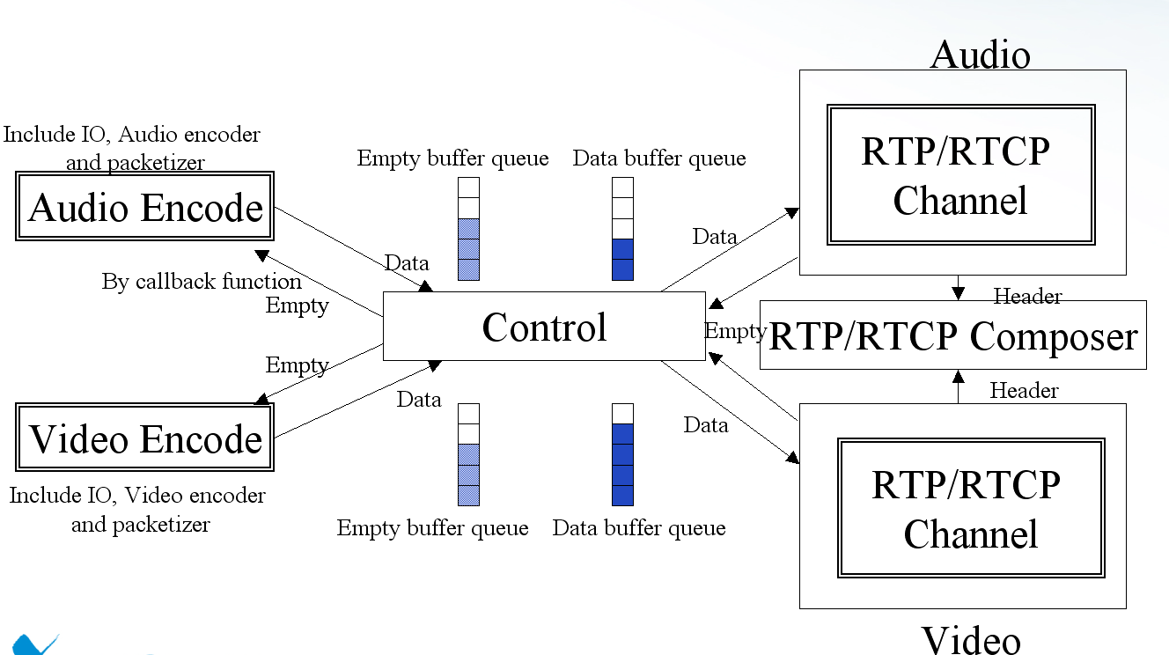
Figure 2.2 Data Flow of RTSP Streaming server

2.3 Call Flow of RTSP Server
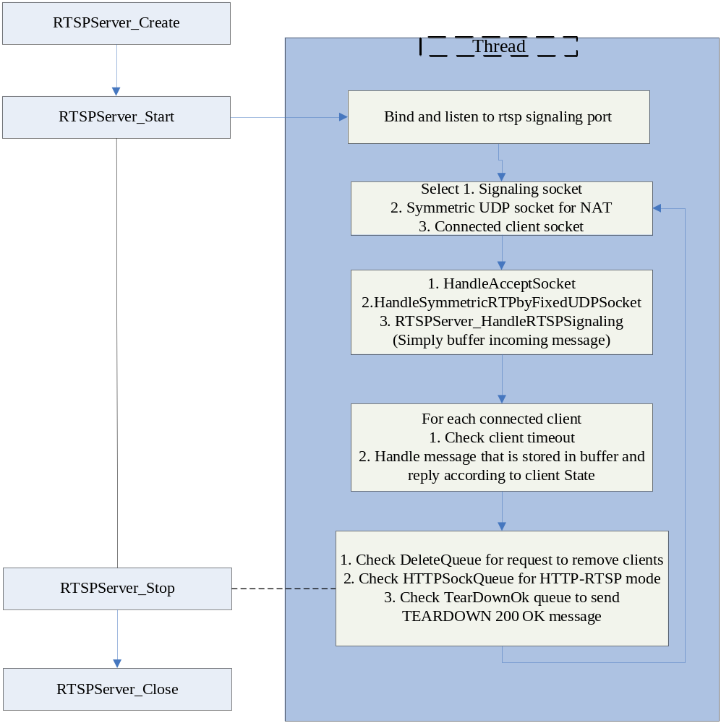
Fig 2.3 The call flow of RTSP Server

2.4 The call flow of Packetizer
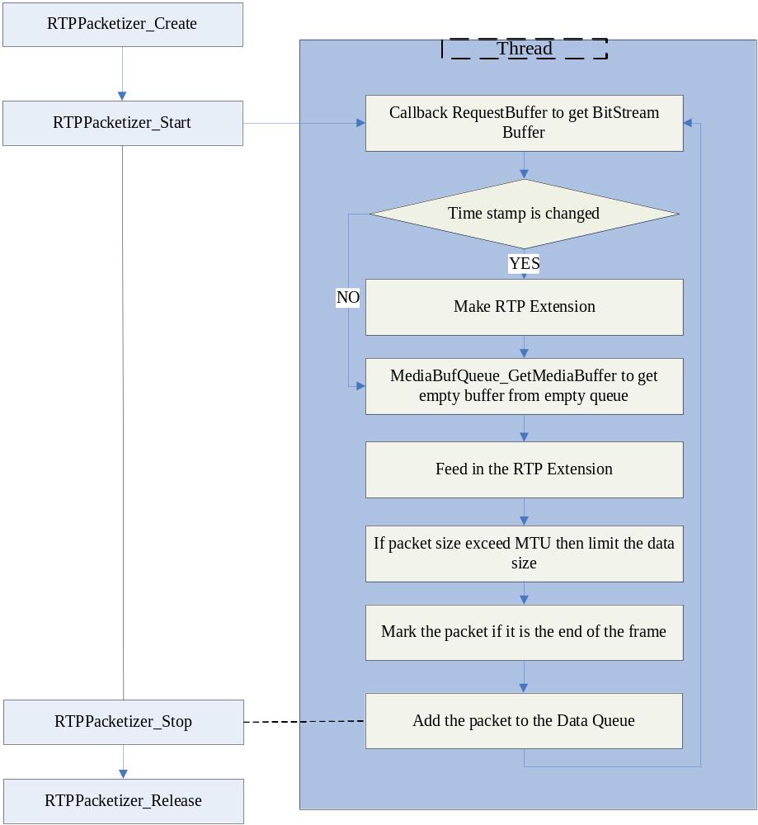
Fig 2.4 The call flow of packetizer

2.5 The call flow of Media Channel
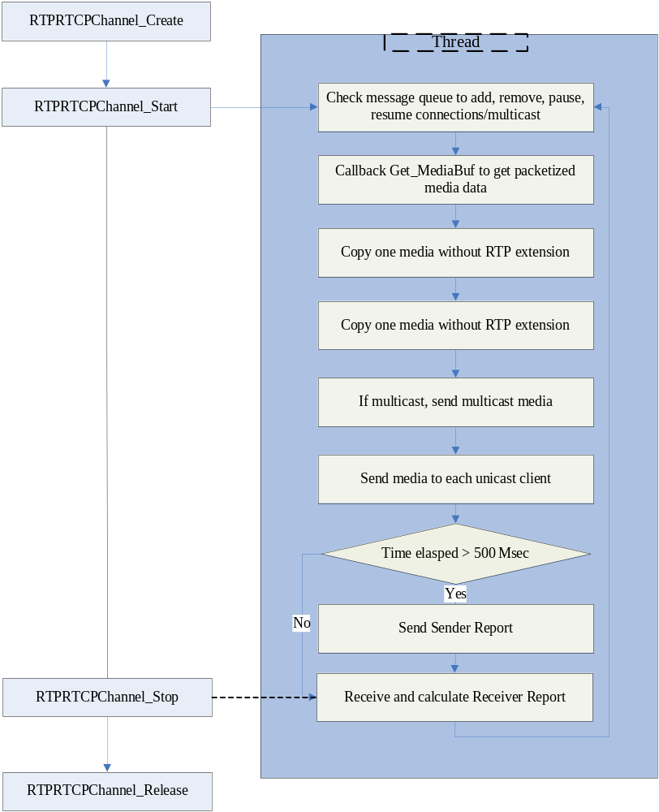
Fig 2.3 The call flow of media channel

Program Usage
Common program usage:
- rtsps –a $IP_ADDRESS –c $Config_file –l $IP_Filter_File –d
$IP_ADDRESS: address of the server
$Config_file: config file for rtsp streaming server
$IP_Filter File: config file for IP filter
-d: add this option to enable daemon mode
In Anubis architecture:
1. Simply execute /etc/init.d/rtsps start to start the rtsp streaming server.
2. /etc/init.d/rtsps stop to stop the rtsp streaming server.

3.1 Return Code
Return value:

Return value | Description | Note
0 | Successfully
1 | fail

3.2 Handled Signals
The Media Renderer process handle server signals as below:

Signal | Corresponding Action
SIGTERM | Terminate process

3.3 Configuration File Structure
The configuration file for rtsp streaming server is as follows:
<root>
<network>
<sip>
<port>5060</port>
<registrarip></registrarip>
<registrarport>0</registrarport>
<outboundproxyip></outboundproxyip>
<outboundproxyport>0</outboundproxyport>
<displayname>0002D1000000</displayname>
<username></username>
<password></password>
<domain>vivotek.com</domain>
<authmode>disable</authmode>
<maxconnnum>1</maxconnnum>
<sessioninfopath>/var/run/ss/sip.info</sessioninfopath>
</sip>
<rtsp>
<port>554</port>
<authmode>disable</authmode>
<maxconnnum>10</maxconnnum>
<sessioninfopath>/var/run/ss/conninfo</sessioninfopath>
<httpfdipcsock>/var/run/http/fdipc0</httpfdipcsock>
<controlipc>/var/run/ss/controlfifo</controlipc>
<v0>
<socket>/var/run/venc/s0/mediasck_0</socket>
<fifo>/var/run/venc/s0/controlfifo</fifo>
</v0>
<v1>
<socket>/var/run/venc/s1/mediasck_0</socket>
<fifo>/var/run/venc/s1/controlfifo</fifo>
</v1>
<a0>
<socket>/var/run/aenc/s0/mediasck_0</socket>
<fifo>/var/run/aenc/s0/controlfifo</fifo>
<decodesocket>/var/run/aenc/s0/decodesck_0</decodesocket>
</a0>

<s0>
<enable>1</enable>
<accessname>live.sdp</accessname>
<videotrack>0</videotrack>
<audiotrack>0</audiotrack>
<multicast>
<alwaysmulticast>0</alwaysmulticast>
<videoport>5560</videoport>
<audioport>5562</audioport>
<ipaddress>239.128.1.101</ipaddress>
<ttl>15</ttl>
<vvtkextension>1</vvtkextension>
</multicast>
</s0>
<s1>
<enable>1</enable>
<accessname>live2.sdp</accessname>
<videotrack>1</videotrack>
<audiotrack>0</audiotrack>
<multicast>
<alwaysmulticast>0</alwaysmulticast>
<videoport>5564</videoport>
<audioport>5566</audioport>
<ipaddress>239.128.1.100</ipaddress>
<ttl>15</ttl>
<vvtkextension>1</vvtkextension>
</multicast>
</s1>
</rtsp>
<rtp>
<videoport>5556</videoport>
<audioport>5558</audioport>
</rtp>
</network>

4. Related Libraries
<common>
<osisolate>
<encrypt_vivostrcodec>
<encrypt_base64>
<encrypt_md5>
<rtsprtpcommon>
<vspserver>
<rtpmediaqueue>
<rtprtcp>
<rtppacketizer>
<mediachannel>
<rtspserver>
<ipfilter>
<netutility>
<sipua>
<sdpdecoder>
<rtspstreamingserver>
<account>
<expat>
<message>
<xmlsparser>

5. Resource Usage
- Code size: 157 kbyte
- Memory usage:
  - Vmsize: 2420 Kb
  - VmRss: 1104 Kb
- CPU overhead: dependent on client number.

<End of document>

