打开车载代码 搜索 设置报警回调函数

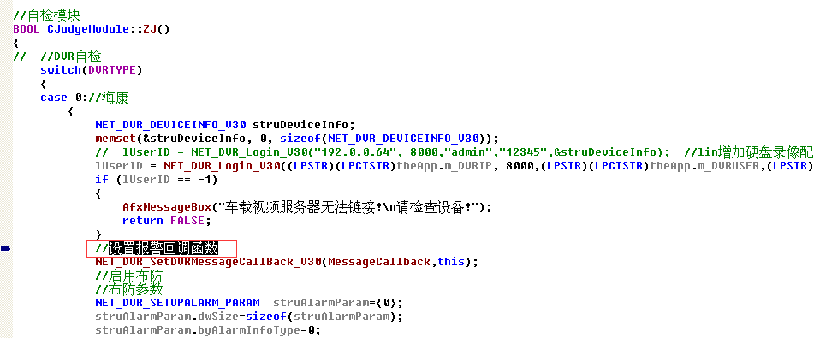
这之前加入

itypeSPZD=0;
DWORD dwReturn = 0;
NET_DVR_PICCFG_V30 struDVRPicCfgV30;
memset(&struDVRPicCfgV30,0,sizeof(NET_DVR_PICCFG_V30));
if(!NET_DVR_GetDVRConfig(lUserID,NET_DVR_GET_PICCFG_V30,1,&struDVRPicCfgV30,sizeof(NET_DVR_PICCFG_V30),&dwReturn))
{
TRACE("获取设备的配置信息失败!Errid=%d\n",NET_DVR_GetLastError());
return FALSE;
}
struDVRPicCfgV30.struHideAlarm.dwEnableHideAlarm=1;//0-否，1-低灵敏度，2-中灵敏度，3-高灵敏度
struDVRPicCfgV30.struHideAlarm.wHideAlarmAreaTopLeftX=100;
struDVRPicCfgV30.struHideAlarm.wHideAlarmAreaTopLeftY=100;
struDVRPicCfgV30.struHideAlarm.wHideAlarmAreaWidth=450;
struDVRPicCfgV30.struHideAlarm.wHideAlarmAreaHeight=320;
struDVRPicCfgV30.struHideAlarm.strHideAlarmHandleType.dwHandleType=12;
struDVRPicCfgV30.struHideAlarm.strHideAlarmHandleType.byRelAlarmOut[0]=1;
struDVRPicCfgV30.struHideAlarm.strHideAlarmHandleType.byRelAlarmOut[1]=1;
if (!NET_DVR_SetDVRConfig(lUserID,NET_DVR_SET_PICCFG_V30,1,&struDVRPicCfgV30,sizeof(NET_DVR_PICCFG_V30)))
{
TRACE("设置设备的配置信息失败!Errid=%d\n",NET_DVR_GetLastError());
return FALSE;
}

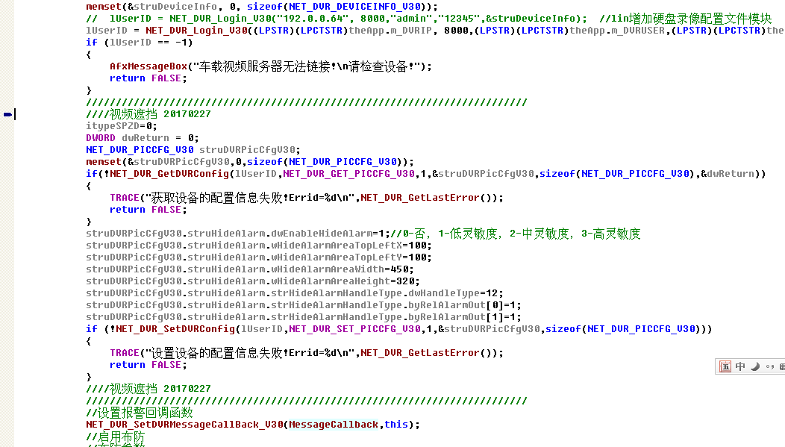
这个代码是加入了 区域设置 和敏度设置 测试过了 1-低灵敏度 就可以了

第二步 搜索CALLBACK MessageCallback

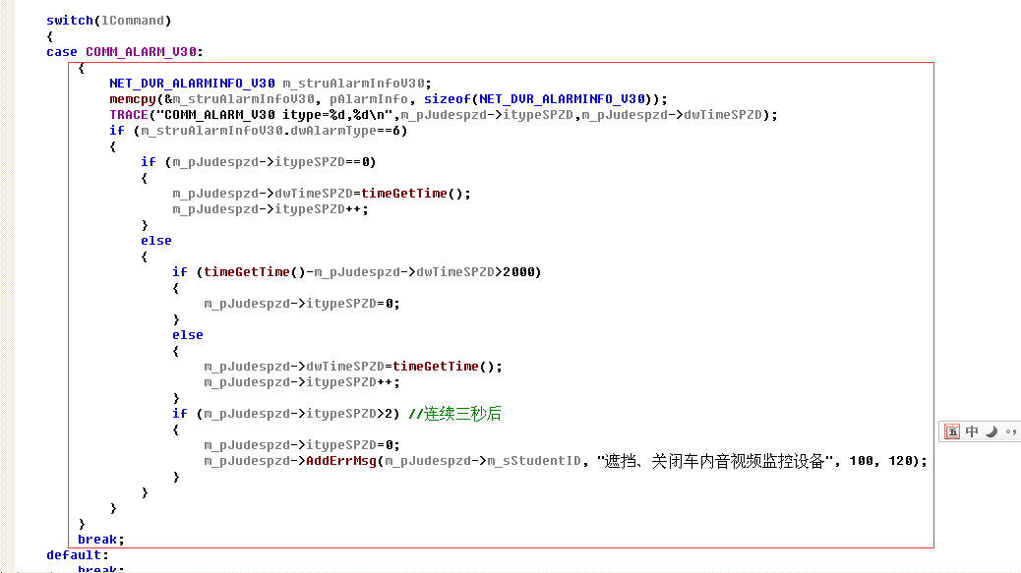

void CALLBACK MessageCallback(LONG lCommand, NET_DVR_ALARMER *pAlarmer, char *pAlarmInfo, DWORD dwBufLen, void* pUser)
{
// TRACE("MessageCallback %d",lCommand);
//视频遮挡 20170227
CJudgeModule *m_pJudespzd=(CJudgeModule *)pUser;

switch(lCommand)
{
case COMM_ALARM_V30:
{
NET_DVR_ALARMINFO_V30 m_struAlarmInfoV30;
memcpy(&m_struAlarmInfoV30, pAlarmInfo, sizeof(NET_DVR_ALARMINFO_V30));
TRACE("COMM_ALARM_V30 itype=%d,%d\n",m_pJudespzd->itypeSPZD,m_pJudespzd->dwTimeSPZD);
if (m_struAlarmInfoV30.dwAlarmType==6)
{
if (m_pJudespzd->itypeSPZD==0)
{
m_pJudespzd->dwTimeSPZD=timeGetTime();
m_pJudespzd->itypeSPZD++;
}
else
{
if (timeGetTime()-m_pJudespzd->dwTimeSPZD>2000)
{
m_pJudespzd->itypeSPZD=0;
}
else
{
m_pJudespzd->dwTimeSPZD=timeGetTime();
m_pJudespzd->itypeSPZD++;
}
if (m_pJudespzd->itypeSPZD>2) //连续三秒后
{
m_pJudespzd->itypeSPZD=0;
m_pJudespzd->AddErrMsg(m_pJudespzd->m_sStudentID, "遮挡、关闭车内音视频监控设备", 100, 120);
}
}
}
}
break;
default:
break;
}
}

第三步
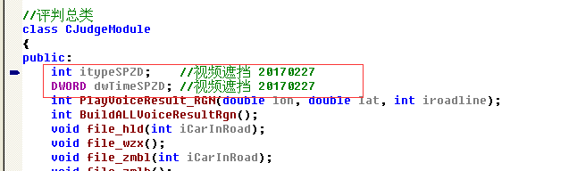

int itypeSPZD; //视频遮挡 20170227
DWORD dwTimeSPZD; //视频遮挡 20170227

