*Applied Mechanics and Materials Vol. 734 (2015) pp 340-344 Submitted: 2014-11-19*

*© (2015) Trans Tech Publications, Switzerland Accepted: 2014-11-27*

[*doi:10.4028/www.scientific.net/AMM.734.340*](http://dx.doi.org/10.4028/www.scientific.net/AMM.734.340) *Online: 2015-02-25*

**The Internet of things coffee vending machine**

Zhenlei Yang1, a, Lingyun Zhao1, b, Liangtian Gu1, c

1 Engineering Training Center, Tianjin university of Technology and Education, China

[ayzhl333@126.com,](mailto:ayzhl333@126.com) [b402708212@qq.com,](mailto:b402708212@qq.com) [cgubizi1991@sohu.comcemail](mailto:cgubizi1991@sohu.comcemail)

**Keywords:** Internet of things. The coffee vending machines. Emergency short message service.

**Abstract.** In the paper the author put forward the design of the coffee vending machines based on the technology of internet of things and its remote management system, which is aiming at the present problems, such as the high administrative cost and the difficulties in data analysis. This design not only makes the sales and supply information available, it can survey this information into cloud corner through GPRS as well.

# Introduction

The vending Coffee machine is widely used in various countries and regions of the world. However, in the daily operation and maintenance it continues to use the traditional manual administration and hand-written notes. It is very hard for the disperse vending machine to be effectively managed. One the basis of the present communication network platform, how to make a vending machine to form a chain sales network and provide a more convenient way of marketing and management mechanism, has become the key factors affecting its development. In this paper, the new coffee vending machine is designed based on the technology of Internet of things and remote management system and the present GPRS wireless network. Management personnel can timely understand the vending machine sales of coffee, cup and powder inventory, such as water temperature state information. At the same time according to the position information of each vending machine, working conditions, such as beverage inventory and sales data, the system provides a decision-making reference for the machines on the selling fleet placement position, drinks and beverage distribution. And the system can timely report vending machine fault event, reduce the fault shutdown time.

# System overview

The design is shown in Fig.1.This system is mainly consisting of two subsystems—Coffee vending machine terminal control system and network equipment management system. Terminal control system is composed of hardware circuit and control software. The controller not only will be responsible for the control of vending machines institutions, completing sell and recording data, and so on selling, but also test the inventory of glass and beverage, water temperature and other status information by patrolling type of mode, and these information will be sent to the networking equipment through GPRS wireless network management system. Terminal control system is composed of hardware circuit and control software. The controller not only will be responsible for the control of vending machine institutions, completing sell and recording data, and so on selling, but also test the inventory afterwards. Networking equipment includes public database management system, the primary server, the user server, public information, emergency short service, etc. Terminal upload information and management of user information can be managed, stored, read and updated by public database, the master server is responsible for the daily information and administrator of device management service, the user server is responsible for the daily information and administrator of device management service. The user server is available for user registration and query vending machines in the network information such as location, selling coffee varieties. Public network, relative to the Intranet, is a way of Internet access. It supports access to any computer on the Internet and mobile terminals, and truly realizes management anytime and anywhere. Emergency short messages service is based on mobile phone short message. With this service, the emergency

All rights reserved. No part of contents of this paper may be reproduced or transmitted in any form or by any means without the written permission of Trans Tech Publications, [www.ttp.net](http://www.ttp.net/). (ID: 141.211.4.224, University of Michigan Library, Media Union Library, Ann Arbor, USA-10/07/15,23:09:41)

management to the terminal equipment can be executed via text message even in the network fault state.

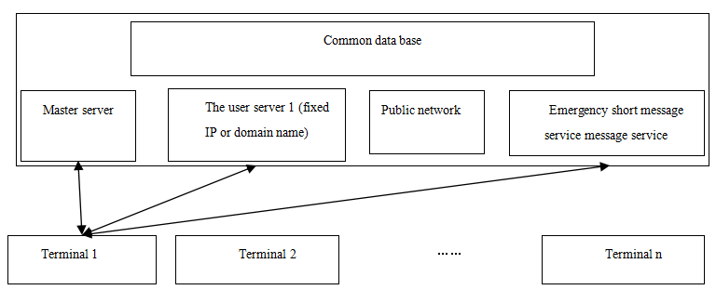

Fig.1 System diagram box

# Terminal control system of the new coffee vending machine

Hardware of the control system consists of the host controller, GPRS communication module, display module, power supply module, etc. The design is shown in Fig.2. Main control unit adopts STM32F103 series single chip microcomputer .The STM32F103, based on the kernel Cortex-M3, is a 32-bit mid-range ARM microcontroller produced by ST Microelectronics (ST) Company. It comes with a rich set of interface resources. Its serial port, general I/O mouth and timer are used in the system. ST Company provides rich library function, making the development of STM32F103 simple.

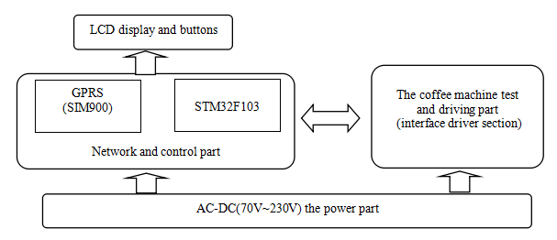

Fig.2 Terminal control system

GPRS data service and emergency short message service is to use SIM900, serial communication module and the host controller. The communication circuit is shown in fig.3.

R1 IGT

V4.2

C1 105pF



SIMVCC

R15 10K

C9 0.1UF

U4

SIMRST

SIMCLK

R17 2 2

1

2

3

4

5

6

R19 22

U2

SIMCARD

SIMDATA

51

50

49

48

47

R20

22

D18 D19 D20 D21 TVS TVS TVS TVS

SIMCard SMF05C

46

45

44

43

42

41

U3 MIC29302BU

+12V

1

2

V4.2

4

40

39

38

37

R13 R14

100K 1K

EC2 + C8

0.1UF

EC3 +

+ EC4

1UF/16V

330UF/16V

36 100UF/16V

35

R16

43K

VCC GND RESET VPP CLK IO

EN

IN

OUT



EMP1 R2

2K

68

67

66

65

64

63

62

61

60

59

58

57

56

55

54

53

52

GPIO12 GPIO11 STATUS GND GND GND GND GND

RF GND GND VBAT VBAT VBAT GND GND

netLED

Q1 NPN

1K

RF

SYNC



|  |  |  |
| --- | --- | --- |
|  | IGT | 1 |
|  | 2 |
|  | 3 |
| RING | 4 |
|  | 5 |
| R6 |  | 6 |
| 1K |  | 7 |

8

PWRKEY

PWRKEYOUT DTR

RI DCD DSR CTS RTS TXD_O RXD_I

DISP_CLK DISP_DATA DISP_D/C DISP_CS VDD_EXT nRESET GND

GPIO10/KBC0

GPIO9/KBC1 GPIO8/KBC2 GPIO7/KBC3 GPIO6/KBC4

GND GND GPIO5/KBR0 GPIO4/KBR1 GPIO3/KBR2 GPIO2/KBR3 GPIO1/KBR4

GND SCL SDA PWM2 PWM1

GSM_TXD R7 1K 9

GND

ADJ

GSM_RXD 10

D16 R8 1K 11

12

LED 13

3

5

14

15

GSMRST 16

GND MICP MICN SPP SPN LINE_R LINE_L ADC VRTC

DBG_TXD DBG_RXD GND SIM_VDD SIM_DATA SIM_CLK SIM_RST SIM_PRES

17

C2

EMP0

R10 2K

Q3

8050

GND

RF

R11

C50 0.1UF

0.1UF

J1

1

2

+

EC1

SIM900

R4

SIMRST SIMCLK SIMDATA SIMVCC

18

19

20

21

22

23

24

25

26

27

28

29

30

31

32

33

34

D15

SYNC

R9 4.7K

EPN1 EPP1 MICN1 MICP1

C6

0.1UF

Header 2

10UF/16V

V4.2

1K

LED

Q2 8050

GND GND

Fig.3 Data communication hardware circuit

With color screen display, the module can show Chinese, English, Numbers, pictures and other information. This system is used as a beverage selling process and administrators to jointly work with machine setup and buttons so as to realize the interaction of people and machines.

Power supply is divided into two parts to separate the power supply. And cooling and heating are supplied directly by the mains supply. Part of the power control system is switching power supply, which has the advantage of small volume, low cost, wide output power working voltage range, etc.

# The analysis of the terminal control system software

Fig.4 is the software flow chart of terminal control system; the system can automatically detect presence of GPRS connection when it is started. Once it is connected, start networking state, and then go into the networking mode.

If there is no GPRS connection, the reason may be that the administrator did not unlock the function of GPRS information service or network failure. In this situation it will go into the stand-alone mode, and the emergency text message service mechanism will be started.

When there is GPRS or SMS service, controller into the interrupt, in sending data model, data sending and receiving data post-processing, data processing end to return to the main program. Scanning update timer interrupt is for display and buttons to provide services; raise the utilization ratio of the MCU processing in this mode.

Scanning update timer interrupt is for display and buttons to provide services, and during this way the utilization ratio of the MCU processing in this mode is raised.

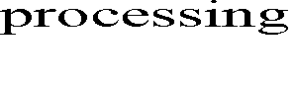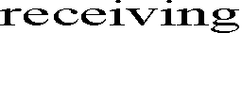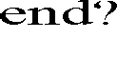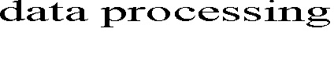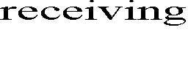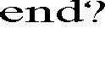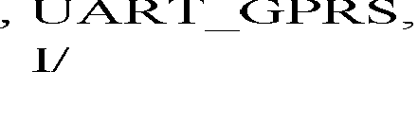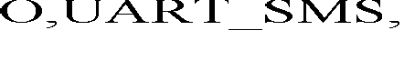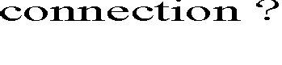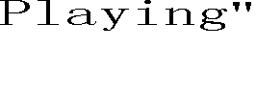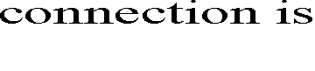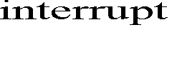

Fig.4 Terminal system control flow chart

# Networking equipment management system of the new coffee vending machine The beat of data communication

Terminal and server data interaction between network equipment management system. The communication initiated by terminal and return by server. A total of two beats a communication terminal and server sends data back.

System provides a Socket service, receiving terminal sends packets and unpack. At the same time, it will unpack the data in the database of the corresponding data in the tabling turn through data analysis.

Their communication between packet formats is in strict accordance with the following manner. Upload terminal server packet format is: the function, production batch number, the chip code,

SIM kaka, permissions, the system time, have been patrolling logo, whether to call the police, the tank is normal, set the water temperature, the water temperature, fooling cup feature is open, if there is more than a cup, compact state, drinks new increasing sales volume, are invalid, check value. Server back to terminal packet format is: function, permissions, the system time, whether sales restrictions, set the water temperature, compact alarm value, drink unit price byte, set the drink water.

# Data processing

Server receives the data needs to be stored in the database. The corresponding data obtained by means of access to the server database.

Administrator can set some parameters threshold. When upload data is less than the threshold, the server will show the different color to prompt the administrator's attention. Setting "powder", for example, less than 20% this is red font display. Server for data processing, in addition to the threshold setting and remind function, also set up regional sales strategy according to sales data model. The administrator can learn the amount of coffee vending machine on the different areas according to the results of the analysis. Because of the low logistics cost, the materials need not taking into consideration.

What are the most important factors that affect earnings are the cost of sales and coffee. So put into coffee of different prices reasonably are the key to maximize profits.

If the cost of the three kinds of drinks, respectively is *x1* , *x2* , *x*3 and sales respectively is y1 , y2 , *y3*

price respectively is 1, 2, 3, and the relationship between sales and prices are assumed to be function:

*Y*  *G(V)*

So the profit is:

*F*  *(V*  *X)G(V)*

(1)

(2)

*G (V)* of the formula 2nd function requires vending machine operation for a period of time, getting a reliable function after a large number of sample data using probability and statistics methods.

It is easy to find that on the premise of guarantee the quality of coffee, the possibility of the cost *X* to reduce is relatively small, and the price *V* can be optimized by the administrator. Unfortunately, one the hand the sales are changed because of the change of the price.

How to get the right price? There is a relatively simple method in computer program. First give a reasonable price range, in the range, with price as variable, and take formula 2nd into the program, then iterates through all variables, the corresponding variable's value of the maximize resulted of the price range is the best price for this kind of drink.

# Interface

**The login server interface**

In order to guarantee the security of the server, authentication is required when the login server. Before login, the client displays as shown in fig.5 on the left. Super administrator login identity can be divided into three classes: supervisor, administrators and users. The supervisor has absolute administrative authority; the management of the administrator permissions is under certain restrictions, such as cannot query the business profit amount that; users need to register and get the administrator permission to land.

# The administrator function selection interface

Authentication is passed then enters the page as shown in fig.5 on the right. And at that time one can query and manage the equipment information.

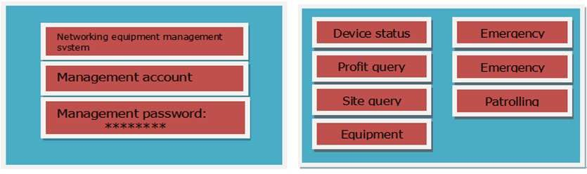

Fig.5 Server interface

# Conclusions

Pre-production debugs prototype terminals, collecting and analyzing a certain amount of data in the running. During these processes we find that the system runs stably, the operation is excellent and the terminal access and management is good enough. It solved the current problems existing in the

vending machine, making the machine more convenient to manage. People can access servers at any time through the computer, mobile phone terminal access servers, such as understanding of sales, and operation and maintenance in the time.

# References

[1]Wen Zhang, The vending machine IC card charge module's design and applies, micro computer information, 2006, PP.201-203.

[2] “Annual statistics of Vending Machine 2008”, Japan Vending Machine Manufacturers association, 2009.

[3] Automatic Merchandisers, “2012 State of the Vending Industry Report”.

[4] G. Schreder, K. Siebenhandl, E. Mayr, and M. Smuc, E. Loos, L. Haddon, and E. Mante-Meijer, Eds., “Theticket machine challenge: Social inclusion by barrier-free ticket vending machines,” in Generational Use of NewMedia. Farnham, UK: Ashgate, 2012.

[5] D. Kaplan, “Android Application Sketch Book,” Apress, 2011.

[6]Mang Zhang, Yang Yong strong 0.1 kind of new vending machine control system's design, mechanical and electrical engineering technology, 2007.PP.50-72.

**Electronics, Automation and Engineering of Power Systems**

[10.4028/www.scientific.net/AMM.734](http://dx.doi.org/www.scientific.net/AMM.734)

**The Internet of Things Coffee Vending Machine**

[10.4028/www.scientific.net/AMM.734.340](http://dx.doi.org/www.scientific.net/AMM.734.340)