1001 netstat -ntlp|grep 9090

1002 service dm-tomcat stop

1003 tail -f /opt/mcu/dm/tomcat/logs/catalina.out

1004 service dm-tomcat stop

1005 netstat -ntlp|grep 9090

1006 service dm-tomcat stop

1007 service dm-tomcat start;tail -f /opt/mcu/dm/tomcat/logs/catalina.out

1008 netstat -ntlp|grep 2191

1009 service dm-zookeeper start

1010 tail -f /opt/mcu/dm/tomcat/logs/catalina.out

1011 service dm-tomcat stop

1012 service dm-tomcat start;tail -f /opt/mcu/dm/tomcat/logs/catalina.out

1013 history

<http://172.16.185.233:9090/>

admin 888888

登录后

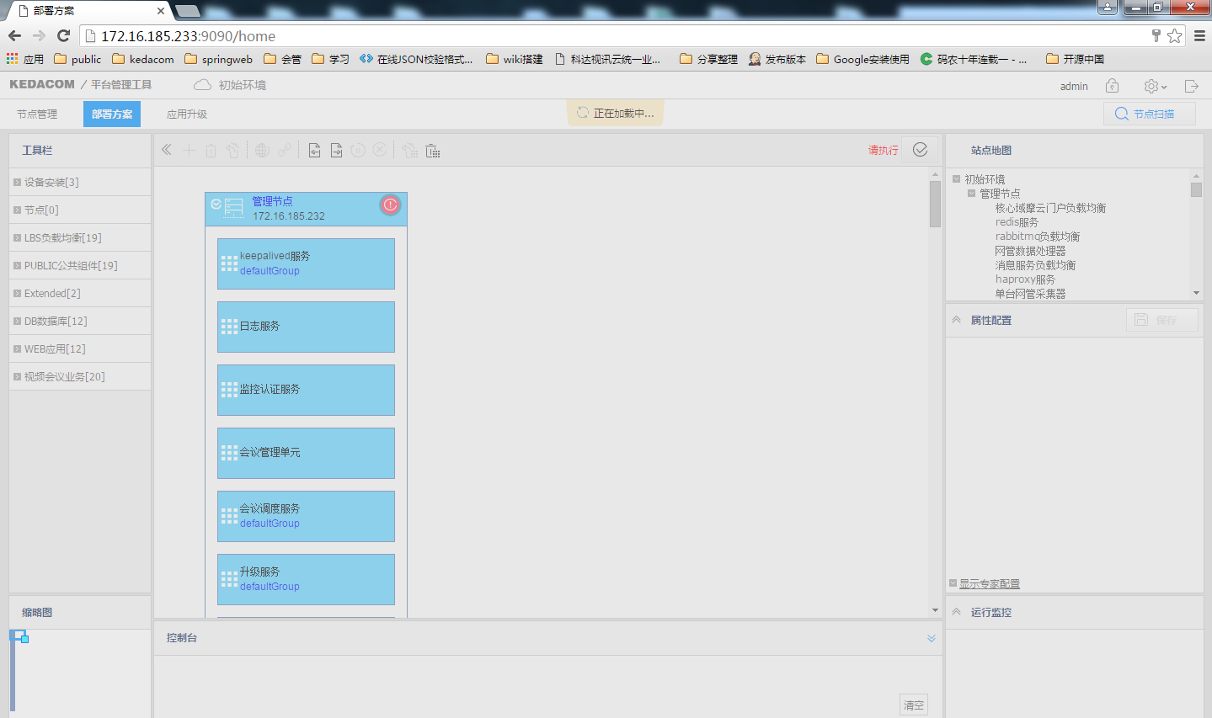

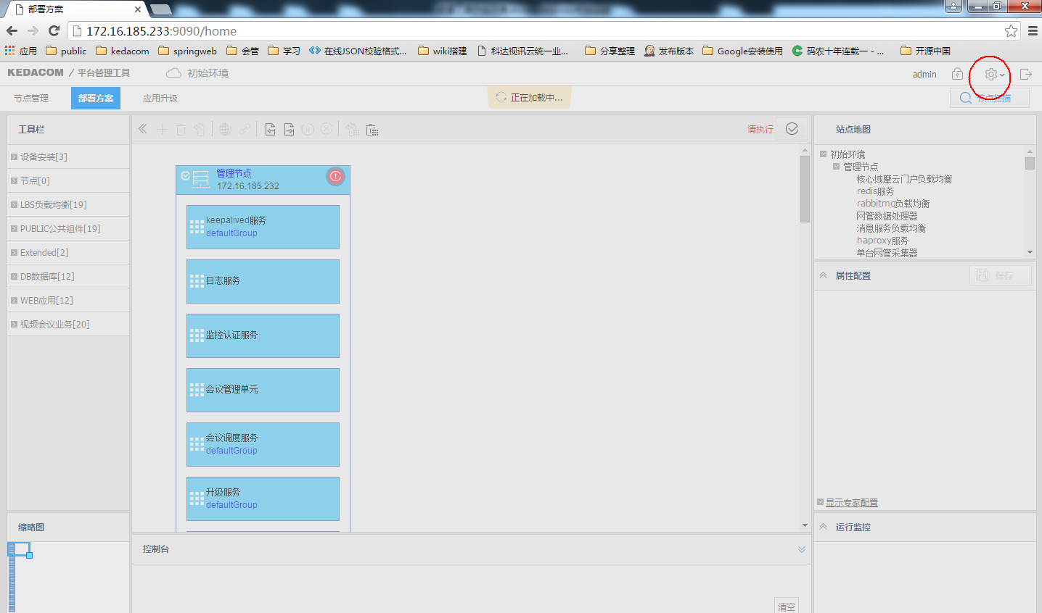

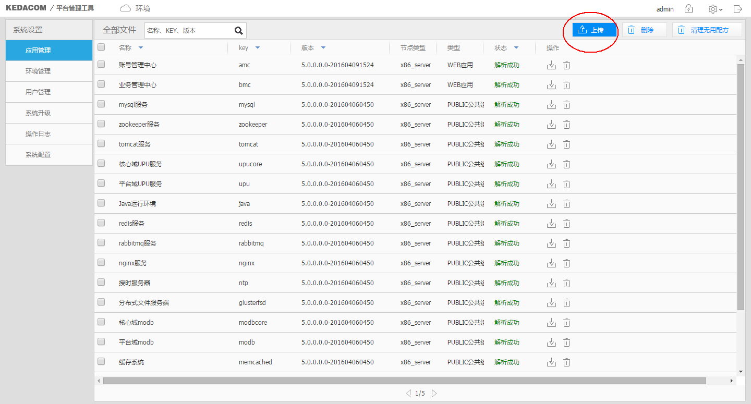

选择地址 ：\\172.16.0.99\DailyVersions\KDV\TS\Mustang\20160422\Mustang_daily_R26088#T0115\ProductDir\recipe\release\web

