**Modern Data Platform – Test Strategy/Approach**

Version: - Draft

Document Control

| **Version** | **Dated** | **Author** | **Reason for revision** |
| --- | --- | --- | --- |
| 0.1 | 21/09/2022 | Ram Baskar | Draft |
| 0.1 | 28/09/2022 | Ram Baskar | Draft – added pictures in multiple sections |
|  |  |  |  |

# Distribution for Review

*< to be populated later>*

| **Reviewer** | **Role** | **Sign Off Date** |
| --- | --- | --- |
|  |  |  |
|  |  |  |
|  |  |  |
|  |  |  |
|  |  |  |
|  |  |  |
|  |  |  |

Contents

1 Introduction 5

1.1 Background 5

1.2 Purpose 5

1.3 Document Objectives 5

2 Scope 6

2.1 In-Scope 6

2.2 Out of Scope 6

3 Test Governance 7

3.1 Software Test Life Cycle (STLC) 7

3.2 Agile Methodology 7

3.3 Test Approach & Techniques 8

3.4 Test Phases 9

3.5 Quality Gates & Entry/Exit Criteria 10

3.6 Defect Life Cycle 10

4 Resource 11

4.1 Test Data 11

4.2 Tools 11

4.3 Roles and Responsibilities 12

4.4 Test Environments 13

4.5 Skills and Resource Requirements 13

4.6 RIDA (Risks, Issues, Dependency & Assumptions) 13

4.7 Reporting & Statistics 14

4.7.1 Test Progress Reporting 14

4.7.2 Test Completion Reporting 14

5 Glossary 15

# Introduction

## Background

The Modern Data Platform (MDP) is an Azure hosted data repository managed by Cloud Data Platform team. The new architecture will replace the existing platform called “MYMI” (also running in Microsoft Azure Platform) with design improvement and aiming to reduce the operational cost. It aims to integrate the data from different sources available in “on-premise” databases and provides consistent information to different user groups across the business, for use in analytics, reporting and data processing activities.

It is intended to provide all the project team members with the overview of functional testing processes that will be adopted for BRIT Modern Data Platform. This document does not intend to comprehensively detail what the coverage of testing will be, for each project/use case, a separate test plan will be created with this level of information.

## Purpose

The purpose of this document is to define how the common quality/acceptance criteria is accomplished to ensure that, the final delivery of the processed/transformed data in MDP environment is functionally fit for purpose for consumers/business user group to access the data via portal, visualisation tools like (SSRS/Tableau/Power BI) and data extract etc.

## Document Objectives

* Define test objectives, In-scope/out of scope functions and corresponding test items to clearly understand what areas need to be tested
* Outline how the test approach will be followed to ensure all parties understand the testing stages and corresponding timelines including test automation where possible
* Define an overall testing process/activity that ensures how the whole Modern Data Platform is tested to the degree required for consumers/business to accept the delivered system into services
* Define entry/exit criteria
* Detail the type/phase of testing e.g., SIT, UAT, NFT etc. that will be conducted to ensure clarity on how relevant test phases will be tested
* Lists the environment(s) and test tools in consideration
* Document the clarity on the roles and responsibilities throughout the testing activities
* Define defect management life cycle

# Scope

## In-Scope

|  |  |
| --- | --- |
| **Functional Area** | **Description** |
| Data Extraction & Ingestion  (via Batch Ingestion) | Extraction, Ingestion & Transformation of data available in on-premises database/file (*CSV/TEXT/XML/JSON* etc) and/or from other cloud like *AWS/GCP* etc *(not applicable at the moment)* into MDP Platform |
| Data Extraction & Ingestion  (via Streaming) | Extraction, Ingestion & Transformation of data coming from streaming like Event Hub/Kafka etc. into MDP Platform. *N/A at the time of creating this document* (future design) |
| Landing Zone  (ADLS Gen2) | Verification of data landing in Parquet/Delta format in an appropriate container/folder across all the available layers (Bronze/Silver/Gold) |
| Data validation  (Azure Synapse) | Data validation between source – target across multiple layers within Data Platform including reconciliation, data completeness, data correctness and data transformation based on transformation rules defined in *data mapping*  *(This includes Reference Data (if any)/Transaction/Dimension/Fact)* |
| Outgoing | Validate the data extract from MDP to 3rd party based on the business requirement/rules defined. *Example Riverstone extract* |
| Other Functions  (Based on MYMI experience  Might not be applicable) | Month-end process including data validation/reconciliation  Quarter-end process including data validation/reconciliation  Financial Adjustment (if applicable) including Temporary/Permanent??? |
| Non-Functional Testing | Performance of all components within MDP Platform like   * Volume & Performance * Azure Synapse Data Pipeline * Data extract to 3rd party * Event Hub / Azure function/Kafka(future) – *N/A at the moment* |
|  |  |

## Out of Scope

|  |  |
| --- | --- |
| **Area** | **Description/Justification** |
| Data Quality | The source system owner is responsible for source data quality |
| Security - Infrastructure | BRIT security team is responsible for infrastructure related security |
| Front-end applications/API | There is no requirement for front-end/web/API related testing in MDP |
| Latency | Latency outside MDP platform will be tested either by dedicated NFT or by Cloud operations team |
| Downstream Applications | Applications outside MDP Platform like portal etc. Analytics related like ML/AI Module & report performance |
| Non-Functional | Infrastructure / Security / Penetration /Alert / Monitoring / Fail-over / High Availability /Backup-restore etc. (Possibly scope for either NFT team/Cloud Operation team) |

# Test Governance

## Software Test Life Cycle (STLC)

**STLC** is a set of specific steps/activities used during the testing process to ensure software quality gates are met to satisfy the acceptance criteria/requirement. Testing is a critical part of preparing software for use, and a STLC helps make this process more sophisticated, consistent and effective. It involves lot of preparation, verification and validation activities and is not just a single isolate activity. Many STLC setups start with an analysis of testing requirements, followed by test preparation which includes test estimation, planning and test data preparation. Later, there is test execution and other follow-ups, such as regression testing for more complex functionality and retesting some of the elements based on the bug/defect found during test execution.

The fundamental approach and structure of testing undertaken by MDP QA team is detailed below. Planning & Control is used for overall of each use case/project and the remaining activities are applied to each individual test phase.

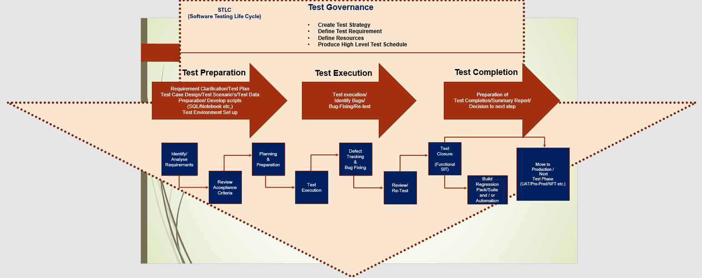

## Agile Methodology

The MDP QA team will use the elements of the Agile project management methodology for all stages of SIT testing. The UAT/E2E acceptance and Pre-Prod approach (if applicable) will subject to further discussion and may undergo further changes in ways of working. QA team will actively contribute to all the agile related events like planning, refinement, retro and product demo. Scrum is the most popular framework that brings effective collaboration between different teams working on complex project/product. We follow **Agile Scrum Methodology**, which is sprint-based system for managing software projects that works on incremental development in project development. The iterations are divided into manageable time slabs, each of about two-week sprints. Every goal-driven sprint offers vital features that constructively develop a complete product/feature. In subsequent sprints, add-on features and enhancements based on customer and team feedback are built into the product releasing the fully tested feature/software/product every 2 weeks *(to be detailed as part of Release Strategy).*

## Test Approach & Techniques

Testing Modern Data Platform is different from traditional application testing as it requires a data driven approach. The standard approach is to consider ETL/data pipeline/data ingestion process using Microsoft azure tools like ADF/Azure Synapse etc. as black box. The data extracted from the on-premise source database tables/files etc. will be moving through various stages across the multiple layers ***(bronze/silver/gold)*** in cloud platform based on data mapping document. The data validation process is to verify the data at each stage including landing/transformation/aggregation for different type of entities like Dimension & Fact etc. and to ensure that, transformed data is fit for the purpose for consumers to access the data using data extract/portal/mobile devices (if any)/visualisation tools like Tableau/Power BI etc for reporting and analysing purposes.

Below is the list of high-level activities for functional system integration testing phase

* Walkthrough of requirements/functionality between Dev/BA to QA team via *3-amigos* call
* Based on the acceptance criteria and data mapping document, QA team will perform the test preparation including estimation, test case design, develop SQL script and test data requirement while the feature is being developed
* Test cases will be reviewed internally to ensure that test coverage is as complete as possible and get tests ready for execution
* Once the code is deployed for SIT via CI/CD pipeline, facilitate the team to work collaboratively to perform testing and identify the defects (if any) in the early stages
* Aim to have SIT testing completed and sign-off completion report prior to promote the code to next phase of testing

To facilitate the coverage of requirements, functional tests will be executed with the multiple data sets from source to make sure that, all the relevant scenarios are covered

Test execution during SIT phase will be covered with at least 2 different data sets.

* Initial Load followed by delta/incremental for Reference data (if applicable)
* Initial Load followed by delta/incremental for transactional data
* Month-end / Quarterly process data validation including boundary value testing *(if applicable)*
* Data extract from Final destination (gold layer) to 3rd party (example for Riverstone)

At the end of the SIT phase, the regression pack will be built and maintained for future test execution.

For functional testing, multiple check points will be defined based on LDM/PDM (if available) and verified at each step where the data is moved from source (on-premises) to cloud environment across multiple layers.

High Level context diagram – Data Ingestion/process in MDP platform

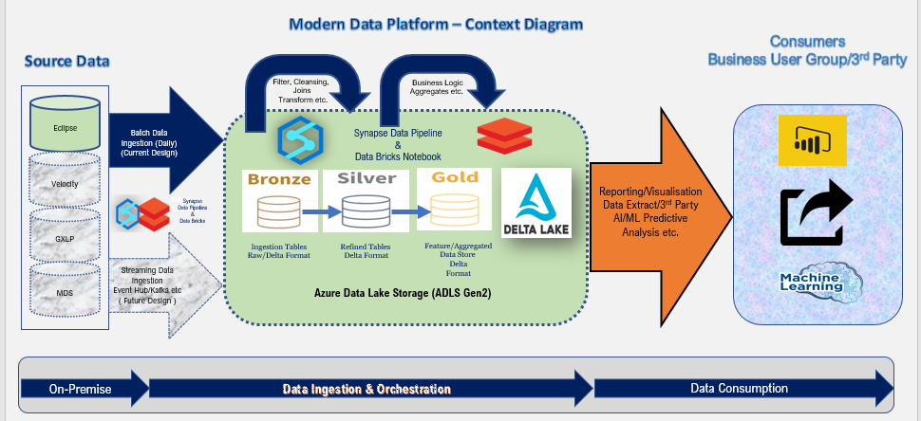

## Test Phases

The test phases identified for Modern Data Platform are listed below. Each test phase should be organised and executed using the STLC approach. The test phases are executed in the order listed but do not necessarily need to be run in synchronisation between individual software/component deliverables until the integration and E2E test phases are reached.

The test phases have been created with the objectives of.

* Confirming each level of testing/delivery is successful
* Supporting the following phase
* Collectively supporting the E2E test phase and acceptance of the final product/feature
* Achieving delivery within sprint goal

|  |  |
| --- | --- |
| **No.** | **Test Phases** |
| 1 | Static Testing |
| 2 | Unit Testing |
| 3 | System Testing (a specific source/layer) |
| 4 | SIT System Integration Testing (multiple source/layers) |
| 5 | UAT (acceptance test from business) |
| 6 | NFT (Non-Functional Testing) |
| 7 | RFO/OAT/Production/Commission Testing) |

All the above test phases are mandatory and is highly recommended from long term strategy perspective. However, for each feature MDP QA team will identify early if there is any need for these and liaise with the relevant stakeholders and obtain an agreement accordingly. In short term, **Dev-Test-Prod** approach will be in place until we built more features in MDP

Test Phases should be run following a linear model. Each test phase should only commence once the previous test phase quality gate has been achieved based on the measurable metrics. By following this approach, it ensures: -

* The overall plan is being adhered to thus ensuring timescales are met
* The test phase is ready to commence
* System/Product/Feature quality can be tracked through STLC
* Defects are found in early stage make it easier, quicker and cheaper to fix
* Test coverage is achieved in the minimum/agreed timescale

Test phases for individual components do not need to be in sync until SIT phase is reached. At this point all components/sources that make up the feature/product need to be ready for Integration testing

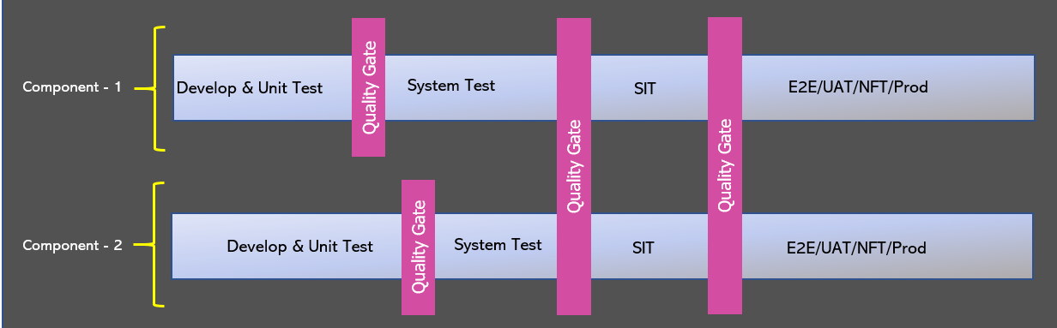

## Quality Gates & Entry/Exit Criteria

Quality Gates are generally positioned between each test phase. There should be a separate set of criteria to measure completeness of the delivering test phase (exit criteria) followed by a measure of the readiness to move into the subsequent test phase (entry criteria). The table below provides a generic list of what will be contained within the quality gates

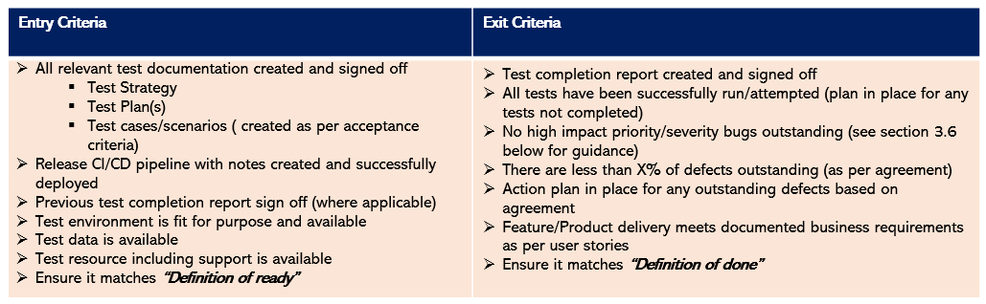

Clear, measurable quality gates must be established and agreed before testing commences to ensure both progress and quality can be quantified throughout the project. At the start and end of each test phase the criteria should be assessed to ensure it has been met before moving into the next test phase or accepting delivery of the final feature/product. If the criteria have not been achieved, then the next test phase should not commence until all outstanding criteria have been addressed.  If quality gates are not implemented or adhered to then this will result in several outcomes as below: -

* Slow test progress
* Late identification of bugs (which take longer to analyse/fix/retest)
* Final quality of the delivered feature may not meet business acceptance criteria

Each test plan should contain explicit entry/exit criteria relevant to the particular test phase.

## Defect Life Cycle

Once the SIT test phases have been reached daily defect meetings will be held to review all outstanding and new faults. The meeting will also be used to provide a general update on the progress of testing and to schedule any fixed defects to be released into test. It is expected that all the relevant stakeholders are expected to be at the meeting. Basic information that will be provided in each defect as part of defect management life cycle is listed below.

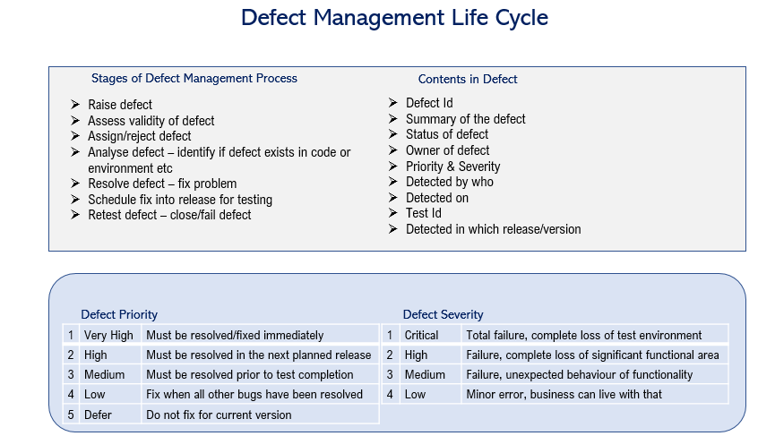

# Resource

## Test Data

One of the main deliverables to start SIT is the source data and will be sourced from the relevant on-premise source system(s) involved in the individual use case as per meta data populated in control framework. It’s expected that, source system owner will be responsible for the data quality. MDP QA team will request test data either cut down version or full copy of test data (based on the individual use case requirement) for an initial load, followed by an updated data for an incremental/delta load. MDP test team is also responsible for extracting and processing the data across the multiple layers and eventually transformed and loaded into gold layer within Data lake in both Parquet/Delta format. MDP QA team is also responsible for validating data reconciliation between Source to Target in all layers starting from bronze, data transformation and data integrity across the entities.

## Tools

MDP QA team will continue to use ADO for test management, test execution and defect management. All the test cases for SIT and Regression Pack will be designed/developed in ADO. Each test case will be linked to user story within the project/use case from coverage perspective. For the earlier test phases whoever is leading should use whatever existing processes are in place.

It is recommended that all defects identified across all the test phases are managed using ADO. This test tool can only be accessed internally to BRIT team

The defect management process is further explained in section 3.6 of this document.

## Roles and Responsibilities

|  |  |
| --- | --- |
| **Role** | **Responsibilities** |
| ???? | * Sign-off Test Strategy * Sign-off Test Plan * Sign-off Test Schedule * Sign-off Test Completion Report(s) |
| LTE/TM  (Lead Test Engineer /  Test Manager) | * Lead the test team and manage testing tasks * Write the test approach and ensure it is followed at all stages * Undertake relevant test phase sign-off * Liaise with specialist teams (Performance, Security etc.) to incorporate non-functional testing into the test approach * Plan the daily testing workload and reporting of progress * Remove any blockers that occur during testing |
| TE  (Test Engineer) | * Define test coverage and prioritise tests * Design test cases and execute tests * Ensure all defects are allocated, fixed and retested * Actively update regression pack for future regression |
| Performance TE  (PTE) | * Write the performance test plan in conjunction with the LTE/TM * Execute performance testing and assist with test sign off * Work with the project team to ensure that security and OAT testing (where required) is executed and signed off |
| Business/Data Analyst  BA/DA | * Contribute to and review test artefacts * Joint responsibility with the LDE/SDE for reviewing and signing off test coverage |
| Data Engineer  DE | * Execute unit testing and provide evidence * Joint responsibility with the BA/DA for reviewing and signing off test coverage |

## Test Environments

Cloud ops team will be responsible to define and manage test environments. There are a number of assumptions associated with the provision and support of test environments which are detailed below: -

* Test environments will be provided for the purpose of SIT followed by other test phases
* Full uninterrupted access will be available to all MDP QA team members (Apart from the need for new releases or agreed outages)
* It is expected that all test environments will be supported in line with existing production support procedures Only Production issues should supersede the support for test environments
* Any issues with test environments will be logged and managed using the defect management process as detailed within this document
* Controlled Release Management process will be followed as per Release Strategy

Summary of environments as below (To be discussed)

|  |  |
| --- | --- |
| **Environment** | **Description** |
| DEV | Development + Unit Test |
| TEST | SIT Functional + Component Integration (within MDP) + NFT |
| UAT | Integration Testing (MDP + Portal/Visualisation Power BI/Tableau etc.) |
| Pre-Prod | Non-Functional Test based on NFT requirements |
| Prod | RFO – Ready for Operation (Data Reconciliation) |

## Skills and Resource Requirements

The MDP QA team would need to have the below detailed skill sets:

* ETL / Business Intelligence / Enterprise Data Warehouse Testing experience
* Knowledge of designing Test Case, System testing, Regression testing
* Knowledge of Test management tools like ADO/JIRA etc.
* Good knowledge of tools like SSIS/SSRS/Power BI, Tableau
* Good understanding about Azure Cloud Technology (ADF/Synapse/Data Lake/Delta Lake/Data Bricks etc.)
* Technical knowledge SQL/ T-SQL/Python
* Ability to develop automation scripts

## RIDA (Risks, Issues, Dependency & Assumptions)

Testing related risks and issues will be managed by existing process within BRIT

## Reporting & Statistics

There are 2 types of test reports that will be generated throughout the delivery of testing.

* Test Progress Reports
* Test Completion Reports

All delivery/test teams across all the test phases will be expected to provide ongoing status reports tracking test/defects progress which will be centrally collated by the MDP QA team and reviewed to ensure the use case/project in on plan and quality gates will be met. A Test Completion Report must be produced at the end of each test phase to demonstrate completion of the test phase as per exit criteria.

### Test Progress Reporting

All testing metrics will be extracted from Microsoft Azure DevOps. Reports will be available via the LTE.

Reports will use the metrics provided plus additional wording to confirm any particular risks or issues which may delay current or future testing or impact quality.

Depending on the nature and size of the project the reports will include below metrics on: -

* Requirement coverage
* Test preparation progress
* Test execution progress (Pass/Fail etc.)
* Defect trends

The LTE/TM will provide a verbal update on status at regular project team meetings.  Whilst the TE will give a status update at the daily stand up.

***A dashboard can be created in ADO for each project/use case.***

### Test Completion Reporting

Test summary/completion reports will be completed as part of the exit criteria from DEV, SIT, UAT, PRE and Performance testing. These reports will confirm that all activities have completed as expected based on this document and the project test plan together with providing confirmation of the final metrics for the testing carried out.

Templates can be used as per the existing processes in place (if available)

# Glossary

| Abbreviation | Meaning |
| --- | --- |
| STLC | Software Test Life Cycle |
| MDP | Modern Data Platform |
| QA | Quality Assurance |
| BI | Business Intelligence |
| ETL | Extract Transform Load |
| NFT | Non-Functional Testing |
| OAT | Operational Acceptance Testing |
| RFO | Ready for Operation |
| SIT | System Integration Test |
| PRE | Pre-Production |
| UAT | User Acceptance Testing |
| RIDA | Risks, Issues, Dependencies & Assumptions log |
| SSIS | SQL Server Integration Services |
| SSRS | SQL Server Reporting Services |
| SME | Subject Matter Expert |
| TCR | Test Completion Report |
| SQL | Structured Query Language |
| TM | Test Manager |
| LTE | Lead Data Test Engineer |
| TE/TA | Data Test Engineer/Test Analyst |
| DA | Data Analyst |
| BA | Business Analyst |
| DE | Data Engineer |
| ADO | Azure DevOps |
| LDM | Logical Data Model |
| PDM | Physical Data Model |

End of the Document