732A54: Big Data Analytics - Lab BDA1 – Spark

*Umamaheswarababu Maddela (umama339)*

*Dinesh Sundaramoorthy (dinsu875)*

**Assignment-1:**

What are the lowest and highest temperatures measured each year for the period 1950-2014. Provide the lists sorted in the descending order with respect to the maximum temperature. In this exercise you will use the temperature-readings.csv file. The output should at least contain the following information (You can also include a Station column so that you may find multiple stations that record the highest (lowest) temperature.):

Year, temperature

**Solution:**

**For Highest Temperatures:**

**Code:**

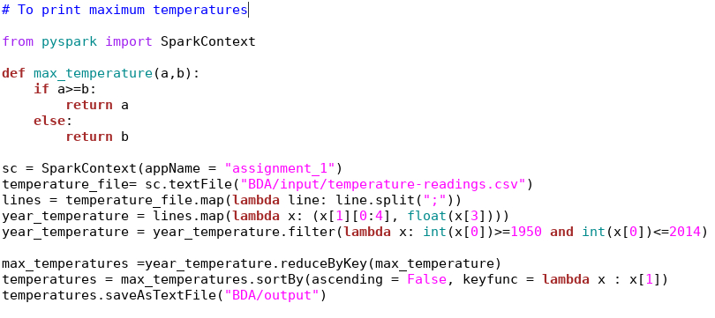

**Output:** (First 5 lines)

(u'1975', 36.1)

(u'1992', 35.4)

(u'1994', 34.7)

(u'2014', 34.4)

(u'2010', 34.4)

**For Lowest Temperatures:**

**Code:**

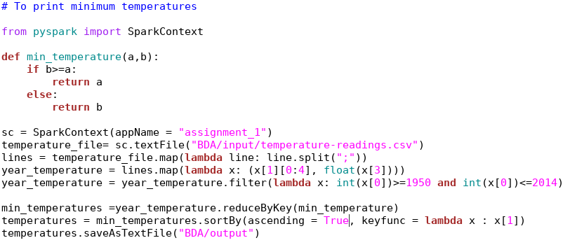

**Output:** (First 5 lines)

(u'1966', -49.4)

(u'1999', -49.0)

(u'1978', -47.7)

(u'1987', -47.3)

(u'1967', -45.4)

**Sorted in the descending order with respect to the maximum temperature:**

**Code:**

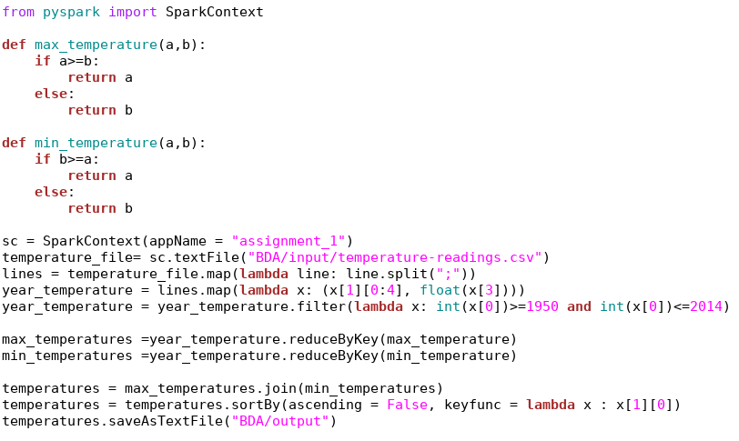

**Output:** (First 20 lines)

(u'1975', (36.1, -37.0))

(u'1992', (35.4, -36.1))

(u'1994', (34.7, -40.5))

(u'2014', (34.4, -42.5))

(u'2010', (34.4, -41.7))

(u'1989', (33.9, -38.2))

(u'1982', (33.8, -42.2))

(u'1968', (33.7, -42.0))

(u'1966', (33.5, -49.4))

(u'2002', (33.3, -42.2))

(u'1983', (33.3, -38.2))

(u'1986', (33.2, -44.2))

(u'1970', (33.2, -39.6))

(u'1956', (33.0, -45.0))

(u'2000', (33.0, -37.6))

(u'1959', (32.8, -43.6))

(u'2006', (32.7, -40.6))

(u'1991', (32.7, -39.3))

(u'1988', (32.6, -39.9))

(u'2011', (32.5, -42.0))

**Assignment-2:**

Count the number of readings for each month in the period of 1950-2014 which are higher than 10 degrees. Repeat the exercise, this time taking only distinct readings from each station. That is, if a station reported a reading above 10 degrees in some month, then it appears only once in the count for that month.

In this exercise you will use the temperature-readings.csv file. The output should contain the following information:

Year, month, count

**Solution:**

**Number of readings for each month in the period of 1950-2014 which are higher than 10 degrees:**

**Code:**

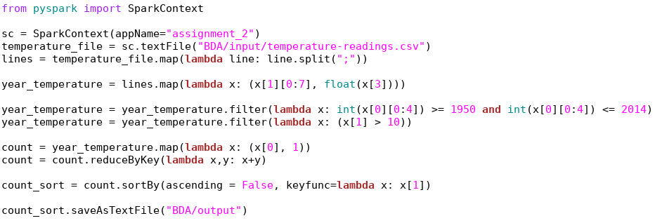

**Output:** (First 20 lines)

**(u'2014-07', 147681)**

**(u'2011-07', 146656)**

**(u'2010-07', 143419)**

**(u'2012-07', 137477)**

**(u'2013-07', 133657)**

**(u'2009-07', 133008)**

**(u'2011-08', 132734)**

**(u'2009-08', 128349)**

**(u'2013-08', 128235)**

**(u'2003-07', 128133)**

**(u'2002-07', 127956)**

**(u'2006-08', 127622)**

**(u'2008-07', 126973)**

**(u'2002-08', 126073)**

**(u'2005-07', 125294)**

**(u'2011-06', 125193)**

**(u'2012-08', 125037)**

**(u'2006-07', 124794)**

**(u'2010-08', 124417)**

**(u'2014-08', 124045)**

**Taking only distinct readings from each station:**

**Code:**

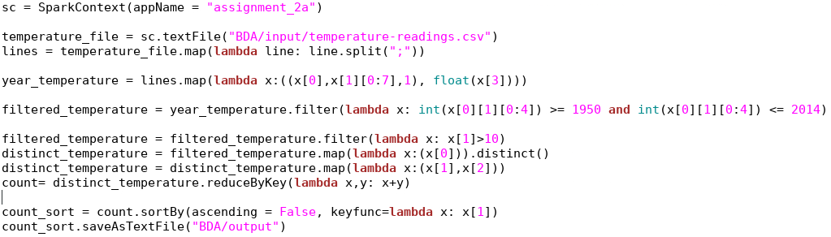

**Output:** (First 20 lines)

**(u'1972-10', 378)**

**(u'1973-06', 377)**

**(u'1973-05', 377)**

**(u'1972-08', 376)**

**(u'1973-09', 376)**

**(u'1972-05', 375)**

**(u'1971-08', 375)**

**(u'1972-09', 375)**

**(u'1972-06', 375)**

**(u'1971-09', 374)**

**(u'1972-07', 374)**

**(u'1971-06', 374)**

**(u'1971-05', 373)**

**(u'1973-08', 373)**

**(u'1974-06', 372)**

**(u'1974-08', 372)**

**(u'1973-07', 370)**

**(u'1970-08', 370)**

**(u'1974-05', 370)**

**(u'1971-07', 370)**

**Assignment-3:**

Find the average monthly temperature for each available station in Sweden. Your result should include average temperature for each station for each month in the period of 1960- 2014. Bear in mind that not every station has the readings for each month in this timeframe. In this exercise you will use the temperature-readings.csv file. The output should contain the following information:

**Year, month, station number, average monthly temperature**

**Solution:**

**Code:**

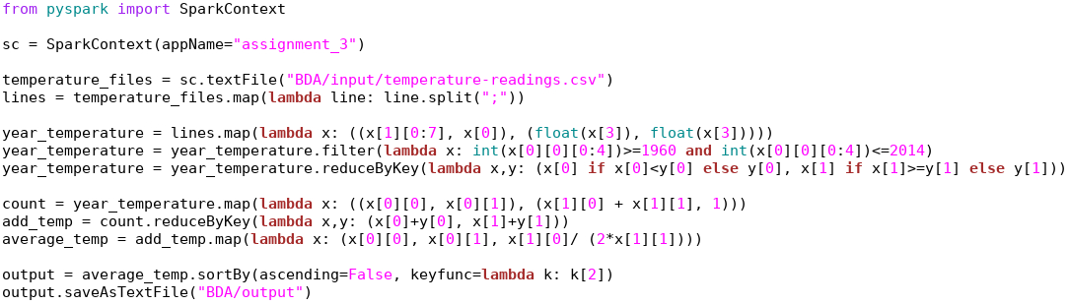

**Output:** (First 20 lines)

**(u'2014-07', u'96000', 26.3)**

**(u'1975-08', u'53560', 24.85)**

**(u'1975-08', u'78140', 24.75)**

**(u'1994-07', u'76000', 24.5)**

**(u'1975-08', u'86200', 24.450000000000003)**

**(u'1994-07', u'85280', 24.25)**

**(u'1975-08', u'87540', 24.099999999999998)**

**(u'1994-07', u'75120', 24.0)**

**(u'1975-08', u'98210', 23.95)**

**(u'1994-07', u'86330', 23.85)**

**(u'2002-08', u'78140', 23.8)**

**(u'2006-07', u'76530', 23.75)**

**(u'1975-08', u'97120', 23.7)**

**(u'1994-07', u'96000', 23.7)**

**(u'1975-08', u'97190', 23.7)**

**(u'1975-08', u'97210', 23.7)**

**(u'1975-08', u'85220', 23.6)**

**(u'1994-07', u'85210', 23.6)**

**(u'1994-07', u'62400', 23.6)**

**(u'1975-08', u'54550', 23.5)**

**Assignment-4:**

Provide a list of stations with their associated maximum measured temperatures and maximum measured daily precipitation. Show only those stations where the maximum temperature is between 25 and 30 degrees and maximum daily precipitation is between 100 mm and 200mm. In this exercise you will use the temperature-readings.csv and precipitation-readings.csv files. The output should contain the following information:

**Station number, maximum measured temperature, maximum daily precipitation**

**Solution:**

**Code:**

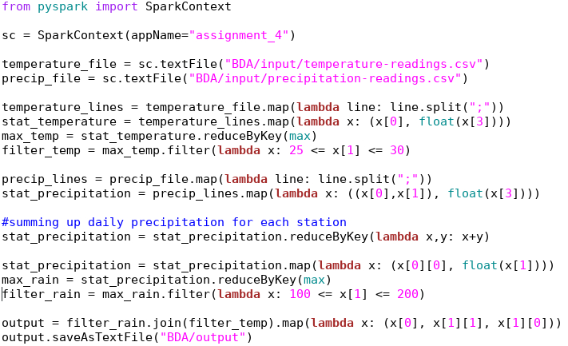

**Output:**

# There is no output for the given filter conditions

**Assignment-5:**

Calculate the average monthly precipitation for the Östergotland region (list of stations is provided in the separate file) for the period 1993-2016. In order to do this, you will first need to calculate the total monthly precipitation for each station before calculating the monthly average (by averaging over stations). In this exercise you will use the precipitation-readings.csv and stations-Ostergotland.csv files.

The output should contain the following information:

**Year, month, average monthly precipitation**

**Solution:**

**Code:**

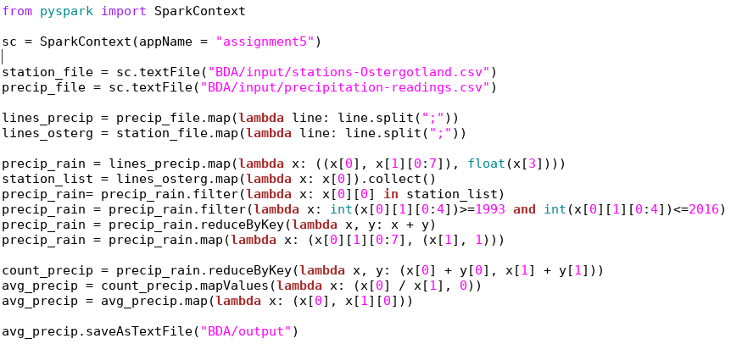

**Output:** (First 20 lines)

**(u'1996-11', 67.11666666666665)**

**(u'2008-03', 42.200000000000024)**

**(u'2008-10', 59.566666666666684)**

**(u'2014-05', 58.000000000000014)**

**(u'2001-11', 26.38333333333334)**

**(u'2011-05', 37.85)**

**(u'2010-09', 43.08333333333335)**

**(u'2010-02', 52.75000000000005)**

**(u'2013-08', 54.075)**

**(u'2002-06', 98.7833333333333)**

**(u'2013-05', 47.92500000000001)**

**(u'1998-11', 28.96666666666668)**

**(u'2002-03', 26.93333333333334)**

**(u'2013-02', 25.525000000000013)**

**(u'2007-08', 54.166666666666664)**

**(u'1995-12', 5.116666666666666)**

**(u'2000-06', 62.01666666666667)**

**(u'2007-02', 33.066666666666684)**

**(u'1993-11', 42.80000000000003)**

**(u'2009-07', 113.16666666666663)**