La base de datos consta de dos archivos, train.csv y test.csv, un archivo para entrenar el modelo y otro archivo para testearlo, cada uno con la misma cantidad de ejemplos por cada clase, la base de datos de entrenamiento tiene 1840 ejemplos por cada clase para un total de 9200 ejemplos y la base de datos de test tiene 460 ejemplos por cada clase para un total de 2300 ejemplos.

Los entrenamientos se realizaron variando de forma aleatoria la cantidad de capas ocultas, el número de neuronas por capa, y los demás hiperparametros mencionados en cada entrenamiento.

**Entrenamientos:**

**Entrenamiento 0**

n_hidden=[2560,1920,1280,960,640,320,160,80,40,20] # 10 capas

learning_rate = 0.0001

training_epochs = 1000

batch_size =50#<=50 & >= 10

display_step = 10 #cada cuantas iteraciónes imprime

n_input = 178

dropout_rate = 0.2

loss_op = tf.reduce_mean(tf.losses.softmax_cross_entropy(logits=logits, onehot_labels=Y))

optimizer = tf.train.AdamOptimizer(learning_rate=learning_rate)

train_op = optimizer.minimize(loss_op)

Optimization Finished!

Cost Min: cost=1.513386794 in epoch: 0993 cost_init=2.172012383 accurrency_init=0.187826082

Accuracy-train: 0.23467392

Accuracy-test: 0.22130434

<class 'numpy.ndarray'> <class 'numpy.ndarray'>

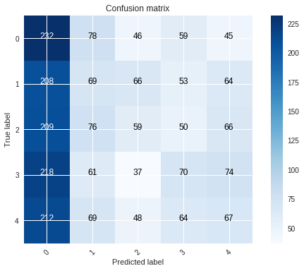TNR Especificidad o verdadesros negativos {0: 0.5396739130434782, 1: 0.8456521739130435, 2: 0.8929347826086956, 3: 0.8771739130434782, 4: 0.8646739130434783}

TPR Sensibilidad o verdaderos positivos {0: 0.5043478260869565, 1: 0.15, 2: 0.1282608695652174, 3: 0.15217391304347827, 4: 0.14565217391304347}

**Entrenamiento 1**

n_hidden=[2560,1920,1280,960,640,320,160,80,40,20] # 10 capas

learning_rate = 0.0001

training_epochs = 1000

batch_size =50#<=50 & >= 10

display_step = 10 #cada cuantas iteraciónes imprime

n_input = 178

dropout_rate = 0.2

train_op = optimizer.minimize(loss_op)

loss_op = tf.reduce_mean(tf.losses.softmax_cross_entropy(logits=logits, onehot_labels=Y))

optimizer =tf.train.GradientDescentOptimizer(learning_rate=learning_rate)

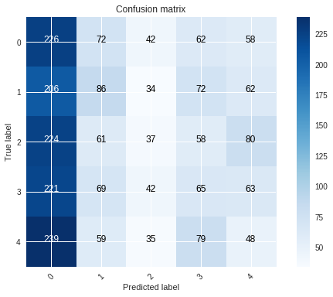Cost Min: cost=1.510820984 in epoch: 0879 cost_init=2.640485015 accurrency_init=0.200000003

Accuracy-train: 0.23445652

Accuracy-test: 0.20434782

<class 'numpy.ndarray'> <class 'numpy.ndarray'>

TNR Especificidad o verdadesros negativos {0: 0.5163043478260869, 1: 0.8581521739130434, 2: 0.9168478260869565, 3: 0.8527173913043479, 4: 0.8570652173913044}

TPR Sensibilidad o verdaderos positivos

{0: 0.49130434782608695,

1: 0.18695652173913044,

2: 0.08043478260869565,

3: 0.14130434782608695,

4: 0.10434782608695652}

**Entrenamiento 2**

n_hidden=[2560,1920,1280,960,640,320,160,80,40,20] # 10 capas

learning_rate = 0.0001

training_epochs = 1000

batch_size =50#<=50 & >= 10

display_step = 10 #cada cuantas iteraciónes imprime

n_input = 178

dropout_rate = 0.2

train_op = optimizer.minimize(loss_op)

optimizer =tf.train.GradientDescentOptimizer(learning_rate=learning_rate)

loss_op = tf.reduce_mean(tf.losses.sigmoid_cross_entropy(logits=logits, multi_class_labels=Y))

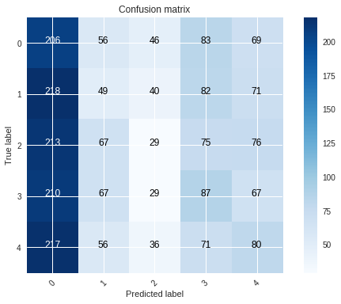Cost Min: cost=0.711314980 in epoch: 0998 cost_init=1.014492849 accurrency_init=0.195217386

Accuracy-train: 0.22836956

Accuracy-test: 0.20043479

<class 'numpy.ndarray'> <class 'numpy.ndarray'>

TNR Especificidad o verdadesros negativos {0: 0.533695652173913, 1: 0.866304347826087, 2: 0.9179347826086957, 3: 0.8309782608695652, 4: 0.846195652173913}

TPR Sensibilidad o verdaderos positivos {0: 0.44782608695652176, 1: 0.10652173913043478, 2: 0.06304347826086956, 3: 0.1891304347826087, 4: 0.17391304347826086}

**Entrenamiento 3**

n_hidden=[2560,1920,1280,960,640,320,160,80,40,20] # 10 capas

learning_rate = 0.0001

training_epochs = 1000

batch_size =50#<=50 & >= 10

display_step = 10 #cada cuantas iteraciónes imprime

n_input = 178

dropout_rate = 0.2

train_op = optimizer.minimize(loss_op)

loss_op = tf.reduce_mean(tf.losses.sigmoid_cross_entropy(logits=logits, multi_class_labels=Y))

optimizer = tf.train.AdamOptimizer(learning_rate=learning_rate)

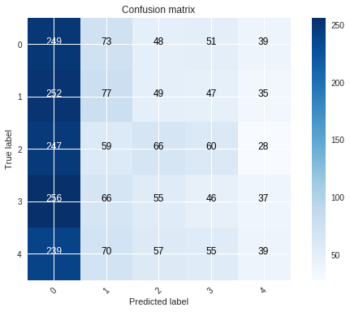Cost Min: cost=0.691820696 in epoch: 0985 cost_init=0.986866643 accurrency_init=0.186086953

Accuracy-train: 0.18315217

Accuracy-test: 0.19217391

<class 'numpy.ndarray'> <class 'numpy.ndarray'>

TNR Especificidad o verdadesros negativos {0: 0.4597826086956522, 1: 0.8543478260869565, 2: 0.8864130434782609, 3: 0.8842391304347826, 4: 0.9244565217391304}

TPR Sensibilidad o verdaderos positivos {0: 0.5413043478260869, 1: 0.1673913043478261, 2: 0.14347826086956522, 3: 0.1, 4: 0.08478260869565217}

**Entrenamiento 4**

learning_rate = 0.0001 #

training_epochs = 1000 #

n_hidden=[2560,5120,10240,5120,2560,1280,640,320,160,80]

dropout_rate = 0.3

batch_size =50

loss_op = tf.reduce_mean(tf.losses.softmax_cross_entropy(logits=logits, onehot_labels=Y))#

optimizer = tf.train.AdamOptimizer(learning_rate=learning_rate)# optimizador

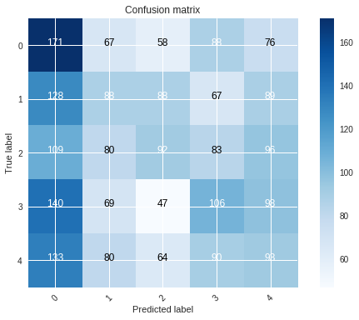Cost Min: cost=1.513967712 in epoch: 0994 cost_init=2.052056408 accurrency_init=0.200434789

Accuracy-train: 0.27380434

Accuracy-test: 0.24347825

<class 'numpy.ndarray'> <class 'numpy.ndarray'>

TNR Especificidad o verdadesros negativos {0: 0.7228260869565217, 1: 0.8391304347826087, 2: 0.8603260869565217, 3: 0.8217391304347826, 4: 0.8048913043478261}

TPR Sensibilidad o verdaderos positivos {0: 0.3717391304347826, 1: 0.19130434782608696, 2: 0.2, 3: 0.23043478260869565, 4: 0.20217391304347826}

**Entrenamiento 5**

n_hidden=[600,500,400,300,350,450,550,650,550,700,600,500,400,300,150,80]

learning_rate = 0.0001 #

training_epochs = 1000 #

batch_size =50# <=10 & <= 50 # numero de ejemplos que van a ser mostrados a la red en cada itereación

display_step = 10 #cada cuantas iteraciónes imprime los resultados de la función de costo

n_input = 178

dropout_rate = 0.3

loss_op = tf.reduce_mean(tf.losses.softmax_cross_entropy(logits=logits, onehot_labels=Y))#

optimizer = tf.train.AdamOptimizer(learning_rate=learning_rate)

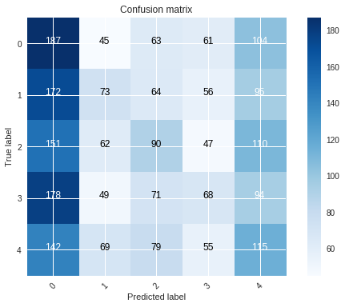Cost Min: cost=1.433175411 in epoch: 1000 cost_init=1.723486026 accurrency_init=0.210869566

Accuracy-train: 0.27934784

Accuracy-test: 0.23391305

<class 'numpy.ndarray'> <class 'numpy.ndarray'>

TNR Especificidad o verdadesros negativos {0: 0.6505434782608696, 1: 0.8777173913043478, 2: 0.8494565217391304, 3: 0.8809782608695652, 4: 0.7809782608695652}

TPR Sensibilidad o verdaderos positivos {0: 0.40652173913043477, 1: 0.15869565217391304, 2: 0.1956521739130435, 3: 0.14782608695652175, 4: 0.25}

**Entrenamiento 6**

n_hidden=[600,500,400,300,350,450,550,650,550,700,600,500,400,300,150,80]

total_examples = len(train_x_orig) # numero de ejemplos de la BD

learning_rate = 0.0001 #

training_epochs = 1000 #

batch_size =50# <=10 & <= 50 # numero de ejemplos que van a ser mostrados a la red en cada itereación

display_step = 10 #cada cuantas iteraciónes imprime los resultados de la función de costo

n_input = 178

n_classes = 5 # numero de clases

dropout_rate = 0.3

loss_op = tf.reduce_mean(tf.losses.softmax_cross_entropy(logits=logits, onehot_labels=Y))

optimizer =tf.train.GradientDescentOptimizer(learning_rate=learning_rate)

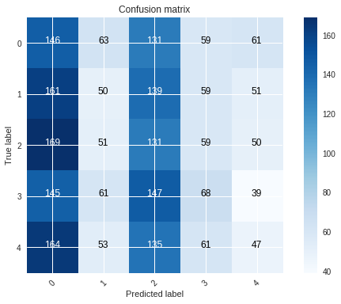Cost Min: cost=1.912183874 in epoch: 0874 cost_init=2.142123218 accurrency_init=0.197826087

Accuracy-train: 0.21021739

Accuracy-test: 0.20956522

<class 'numpy.ndarray'> <class 'numpy.ndarray'>

TNR Especificidad o verdadesros negativos {0: 0.6527173913043478, 1: 0.8760869565217392, 2: 0.7, 3: 0.8706521739130435, 4: 0.8907608695652174}

TPR Sensibilidad o verdaderos positivos {0: 0.3173913043478261, 1: 0.10869565217391304, 2: 0.2847826086956522, 3: 0.14782608695652175, 4: 0.10217391304347827}

**Entrenamiento 7**

n_hidden=[600,500,400,300,350,450,550,650,550,700,600,500,400,300,150,80]

total_examples = len(train_x_orig) # numero de ejemplos de la BD

learning_rate = 0.0001 #

training_epochs = 1000 #

batch_size =50# <=10 & <= 50 # numero de ejemplos que van a ser mostrados a la red en cada itereación

display_step = 10 #cada cuantas iteraciónes imprime los resultados de la función de costo

n_input = 178

n_classes = 5 # numero de clases

dropout_rate = 0.3

loss_op = tf.reduce_mean(tf.losses.sigmoid_cross_entropy(logits=logits, multi_class_labels=Y))

optimizer =tf.train.GradientDescentOptimizer(learning_rate=learning_rate)

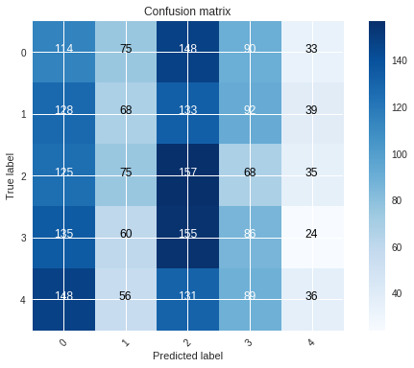Cost Min: cost=0.789823175 in epoch: 0997 cost_init=0.934686455 accurrency_init=0.205217391

Accuracy-train: 0.21728261

Accuracy-test: 0.2073913

<class 'numpy.ndarray'> <class 'numpy.ndarray'>

TNR Especificidad o verdadesros negativos {0: 0.7086956521739131, 1: 0.8554347826086957, 2: 0.6918478260869565, 3: 0.8157608695652174, 4: 0.928804347826087}

TPR Sensibilidad o verdaderos positivos {0: 0.24782608695652175, 1: 0.14782608695652175, 2: 0.34130434782608693, 3: 0.18695652173913044, 4: 0.0782608695652174}

**Entrenamiento 8**

n_hidden=[600,500,400,300,350,450,550,650,550,700,600,500,400,300,150,80]

total_examples = len(train_x_orig) # numero de ejemplos de la BD

learning_rate = 0.0001 #

training_epochs = 1000 #

batch_size =50# <=10 & <= 50 # numero de ejemplos que van a ser mostrados a la red en cada itereación

display_step = 10 #cada cuantas iteraciónes imprime los resultados de la función de costo

n_input = 178

n_classes = 5 # numero de clases

dropout_rate = 0.3

loss_op = tf.reduce_mean(tf.losses.sigmoid_cross_entropy(logits=logits, multi_class_labels=Y))

optimizer = tf.train.AdamOptimizer(learning_rate=learning_rate)

Cost Min: cost=0.693147235 in epoch: 0121 cost_init=0.962858280 accurrency_init=0.193913043

Accuracy-train: 0.2025

Accuracy-test: 0.20043479

<class 'numpy.ndarray'> <class 'numpy.ndarray'>

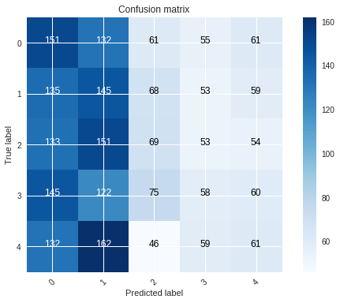TNR Especificidad o verdadesros negativos {0: 0.7038043478260869, 1: 0.6918478260869565, 2: 0.8641304347826086, 3: 0.8804347826086957, 4: 0.8728260869565218}

TPR Sensibilidad o verdaderos positivos {0: 0.3282608695652174, 1: 0.31521739130434784, 2: 0.15, 3: 0.12608695652173912, 4: 0.13260869565217392}

**Entrenamiento 9**

n_hidden=[600,500,400,300]

total_examples = len(train_x_orig) # numero de ejemplos de la BD

learning_rate = 0.001 #

training_epochs = 500 #

batch_size =50# <=10 & <= 50 # numero de ejemplos que van a ser mostrados a la red en cada itereación

display_step = 10 #cada cuantas iteraciónes imprime los resultados de la función de costo

n_input = 178

n_classes = 5 # numero de clases

dropout_rate = 0.4

loss_op = tf.reduce_mean(tf.losses.softmax_cross_entropy(logits=logits, onehot_labels=Y))#

optimizer =tf.train.GradientDescentOptimizer(learning_rate=learning_rate)

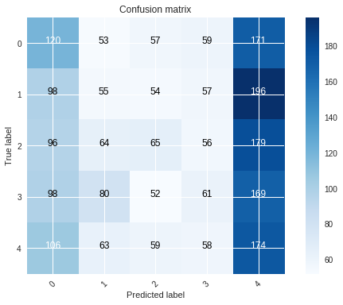Cost Min: cost=1.741002681 in epoch: 0489 cost_init=1.973916676 accurrency_init=0.206521735

Accuracy-train: 0.22043478

Accuracy-test: 0.2173913

<class 'numpy.ndarray'> <class 'numpy.ndarray'>

TNR Especificidad o verdadesros negativos {0: 0.783695652173913, 1: 0.8586956521739131, 2: 0.8793478260869565, 3: 0.875, 4: 0.6114130434782609}

TPR Sensibilidad o verdaderos positivos {0: 0.2608695652173913, 1: 0.11956521739130435, 2: 0.14130434782608695, 3: 0.13260869565217392, 4: 0.3782608695652174}

**Entrenamiento 10**

n_hidden=[600,500,400,300]

learning_rate = 0.001 #

training_epochs = 500 #

batch_size =50# <=10 & <= 50 # numero de ejemplos que van a ser mostrados a la red en cada itereación

display_step = 10 #cada cuantas iteraciónes imprime los resultados de la función de costo

n_input = 178

n_classes = 5 # numero de clases

dropout_rate = 0.4

loss_op = tf.reduce_mean(tf.losses.sigmoid_cross_entropy(logits=logits, multi_class_labels=Y)

optimizer =tf.train.GradientDescentOptimizer(learning_rate=learning_rate)

Cost Min: cost=0.909044848 in epoch: 0490 cost_init=1.127364654 accurrency_init=0.203478262

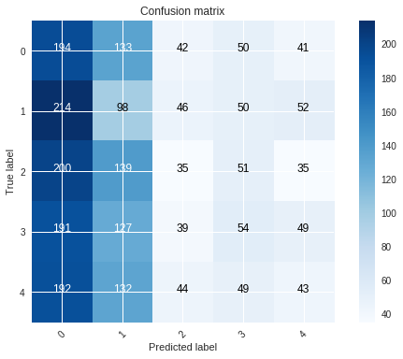Accuracy-train: 0.20913044

Accuracy-test: 0.20608696

<class 'numpy.ndarray'> <class 'numpy.ndarray'>

TNR Especificidad o verdadesros negativos {0: 0.5668478260869565, 1: 0.7114130434782608, 2: 0.9070652173913043, 3: 0.8913043478260869, 4: 0.903804347826087}

TPR Sensibilidad o verdaderos positivos {0: 0.4217391304347826, 1: 0.21304347826086956, 2: 0.07608695652173914, 3: 0.11739130434782609, 4: 0.09347826086956522}

**Entrenamiento 11**

n_hidden=[600,500,400,300]

total_examples = len(train_x_orig) # numero de ejemplos de la BD

learning_rate = 0.001 #

training_epochs = 500 #

batch_size =50# <=10 & <= 50 # numero de ejemplos que van a ser mostrados a la red en cada itereación

display_step = 10 #cada cuantas iteraciónes imprime los resultados de la función de costo

n_input = 178

n_classes = 5 # numero de clases

dropout_rate = 0.4

loss_op = tf.reduce_mean(tf.losses.sigmoid_cross_entropy(logits=logits, multi_class_labels=Y))

optimizer = tf.train.AdamOptimizer(learning_rate=learning_rate)

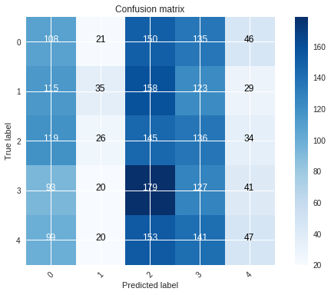Cost Min: cost=0.693015031 in epoch: 0113 cost_init=0.742471015 accurrency_init=0.196521744

Accuracy-train: 0.2

Accuracy-test: 0.2

<class 'numpy.ndarray'> <class 'numpy.ndarray'>

TNR Especificidad o verdadesros negativos {0: 0.7684782608695652, 1: 0.9527173913043478, 2: 0.6521739130434783, 3: 0.7092391304347826, 4: 0.9184782608695652}

TPR Sensibilidad o verdaderos positivos {0: 0.23478260869565218, 1: 0.07608695652173914, 2: 0.31521739130434784, 3: 0.27608695652173915, 4: 0.10217391304347827}

**Entrenamiento 12**

n_hidden=[600,500,400,300]

learning_rate = 0.001 #

training_epochs = 500 #

batch_size =50# <=10 & <= 50 # numero de ejemplos que van a ser mostrados a la red en cada itereación

display_step = 10 #cada cuantas iteraciónes imprime los resultados de la función de costo

n_input = 178

n_classes = 5 # numero de clases

dropout_rate = 0.4

loss_op = tf.reduce_mean(tf.losses.softmax_cross_entropy(logits=logits, onehot_labels=Y))#

optimizer = tf.train.AdamOptimizer(learning_rate=learning_rate)

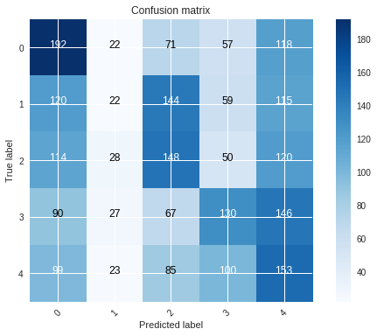Cost Min: cost=1.285008143 in epoch: 0496 cost_init=1.642515669 accurrency_init=0.200000003

Accuracy-train: 0.35293478

Accuracy-test: 0.2969565

<class 'numpy.ndarray'> <class 'numpy.ndarray'>

TNR Especificidad o verdadesros negativos {0: 0.7701086956521739, 1: 0.9456521739130435, 2: 0.8005434782608696, 3: 0.8554347826086957, 4: 0.7288043478260869}

TPR Sensibilidad o verdaderos positivos {0: 0.41739130434782606, 1: 0.04782608695652174, 2: 0.3217391304347826, 3: 0.2826086956521739, 4: 0.33260869565217394}

**Entrenamiento 13**

n_hidden=[600,500,400,300]

total_examples = len(train_x_orig) # numero de ejemplos de la BD

learning_rate = 0.001 #

training_epochs = 1000 #

batch_size =50# <=10 & <= 50 # numero de ejemplos que van a ser mostrados a la red en cada itereación

display_step = 10 #cada cuantas iteraciónes imprime los resultados de la función de costo

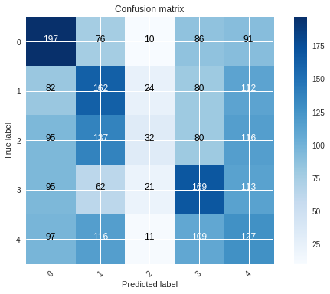n_input = 178

loss_op = tf.reduce_mean(tf.losses.softmax_cross_entropy(logits=logits, onehot_labels=Y))#

optimizer = tf.train.AdamOptimizer(learning_rate=learning_rate)

ost Min: cost=1.252722198 in epoch: 0943 cost_init=1.636424004 accurrency_init=0.190434784

Accuracy-train: 0.39065218

Accuracy-test: 0.30173913

<class 'numpy.ndarray'> <class 'numpy.ndarray'>

TNR Especificidad o verdadesros negativos {0: 0.7994565217391304, 1: 0.7875, 2: 0.9641304347826087, 3: 0.8070652173913043, 4: 0.7652173913043478}

TPR Sensibilidad o verdaderos positivos {0: 0.4282608695652174, 1: 0.3521739130434783, 2: 0.06956521739130435, 3: 0.3673913043478261, 4: 0.27608695652173915}

**Entrenamiento 14**

n_hidden=[600,500,400,300]

learning_rate = 0.001 #

training_epochs = 2000 #

batch_size =50

dropout_rate = 0.4

loss_op = tf.reduce_mean(tf.losses.softmax_cross_entropy(logits=logits, onehot_labels=Y))#

optimizer = tf.train.AdamOptimizer(learning_rate=learning_rate)

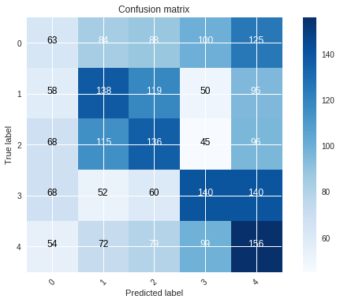

Cost Min: cost=1.226615241 in epoch: 1957 cost_init=1.628229029 accurrency_init=0.207826093

Accuracy-train: 0.42826086

Accuracy-test: 0.34130436

<class 'numpy.ndarray'> <class 'numpy.ndarray'>

TNR Especificidad o verdadesros negativos {0: 0.8652173913043478, 1: 0.8244565217391304, 2: 0.8119565217391305, 3: 0.8402173913043478, 4: 0.7521739130434782}

TPR Sensibilidad o verdaderos positivos {0: 0.13695652173913042, 1: 0.3, 2: 0.2956521739130435, 3: 0.30434782608695654, 4: 0.3391304347826087}

**Entrenamiento 15**

n_hidden=[600,500,400,300]

learning_rate = 0.0001 #

training_epochs = 3000 #

batch_size =30# <=1

n_classes = 5 # numero de clases

dropout_rate = 0.5

loss_op = tf.reduce_mean(tf.losses.softmax_cross_entropy(logits=logits, onehot_labels=Y))#

optimizer = tf.train.AdamOptimizer(learning_rate=learning_rate)

Cost Min: cost=1.006911298 in epoch: 2947 cost_init=1.922930865 accurrency_init=0.211304352

Accuracy-train: 0.52347827

Accuracy-test: 0.3047826

<class 'numpy.ndarray'> <class 'numpy.ndarray'>

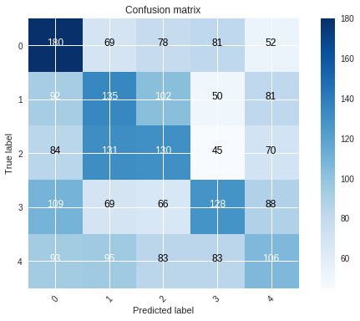TNR Especificidad o verdadesros negativos {0: 0.7945652173913044, 1: 0.8021739130434783, 2: 0.821195652173913, 3: 0.8592391304347826, 4: 0.8418478260869565}

TPR Sensibilidad o verdaderos positivos {0: 0.391304347826087, 1: 0.29347826086956524, 2: 0.2826086956521739, 3: 0.2782608695652174, 4: 0.23043478260869565}

**Entrenamiento 16**

dropout_rate = 0.5

learning_rate = 0.0001 #

training_epochs = 3000 #

batch_size =50

loss_op = tf.reduce_mean(tf.losses.softmax_cross_entropy(logits=logits, onehot_labels=Y))#

optimizer = tf.train.AdamOptimizer(learning_rate=learning_rate)

Cost Min: cost=1.010744223 in epoch: 2894 cost_init=1.924905914 accurrency_init=0.207391307

Accuracy-train: 0.5202174

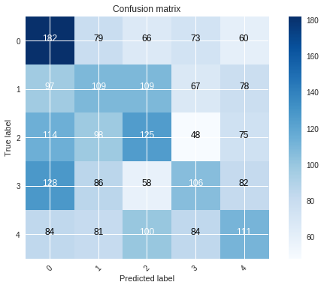Accuracy-test: 0.27130434

<class 'numpy.ndarray'> <class 'numpy.ndarray'>

TNR Especificidad o verdadesros negativos {0: 0.7701086956521739, 1: 0.8130434782608695, 2: 0.8190217391304347, 3: 0.8521739130434782, 4: 0.8396739130434783}

TPR Sensibilidad o verdaderos positivos {0: 0.39565217391304347, 1: 0.23695652173913043, 2: 0.2717391304347826, 3: 0.23043478260869565, 4: 0.24130434782608695}

**Entrenamiento 17**

n_hidden=[300,400,500,400,300,400,500,400,300]

learning_rate = 0.0001 #

training_epochs = 1000 #

batch_size =50

loss_op = tf.reduce_mean(tf.losses.softmax_cross_entropy(logits=logits, onehot_labels=Y))#

optimizer = tf.train.AdamOptimizer(learning_rate=learning_rate)

Cost Min: cost=1.101244644 in epoch: 0996 cost_init=1.960285008 accurrency_init=0.204782605

Accuracy-train: 0.48934782

Accuracy-test: 0.24608696

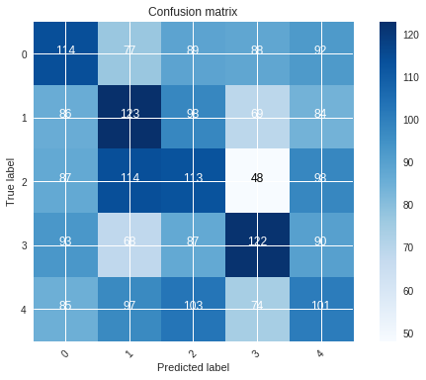<class 'numpy.ndarray'> <class 'numpy.ndarray'>

TNR Especificidad o verdadesros negativos {0: 0.8092391304347826, 1: 0.8065217391304348, 2: 0.7951086956521739, 3: 0.8483695652173913, 4: 0.8021739130434783}

TPR Sensibilidad o verdaderos positivos {0: 0.24782608695652175, 1: 0.2673913043478261, 2: 0.24565217391304348, 3: 0.26521739130434785, 4: 0.21956521739130436}

**Entrenamiento 18**

n_hidden=[300,400,500,400,300,400,500,400,300]

total_examples = len(train_x_orig) # numero de ejemplos de la BD

learning_rate = 0.0001 #

training_epochs = 3000 #

batch_size =40

loss_op = tf.reduce_mean(tf.losses.softmax_cross_entropy(logits=logits, onehot_labels=Y))#

optimizer = tf.train.AdamOptimizer(learning_rate=learning_rate)

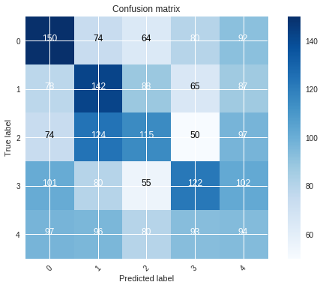Cost Min: cost=1.029384277 in epoch: 2211 cost_init=1.662210825 accurrency_init=0.202173918

Accuracy-train: 0.5679348

Accuracy-test: 0.2721739

<class 'numpy.ndarray'> <class 'numpy.ndarray'>

TNR Especificidad o verdadesros negativos {0: 0.8097826086956522, 1: 0.7967391304347826, 2: 0.8440217391304348, 3: 0.8434782608695652, 4: 0.7945652173913044}

TPR Sensibilidad o verdaderos positivos {0: 0.32608695652173914, 1: 0.30869565217391304, 2: 0.25, 3: 0.26521739130434785, 4: 0.20434782608695654}

**Entrenamiento 19**

learning_rate = 0.0001 #

training_epochs = 1000 #

batch_size =50

n_hidden=[300,350,400,450,400,350,300,250,200]

dropout_rate = 0.5

loss_op = tf.reduce_mean(tf.losses.softmax_cross_entropy(logits=logits, onehot_labels=Y))#

optimizer = tf.train.AdamOptimizer(learning_rate=learning_rate)

Cost Min: cost=1.069706586 in epoch: 0877 cost_init=1.831158485 accurrency_init=0.200869560

Accuracy-train: 0.4954348

Accuracy-test: 0.23043478

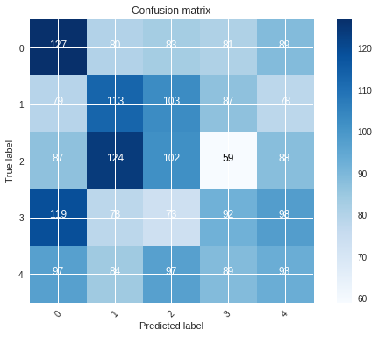<class 'numpy.ndarray'> <class 'numpy.ndarray'>

TNR Especificidad o verdadesros negativos {0: 0.7923913043478261, 1: 0.8010869565217391, 2: 0.8065217391304348, 3: 0.8282608695652174, 4: 0.8081521739130435}

TPR Sensibilidad o verdaderos positivos {0: 0.27608695652173915, 1: 0.24565217391304348, 2: 0.2217391304347826, 3: 0.2, 4: 0.20217391304347826}

**Entrenamiento 20**

n_hidden=[350,300,2500,200]

total_examples = len(train_x_orig) # numero de ejemplos de la BD

learning_rate = 0.0001 #

training_epochs = 3000 #

batch_size =30

dropout_rate = 0.5

loss_op = tf.reduce_mean(tf.losses.softmax_cross_entropy(logits=logits, onehot_labels=Y))#

optimizer = tf.train.AdamOptimizer(learning_rate=learning_rate)

Cost Min: cost=1.000508346 in epoch: 2346 cost_init=1.912574027 accurrency_init=0.190434784

Accuracy-train: 0.51152176

Accuracy-test: 0.29347825

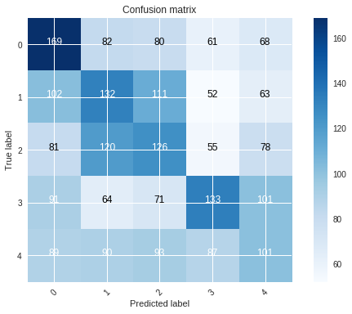<class 'numpy.ndarray'> <class 'numpy.ndarray'>

TNR Especificidad o verdadesros negativos {0: 0.8027173913043478, 1: 0.8065217391304348, 2: 0.8070652173913043, 3: 0.8614130434782609, 4: 0.8315217391304348}

TPR Sensibilidad o verdaderos positivos {0: 0.3673913043478261, 1: 0.28695652173913044, 2: 0.27391304347826084, 3: 0.2891304347826087, 4: 0.21956521739130436}

**Entrenamiento 21**

n_hidden=[356,260,178,130,89,45,20]

learning_rate = 0.0001

training_epochs = 300

batch_size =50

loss_op = tf.reduce_mean(tf.losses.sigmoid_cross_entropy(logits=logits, multi_class_labels=Y))

optimizer = tf.train.AdamOptimizer(learning_rate=learning_rate)

Accuracy-train: 0.35630435

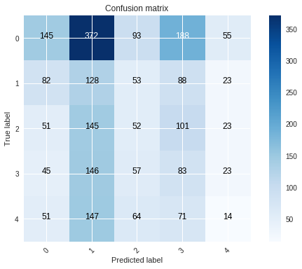Accuracy-test: 0.37086958

<class 'numpy.ndarray'> <class 'numpy.ndarray'>

TNR Especificidad o verdadesros negativos {0: 0.8417415342087077, 1: 0.5794392523364486, 2: 0.8615145228215768, 3: 0.7697841726618705, 4: 0.9365079365079365}

TPR Sensibilidad o verdaderos positivos {0: 0.16998827667057445, 1: 0.3422459893048128, 2: 0.13978494623655913, 3: 0.2344632768361582, 4: 0.040345821325648415}