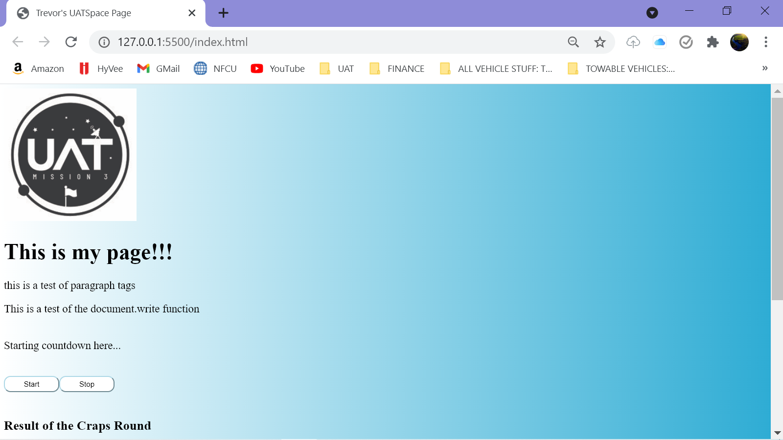

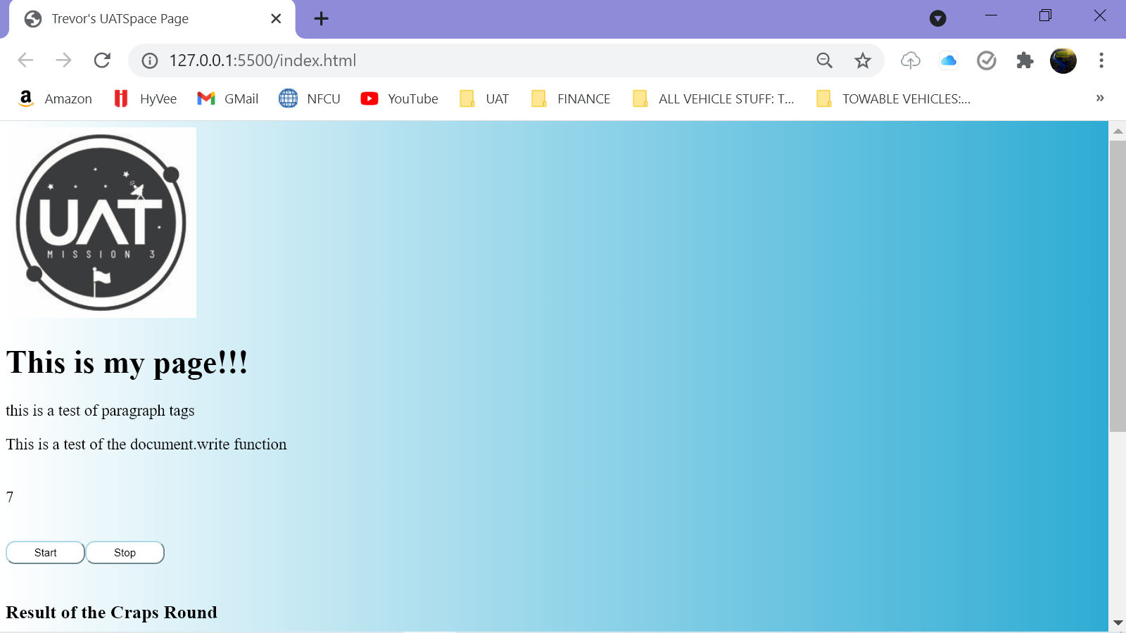

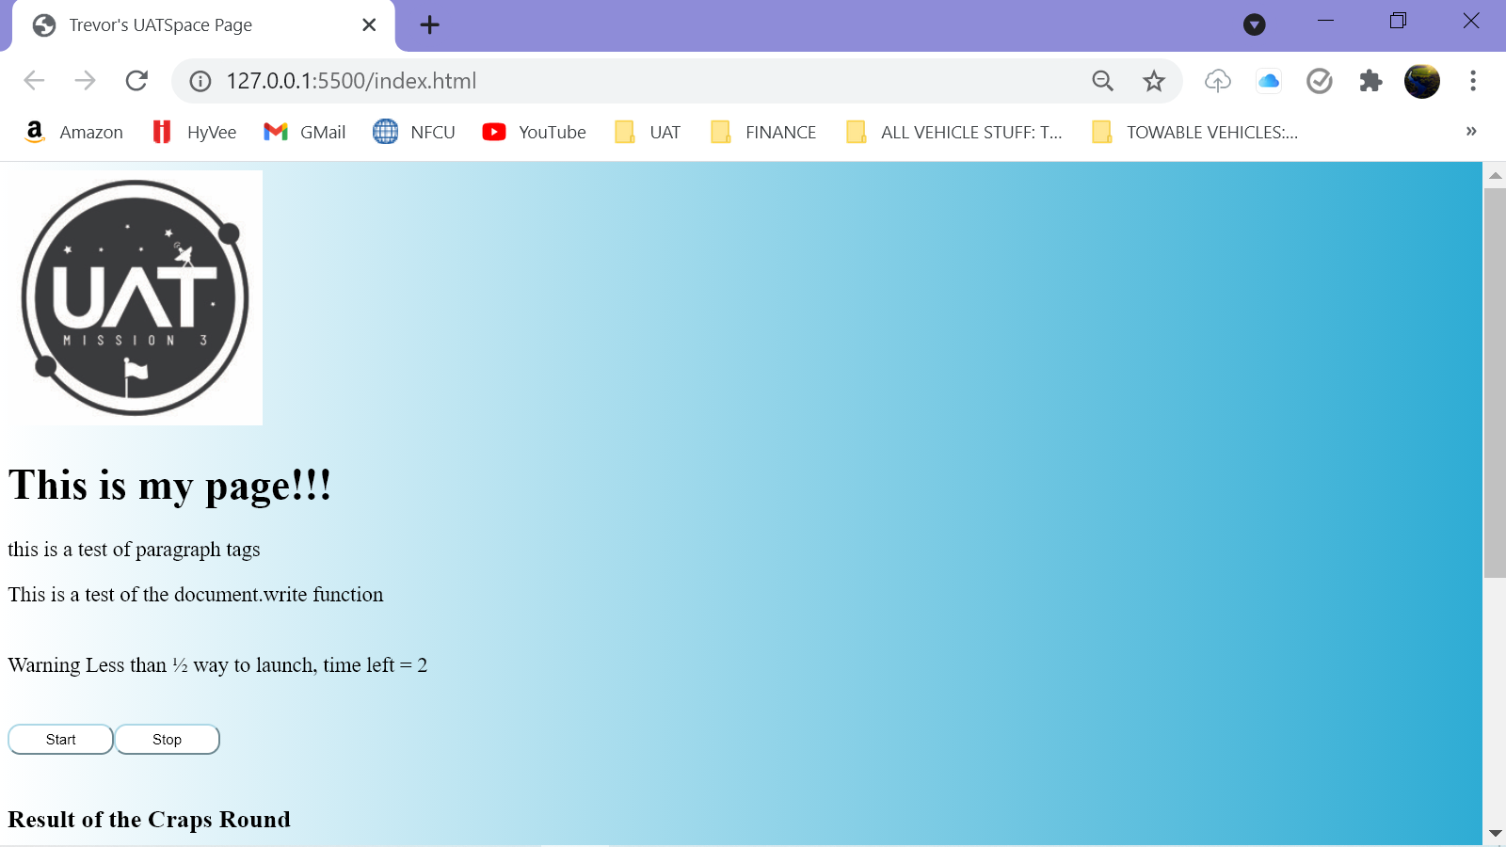

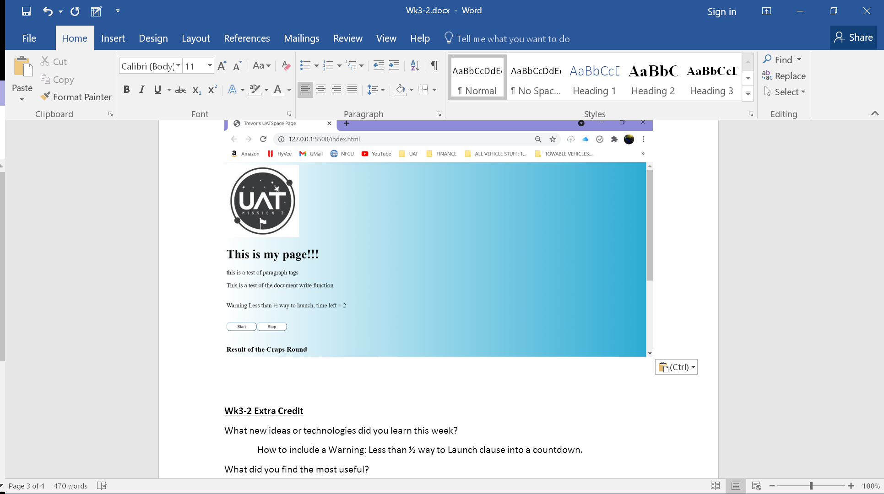

**Wk3-2 Extra Credit**

What new ideas or technologies did you learn this week?

How to include a Warning: Less than ½ way to Launch clause into a countdown.

What did you find the most useful?

Ctrl+F is the Find toolbar that let’s you search for I’s for example. It’ll include If’s, Timeouts, etc. Then use the Up/Down arrows to scroll through all instances.

What did you find the most confusing?

How to code a countdown in multiple ways. When and how to interchange I and Count variables.

What surprised you most about class this week?

How easy it is to find which parenthesis go with which. Highlight function is cool.

What do you wish you had done differently?

I wish I knew Ctrl+Slash will bring it all back.

What do you wish you could tell "past you" to help "present you" code in a more manageable fashion?

The ability to say the same thing in multiple ways is pretty important

What will you do so that "future you" improves as a programmer?

Continue practicing writing code, continue taking notes, and continue reading Eloquent Javascript.

How do you plan to use what you learned this week in the future?

Knowing how to use timers is pretty important for a few projects I’d like to undergo in the future, like fetching every 15 minutes instead of constantly. Having a diverse approach would be a lot better than only knowing one method and not having it work.